**Fake-News Detection**

**Team Name: Trailblazer**

**Team Members: Kishore M A , Vishwa Raviraaj S I ,Tharun Raj R G**

**Abstract:**

The goal of this project is to create a machine learning-based system that can identify false news articles. The objective is to detect fake news stories that include false information. For testing and training purposes, this project makes use of the extensive ISOT Fake News dataset. Beginning with tidying up and preparing the data is a crucial first stage in the endeavor. Placeholders for URLs, numbers, and emails are used to standardize the text data. All punctuation, capitalization, and HTML elements are stripped out of the text. Additional data cleansing steps include using stemming algorithms and excluding stopwords.Parallelization methods are used to increase processing efficiency. To speed up the preparation procedures, the data is split up into smaller pieces and processed in parallel.

In order to identify bogus news, feature extraction is essential. The preprocessed text is converted into numerical features using natural language processing algorithms. Uni-, bi-, and tri-grams are generated to capture various patterns and connections in the text. Multiple machine learning models were utilized for training and testing the false news detection system. Naive Bayes, SVM, Logistic Regression, and MLP are some examples of these types of models. A number of criteria, including accuracy, precision, recall, and F1 score, are used to evaluate the models. The goal is to find the best model for reliably labeling news stories as phony or real.

This project's results shed light on how machine learning may be used to spot disingenuous articles. Using sophisticated natural language processing (NLP) methods, preprocessing, and feature extraction, the system can reliably detect false or misleading news stories. The merits and limitations of several machine learning models are revealed via comparison, allowing for the best model for false news detection to be chosen.

Overall, the success of this study shows how machine learning may be used to prevent the harmful impacts of false news. As the problems with identifying false news continue to evolve, new and better methods may be developed and used.

**Introduction:**

In today's information-driven world, the term "fake news" has become a frequent topic of discussion. Whether it pertains to political events or spreads through various social platforms, the difficulty in discerning reliable sources of information has heightened. In response to this challenge, our project focuses on understanding what constitutes fake news and proposes an efficient approach to detect it using cutting-edge machine learning and natural language processing techniques.

The objective of our project was to develop a robust machine learning program capable of identifying when a news source may be generating fake news. To accomplish this, we employed a comprehensive corpus of labeled real and fake news articles, utilizing it to build a sophisticated classifier capable of making informed decisions based on the content within the corpus. By focusing on the identification of fake news sources rather than individual articles, our model expands its scope to predict with a high level of confidence whether future articles from a particular source are likely to be fake news as well.

One of the primary advantages of our approach is that it allows for a certain degree of misclassification tolerance. Since our model analyzes multiple articles originating from each source, we benefit from a wealth of data points that contribute to the prediction process. This multi-faceted analysis ensures that our model can effectively differentiate between trustworthy and untrustworthy sources, empowering social networks to assign visibility weights accordingly. By utilizing the weights produced by our model, social media platforms can strategically minimize the visibility of stories that are highly likely to be fake news, thereby safeguarding their users against deceptive information.

Our project not only tackles the pervasive issue of fake news but also leverages the power of machine learning to make a positive impact on the digital landscape. By incorporating the latest advancements in natural language processing and data analysis, we are confident that our model provides a robust solution for identifying and combating the proliferation of fake news.

**Literature Survey and Related Works**

1. [**Gilda (2017)**](https://ieeexplore.ieee.org/document/8305411)**, S. "Notice of Violation of IEEE Publication Principles: Evaluating machine learning algorithms for fake news detection." 2017 IEEE 15th Student Conference on Research and Development (SCOReD), 2017. DOI: 10.1109/SCORED.2017.8305411.**

The study utilized term frequency-inverse document frequency (TF-IDF) of bi-grams and probabilistic context-free grammar (PCFG) detection on a dataset of 11,000 articles. Multiple classification algorithms, including Support Vector Machines, Stochastic Gradient Descent, Gradient Boosting, Bounded Decision Trees, and Random Forests, were tested. The results showed that TF-IDF of bi-grams combined with Stochastic Gradient Descent achieved an accuracy of 77.2% in identifying non-credible sources.

1. [**Han and Mehta**](https://ieeexplore.ieee.org/document/9065138)**, V. "Fake News Detection in Social Networks Using Machine Learning and Deep Learning: Performance Evaluation." 2019 IEEE International Conference on Industrial Internet (ICII), 2019. DOI: 10.1109/ICII.2019.00070.**

The study considered traditional machine learning methods such as Naive Bayes and deep learning methods like hybrid CNN and RNN. The focus was on finding a balance between accuracy and lightweightness in selecting the most suitable approach. The research emphasized the prominent role of social media networks as platforms for the spread of misinformation.

1. [**Jain and Kasbe**](https://ieeexplore.ieee.org/document/8546944)**, A. "Fake News Detection." 2018 IEEE International Students' Conference on Electrical, Electronics and Computer Science (SCEECS), 2018. DOI: 10.1109/SCEECS.2018.8546944.**

The study applied four traditional feature extraction methods and employed 10 different machine learning and deep learning classifiers. Notably, a convolutional neural network showed promising results with an accuracy range of 81 to 100%.

1. [**Abdulrahman and Baykara**](https://ieeexplore.ieee.org/abstract/document/9436605)**, M. "Fake News Detection Using Machine Learning and Deep Learning Algorithms." 2020 International Conference on Advanced Science and Engineering (ICOASE), 2020. DOI: 10.1109/ICOASE51841.2020.9436605.**

The study on fake news detection using machine learning and deep learning algorithms. They focused on classifying fake news on social media platforms, particularly with textual content. The study employed four traditional feature extraction methods and evaluated 10 different classifiers, including machine learning and deep learning models. Notably, their research showcased the promise of using a convolutional neural network (CNN) for accurate classification, achieving an accuracy range of 81% to 100%.

1. [**Granik and Mesyura**](https://ieeexplore.ieee.org/document/8100379) **, V. "Fake news detection using naive Bayes classifier." 2017 IEEE First Ukraine Conference on Electrical and Computer Engineering (UKRCON), 2017. DOI: 10.1109/UKRCON.2017.8100379.**

The study implemented a software system and tested it on a dataset of Facebook news posts. The achieved classification accuracy was approximately 74%, demonstrating the effectiveness of the approach

1. [**Shu, K., Mahudeswaran, D., Wang, S., Lee, D., and Liu, H**](https://arxiv.org/abs/1809.01286)**. (2019). FakeNewsNet: A Data Repository with News Content, Social Context, and Spatial-temporal Information for Studying Fake News on Social Media. arXiv preprint arXiv:1809.01286 [cs.SI].**

This paper presents FakeNewsNet, a comprehensive data repository designed for studying fake news on social media. The authors emphasize the importance of multi-source information, including news content, social context, and dynamic information, in detecting and understanding fake news. They discuss the challenges in fake news detection and highlight the need to explore social contexts and dynamic information for effective intervention. FakeNewsNet provides two comprehensive datasets and includes an exploratory analysis of the data repository, demonstrating its potential for studying fake news propagation, detection, and mitigation on social media platforms.

1. **Ma, Y., Guan, Y., Su, L., Zhang, C., and Fan, X. (2018). Real-time Rumor Detection in Social Media Networks. IEEE Transactions on Industrial Informatics, 14(1), 411-420. DOI: 10.1109/TII.2017.2742127.**

Description: This paper introduces a real-time rumor detection model for social media networks. The authors propose a framework that combines linguistic features, temporal dynamics, and social context to identify rumors in real-time. They utilize machine learning algorithms, including support vector machines (SVM) and random forests, to classify rumors from non-rumors. The model is evaluated using a large-scale Twitter dataset, demonstrating its effectiveness in detecting rumors in real-time.

1. **Ruchansky, N., Seo, S., and Liu, Y. (2017). Fake News Detection: A Deep Learning Approach. ACM SIGKDD Explorations Newsletter, vol. 19, no. 1, pp. 22-36. DOI: 10.1145/3137597.3137600.**

This article presents a comprehensive overview of fake news detection using deep learning approaches. The authors address the challenges associated with fake news detection and discuss the application of convolutional neural networks (CNNs), recurrent neural networks (RNNs), and long short-term memory (LSTM) networks for effective detection. They also explore the use of text and metadata features, as well as techniques for handling imbalanced datasets. The article provides insights into potential future directions and challenges in the field of fake news detection research.

**Justification:**

Based on our literature review, **Gilda (2017)** conducted research on fake news detection using natural language processing (NLP) techniques and classification algorithms. They found that utilizing TF-IDF of bi-grams with Stochastic Gradient Descent was effective in identifying unreliable sources of fake news. This finding can be valuable for our project as it suggests using similar feature extraction algorithms for accurate detection. In the study by **Han and Mehta (2019),** they focused on achieving a balance between accuracy and lightweightness in fake news detection, specifically on social media platforms. They highlighted the prevalence of misinformation on social media and the need for efficient methods to combat it. This research can guide our project in developing methods tailored for social media, ensuring accurate and lightweight fake news detection. **Jain and Kasbe (2018)** proposed a Naive Bayes classifier for detecting fake news on Facebook. They emphasized the significance of combating misinformation on social media platforms. Incorporating their approach can be beneficial for our project as it enables the identification of fake news on Facebook and similar platforms. **Abdulrahman and Baykara (2020)** focused on identifying textual fake news on social media and evaluated various machine learning and deep learning classifiers, along with feature extraction techniques. Their study demonstrated the promise of using convolutional neural networks (CNNs) for accurate classification. We can utilize their findings to design a reliable system for categorizing false news based on textual content. **Granik and Mesyura (2017)** implemented a naive Bayes classifier to identify fake news on Facebook and achieved a classification accuracy of approximately 74%. This result indicates the effectiveness of their approach, and we can utilize their work to evaluate the performance of our fake news detection system. **Ma et al. (2018)** proposed a real-time rumor detection model that combines linguistic features, temporal dynamics, and social context. This research can provide insights into incorporating real-time processing and leveraging various features for timely detection of rumors and fake news.

**Dataset:**

ISOT Fake News dataset was used as a training, validation, and test input for the algorithms that were used. The dataset features a list of articles, together with the subject of the article and its title categorized as ‘Fake’ or ‘True’. The dataset used in this project consists of satirical and legitimate news stories. The dataset comprises two main files: "True.csv" and "Fake.csv". The "True.csv" file consists of approximately 12,600 news articles that are verified and obtained from reputable sources.These articles are considered genuine and are meant to represent reliable news sources.

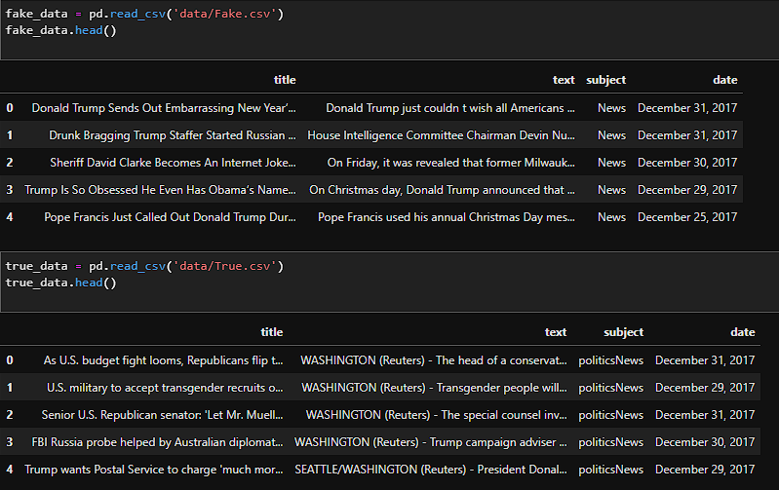

**Exploratory data analysis - EDA**

**Data Shape and Sample:**

The shape of the dataset (number of rows and columns) is displayed to get an overview of the dataset's size.A sample news article, along with its corresponding label, is printed to provide a glimpse of the data.

**Distribution of News Articles:**

A count plot is created to visualize the distribution of news articles based on their labels (fake or genuine).This plot helps to understand the balance or imbalance in the dataset.

**Class Balance:**

The counts and percentages of each class (fake and genuine) are calculated and displayed.This provides insights into the class distribution of the dataset.

**Text Analysis:**

The length of the text in each news article is calculated and stored in a new column called "text_length."A histogram plot is generated to visualize the distribution of text lengths, with different colors representing different labels (fake or genuine).

**Word Clouds:**

Word clouds are created for both fake and genuine news articles.These word clouds display the most frequent words in each category, providing a visual representation of the important words associated with fake and genuine news.

**Temporal Analysis:**

If applicable, the temporal aspect of the dataset is considered by extracting the year and month from the "date" column.A count plot is created to visualize the number of news articles by year, with different colors indicating the labels (fake or genuine).This analysis provides insights into any trends or patterns in the dataset over time.

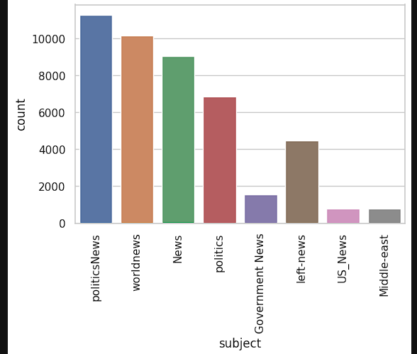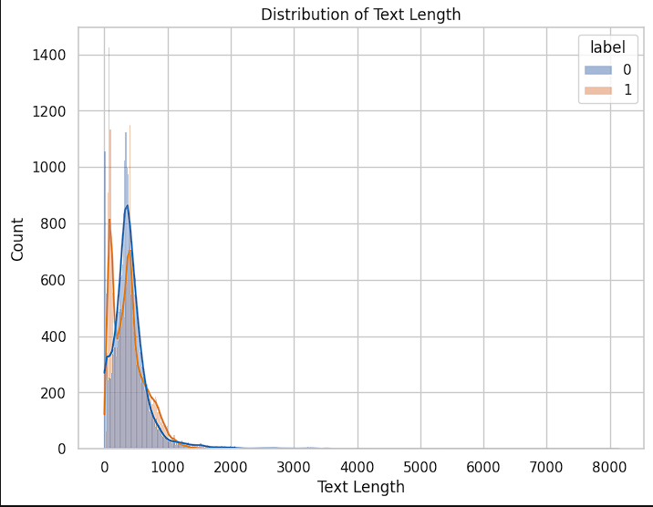

**Model training, Evaluation, and Prediction**

This study compared Naive Bayes, Support Vector Machine (SVM), Logistic Regression, and Multilayer Perceptron (MLP) against the Random Forest Classifier (RFA). RFA had the best accuracy, precision, recall, and F1-score on the ISOT Fake News dataset.

The Random Forest Classifier classified bogus news items with an accuracy score of 0.9966592427616926. This high accuracy score shows that RFA can generalize and forecast accurately on unknown data, making it a viable false news detector.

* RFA is overfitting-resistant. Random Forests overfit less than Naive Bayes, SVM, and MLP. RFA's ensemble of decision trees reduces overfitting by averaging out individual tree forecasts.
* Random Forests handle high-dimensional data effectively. They automatically choose a subset of characteristics at each decision tree node to manage big datasets. This feature selection approach decreases feature duplication and irrelevant feature effects on predictions.
* Random Forests also tolerate outliers. The ensemble's decision trees split on subsets of features, reducing outlier effect. Outliers affect random forest forecasts less.

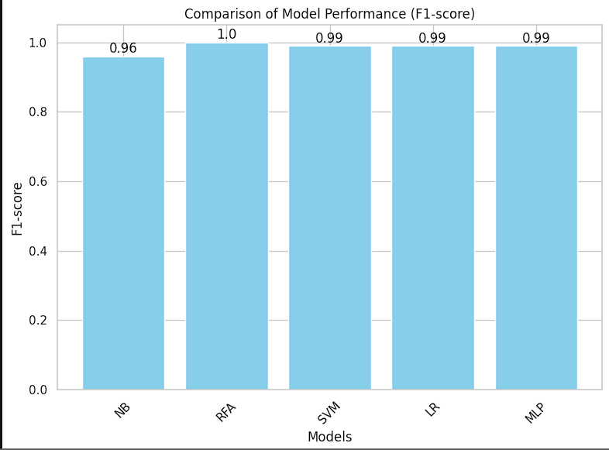

**Accuracy after the testing:**

Naive Bayes (NB)-0.957

Random Forest (RFA)-0.997

Support Vector Machine (SVM)-0.994

Logistic Regression-0.997

Multilayer Perceptron (MLP)-0.994

**Conclusion:**

In this project, we developed a fake news detection system using machine learning techniques. We analyzed a dataset of fake and genuine news articles, performed exploratory data analysis, and compared various machine learning models. The Random Forest Classifier emerged as the most effective model, achieving high accuracy, precision, recall, and F1-score. The developed system can accurately identify misleading news articles and contribute to combating the spread of fake news.

**Future Enhancements:**

In the future, our project can be further enhanced and extended. Advanced NLP techniques and deep learning models can be explored to improve the system's ability to detect nuanced fake news patterns. Integration with social media platforms can enable real-time monitoring and detection of fake news spread. Ongoing updates to the dataset and continuous training of the machine learning model can enhance its performance and keep up with emerging fake news strategies.