**Software Requirements Specification**

**On**

**LIBRARY MANAGEMENT SYSTEM**

**A Report for the Evaluation of MTE PBL Web Tech**

**Submitted by:**

**Satyanarayan Pandey 1713101249**

**17SCSE101260**

Under the Supervision of

PADMANABHAN P SIR

School of Computing Science and Engineering Greater Noida, Uttar Pradesh Winter 2019-2020

**TABLE OF CONTENTS**

1. Abstract

2. Introduction

(i) Overall description

(ii) Purpose

(iii) Motivations and scope

3. Use Case Diagram

4. Flow Chart

5. References

**1 ABSTRACT**

The Library Management System is gaining more importance as the number of its users are increasing rapidly. As the number is rising there is a need of effective management of library, one such effective system is our Library Management System its designed using html CSS JavaScript as front end and MySQL as backend.

The transactions like login, register, add, search, delete, issue is provided. The Library Management System stores the details like name, address, ID number, Date of Birth of members working in the library and users who come to library. The details of books like book name, book number, subject to which it belongs, author, edition, year of publication, the total number of books that are present in the library etc are also stored.

**2. INTRODUCTION**

**(i)PURPOSE**

The purpose of this project is to provide a friendly environment to maintain the details of books and library members. The main purpose of this project is to maintain easy circulation system using computers and to provide different reports. The Library System is a package to be used by Libraries to improve the efficiency of Librarians, Library employees and Users. The system provides books catalogue and information to members and helps them decide on the books to borrow from the library. The Librarian can keep the books catalogue updated all the time so that the members (students and the professors) get the updated information all the time.

**(ii)SCOPE**

The document only covers the requirements specifications for the Library Management System. This document does not provide any references to the other component of the Library Management System. All the external interfaces and the dependencies are also identified in this document. The overall scope of the feasibility study is to provide sufficient information to allow a decision to be made as to whether the Library Management System project should proceed and if so, its relative priority in the context of other existing Library Management Technology.

**(iii) Overall description**

**FUNCTIONAL REQUIREMENTS**

The Library Management System must have the following functional requirements:

1. The LMS should store all information about librarian and other users (students and faculty members) – their login info, books issued, etc.

2. The LMS should store all information about the books and users in two separated databases.

3. The LMS should allow searching books/journals by author, title, keywords or availability.

4. The LMS should generate request’s reports for librarian, upon which he/she could make decisions about accepting/rejecting the requests.

5. The LMS should allow users to view their personal information and status (numbers of books issued, days left, etc.)

6. The LMS should provide modules to issue, return request and renew books.

7. The users should be able to calculate and clear dues, request etc.

8. The librarian must be able to add/remove books, manage users, process dues etc.

Use case analysis of the different functionalities has been provided in section 5 for better understanding of the system

**NON-FUNCTIONAL REQUIREMENTS**

**Usability Requirements**

The user interface should be interactive, simple and easy to understand. The system should prompt for the user and administrator to login to the application for proper input criteria.

**Error Handling**

Library management system shall handle expected and non-expected errors in ways that prevent loss in information and long downtime period.

**Security Requirements**

The LMS should provide databases’ modification only for the librarian after proper authorization.

The system shall accommodate high number of books and users without any fault.

**Software Requirements**

1. Database - MYSQL is used as database as it easy to maintain and retrieve records by simple queries which are in English language which are easy to understand and easy to write.

2. Development tools and Programming language- HTML is used to write the whole code and develop webpages with CSS, JavaScript for styling work.

Hardware Requirements

1. Intel core i3 and above is required for a stable experience and fast retrieval of data.

2. 2 GB RAM is required as it will provide fast reading and writing capabilities which will in turn result in better performance time.

**3. Use Case Diagram**

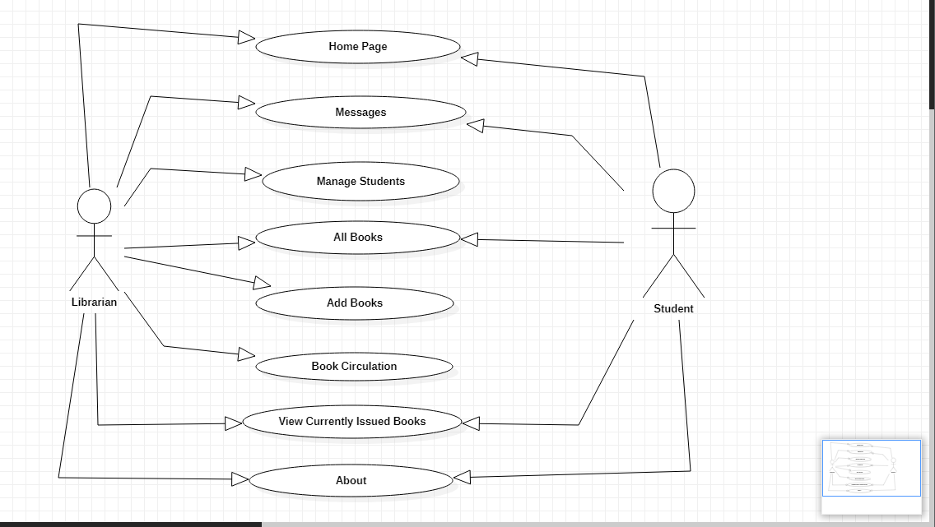

**4. Flow Chart**

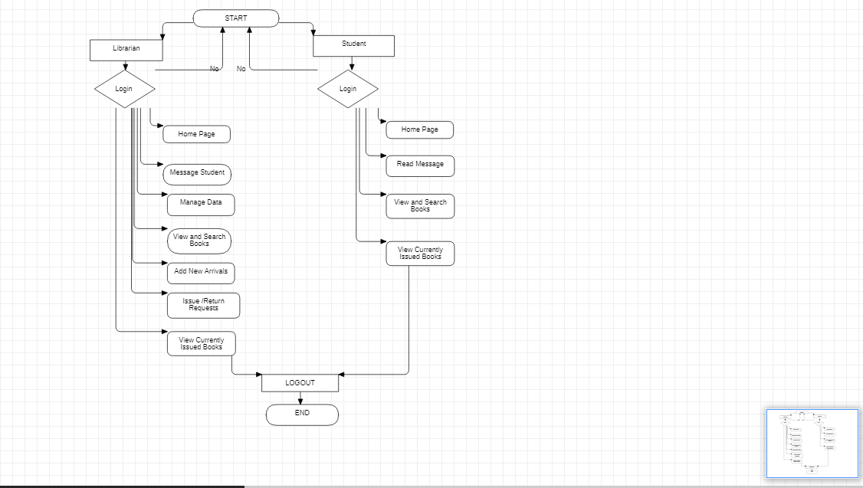

**5. REFERENCES**

Fundamentals of Database System by MySQL .HTML CSS JavaScript by w3schools.