## Vb大作业程序设计报告

### 界面设计

1.1.1 首页

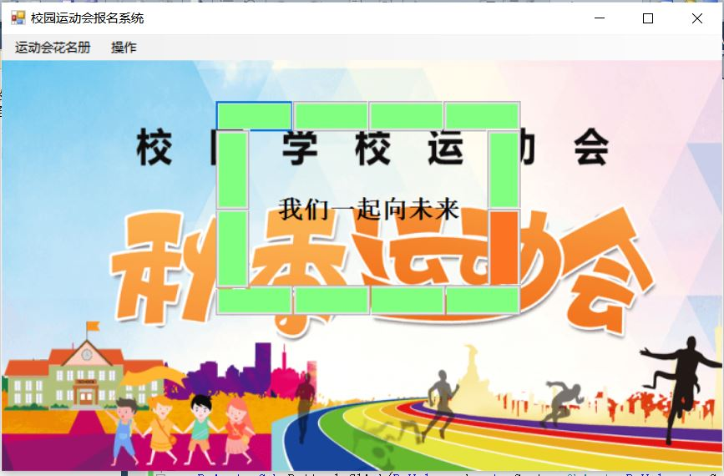

1.1.2首页菜单设计

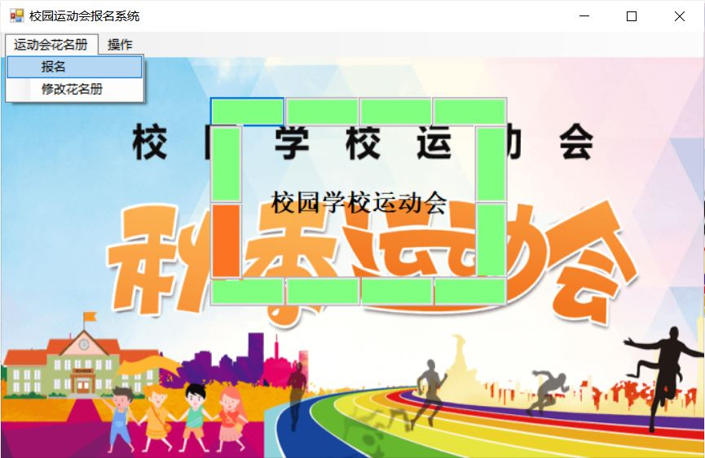

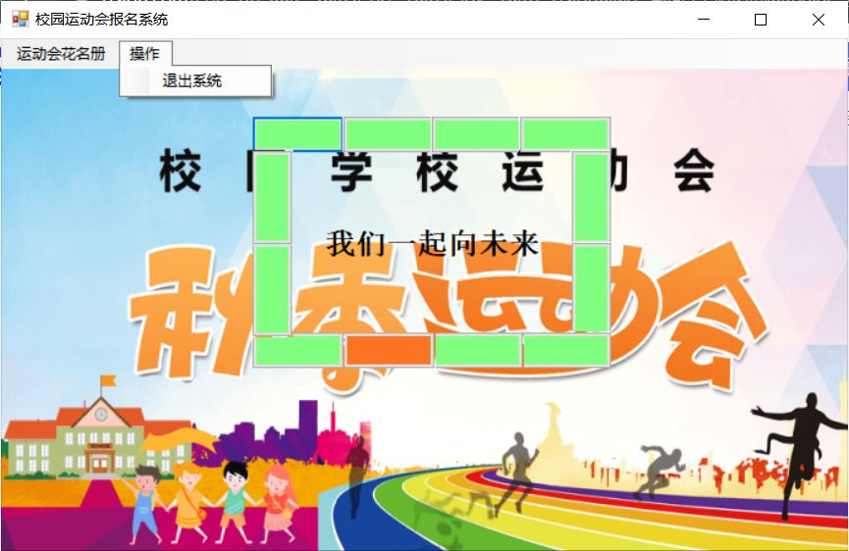

1.2 报名界面

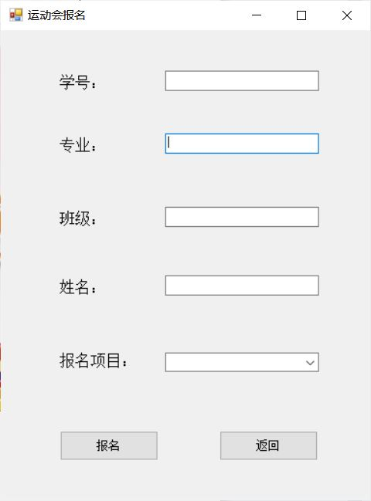

1.3 花名册界面

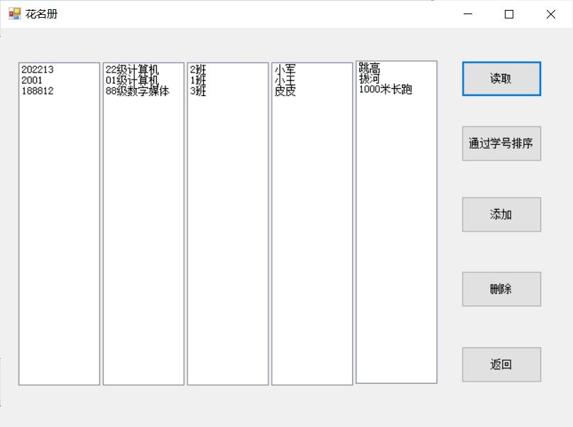

### 内容介绍

这个是一个运动会报名系统,在首页用12按钮组成了一个绿色围栏,其中一个橙色按钮顺时针旋转.旋转一圈位于中间的标题会在”校园学校运动会”和”我们一起向前进”间进行改变.

首页有一个菜单栏,菜单栏中的 操作->退出 可以退出程序. 运动会花名册->报名 可以打开报名界面同时隐藏当前窗口. 运动会花名册->修改花名册 可以打开花名册界面同时隐藏当前窗口.

在报名界面,我们输入学号,专业,班级,姓名,报名项目等信息点击报名,就可以完成报名,信息将会录入到roster.txt文件中.点击返回按钮返回首页.

在花名册界面,我们点击读取按钮,就可以从roster.txt文件中读取到所有报名信息.点击通过学号排序就可以根据学号升序排序.点击添加按钮打开报名界面同时隐藏当前窗口.点击删除按钮弹出输入框输入学号,根据学号进行删除操作.点击返回按钮返回首页.

### 功能代码介绍

3.1首页围栏效果

* + 1. 逻辑说明

我们将12个按钮设置成一个控件数组,以下标控制它们.再使用一个定时器,以0.1秒的速度调用.在定时器中每一次使得一个按钮的颜色变成橙色,每经过12个按钮改变中间标题的内容.

* + 1. 相关代码

Module1.Button(0) = Me.Button1

Module1.Button(1) = Me.Button2

Module1.Button(2) = Me.Button3

Module1.Button(3) = Me.Button4

Module1.Button(4) = Me.Button5

Module1.Button(5) = Me.Button6

Module1.Button(6) = Me.Button7

Module1.Button(7) = Me.Button8

Module1.Button(8) = Me.Button9

Module1.Button(9) = Me.Button10

Module1.Button(10) = Me.Button11

Module1.Button(11) = Me.Button12

For i = 0 To 11 Step 1

Module1.Button(i).BackColor = System.Drawing.Color.FromArgb(CType(128, Byte), CType(255, Byte), CType(128, Byte))

Next i

Private Sub Timer1_Tick(ByVal sender As System.Object, ByVal e As System.EventArgs) Handles Timer1.Tick

Module1.Button(Module1.num).BackColor = System.Drawing.Color.FromArgb(CType(128, Byte), CType(255, Byte), CType(128, Byte))

Module1.num += 1

If Module1.num = 12 Then

Module1.num = 0

If Label1.Text = "校园学校运动会" Then

Label1.Text = "我们一起向未来"

Else

Label1.Text = "校园学校运动会"

End If

End If

Module1.Button(Module1.num).BackColor = System.Drawing.Color.FromArgb(CType(252, Byte), CType(115, Byte), CType(35, Byte))

End Sub

* 1. 报名
     1. 逻辑说明

我们先获取学号,专业,班级,姓名,报名项目等相关数据,在通过StreamWriter类进行文件写入,最后将字符串都置空

* + 1. 相关代码

Using sw As StreamWriter = New StreamWriter("roster.txt", True)

Dim str As String

str = TextBox4.Text + "," + TextBox1.Text + "," + TextBox2.Text + "," + TextBox3.Text + "," + ComboBox1.Items(ComboBox1.SelectedIndex)

sw.WriteLine(str)

End Using

MsgBox("注册成功|")

TextBox1.Text = ""

TextBox2.Text = ""

TextBox3.Text = ""

TextBox4.Text = ""

ComboBox1.SelectedIndex = 0

* 1. 读取
     1. 逻辑说明

我们先把所有的listbox都置空,再使用StreamReader去逐行读取roster.txt文件,存入先前生成的string类型数组.每一次读取都使用ReDim Preserve 方法对数组进行扩充,在所有数据读取完毕以后,我们遍历string数组同时使用Split方法去分割字符串,将数据分别放入对应的listbox中.

* + 1. 相关代码

ListBox1.Items.Clear()

ListBox2.Items.Clear()

ListBox3.Items.Clear()

ListBox4.Items.Clear()

ListBox5.Items.Clear()

count = 1

Using sr As StreamReader = New StreamReader("roster.txt")

Dim line As String

line = sr.ReadLine()

While line <> Nothing

strData(count) = line

count = count + 1

ReDim Preserve strData(count)

line = sr.ReadLine()

End While

End Using

For i As Integer = 1 To count - 1

Dim data(6) As String

data = strData(i).Split(",")

ListBox1.Items.Add(data(0))

ListBox2.Items.Add(data(1))

ListBox3.Items.Add(data(2))

ListBox4.Items.Add(data(3))

ListBox5.Items.Add(data(4))

Next

* 1. 通过学号排序
     1. 逻辑说明

先置空所有的listbox,再遍历String数组同时使用Split分割字符串,取下标为0的元素(也就是学号),使用冒泡排序法逐个比较学号,学号小的排前面.

* + 1. 相关代码

Private Sub Button3_Click(ByVal sender As System.Object, ByVal e As System.EventArgs) Handles Button3.Click

ListBox1.Items.Clear()

ListBox2.Items.Clear()

ListBox3.Items.Clear()

ListBox4.Items.Clear()

ListBox5.Items.Clear()

For i As Integer = 1 To count - 1

Dim data(6) As String

data = strData(i).Split(",")

Dim a As Integer

a = data(0)

For j As Integer = i + 1 To count - 1

Dim data2(6) As String

data2 = strData(j).Split(",")

Dim b As Integer

b = data2(0)

If a > b Then

Dim tem As String

tem = strData(i)

strData(i) = strData(j)

strData(j) = tem

End If

Next

Next

For i As Integer = 1 To count - 1

Dim data(6) As String

data = strData(i).Split(",")

ListBox1.Items.Add(data(0))

ListBox2.Items.Add(data(1))

ListBox3.Items.Add(data(2))

ListBox4.Items.Add(data(3))

ListBox5.Items.Add(data(4))

Next

End Sub

* 1. 删除
     1. 逻辑说明

所有InputBox获取用户输入的学号,再遍历string数组同时使用Split分割字符串,取下标为0的元素(也就是学号),逐个与用户输入的学号进行比对,当学号与用户输入的学号相等时,使用RemoveAt方法删除listbox的值,最后重新写入到文件中.

* + 1. 相关代码

Private Sub Button1_Click(ByVal sender As System.Object, ByVal e As System.EventArgs) Handles Button1.Click

Dim number As String

number = InputBox("请?输?入?要癮删?除y运?动ˉ员±的?学§号?")

For i As Integer = 1 To count - 1

Dim data(6) As String

data = strData(i).Split(",")

If data(0).Trim = number Then

ListBox1.Items.RemoveAt(i - 1)

ListBox2.Items.RemoveAt(i - 1)

ListBox3.Items.RemoveAt(i - 1)

ListBox4.Items.RemoveAt(i - 1)

ListBox5.Items.RemoveAt(i - 1)

For j As Integer = i + 1 To count - 1

strData(i) = strData(j)

Next

count = count - 1

End If

Next

Using sw As StreamWriter = New StreamWriter("roster.txt")

Dim str As String

str = ""

For i As Integer = 1 To count - 1

str = str + strData(i) + vbCrLf

Next

sw.WriteLine(str)

End Using

End Sub