Full-Coverage Location-Routing Planning for Farmland under Controlled Complex 3D Geographic Environments: A Case Study of Zunhua, China
Xinxin Zhou¹, Runtian Wang¹, Yulin Xiao¹,Yuanpei Gou⁴, Lin Li⁵, Siyu Zhu¹, Yong Wang^{2*} , Linwang Yuan^{3*}
1 School of Internet of Things, Nanjing University of Posts and Telecommunications, Nanjing, 210023, Jiangsu, China.
2* School of Geographic Information and Tourism, Chuzhou University, Chuzhou, 239000, Anhui, China.
3* School of Geography, Nanjing Normal University, Nanjing, 210023, Jiangsu, China.
4 Hebei Mining Environment Remediation Technology Center, The Second Geological Team of Hebei Bureau of Geology and Mineral Exploration and Development, Shijiazhuang, 063000, Hebei, China.
5 Jiangsu Provincial Land Development and Consolidation Center, 211000, Nanjing, China.
*Corresponding authors. E-mails: wangyong@chzu.edu.cn; yuanlinwang@njnu. edu.cn

Abstract
Farmland protection and monitoring are essential for improving cultivated-land quality and safeguarding food security. Unmanned Aerial Vehicle (UAV) panoramic monitoring can alleviate the limited spatiotemporal resolution of satellite observations and the high acquisition cost of conventional UAV photogrammetry, thereby providing an efficient alternative for farmland protection. However, operational deployment still faces two major challenges: strong interference from complex 3D geographic environments and the difficulty of rapidly covering spatially fragmented farmland patches. This study integrates multi-source 3D geospatial data and develops a Cultivated-land Full-Coverage Panoramic Point Generation algorithm (CFCPG) and a Visibility-Cost Matrix Set considering the 3D Geographic Environment (VCMS-3DGE). On this basis, a Full-Coverage Location-Routing Problem (FCLRP) is formulated and solved using a Greedy-initialized Adaptive Large Neighborhood Search with Variable Neighborhood Descent (G-ALNS-VND). On the 13 Barreto STANDARD benchmark instances, G-ALNS-VND achieved a mean gap of 3.76%, 1.35 percentage points lower than the closest competitor, standard ALNS (5.11%), corresponding to a relative reduction of 26.49%. A case study in Zunhua, Hebei Province, China, contained 153 farmland patches covering 629.13 km². The resulting plan used 34 take-off/landing sites and 99 routes, covering 138 farmland patches and 540.66 km², with an overall coverage rate of 85.94%. The results demonstrate coordinated optimization of candidate sites, panoramic acquisition points, and multiple UAV routes. The proposed framework provides a methodological basis for rapid, large-area UAV farmland monitoring in terrain-relief regions subject to low-altitude flight constraints.

Keywords
farmland protection; farmland monitoring; UAV take-off/landing site; location-routing problem; ALNS; UAV nest; UAV panorama;

Introduction
China supports nearly 20% of the world's population with about 9% of the world's cultivated land, while its per-capita cultivated-land area is only 1.36 mu, less than 40% of the global average. Over the past three decades, rapid urbanization and intensive agricultural use have jointly increased the risks of cultivated-land loss and land-use conversion, intensifying the need for integrated protection and monitoring. China has consequently incorporated farmland protection into its national development and land-use policy framework, emphasizing the prevention of both non-agricultural conversion and non-grain use of cultivated land^{[1]}. Conventional farmland monitoring relies mainly on ground sampling, manual field inspections, and medium- to low-resolution satellite remote sensing. Although these approaches remain fundamental to farmland regulation, field inspection is inherently local and labor-intensive, while medium- and low-resolution imagery can miss small, fragmented violations. These limitations create mismatches in spatial and temporal resolution, delayed change detection, and high costs for region-wide coverage, motivating the development of integrated satellite-air-ground-network monitoring for dynamic, multiscale observation of cultivated land.
Farmland protection monitoring can be broadly divided into four categories: satellite remote sensing, Unmanned Aerial Vehicle (UAV) remote sensing, ground-based video monitoring, and Internet of Things Internet-based monitoring^{[2]}. Satellite observations using different sensors can monitor crop growth and non-agricultural land conversion, whereas UAV remote sensing, including aerial photogrammetry and targeted inspection, provides flexible, efficient, and high-resolution support for fine-scale farmland management and has been extended to agricultural, marine, disaster, and ecological monitoring^{[3]}. Agricultural UAV inspection can rapidly cover target fields and collect multi-source information, with representative studies including onboard perception and remote-sensing object detection^{[4]}, UAV task planning and multi-technology coordinated monitoring^{[5-6]}, and grassland vegetation classification and biomass mapping^{[7-8]}. Video/image intelligence has also been used for dynamic construction-site monitoring^{[9]}, UAV hyperspectral sensing has been applied to dynamic algal-bloom monitoring^{[10]}, and UAVs can support agricultural ecology and biodiversity assessment^{[11]}. Nevertheless, existing integrated monitoring systems often focus on optimizing individual sensing devices rather than matching the operational requirements of natural-resource management. In practice, region-wide monitoring remains affected by long revisit or processing cycles, substantial manual interpretation and field-verification workloads, and limited operational timeliness. Commercial satellite observations are constrained by orbit and weather conditions, while UAV operations are constrained by airspace approval, acquisition efficiency, and computing resources. These limitations make it difficult to achieve frequent, region-wide, fine-grained monitoring. Although low-altitude UAV inspection is increasingly used by natural-resource agencies, inspection-point deployment often lacks a rigorous spatial-optimization basis, making it difficult to balance monitoring coverage and operational cost while controlling data volume and interpretation workload. UAV panoramic acquisition offers a complementary option because it can provide wide scene coverage with relatively low hardware and data requirements. Recent research has therefore progressed from simple image acquisition toward integrated optimization of facility/fleet decisions, constrained multi-UAV path planning, terrain-aware agricultural trajectories, weed-localization route learning, orchard air-ground cooperative planning, and livestock-monitoring routes^{[27,29-30,33,38-40]}.
Region-wide UAV panoramic monitoring of farmland requires jointly determining multiple take-off/landing sites and the routes used to visit panoramic acquisition points over a large area. The problem is therefore a coupled location-routing problem (CLRP). UAV-oriented CLRP research involves the location and coverage layout of nests or landing pads^{[12]}, inspection-route planning for observation points^{[13]}, and coordinated site-route optimization and intelligent navigation^{[14-15]}. Such methods are applicable to inspection of complex infrastructure, including bridges, steel structures, and post-earthquake buildings^{[16]}, as well as power and pipeline inspection, agricultural and forestry resource monitoring, ecological-corridor management, and urban spatial governance. In agricultural settings, route optimization has likewise evolved from single-vehicle shortest-path planning toward trajectory optimization and complete-coverage planning that jointly account for operational processes and field constraints^{[28,31]}.
Existing CLRP-related solution approaches can be broadly grouped into three categories. The first treats routing as the core problem and location as an outer or subordinate decision: candidate nest locations are evaluated, panoramic inspection routes are optimized for each location scheme using coverage or shortest-path methods, and a heuristic or intelligent search is then used to select the best combined location-routing plan. For example, coverage path planning for 3D aircraft-surface inspection has used discrete 3D grids and improved WaveFront methods to avoid local optima while ensuring collision-free complete coverage^{[17]}. The second category introduces chaos, randomness, or specialized search patterns into coverage planning; an example is the use of a Lü chaotic system to generate chaotic trajectories and tune parameters for complete coverage in specific mission settings^{[18]}. The third category uses metaheuristics to jointly optimize routing and task assignment, for example by formulating multi-UAV allocation and routing as a multi-objective problem that balances completion time, distance/energy, risk, and benefit^{[19-20]}. Adaptive Large Neighborhood Search (ALNS) is particularly suitable for iteratively restructuring complete location-routing solutions. It has been successfully applied to truck-drone routing and flying-sidekick problems with multiple vehicles and deliveries^{[21-22]}, UAV routing with recharging constraints^{[23]}, and urban multi-depot UAV service-network design that jointly determines depot locations, visitation frequencies, and UAV routes^{[24]}. However, ALNS-based UAV CLRP studies remain concentrated on logistics problems with predefined customer locations and do not directly address region-wide farmland panoramic monitoring under complex geographic constraints. Recent UAV-routing research has further incorporated uncertainty, network congestion, repeated visits, facility placement, and air-ground cooperative network design into integrated optimization frameworks, providing a direct methodological basis for the facility-route coupling considered in the FCLRP^{[26,32,34-37]}.
In summary, region-wide UAV panoramic location-routing for farmland faces three key challenges. First, UAV inspection methods designed for individual facilities or small fields cannot efficiently support rapid full-area coverage, creating a need for a systematic method to generate region-wide panoramic acquisition points. Second, a UAV CLRP for farmland must explicitly incorporate 3D geographic constraints, requiring a representation of terrain-dependent visibility, flight distance, and accessibility together with an appropriate FCLRP formulation. Third, the resulting FCLRP is difficult to solve because site decisions, task allocation, routes, and multiple hard constraints are strongly coupled, motivating an enhanced metaheuristic solver. Accordingly, this study develops a full-coverage panoramic-point generation method, formulates a Full-Coverage Location-Routing Problem (FCLRP) for UAV take-off/landing-site selection and panoramic inspection routing, and proposes Greedy-initialized Adaptive Large Neighborhood Search with Variable Neighborhood Descent (G-ALNS-VND) to solve it. The framework is evaluated through benchmark comparisons and a case study using real geospatial data from Zunhua, China.

Problem Description and Study Data

Overall Framework and Problem Definition
To address the effects of complex 3D geographic environments and spatially fragmented farmland on UAV panoramic monitoring, this study develops the workflow shown in Fig. 1. Multi-source 3D geospatial data are integrated to construct the Cultivated-land Full-Coverage Panoramic Point Generation algorithm (CFCPG) and the Visibility-Cost Matrix Set considering the 3D Geographic Environment (VCMS-3DGE), formulate the FCLRP, and solve it using G-ALNS-VND. The experimental evaluation first examines the algorithmic improvement of G-ALNS-VND on the Barreto benchmark set and then evaluates its practical applicability in the mountainous-hilly environment of Zunhua.
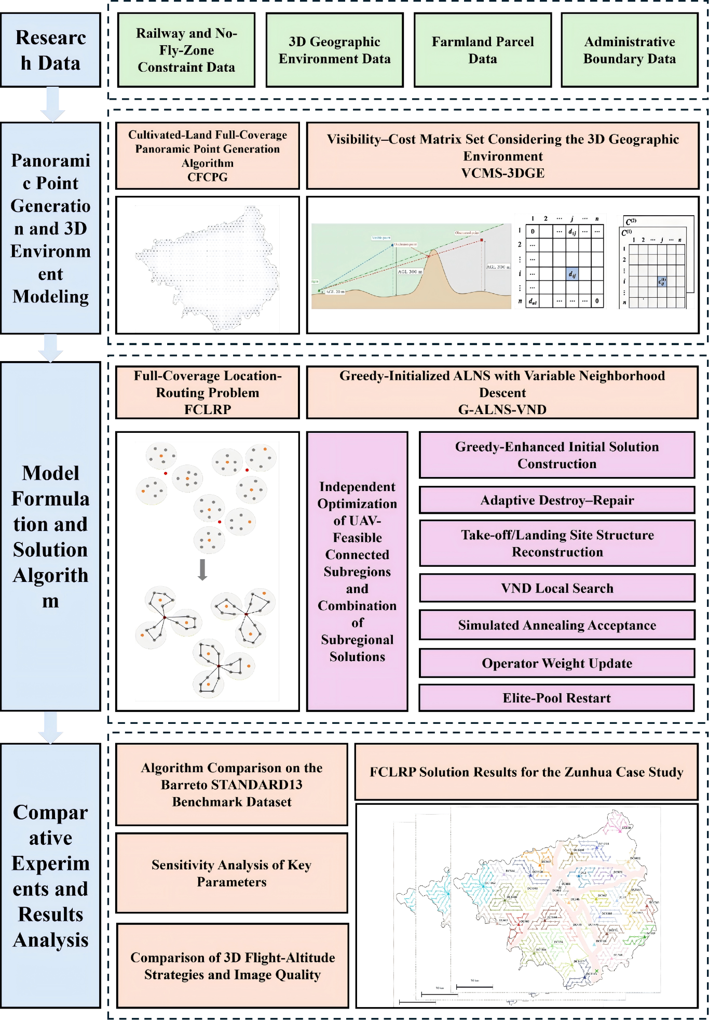
Fig. 1 Overall methodological workflow

Study Area and Data
Zunhua is located in northeastern Hebei Province, northwest of Tangshan, within the Beijing-Tianjin-Tangshan-Chengde region. It extends from 39°54′56″ to 40°22′18″ N and from 117°33′45″ to 118°14′00″ E, covering approximately 1,521 km² and characterized by a warm-temperate monsoon semi-humid climate. Terrain relief is pronounced, with generally higher elevations in the north and northeast and lower elevations in the central and southern parts. Mountains, hills, valleys, and relatively flat areas are interspersed. Elevation ranges from approximately 8 to 876 m, yielding a maximum relief of about 868 m. Cultivated land covers approximately 629 km², or 41.5% of the city, and is dominated by dry cropland. Farmland is concentrated mainly in the relatively flat central and southern areas and in valleys, where it occurs as patches of varying size. Mountains, built-up land, and other non-cropland features fragment these patches and produce a spatially dispersed pattern. The combination of pronounced topographic relief, fragmented farmland, and a large study area makes Zunhua a representative setting for evaluating panoramic-point dispersion, constrained service ranges of candidate take-off/landing sites, and differences in 3D flight cost.
The spatial distribution of the input data is shown in Fig. 2, including the administrative boundary of Zunhua (Fig. 2(d)), railway lines (Fig. 2(e)), the DEM (Fig. 2(f)), farmland patches (Fig. 2(g)), and candidate take-off/landing sites (Fig. 2(h)). All datasets were projected in CGCS2000. Railway data were used to simulate no-fly exclusion zones and partition the study area into UAV-feasible connected subregions. The DEM was used for line-of-sight assessment and 3D flight-distance calculation, while farmland polygons defined the target areas for panoramic monitoring.
The Zunhua experiment is treated as a controlled location-routing case driven by real geospatial data. Farmland, DEM, administrative-boundary, and railway datasets are real spatial data, whereas candidate take-off/landing sites are represented by a relatively uniform discrete candidate set. The case study therefore focuses on evaluating the coordinated optimization of facility number, service assignment, and flight routes under complex terrain constraints rather than the engineering constructability of individual candidate sites.
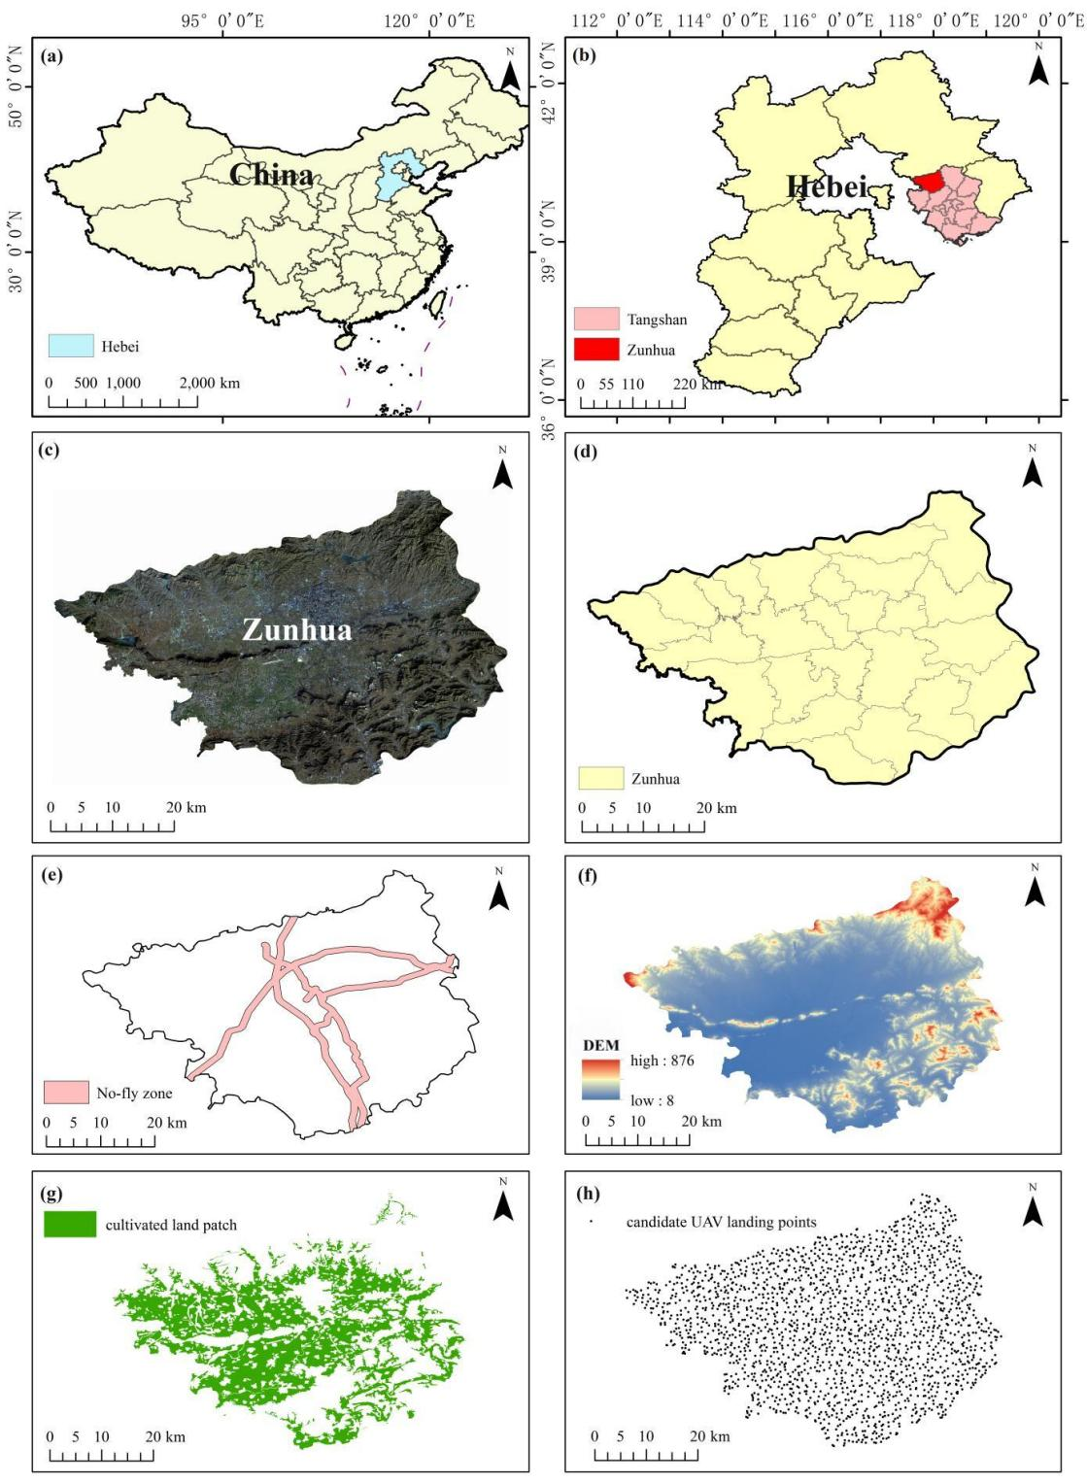
Fig. 2 Study area and input data. (d) Administrative boundary and (e) railway data were obtained from OpenStreetMap (OSM); (f) DEM data were obtained from the Alaska Satellite Facility (ASF; search.asf.alaska.edu); (g) farmland polygons were extracted from the 2020 CNLUCC dataset; and (h) candidate take-off/landing sites were generated as a relatively uniform discrete candidate set.

Methods

Cultivated-Land Full-Coverage Panoramic Point Generation (CFCPG)
CFCPG rapidly generates panoramic acquisition points for region-wide farmland coverage through four steps: initial full-area point generation, removal of points in no-fly zones, retention of points associated with farmland, and partitioning into UAV-feasible connected subregions. The overall procedure is illustrated in Fig. 3.
Step 1: Initial generation of full-area panoramic points. To acquire panoramic imagery over the study area, circular coverage footprints with radius $r$ are constructed in the horizontal plane, with adjacent circle centers separated by $\sqrt{3}r$. The circle centers are defined as panoramic acquisition points, and the complete initial set is denoted by $B_{o}$.
Step 2: Removal of panoramic points in no-fly zones. Considering that no-fly zones cannot be crossed, the initial point set $B_{o}$ is filtered to remove panoramic points located within these areas. Because the monitoring objective is region-wide farmland observation, only panoramic points whose coverage footprints intersect farmland patches are retained as valid points, forming the set $B$.
Step 3: Retention of farmland-related panoramic points. The valid panoramic-point set is spatially overlaid with farmland polygons, and points associated with farmland are retained as acquisition targets.
Step 4: Partitioning into UAV-feasible connected subregions. The retained panoramic points are divided according to no-fly boundaries. A UAV-feasible connected subregion ($Ω_{k}$) is a spatial unit within which continuous UAV operation is permitted; such units are typically separated by no-crossing features such as expressways or railways. Candidate take-off/landing sites and panoramic points are assigned to unique subregions according to their coordinates$Ω_{k}$. Subregions $Ω_{k}$ are obtained by subtracting the no-fly exclusion area $H$ from the study-area boundary $Ω$, as follows:
 | $$\underset{k∈K}{⋃}Ω_{k}=Ω-H,Ω_{g}∩Ω_{k}=∅\left(g≠k\right).$$ | (3-1)
Let $K$ denote the index set of UAV-feasible connected subregions and $g,k∈K$ the subregion index. The panoramic-point set in $Ω_{k}$ is denoted by $B_{k}^{'}$, satisfying $⋃B_{k}^{'}=B$. Each subregion $Ω_{k}$ is treated as an independent FCLRP modeling and solution unit, and the resulting subregion-level solutions can be directly combined to obtain the final plan for the entire study area.
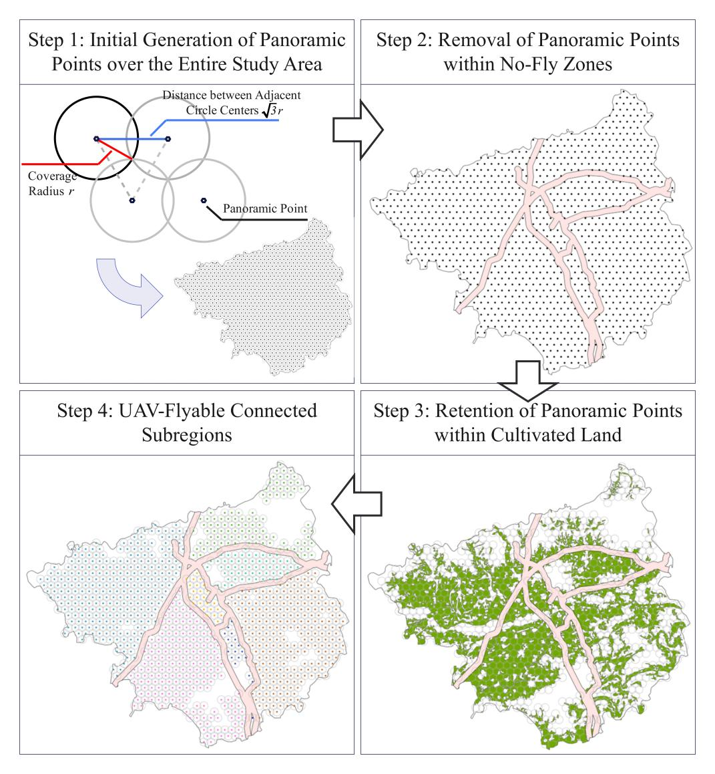
Fig. 3 Schematic workflow of the CFCPG algorithm

Visibility-Cost Matrix Set Considering the 3D Geographic Environment (VCMS-3DGE)
UAV monitoring routes over farmland are strongly affected by the 3D geographic environment. VCMS-3DGE constructs a DEM-based line-of-sight matrix between candidate take-off/landing sites and panoramic acquisition points, together with directed ascent and descent distance matrices and a horizontal flight-distance matrix. These components embed 3D geographic information into the FCLRP and improve the practical realism of site-selection and routing decisions.

DEM-Based Line-of-Sight Matrix between Take-Off/Landing Sites and Panoramic Points
The main communication links between a UAV take-off/landing station or ground controller and an airborne UAV commonly operate at 900 MHz or 2.4 GHz. Mountains and reinforced-concrete structures can cause radio-frequency attenuation, Fresnel-zone obstruction, and multipath effects. To reduce the risk of communication loss in non-line-of-sight areas, consider a UAV-feasible connected subregion $Ω_{k}$, a take-off/landing site $a_{i}$ $(a_{i}∈A_{k})$, and a panoramic acquisition point $b_{j}$ $(b_{j}∈B_{k}^{'}$). Let the installation elevation of $a_{i}$ be $h_{i}^{a}$ and the elevation of $b_{j}$ be $h_{j}^{b}$. The take-off/landing-site-to-panoramic-point line-of-sight matrix in $Ω_{k}$ is $V_{k}={\left[v_{ij}^{ab}\right]}_{k}$, where $v_{ij}^{ab}$ indicates the visibility relationship between $a_{i}$ and $b_{j}$: $v_{ij}^{ab}=$ = 1 if line of sight is satisfied and $v_{ij}^{ab}=$ = 0 otherwise (Fig. 4). The maximum line-of-sight distance is denoted by $r_{max}$. Because $a_{i}$ and $b_{j}$ belong to the same connected subregion, a straight-line terrain profile is extracted from $a_{i}$ to $b_{j}$. Let $s∈\left[0,1\right]$ denote the normalized position between $a_{i}$ and $b_{j}$, and let $z_{ij}^{ab}\left(s\right)$ denote the terrain elevation at that position. Line of sight, $v_{ij}^{ab}=1$, must then satisfy:
 | $$\sqrt{∥a_{i}-b_{j}∥_{2}^{2}+{\left(h_{i}^{a}-h_{j}^{b}\right)}^{2}}<r_{max},$$  $$z_{ij}^{ab}\left(s\right)<h_{i}^{a}+s\left(h_{j}^{b}-h_{i}^{a}\right), ∀s∈\left[0,1\right].$$ | (3-2)
The final set of panoramic acquisition points in subregion $k$ that have at least one line-of-sight candidate take-off/landing site is denoted by $B_{k}$.
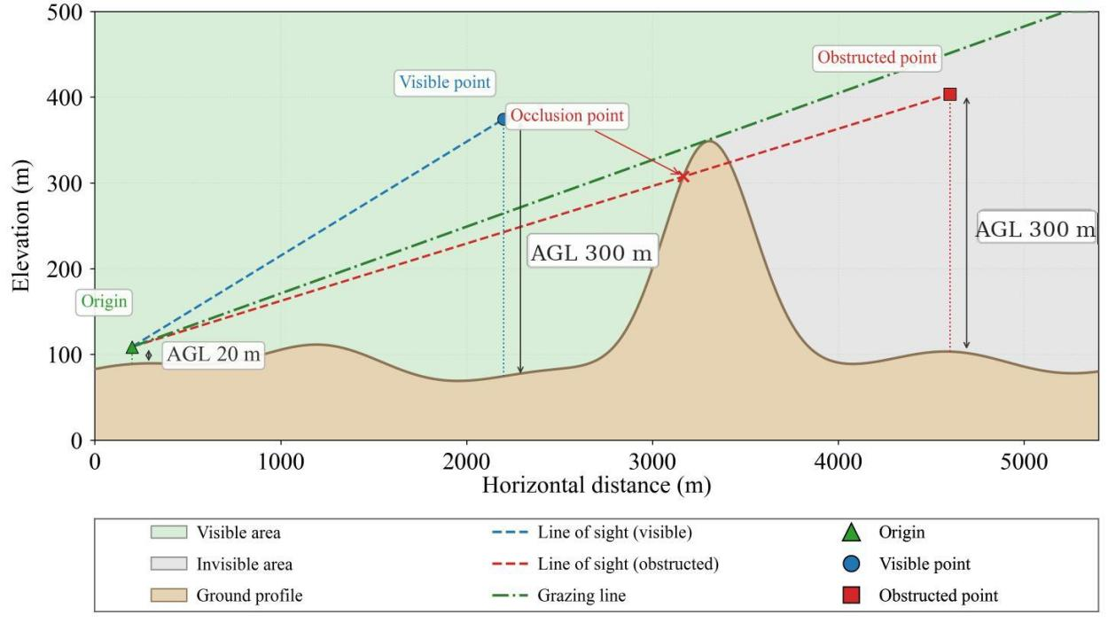
Fig. 4 Communication line-of-sight relationship between UAV take-off/landing sites and panoramic acquisition points in a 3D geographic environment. The installation height of a take-off/landing site is assumed to be 20 m above its local ground elevation, whereas the normal operating height of a panoramic acquisition point is 120 m above local ground level. If terrain or obstacles violate the required clearance, the corresponding flight segment is locally raised according to Section 3.2.2.

3D Directed Flight-Distance Matrices
A terrain-following UAV route is represented by ascent, horizontal flight, and descent. To describe this 3D movement, define $E_{k}$ = $A_{k}∪B_{k}$ as the node set in UAV-feasible connected subregion $k$. Let the task elevation of node $e_{i}$ be $h_{i}$; the corresponding take-off/landing elevation is used when $e_{i}=a_{i}$, and the panoramic acquisition elevation is used when $e_{i}=b_{i}$. Within the same subregion, the actual horizontal trajectory from node $e_{i}$ to node $e_{j}$ is denoted by $L_{ij}^{e}$, and the horizontal-distance matrix is denoted by $D_{k}^{horz}={\left[D_{ij}^{horz}\right]}_{k}$, where:
 | $$D_{ij}^{horz}=\sqrt[2]{∥e_{i}-e_{j}∥_{2}^{2}}.$$ | (3-3)
When the straight segment between two nodes does not enter a no-fly exclusion zone, the horizontal trajectory is the direct connection between the nodes. If the segment intersects a no-fly zone, the trajectory and its distance are corrected using the safe detour rule in Section 3.2.3.
To determine the elevation relationship between two nodes and whether an altitude increase is required for obstacle clearance, a DEM profile is extracted along $L_{ij}^{e}$. Let the ground elevation at any position $x$ along the trajectory be $z_{x}$. Because a real UAV has nonzero dimensions and the terrain may contain vegetation and buildings, the flight trajectory cannot be tangent to the ground; therefore, a terrain-clearance margin $δ_{h}$ is imposed. The minimum cruising elevation $h_{ij}^{min}$ of segment $\overline{e_{i}e_{j}}$ is jointly determined by the elevations of its endpoints and the maximum terrain elevation along the segment:
 | $$h_{ij}^{min}=max\left\{h_{i}^{e},{ h}_{j}^{e},\max_{x∈L_{ij}^{e}}z\left(x\right)+δ_{h}\right\}.$$ | (3-4)
Ascent and descent are recorded separately in two directed flight-distance matrices, denoted by $D_{k}^{up}={\left[D_{ij}^{up}\right]}_{k}$ and $D_{k}^{down}={\left[D_{ij}^{down}\right]}_{k}$.
 | $$D_{ij}^{up}=max\left(0,h_{ij}^{min}-h_{i}\right),D^{down}=max\left(0,h_{ij}^{min}-h_{j}\right),$$ | (3-5)
The total directed flight distance of the segment is denoted by $D_{ij}$:
 | $$D_{ij}=D_{ij}^{up}+D_{ij}^{horz}+D_{ij}^{down}.$$ | (3-6)
The total distance matrix $D_{k}={[D_{ij}]}_{k}$ in UAV-feasible connected subregion $k$ is used consistently for objective evaluation, insertion costs, local search, and route-length constraints.
As shown in Fig. 5, a route located in an area with pronounced terrain relief is used to illustrate the ascent, horizontal-flight, and descent processes. Its 3D view is shown in Fig. 5(b). Starting from the take-off/landing site, the UAV ascends to p1, visits all panoramic acquisition points, returns above the take-off/landing site, and then descends. Fig. 5(c) expands the route into a profile view. For segment p3-p4, the UAV ascends to the elevation of p4 and then flies horizontally without descending; for segment p5-p6, no ascent is needed, and the UAV flies horizontally to a position above p6 before descending to the elevation of p6.
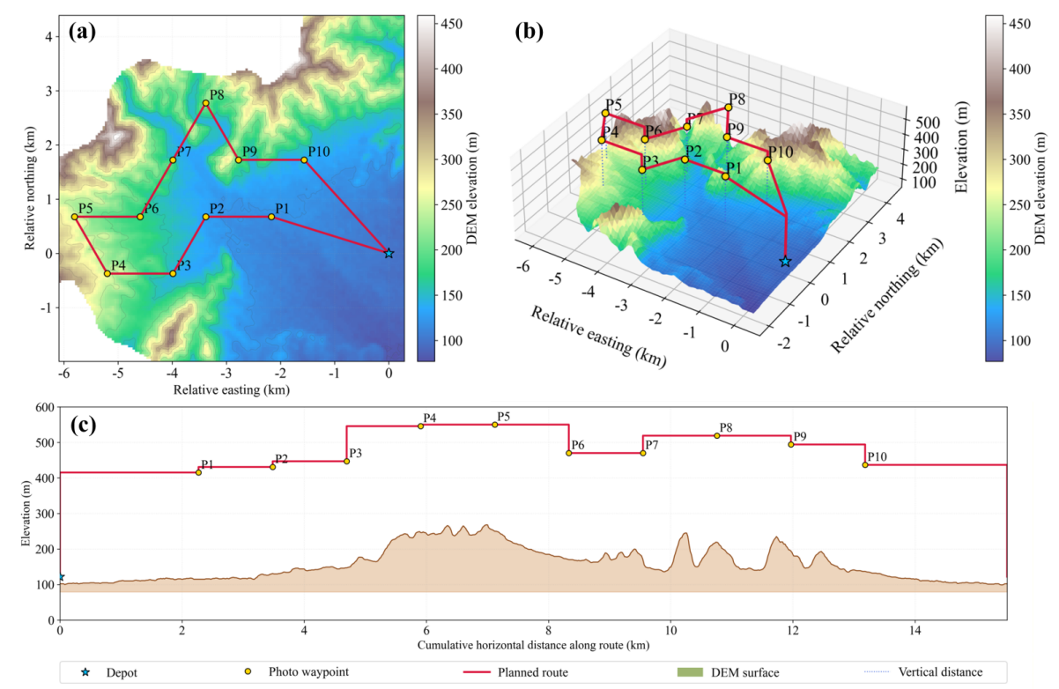
Fig. 5 Terrain-following flight represented by the directed-distance matrices: (a) plan view of the flight area; (b) oblique 3D view; and (c) profile view of motion between consecutive nodes

Safe Horizontal Trajectories under No-Fly-Zone Constraints
As illustrated in Fig. 6, the take-off/landing site $a_{1}$ and the two panoramic acquisition points $b_{1}$ and $b_{2}$ satisfy the line-of-sight and other feasibility constraints, but a no-fly zone blocks the direct horizontal path. Horizontal flight therefore cannot be represented solely by straight-line distance and must include a safe no-fly-zone detour rule.
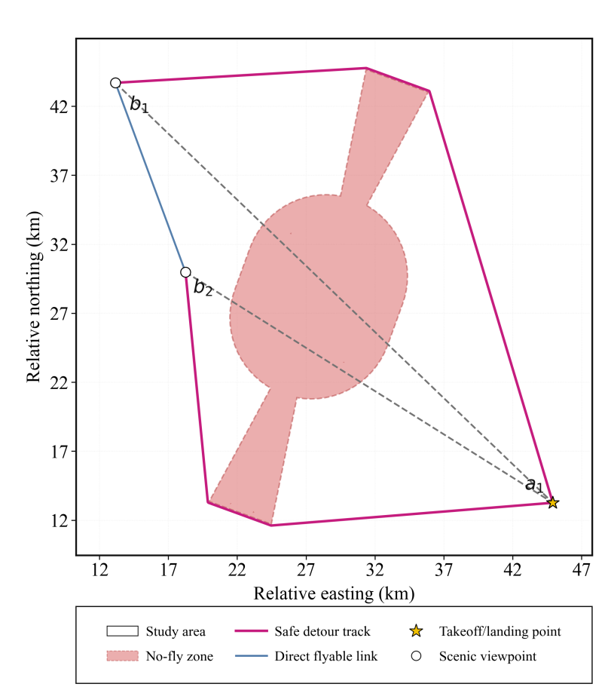
Fig. 6 Schematic of a safe detour around a no-fly zone
The horizontal-distance matrix defined in Section 3.2.2 applies only when a straight segment between two nodes does not enter a no-fly exclusion zone. If the line segment crosses a no-fly zone, direct flight is infeasible and a safe detour must be constructed along the no-fly boundary, with the horizontal travel distance recalculated. For each node pair in the same UAV-feasible connected subregion, a no-fly-zone intersection matrix is constructed as follows:
 | $$f_{ij}=\left\{\begin{matrix}1, & \overline{e_{i}e_{j}}∩H≠⌀, \\ 0, & else.\end{matrix}\right.$$ | (3-7)
When $f_{ij}=0$, the direct horizontal segment does not intersect a no-fly zone and the Euclidean distance between the two nodes is used. When $f_{ij}=1$, the direct segment intersects a no-fly zone and a safe trajectory is constructed using a 'near-tangent entry - safe-boundary detour - near-tangent exit' scheme. Let $T_{i}$ be the set of near-tangent boundary access points around node $e_{i}$, and let $d_{∂H}(u,v)$ denote the shortest boundary-arc path between two sampled boundary points $u、v$. When $f_{ij}=1$, the corrected safe horizontal-distance matrix $D_{k}^{sh}={\left[D_{ij}^{sh}\right]}_{k}$ is defined to store the actual horizontal travel distance for either direct flight or detour flight:
 | $$D_{ij}^{sh}=\left\{\begin{matrix}∥x_{i}-x_{j}∥_{2}, & f_{ij}=0, \\ \min_{u∈T_{i}, v∈T_{j}}\left(∥x_{i}-x_{u}∥_{2}+d_{∂H}\left(u,v\right)+∥x_{v}-x_{j}∥_{2}\right), & f_{ij}=1, \\ +∞, & else.\end{matrix}\right.$$ | (3-8)
For a single closed boundary, $d_{∂H}\left(u,v\right)$ is the smaller of the clockwise and counterclockwise boundary-arc lengths. For multiple closed boundaries, the shortest path is obtained on a sparse graph formed by adjacent boundary samples and a limited number of safe connection edges. The straight or detour curve associated with a finite horizontal distance corresponds to trajectory $L_{ij}^{e}$. If $D_{ij}^{sh}=+∞$, no safe horizontal trajectory exists between the two nodes. Boundary sampling/access points $u、v$ are used only for geometric detour-distance calculation; they are not included in $A_{k}$ or $B_{k}$ and do not participate in site selection, route insertion, or neighborhood-search operators. The finiteness of matrix $D_{k}^{sh}$ therefore serves directly as the safety-reachability criterion, so no additional reachability matrix is required.
After this correction, direct and detour segments are represented uniformly by the safe horizontal-distance matrix and are further incorporated into the 3D directed flight-distance calculation. The resulting unified cost matrix is used consistently in the FCLRP objective function, insertion cost, local search, and maximum-route-length constraint, ensuring that no-fly-zone safety remains a hard constraint throughout the optimization process.

Full-Coverage Location-Routing Problem (FCLRP)

Objective Function
Let the total FCLRP cost in UAV-feasible connected subregion $k$ be $C_{k}$. It consists of take-off/landing-site construction cost, route fixed cost, and flight-distance cost. The objective is to minimize total cost while satisfying panoramic-point coverage, route-length, capacity, line-of-sight, and safety-reachability constraints, as shown in Eq. (3-9).
 | $$minC_{k}=\sum_{a_{l}^{k}∈A_{k}^{open}}{c_{l}^{k}}+c_{r}\sum_{a_{l}^{k}∈A_{k}^{open}}{\left|S_{l}^{k}\right|}+c_{d}\sum_{a_{l}^{k}∈A_{k}^{open}}{\sum_{s_{m}∈S_{l}^{k}}{\sum_{\left(i,j\right)∈s_{m}}{D_{ij}}}}.$$ | (3-9)
For any UAV-feasible connected subregion $Ω_{k}$, a set of open take-off/landing sites $A_{k}^{open}$ is selected from the candidate set $A_{k}$. For each open site $a_{l}^{k}∈A_{k}^{open}$, let $S_{l}^{k}$ denote the set of closed routes originating from that site, and let $s_{m}∈S_{l}^{k}$ denote one such route. The first term of the objective function is the construction cost of the open take-off/landing sites, obtained by summing $c_{l}^{k}$ over all opened sites. The second term is the route fixed cost, where $c_{r}$ is the fixed cost for activating one closed route and $S_{l}^{k}$ denotes the route set assigned to site $a_{l}^{k}$. The third term is the flight-distance cost, where $c_{d}$ is the unit flight-distance cost and $D_{ij}$ is the total directed flight distance from node $e_{i}$ to node $e_{j}$ defined in Eq. (3-6). Summing $D_{ij}$ over all consecutive ordered segments of all routes and multiplying by $c_{d}$ yields the total flight-distance cost.
Opening additional take-off/landing sites may shorten routes and reduce flight distance but increases construction cost. Conversely, opening fewer sites reduces construction cost but can increase the number of tasks assigned to each site, the number of routes, or total flight distance. Likewise, under the capacity and maximum-route-length constraints, reducing the number of routes may lower fixed route costs but lengthen individual routes. The three cost components therefore jointly balance the number of open sites, the number of routes, and route geometry.

Constraints
For clarity, let $b∈B_{k}$ denote any valid panoramic acquisition point in subregion $k$, let $l$ denote the index of an open take-off/landing site, let $i$ and $j$ denote consecutive ordered node indices in route $s_{m}$, and let $1(⋅)$ be an indicator function equal to 1 when the condition in parentheses holds and 0 otherwise. Symbols $A_{k}^{open}$ and $S_{l}^{k}$ follow the definitions given above.
(1) Unique full-coverage service constraint. Every valid line-of-sight panoramic acquisition point in the subregion must be served by exactly one route, with neither omission nor duplicate service:
 | $$\sum_{a_{l}^{k}∈A_{k}^{open}}{\sum_{s_{m}∈S_{l}^{k}}{1}}\left(b∈s_{m}\right)=1,∀b∈B_{k}.$$ | (3-10)
(2) Closed-route origin and return constraint. If route $s_{m}$ contains $n$ panoramic acquisition points, it must depart from and return to its assigned take-off/landing site, and all internal nodes must be valid panoramic acquisition points in the same subregion:
 | $$s_{m}=\left(a_{l}^{k},b_{1},b_{2},…,b_{n},a_{l}^{k}\right),b_{j}∈B_{k},j=1,...,n,∀s_{m}∈S_{l}^{k}.$$ | (3-11)
(3) Route-load limit per take-off/landing site. Let the maximum number of routes that can be assigned to a single open site be $M$. Then:
 | $$\left|S_{l}^{k}\right|≤M,∀a_{l}^{k}∈A_{k}^{open}.$$ | (3-12)
(4) Per-route acquisition-capacity constraint. Let the demand of panoramic acquisition point $b$ be $q_{b}$, and let the route capacity be $Q$. Each route must satisfy:
 | $$\sum_{b∈s_{m}}{q_{b}}≤Q,∀s_{m}∈S_{l}^{k},a_{l}^{k}∈A_{k}^{open}.$$ | (3-13)
(5) Maximum 3D route-length constraint. Let the maximum allowable flight distance of one route be $L_{max}$. The actual 3D flight distance of each route must not exceed this limit:
 | $$\sum_{\left(i,j\right)∈s_{m}}{D_{ij}}≤L_{max},∀s_{m}∈S_{l}^{k},a_{l}^{k}∈A_{k}^{open}.$$ | (3-14)
(6) Take-off/landing-site-to-panoramic-point line-of-sight and trajectory-reachability constraint. $v_{a_{l}^{k}b}$ denotes the visibility relation in matrix $V_{k}$ between open take-off/landing site $a_{l}^{k}$ and panoramic point $b$. Any panoramic acquisition point assigned to site $a_{l}^{k}$ must be in line of sight of that site, and a safe horizontal trajectory must exist between every pair of consecutive route nodes:
 | $$1\left(b∈s_{m}\right)≤v_{a_{l}^{k}b},D_{a_{l}^{k}b}^{horz}<+∞,∀\left(a_{l}^{k},b\right)∈s_{m}.$$ | (3-15)
Capacity, route-length, line-of-sight, and no-fly-zone safety requirements are all treated as hard constraints.

G-ALNS-VND Solution Algorithm
G-ALNS-VND is designed to generate a high-quality initial solution using a greedy construction strategy, perform global destroy-repair exploration with ALNS, and further refine route structures using VND local search.

Greedy Construction of the Initial Feasible Solution
Direct random construction of initial solutions for large FCLRP instances frequently violates line-of-sight, route-length, take-off/landing-site load, or other hard constraints and substantially increases feasibility-checking overhead. A hierarchical greedy procedure is therefore used. Candidate sites are first selected and improved according to a maximum-coverage criterion; all panoramic acquisition points are then inserted using a minimum incremental-cost rule to construct baseline routes; finally, several local site-restructuring operators pre-optimize the coupled site-route structure. The resulting strengthened solution satisfies all hard constraints and provides a relatively low-cost starting point for the subsequent G-ALNS iterations.

Greedy Maximum-Coverage Selection of Take-Off/Landing Sites
A maximum-coverage site set is a combination of take-off/landing sites that covers all panoramic acquisition points in subregion k while satisfying the line-of-sight requirement. For candidate site $a_{i}∈A_{k}$, let $C_{i}^{k}$ denote the panoramic-point set that can be served by $a_{i}$ through a single-point round trip. Membership in this set requires both line of sight and a round-trip distance within the maximum route length:
 | $$C_{i}^{k}=\left\{b_{j}∈B_{k} | v_{ij}^{ab}=1,2D_{ij}≤L_{max}\right\}.$$ | (3-16)
Let $U_{k}$ denote the panoramic acquisition points not yet covered by the current open-site set. If a panoramic point can be covered by only one candidate site $a^{only}$, that site is mandatory and is added to the open set $A_{k}^{open}$. Thereafter, while $U_{k}$ is nonempty, the next candidate site is selected by lexicographic preference for (i) the largest number of newly covered points, (ii) the smallest mean service distance to those newly covered points, and (iii) the lowest construction cost; $U_{k}$ is then updated.
After all panoramic acquisition points are covered, one-to-one site replacement is performed on the open set. A replacement is accepted only if full coverage is preserved and the sum of construction cost and the nearest feasible round-trip cost for all panoramic points is reduced.

Initial Route Construction
Given the selected take-off/landing-site set, panoramic acquisition points are inserted in the priority order 'fewer feasible serving sites first, larger demand first, and larger minimum round-trip distance first.' Two insertion modes are considered: insertion into an existing route (Fig. 7(a1)) and creation of a new single-point route (Fig. 7(a2)).
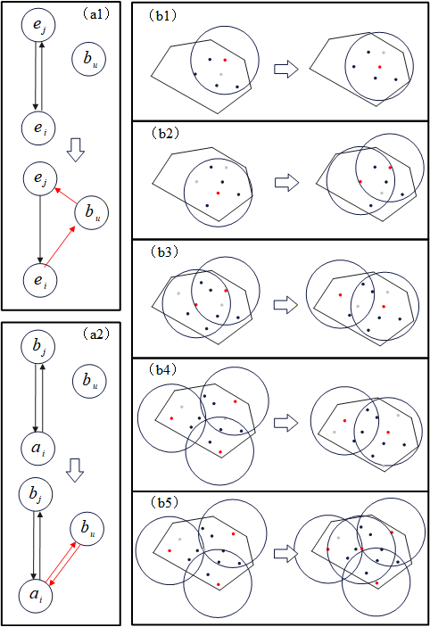
Fig. 7 Creation of a new route and insertion of a panoramic acquisition point
For consecutive nodes $e_{i}$ and $e_{j}$ on an existing route, let the incremental cost of inserting panoramic point $b_{u}$ be $Δ_{u}^{ins}\left(e_{i},e_{j}\right)$. If a new single-point route is created from take-off/landing site $a_{i}$, its incremental cost is $Δ_{u}^{new}\left(a_{i}\right)$:
 | $$Δ_{u}^{ins}\left(e_{i},e_{j}\right)=c_{d}\left(D_{iu}+D_{uj}-D_{ij}\right),$$  $$Δ_{u}^{new}\left(a_{i}\right)=c_{r}+2c_{d}D_{{a_{i}b}_{u}}.$$ | (3-17)
At each step, the minimum-cost option is selected from all feasible insertion positions and feasible new-route options. Capacity, route length, take-off/landing-site-to-panoramic-point line of sight, safe horizontal trajectories, and the maximum number of routes per site are checked simultaneously. If any panoramic acquisition point has no feasible insertion position, the current site combination cannot produce an initial feasible solution.

Joint Strengthening of the Initial Site-Route Solution
After line-of-sight coverage and strict insertion are completed, neighboring open-site groups within the same UAV-feasible connected subregion are ranked according to the number of panoramic points they serve and the union area of their coverage circles. Five local restructuring operations are then attempted sequentially: 1->1 relocation, 2->2 relocation, 3->2 local merging, 1->2 single-site expansion, and 3->4 large-area expansion, as illustrated in Fig. 7(b1)-(b5). Replacement candidates are restricted to the vicinity of the original local panoramic points and sites and must preserve coverage of the original local panoramic-point set.
Let the current solution be $X$ and the locally reconstructed candidate solution be $X'$. The minimum relative-improvement threshold for operation type $m$ is $η_{m}$. Using the subregion total-cost notation $C_{k}$, $C_{k}(S)$ and $C_{k}(S')$ denote the total costs of the current and candidate solutions, respectively. Each candidate combination reconstructs the local routes and is accepted according to the complete objective function:
 | $$C_{k}\left(X'\right)<\left(1-η_{m}\right)C_{k}\left(X\right).$$ | (3-18)
For the 1->1, 2->2, and 3->2 operations, $η_{m}$ can be set to 0, meaning that any strict reduction in total cost is sufficient for acceptance. Higher positive thresholds are used for 1->2 and 3->4 operations because they increase the number of open sites and should therefore be accepted only when the associated route-distance improvement is substantial. The strengthening process terminates after several consecutive rounds without an acceptable improvement or when the maximum number of strengthening rounds is reached, yielding the initial solution.

Adaptive Large Neighborhood Search with VND Intensification
Standard ALNS relies mainly on destroy and repair operators for coarse-grained global exploration and lacks specialized fine-scale local improvement of route structures. In addition, conventional ALNS variants often keep facility locations fixed after initialization and therefore cannot simultaneously optimize facility construction cost and UAV flight distance. G-ALNS-VND starts from the strengthened initial solution and integrates five mechanisms: adaptive destroy-repair search, take-off/landing-site restructuring, multilevel VND route intensification, simulated-annealing acceptance, and elite-pool restart. These mechanisms allow site selection and UAV routing to be optimized jointly under multiple hard constraints and terrain-dependent 3D costs.
Each iteration applies an adaptive destroy operator to partially decompose the current solution, a repair operator to reconstruct feasible routes, site operators to modify facility structure, VND to intensify route search, and a simulated-annealing criterion to decide whether the candidate solution is accepted. When search stagnates, an elite-pool restart is triggered. Iteration continues until the maximum number of iterations is reached, as shown in Fig. 8.
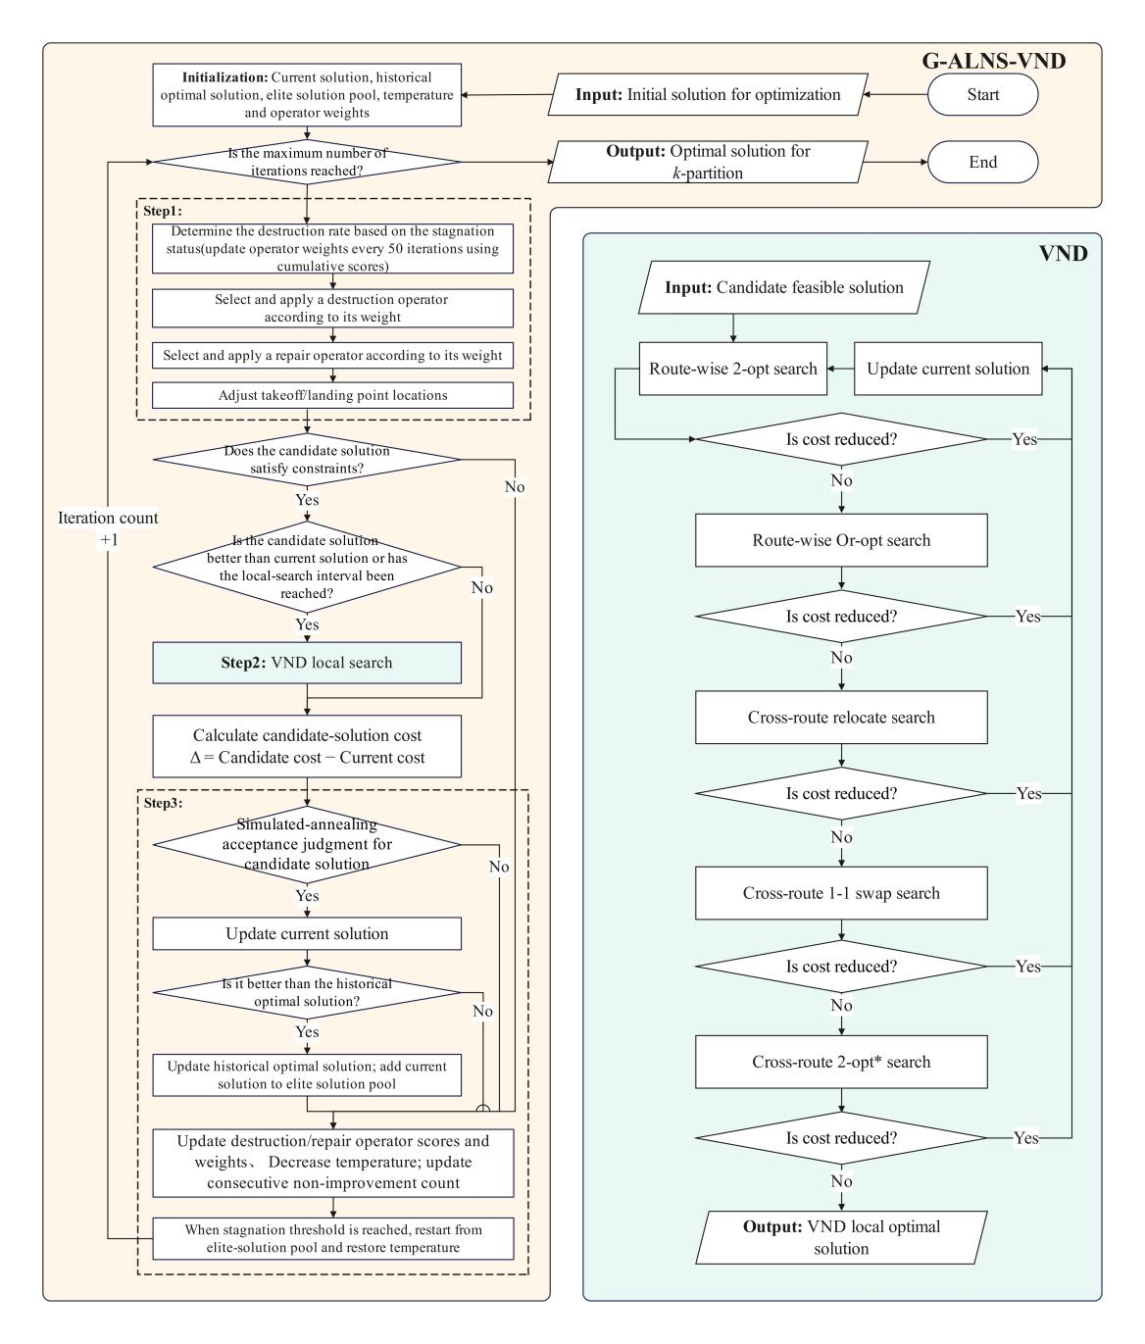
Fig. 8 Flowchart of the G-ALNS-VND algorithm
The maximum number of iterations is used as a hard termination condition. When the iteration limit is reached, destroy-repair operations, VND local search, and site restructuring stop, and the best feasible solution found for the subregion is returned as the final UAV panoramic-monitoring site-selection and route-planning scheme.

Adaptive Neighborhood Operators
(1) Adaptive destroy probability and destroy size
Within each UAV-feasible connected subregion, G-ALNS-VND updates the current solution $X_{t}$, historical best solution $X^{best}$, and elite pool $E$ at iteration $t$. In operator set $O∈\{O_{D},O_{D}\}$, $O_{D}$ and $O_{R}$ denote the destroy- and repair-operator sets, respectively. Let the current weight of operator $o$ be $w_{o}$ and its roulette-wheel selection probability be $p_{o}$. Then:
 | $$p_{o}=\frac{w_{o}}{\sum_{q∈O}{w_{q}}},o∈O.$$ | (3-19)
Ordinary destroy operators remove a subset of panoramic acquisition points, which are subsequently reinserted by a repair operator. Site-structure operators instead reconstruct a local open-site structure and its associated routes directly. Every candidate solution must pass the complete set of hard-constraint checks before entering the acceptance stage.
Let the destroy rate at iteration $t$ be $ξ_{t}$, with lower and upper bounds $ξ_{min}$ and $ξ_{max}$, respectively. As the number of consecutive non-improving iterations increases, $ξ_{t}$ gradually increases within this interval and is perturbed by a small random term; after a new improvement is obtained, the destroy rate returns to a smaller range. If at most $q_{max}$ panoramic acquisition points may be removed in one iteration, the actual number removed, $q_{t}$, is:
 | $$q_{t}=min\left\{q_{max},max\left(1,round\left(\left|B_{k}\right|ξ_{t}\right)\right)\right\}, ξ_{t}∈\left[ξ_{min},ξ_{max}\right].$$ | (3-20)
This mechanism enables fine-grained search with small neighborhoods during the early stage and automatically enlarges the reconstruction scope when the search stagnates.
(2) Destroy operators
(1) Random removal: randomly remove $q_{t}$ currently served panoramic acquisition points to maintain neighborhood diversity.
(2) Worst removal: let the predecessor and successor nodes of panoramic point $b_{u}$ on its route be $e_{i}$ and $e_{j}$, respectively. The flight distance saved by removing this point is denoted by $Δ_{u}^{rem}$:
 | $$Δ_{u}^{rem}=D_{iu}+D_{uj}-D_{ij}.$$ | (3-21)
Panoramic acquisition points with larger $Δ_{u}^{rem}$ values are preferentially removed because they have higher marginal route costs.
(3) Relatedness removal: randomly select a seed panoramic point and evaluate relatedness using actual flight distance, demand difference, whether two points are assigned to the same take-off/landing site, and whether they belong to the same route. Points more closely related to the seed are removed first.
(4) Entire-route removal: rank routes by average route cost per panoramic point and preferentially remove panoramic points from high-cost routes, allowing the repair stage to reorganize entire route segments.
(5) Spatial-cluster removal: select a random panoramic point as a center and remove nearby panoramic points according to actual flight distance, creating a local void that promotes regional reassignment.
(3) Repair operators
The repair operators include greedy insertion, Regret-2, Regret-3, and Regret-4. For Regret-$y$, let the repair order be $y∈\{2,3,4\}$. For an uninserted panoramic point $b_{u}$, all feasible insertion positions in existing routes and all feasible new-route positions are enumerated, and their incremental costs are sorted in ascending order as $Δ_{u,(1)}≤Δ_{u,(2)}≤⋯$. The Regret-$y$ value of panoramic point $b_{u}$ is denoted by $G_{u}^{\left(y\right)}$:
 | $$G_{u}^{\left(y\right)}=\sum_{m=2}^{y}{\left(Δ_{u,m}-Δ_{u,1}\right)}.$$ | (3-22)
At each iteration, the panoramic point with the largest $G_{u}^{\left(y\right)}$ value is inserted first at its best feasible position. If a point has fewer than $y$ feasible positions, its insertion priority is increased to avoid losing its last feasible option after other points are inserted. Greedy insertion selects the point-position pair with the minimum current incremental cost and adds a small random perturbation to increase solution diversity.
Greedy insertion focuses on the currently cheapest move, whereas Regret-$y$ repair estimates the additional future cost that may be incurred if a point is not inserted immediately. By comparing multiple feasible positions for the same panoramic point, the method prioritizes points that are most likely to lose high-quality insertion opportunities. Regret-2, Regret-3, and Regret-4 differ only in the number of alternative positions used in the regret calculation; the same hard constraints are checked after repair.
(4) Take-off/landing-site structure operators
To keep the number and spatial locations of open take-off/landing sites active during ALNS, three site-structure operators are used: 2->2 relocation, 3->2 merging, and 3->4 expansion. Each operator first identifies neighboring groups of open sites within the same UAV-feasible connected subregion and pools the local panoramic points currently served by those sites. A limited candidate-site pool is then generated according to local spatial extent, line-of-sight coverage capability, and proxy cost, from which a small number of combinations are selected for complete route reconstruction.
The 2->2 relocation operator preserves the number of local open sites and replaces the two current sites with two candidate locations to improve the spatial match between sites and panoramic points. The 3->2 merging operator reallocates the local tasks served by three neighboring open sites to two candidate sites, removing redundant facilities and reducing construction cost. The 3->4 expansion operator reallocates the tasks of three sites to four candidate sites and can be accepted only when the additional construction cost is sufficiently offset by shorter routes and improved route organization. Each candidate combination reconstructs local closed routes, reinserts them into the complete subregion solution, and checks capacity, route length, line of sight, safe horizontal trajectories, and the maximum number of routes per site. A reconstructed solution becomes a valid ALNS candidate only when the complete objective-function reduction reaches the specified threshold.
(5) Operator-weight update
Operator performance is accumulated over evaluation segments of fixed length. Let $π_{o}$ be the cumulative reward and $n_{o}$ the number of uses of operator $o$ in the current evaluation segment. Let $θ$ denote the reaction factor and $w_{min}$ the minimum operator weight. At the end of an evaluation segment, the operator weight is updated as:
 | $$w_{o}←max\left\{w_{min},\left(1-θ\right)w_{o}+θ\frac{π_{o}}{n_{o}}\right\},n_{o}>0.$$ | (3-23)
Operators that produce a new global best solution, an accepted improving solution, or an accepted non-improving solution receive decreasing levels of reward, respectively. Infeasible or rejected candidate solutions receive no reward. The minimum weight ensures that every operator retains a nonzero long-term exploration probability.

VND Local Search
When a candidate solution improves on the current solution, or at fixed iteration intervals, Variable Neighborhood Descent (VND) is applied. The local search first performs intra-route 2-opt and Or-opt moves (Fig. 9(a)-(b)), followed by inter-route relocate, 1-1 swap, and 2-opt* tail-exchange moves (Fig. 9(c)-(e)), using a first-improvement strategy. Every move rechecks capacity, route length, line of sight, and safe-horizontal-trajectory constraints. The five neighborhood structures are illustrated in Fig. 9.
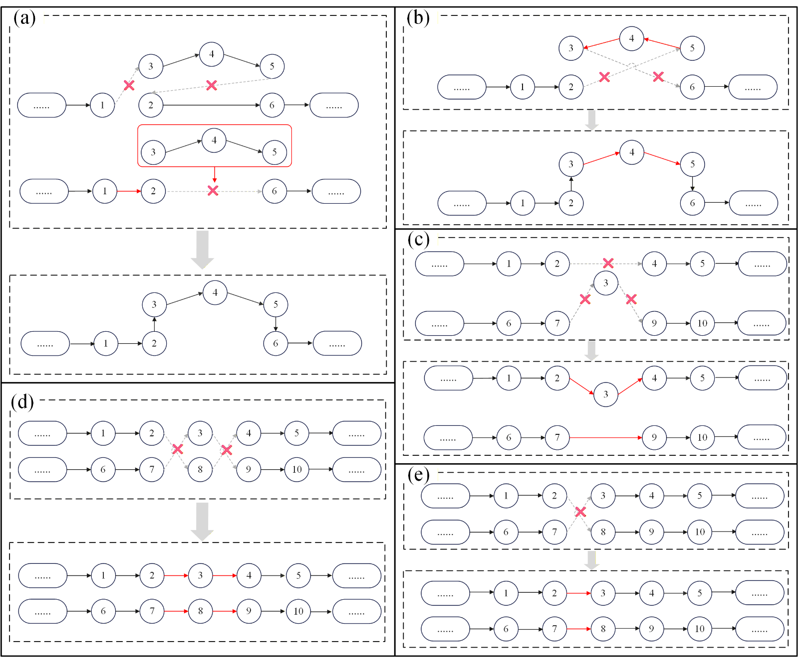
Fig. 9 Five VND neighborhood operators: (a) intra-route 2-opt; (b) intra-route Or-opt; (c) inter-route relocate; (d) inter-route 1-1 swap; and (e) inter-route 2-opt*
VND follows a restart-on-improvement strategy. Whenever a neighborhood produces a feasible lower-cost solution, that solution is accepted and the search restarts from 2-opt. The current VND call terminates only when all five neighborhoods have been searched without improvement.

Simulated-Annealing Acceptance and Elite Restart
For subregion $k$, let the cost difference between candidate solution $X'$ and current solution $X_{t}$ be ${ΔC}_{t}=C_{k}\left(X'\right)-C_{k}\left(X_{t}\right)$, and let the temperature at iteration $t$ be $T_{t}$. The simulated-annealing acceptance probability is denoted by $P_{acc}$. Improving solutions are accepted directly, whereas non-improving solutions are accepted with this probability:
 | $$P_{acc}=\left\{\begin{matrix}1, & {ΔC}_{t}≤0, \\ exp\left(-{{ΔC}_{t}}/{T_{t}}\right), & {ΔC}_{t}>0.\end{matrix}\right.$$ | (3-24)
The initial temperature is derived from a prescribed relative deterioration level and its target acceptance probability. Let the terminal temperature be $T_{end}$ and the geometric cooling factor be $α$. The temperature is updated according to:
 | $$T_{t+1}=max\left(T_{end},αT_{t}\right),α∈(0,1).$$ | (3-25)
If the number of consecutive non-improving iterations reaches the stagnation threshold, a high-quality solution is selected from the elite pool $E$ as the new current solution, and the temperature is restored to at least a specified fraction of its initial value. Elite restart helps the search escape long-term stagnation while retaining high-quality historical structures as new starting points.

Experiments and Results
The experiments evaluate the proposed method at two levels: general-purpose optimization performance and practical performance under real geographic constraints. The design includes comparisons between G-ALNS-VND and classical algorithms on the Barreto STANDARD13 CLRP benchmark, a real-data case study in Zunhua, and parameter-sensitivity analysis.

Benchmark Comparison
Barreto STANDARD13 contains 13 classical CLRP instances^{[25]}, with 21-150 customers and 5-10 candidate depots, and therefore provides a range of problem sizes for evaluating joint facility-location and routing performance. For these benchmark tests, only the standard CLRP constraints on facility capacity, vehicle capacity, route closure, and cost are retained so that all six algorithms solve exactly the same problem definition.
All six algorithms use the same instances, objective function, constraints, random-seed set, and wall-clock time budget for each instance size. Each instance is independently repeated five times. The aggregate results are reported in Table 1.
Table 1 Overall results of the six algorithms on Barreto STANDARD13 (Note: Gap is the percentage deviation of the best objective value obtained within the specified time budget from the best-known value; values closer to 0 indicate better solution quality.)
Algorithm | No. of instances | Mean MeanGap (%) | Median MeanGap (%) | Mean BestGap (%) | No. of instances with best mean Gap
SA | 13 | 18.10 | 22.12 | 12.06 | 1
GRASP-VNS | 13 | 13.37 | 5.26 | 11.41 | 2
GVTNS | 13 | 30.76 | 28.97 | 22.77 | 0
HGA | 13 | 8.07 | 7.61 | 5.87 | 1
ALNS | 13 | 5.11 | 4.13 | 2.10 | 5
G-ALNS-VND | 13 | 3.76 | 3.44 | 1.98 | 5
As shown in Table 1, G-ALNS-VND provides the best average solution quality. Its mean Mean Gap is 3.76%, the lowest among the six algorithms and 1.35 percentage points below standard ALNS (5.11%), corresponding to a relative reduction of approximately 26.5%. Its mean Best Gap is 1.98%, also lower than the 2.10% obtained by standard ALNS, and it achieves the best mean Gap on five instances. The Gap distributions across five random seeds indicate that the advantage is not driven by a small number of favorable runs but is maintained across most instances and repetitions. Because the benchmark formulation excludes DEM, no-fly-zone, and line-of-sight constraints, the improvement demonstrates that the enhanced search structure itself provides better overall solution quality than standard ALNS and the other comparison methods.

Zunhua Case-Study Results
The Zunhua case study uses a construction cost of CNY 50,000 per open take-off/landing site, a maximum line-of-sight distance of 6 km, a single-UAV service radius of 10 km, and an iteration budget of 1,000. Across five runs, the mean total cost is CNY 3,026,568.06, including CNY 1,710,000.00 in take-off/landing-site construction cost and CNY 1,316,568.06 in flight cost, with a mean of 99 routes and 34.2 selected sites. Their spatial distribution is shown in Fig. 10. In Fig. 10(a), routes belonging to different take-off/landing sites are shown with different colors, and no-fly areas are indicated in light red. All routes satisfy the line-of-sight, no-fly-zone, and route-length constraints. The route lengths associated with each site are shown by matching colors in Fig. 10(b). For the representative run with random seed 11, 34 sites are opened and 99 routes are generated, with a total cost of CNY 3,023,751.43, including CNY 1,700,000.00 in construction cost and CNY 1,323,751.43 in flight cost. Some sites serve only short routes and are visually inconspicuous at the full-study-area scale, but they still carry assigned tasks and contribute to the objective. Under the baseline setting, construction cost accounts for approximately 56.5% of total cost and flight cost for approximately 43.5%. Thus, facility-opening decisions strongly influence total cost, while route organization and terrain-dependent accessibility remain substantial contributors. Optimizing routes only after fixing facility locations would therefore ignore the coupling among facility number, service assignment, and flight distance. G-ALNS-VND jointly adjusts site structure, task assignment, and local route geometry so that fixed construction expenditure and flight cost can be balanced within a single objective function.
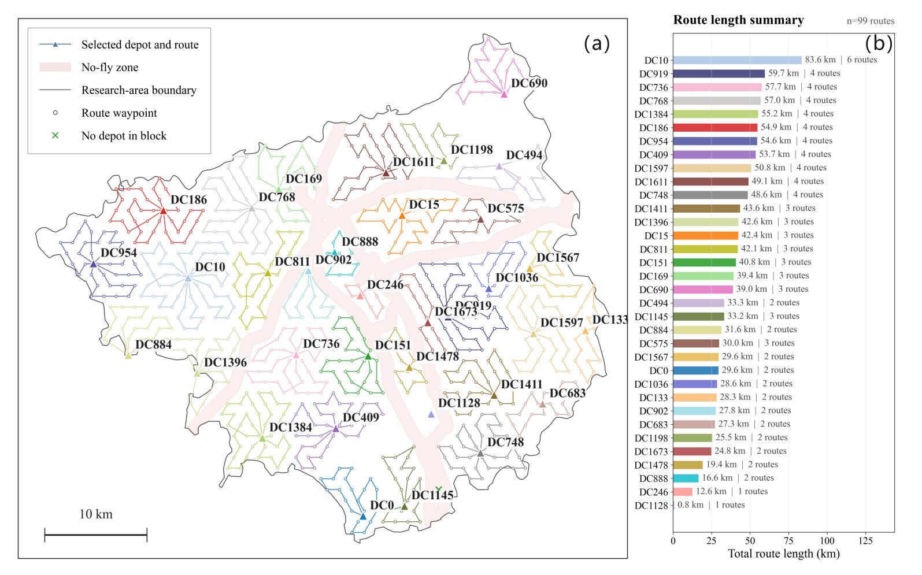
Fig. 10 FCLRP solution for the Zunhua case study
如何进一步丰富实验？？？？

Parameter Sensitivity Analysis
The sensitivity analysis evaluates how key engineering parameters affect the number of facilities, total cost, and computation time and assesses the reasonableness of the baseline parameter setting. A one-factor-at-a-time design is used, with a construction cost of CNY 50,000, a maximum line-of-sight distance of 6,000 m, a service radius of 10,000 m, and an iteration budget of 1,000 as the central setting. When one parameter is varied, all other parameters, study-area data, constraints, and five random seeds are held constant to avoid confounded attribution. Table 2 reports the mean results of five independent runs for each parameter level.
Table 2 Sensitivity of the solution to key parameters
Parameter | Value | Mean total cost (CNY) | Mean no. of open sites | Mean solution time (s)
Construction cost (CNY/site) | 25,000 | 2,177,248 | 34.4 | 1,300
 | 37,500 | 2,601,128 | 34.2 | 1,452
 | 50,000 | 3,026,568 | 34.2 | 1,455
 | 62,500 | 3,458,984 | 34.2 | 1,437
 | 75,000 | 3,890,589 | 34.2 | 1,396
Maximum line-of-sight distance (m) | 4,000 | 3,863,081 | 52 | 1,774
 | 5,000 | 3,347,974 | 41.2 | 1,570
 | 6,000 | 3,026,568 | 34.2 | 1,453
 | 7,000 | 2,727,091 | 26.8 | 1,193
 | 8,000 | 2,584,428 | 23 | 1,227
Single-UAV service radius (m) | 8,000 | 3,010,068 | 33.8 | 1,078
 | 9,000 | 3,005,101 | 33.8 | 1,118
 | 10,000 | 3,026,568 | 34.2 | 1,451
 | 11,000 | 3,025,704 | 34.2 | 1,558
 | 12,000 | 3,015,430 | 34 | 1,694
ALNS iterations | 250 | 3,042,442 | 34 | 494
 | 500 | 3,040,263 | 34.2 | 738
 | 1,000 | 3,026,568 | 34.2 | 1,455
 | 1,500 | 3,006,903 | 33.8 | 2,856
 | 2,000 | 3,020,076 | 34.2 | 4,297
The parameters have markedly different effects on the optimized solution. As construction cost increases from CNY 25,000 to CNY 75,000 per site, total cost rises substantially, whereas the mean number of open sites remains close to 34, indicating that this parameter mainly affects economic valuation rather than facility layout. Maximum line-of-sight distance is much more influential. Increasing it from 4,000 to 8,000 m reduces the mean number of open sites from 52.0 to 23.0 and the mean total cost from CNY 3,863,081 to CNY 2,584,428, because each site can serve a larger set of panoramic acquisition points. By contrast, varying the single-UAV service radius from 8,000 to 12,000 m produces little change in total cost or facility number, indicating relatively low sensitivity within the tested range.
The number of ALNS iterations primarily reflects the trade-off between solution quality and computational effort. Increasing the iteration budget from 250 to 1,500 generally reduces mean total cost, but the improvement is limited while mean computation time increases from 494 to 2,856 s. Increasing the budget further to 2,000 iterations does not yield an additional reduction in mean total cost. Considering both solution quality and runtime, 1,000 iterations provides a relatively stable compromise and is therefore used as the default setting.
Overall, maximum line-of-sight distance has the strongest effect on facility configuration and total cost, construction cost mainly changes the economic cost level, the single-UAV service radius is comparatively insensitive within the tested interval, and the iteration budget governs the balance between solution quality and computation time. Accordingly, the baseline parameter combination is CNY 50,000 construction cost per site, a 6,000 m maximum line-of-sight distance, a 10,000 m service radius, and 1,000 ALNS iterations.

Comparison of 3D Flight Strategies
The 3D route comparison evaluates whether the proposed strategy of maintaining an operating height of 120 m above local ground level and locally climbing over terrain or obstacles is more suitable for a topographically variable survey area than flying at a uniform altitude of 300 m relative to the take-off site. The two strategies are shown in Fig. 11(a). Under the proposed strategy, the UAV normally maintains an approximately 120 m above-ground-level imaging height; when terrain or an obstacle violates the required clearance, it climbs temporarily, crosses the obstacle, and then descends to resume the 120 m imaging height. The comparison strategy uses a uniform 300 m altitude relative to the take-off site and does not actively return to a fixed height above local ground. As shown in Fig. 11, comparable ground regions are selected under both strategies and displayed with the same crop extent and scale. Terrain-following flight produces clearer and more consistent field boundaries and vegetation texture. A lower and more stable above-ground imaging height places target objects on more pixels and reduces scale variation caused by terrain relief. Although the 300 m fixed-altitude strategy is simpler to control, its actual above-ground height varies across undulating terrain, resulting in larger scale differences between low and elevated areas and potentially reducing texture clarity and the stability of the effective imaging footprint.
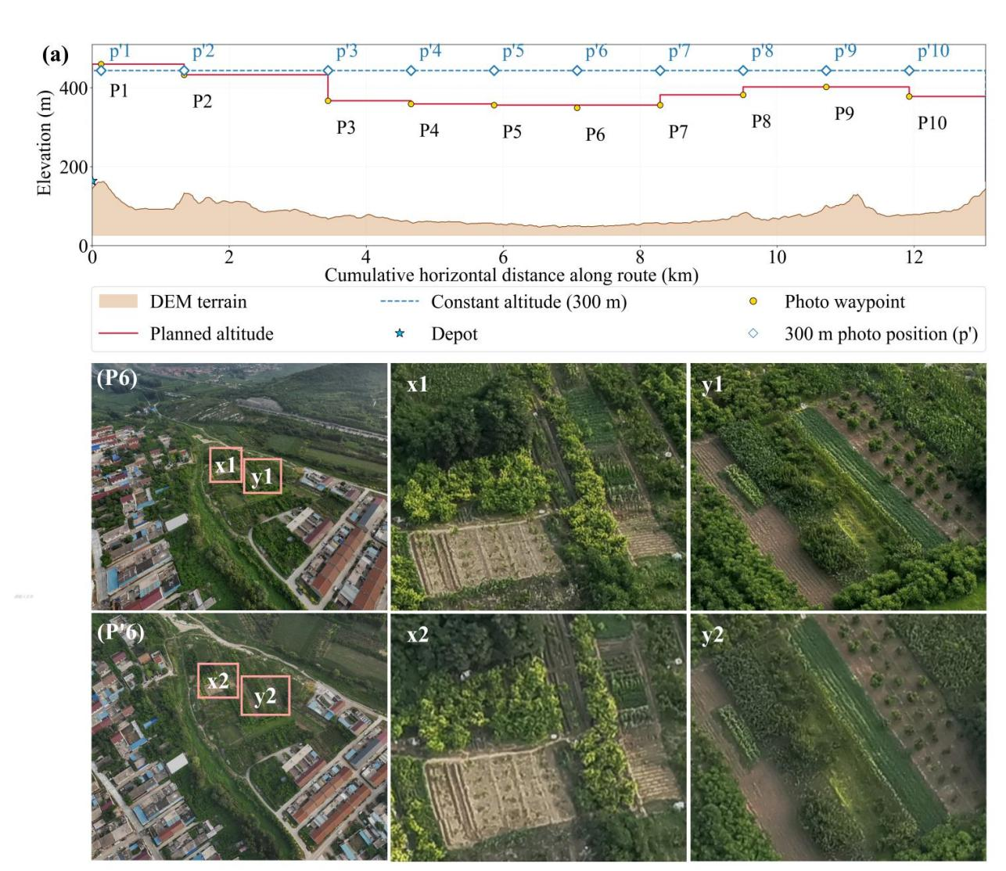
Fig. 11 Visual comparison of imagery acquired using different flight-height strategies (x1 and y1: imagery acquired at 120 m above local ground; x2 and y2: imagery acquired at a fixed altitude of 300 m relative to the take-off site)

Discussion

Effectiveness of Panoramic Coverage for Agricultural Monitoring
Panoramic imagery is used here as an information-acquisition mode for large-area farmland inspection rather than as a replacement for conventional orthophotogrammetry. Orthophoto acquisition requires continuous flight strips with substantial overlap for photogrammetric reconstruction, enabling geometrically consistent products but at the cost of higher waypoint density, longer continuous flight time, and larger raw-data volumes. Panoramic acquisition instead uses discrete observation locations and does not require high-overlap strips across the entire area, allowing continuous monitoring demand to be converted into a finite set of discrete acquisition points that directly correspond to the site-selection and routing decisions of the FCLRP. Recent UAV and agricultural-machine studies likewise show that terrain-aware, complete-coverage, and task-specific route design can reduce unnecessary movement and improve operational efficiency^{[30-31,33]}. Over the same experimental area, acquisition times for orthophoto, video, and panoramic imagery are 120, 16, and 30 min, respectively, with data volumes of 16.7 GB, 8 GB, and 180 MB (Table 3). Compared with orthophoto acquisition, panoramic acquisition reduces acquisition time from 120 to 30 min (75%) and data volume from 16.7 GB to 180 MB (approximately 98.9%). Video provides the shortest continuous acquisition time but still produces 8 GB of data and requires subsequent selection of informative frames. Panoramic acquisition therefore does not maximize a single indicator such as spatial accuracy or minimum flight time; rather, it provides a practical compromise among acquisition efficiency, data volume, and discrete spatial positioning.
Table 3 Performance comparison of different UAV data-acquisition techniques
Comparison Dimension | Orthophoto | Video | Panorama
Flight Altitude | 220 m | 120 m | 120 m
Acquisition Time | 2 h | 16 min | 30 min
Processing Time | 1 h | - | -
Data Volume | 16.7 GB | 8 GB | 180 MB
Fig. 12 further illustrates the visual differences among the three data types. Panoramic imagery retains field boundaries, vegetation texture, and surrounding objects that are useful for inspection interpretation, making it suitable for large-area preliminary screening of farmland change and anomaly detection. Orthophotos remain preferable for high-precision area measurement, topographic mapping, and photogrammetric reconstruction. The efficiency advantage of panoramic acquisition also has clear limits. A fixed coverage radius is only an approximation of the effective observable area of each panoramic point; on steep terrain or where occlusion is severe, the actual visible ground area may deviate from an ideal planar circle. In addition, crop type, phenological stage, solar elevation, and image-quality requirements are not yet incorporated into point generation. The proposed approach is therefore most appropriate for anomaly discovery, parcel-change identification, and routine inspection, whereas applications requiring continuous seamless imagery or quantitative remote-sensing retrieval should combine panoramic monitoring with orthophoto, hyperspectral, or other remote-sensing data.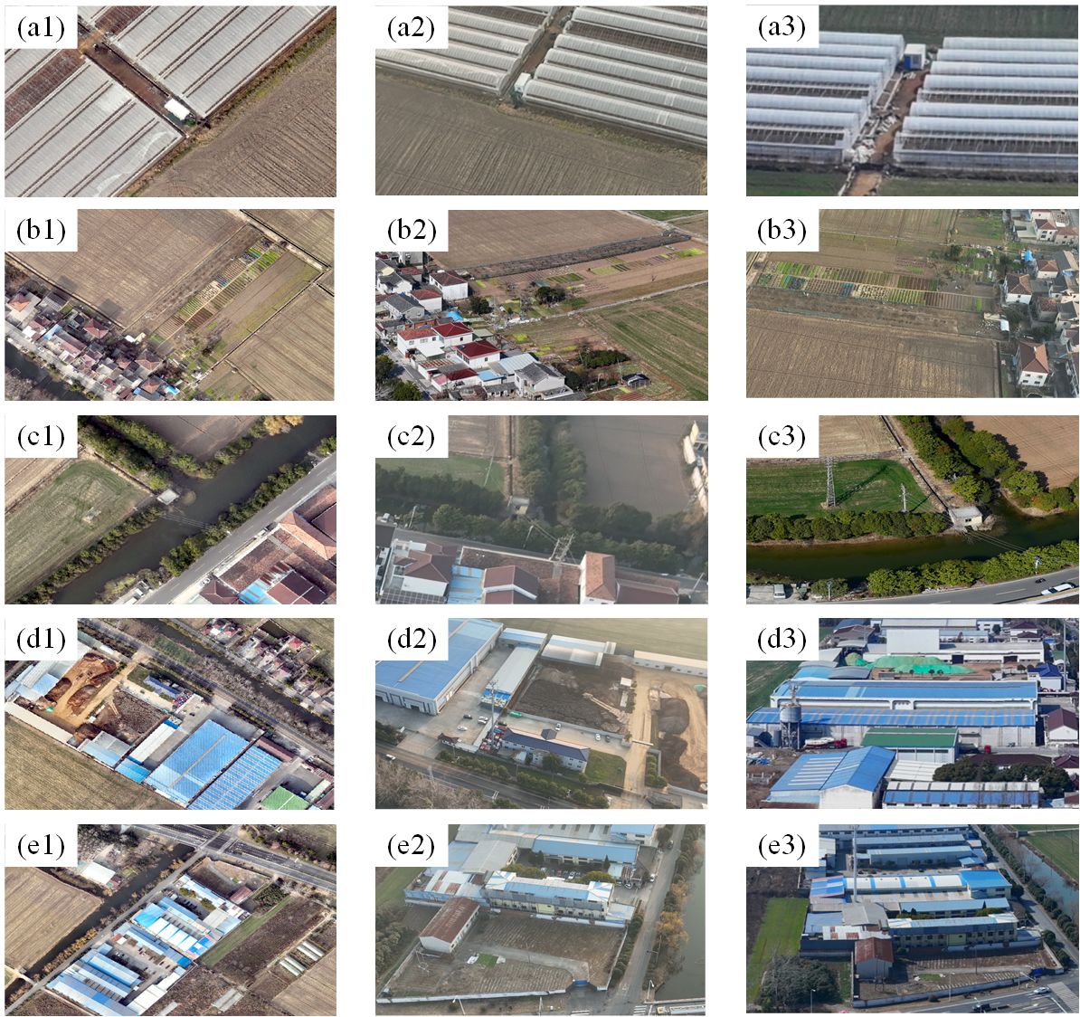
Fig. 12 Example products from different UAV data-acquisition techniques

Application to Farmland Protection Monitoring
From an operational farmland-inspection perspective, the results show that large-area UAV monitoring cannot be reduced to a shortest-route problem. The representative Zunhua solution opens 34 take-off/landing sites and organizes 99 closed routes, indicating strong coupling among facility location, panoramic-point assignment, and route structure in a large, fragmented, and topographically variable region. Related UAV location-routing studies likewise show that jointly modeling facility placement, routing structure, service time, and uncertainty can avoid locally optimal solutions created by sequential decision making^{[34,37]}. Compared with a two-stage approach that first fixes take-off/landing sites and then optimizes routes, the FCLRP jointly balances facility construction cost, route fixed cost, and 3D flight-distance cost and thus better represents region-scale UAV inspection planning. The sensitivity analysis further shows that geographic constraints affect not only route geometry but also facility configuration. Increasing the maximum line-of-sight distance from 4 to 8 km reduces the mean number of open sites from 52 to 23, whereas changing the single-UAV service radius from 8 to 12 km produces little change in facility number or total cost. Hence, in terrain-relief agricultural regions, service capability is not determined solely by nominal UAV range; communication line of sight can also be restrictive. Joint facility/fleet planning, agricultural UAV trajectory optimization, constrained multi-UAV routing, and cooperative agricultural planning reflect the same resource-route coupling^{[27-29,38-40]}. Practical UAV-nest or fixed-site deployment should therefore not rely only on equal-distance placement based on planar service radii but should consider DEM-based line of sight, no-fly constraints, and actual 3D flight distance during facility planning. The proposed framework is best viewed as a front-end for 'planning - rapid acquisition - anomaly screening' in region-scale farmland inspection. FCLRP first determines a limited set of take-off/landing sites and their service regions and generates closed routes satisfying route-length, capacity, line-of-sight, and no-fly-zone safety constraints. Georeferenced panoramic imagery can then be linked to object detection, change detection, or manual interpretation to screen suspected farmland changes, after which high-resolution orthophoto surveys or field verification can be targeted to priority areas. It should be emphasized that the Zunhua case uses real farmland, DEM, administrative-boundary, and railway data, but the candidate take-off/landing sites remain a controlled, relatively uniform discrete set. Road accessibility, land ownership, electricity and communication infrastructure, construction conditions, and site safety are not yet considered. The resulting sites should therefore be interpreted as planning-level optimization outputs rather than directly constructible final facility locations. Future implementation can first use roads, settlements, power infrastructure, and land-use data to generate an engineering-feasible candidate-site set and then apply FCLRP for facility selection and coordinated route optimization. A representative planning interface and panoramic-inspection workflow are shown in Fig. 13.
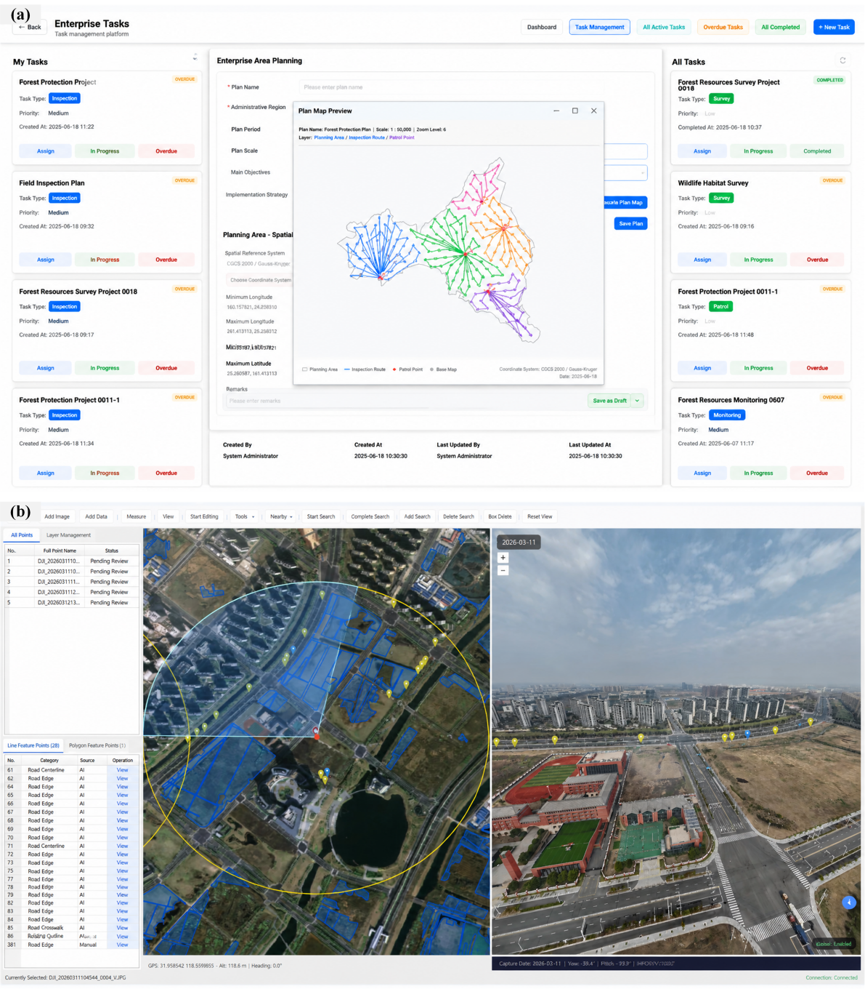
Fig. 13 Example farmland-protection monitoring system and panoramic UAV route operation

Conclusion
This study develops a UAV panoramic location-routing framework for large-area farmland monitoring under pronounced terrain relief, fragmented farmland distribution, and low-altitude flight constraints. The framework comprises CFCPG, VCMS-3DGE, FCLRP, and G-ALNS-VND. CFCPG converts continuous farmland space into discrete panoramic demand points; VCMS-3DGE maps DEM-based line of sight, 3D directed flight distance, and safe no-fly-zone detours into a unified cost representation; FCLRP jointly balances take-off/landing-site construction, route activation, and flight-distance costs; and G-ALNS-VND combines greedy initialization, site restructuring, and VND local search to iteratively optimize facilities and routes. On the Barreto STANDARD13 benchmark, G-ALNS-VND achieves a mean MeanGap of 3.76%, reducing the standard-ALNS value of 5.11% by 1.35 percentage points, or 26.5% in relative terms. The Zunhua case study further demonstrates that the method can generate feasible multi-site, multi-route plans under real complex geographic constraints.
Several extensions remain for future work. First, the current FCLRP is a static single-period model and does not differentiate monitoring priorities among historically high-risk violation areas, urban-expansion fronts, or other risk categories, nor does it consider crop-season dynamics or event-triggered re-optimization. Second, 3D flight distance is used as the main proxy for route length and flight cost, without explicitly modeling wind speed, payload, battery state of charge, flight speed, or different energy-consumption rates during ascent, cruise, and descent. Third, candidate take-off/landing sites in the Zunhua case are represented by a controlled, relatively uniform set; future work should incorporate road accessibility, slope, land ownership, and construction conditions to generate engineering-feasible candidates.

Declarations

Ethics approval and consent to participate
All data which are collected from the Internet are open source, ethically free, and privacy-free. Also, the openness of data acquisition brings advantages for our research method to be extended to other cities.

Consent for publication
This manuscript doesn't contain any person's data (including any individual details, images, or videos) or consent for publication.

Availability of data and materials
The UAV-OMVCD dataset has been publicly released on GitHub (link: https://github.com/LazyKnight123/UAV-OMVCD) to support BCD research and model development for typical regions in China. These data are also available from the corresponding authors Zhenjun Yan, Yuanyuan Guo upon reasonable request.

Abbreviations
UAV, Unmanned Aerial Vehicle
CFCPG, Cultivated-Land Full-Coverage Panoramic Point Generation algorithm
VCMS-3DGE, Visibility-Cost Matrix Set Considering the 3D Geographic Environment
FCLRP, Full-Coverage Location-Routing Problem
G-ALNS-VND, Greedy-Initialized Adaptive Large Neighborhood Search with Variable Neighborhood Descent

Competing interests
The authors declare that they have no competing interests.

Funding
This research was supported by Open Project of Jiangsu Provincial Key Laboratory of New Remote Sensing and Geographic Information Technologies (No. RSGIT-2025-06), Jiangsu Provincial Natural Resources Research Project (No. 2026051) ,Science and Technology Project of Hebei Provincial Department of Natural Resources (13000026P00F2D410837J), Qinghai Province Kunlun Talents High-End Innovation and Entrepreneurship Talent Program (QHKLYC-GDCXCY-2024-434), the Key Project of Natural Science Research for Universities of Anhui Province (No.2024AH051424), Research Project of Hebei Provincial Bureau of Geological and Mineral Exploration and Development (13000026P0069B410455E)

Acknowledgments
The authors would like to thank the anonymous referees and editor for their valuable comments, which significantly improved this paper.

Notations
Table A1 Description of the symbols
Category | Symbol | Description
Index | $$\text{i}\text{,}\text{j}$$ | General node index; within ${\text{a}}_{\text{i}}$, ${\text{b}}_{\text{j}}$, ${\text{e}}_{\text{i}}$, and ${\text{e}}_{\text{j}}$, it is used to identify candidate take-off/landing sites, panoramic acquisition points, or general nodes, and in route equations it denotes consecutive ordered nodes.
 | $$\text{g}\text{,}\text{k}$$ | Index of a UAV-feasible connected subregion, $\text{g}\text{,}\text{k}\text{∈}\text{K}$.
 | $$\text{l}$$ | Index of an open take-off/landing site in subregion $\text{k}$; ${\text{a}}_{\text{l}}^{\text{k}}$ denotes the $\text{l}$th open site in subregion $\text{k}$.
 | $$\text{m}$$ | Depending on context, denotes a closed-route index, an initial-solution strengthening operation type, or a summation index over alternative insertion positions in the Regret-$\text{y}$ calculation.
 | $$\text{s}\text{,}\text{x}$$ | $\text{s}$ is the normalized position along a take-off/landing-site-to-panoramic-point line-of-sight profile; $\text{x}$ is an arbitrary position on a safe horizontal trajectory.
 | $$\text{o}\text{,}\text{q}$$ | $\text{o}$ is an ALNS operator index; $\text{q}$ is the summation index used in roulette-wheel operator-probability calculations.
 | $$\text{t}$$ | Iteration index of G-ALNS-VND / ALNS.
 | $$\text{y}$$ | Repair order in Regret-$\text{y}$; $\text{y}\text{∈\{2,3,4\}}$.
 | $$\text{u}\text{,}\text{v}$$ | Index $\text{u}$ is used in insertion/removal operators to identify the panoramic acquisition point ${\text{b}}_{\text{u}}$ being processed; in the no-fly-zone detour section, $\text{u}\text{,}\text{v}$ denotes a sampled or access point on the no-fly boundary.
Parameter | $$\text{r}$$ | Circular coverage radius of a panoramic image; the center spacing between adjacent coverage circles is $\text{3}\text{r}$ as specified in the text.
 | $$\text{Ω,}\text{H}$$ | Administrative boundary of the study area and the no-fly safety exclusion zone.
 | $$\text{K}\text{,}{\text{Ω}}_{\text{k}}$$ | Index set of UAV-feasible connected subregions and the $\text{k}$th UAV-feasible connected subregion.
 | $${\text{B}}_{\text{o}}\text{,}\text{B}\text{,}{\text{B}}_{\text{k}}\text{',}{\text{B}}_{\text{k}}$$ | Initial full-area panoramic-point set; valid panoramic-point set after no-fly-zone and farmland filtering; panoramic-point set in subregion $\text{k}$ before line-of-sight filtering; and final valid panoramic-point set after line-of-sight filtering.
 | $${\text{A}}_{\text{o}}\text{,}\text{A}\text{,}{\text{A}}_{\text{k}}$$ | Original candidate take-off/landing-site set; candidate-site set after filtering by no-fly-zone and valid-DEM conditions; and candidate-site set in subregion $\text{k}$.
 | $${\text{a}}_{\text{i}}\text{,}{\text{b}}_{\text{j}}$$ | The $\text{i}$th candidate take-off/landing site and the $\text{j}$th panoramic acquisition point in a subregion.
 | $${\text{h}}_{\text{i}}^{\text{a}}\text{,}{\text{h}}_{\text{j}}^{\text{b}}$$ | Installation elevation of candidate take-off/landing site ${\text{a}}_{\text{i}}$ and acquisition elevation of panoramic point ${\text{b}}_{\text{j}}$.
 | $${\text{V}}_{\text{k}}\text{=}{\left[{\text{v}}_{\text{ij}}^{\text{ab}}\right]}_{\text{k}}$$ | Candidate-site-to-panoramic-point line-of-sight matrix in subregion $\text{k}$; ${\text{v}}_{\text{ij}}^{\text{ab}}\text{=1}$ = 1 indicates that the line-of-sight condition is satisfied, otherwise $\text{0}$ = 0.
 | $${\text{r}}_{\text{max}}$$ | Maximum line-of-sight distance between a take-off/landing site and a panoramic acquisition point.
 | $${\text{z}}_{\text{ij}}^{\text{ab}}\left(\text{s}\right)$$ | DEM terrain elevation at normalized position $\text{s}$ on the straight-line profile from take-off/landing site ${\text{a}}_{\text{i}}$ to panoramic point ${\text{b}}_{\text{j}}$.
 | $${\text{E}}_{\text{k}}\text{=}{\text{A}}_{\text{k}}\text{∪}{\text{B}}_{\text{k}}\text{, }{\text{e}}_{\text{i}}$$ | Unified node set in subregion $\text{k}$ and any node in that set.
 | $${\text{h}}_{\text{i}}$$ | Task elevation of node ${\text{e}}_{\text{i}}$; for a take-off/landing site, the corresponding site elevation is used, and for a panoramic point, the acquisition elevation is used.
 | $${\text{L}}_{\text{ij}}^{\text{e}}$$ | Actual safe horizontal trajectory from node ${\text{e}}_{\text{i}}$ to node ${\text{e}}_{\text{j}}$.
 | $${\text{z}}_{\text{x}}\text{,}{\text{δ}}_{\text{h}}\text{,}{\text{h}}_{\text{ij}}^{\text{min}}$$ | DEM ground elevation at trajectory position $\text{x}$, terrain-clearance margin, and minimum absolute cruising elevation of segment ${\text{e}}_{\text{i}}\text{→}{\text{e}}_{\text{j}}$.
 | $${\text{D}}_{\text{k}}^{\text{horz}}\text{,}{\text{D}}_{\text{k}}^{\text{up}}\text{,}{\text{D}}_{\text{k}}^{\text{down}}\text{,}{\text{D}}_{\text{k}}$$ | Horizontal-flight distance matrix, directed ascent-distance matrix, directed descent-distance matrix, and total directed flight-distance matrix in subregion $\text{k}$; the corresponding matrix elements are ${\text{D}}_{\text{ij}}^{\text{horz}}$, ${\text{D}}_{\text{ij}}^{\text{up}}$, ${\text{D}}_{\text{ij}}^{\text{down}}$, and ${\text{D}}_{\text{ij}}$.
 | $${\text{c}}_{\text{l}}^{\text{k}}\text{,}{\text{c}}_{\text{r}}\text{,}{\text{c}}_{\text{d}}$$ | Construction cost of open take-off/landing site ${\text{a}}_{\text{l}}^{\text{k}}$, fixed cost per route, and unit flight-distance cost.
 | $$1\left(⋅\right)$$ | Indicator function; equals 1 when the condition in parentheses holds and 0 otherwise.
 | $$\text{M}$$ | Maximum number of routes that can be assigned to one open take-off/landing site.
 | $${\text{q}}_{\text{b}}\text{,}\text{Q}$$ | Task demand of panoramic acquisition point $\text{b}$ and capacity limit of one route.
 | $${\text{L}}_{\text{max}}$$ | Maximum allowable 3D flight distance of a closed route.
 | $${\text{C}}_{\text{i}}^{\text{k}}$$ | Set of panoramic acquisition points that candidate site ${\text{a}}_{\text{i}}$ in subregion $\text{k}$ can serve while satisfying line of sight and the single-point round-trip maximum-distance condition.
 | $${\text{η}}_{\text{m}}$$ | Minimum relative-improvement threshold for local restructuring operation type $\text{m}$ during initial site-route strengthening.
 | $${\text{O}}_{\text{D}}\text{,}{\text{O}}_{\text{R}}\text{,}\text{O}$$ | Destroy-operator set, repair-operator set, and the operator set currently used in roulette-wheel selection.
 | $${\text{ξ}}_{\text{min}}\text{,}{\text{ξ}}_{\text{max}}\text{,}{\text{q}}_{\text{max}}$$ | Lower and upper bounds of the adaptive destroy rate and the maximum number of panoramic acquisition points that may be removed in one iteration.
 | $$\text{θ}\text{,}{\text{w}}_{\text{min}}$$ | Reaction factor for operator-weight updating and minimum operator weight.
 | $${\text{T}}_{\text{end}}\text{,}\text{α}$$ | Terminal simulated-annealing temperature and geometric cooling factor.
 | $${\text{F}}_{\text{k}}\text{=}{\left[{\text{f}}_{\text{ij}}\right]}_{\text{k}}$$ | No-fly-zone intersection matrix in subregion $\text{k}$; ${\text{f}}_{\text{ij}}\text{=1}$ = 1 if the direct horizontal segment between nodes ${\text{e}}_{\text{i}}$ and ${\text{e}}_{\text{j}}$ intersects no-fly zone $\text{H}$, otherwise 0.
 | $${\text{T}}_{\text{i}}\text{,}{\text{T}}_{\text{j}}$$ | Sets of near-tangent boundary access points around nodes ${\text{e}}_{\text{i}}$ and ${\text{e}}_{\text{j}}$ that can be used for no-fly-zone detours.
 | $${\text{d}}_{\text{∂}\text{H}}\left(\text{u}\text{,}\text{v}\right)$$ | Shortest arc length / shortest boundary-path length along the safe boundary between sampled or access points $\text{u}$ and $\text{v}$ on the no-fly boundary.
 | $${\text{D}}_{\text{k}}^{\text{sh}}\text{=}{\left[{\text{D}}_{\text{ij}}^{\text{sh}}\right]}_{\text{k}}$$ | Corrected safe horizontal-distance matrix in subregion $\text{k}$; stores the actual safe horizontal travel distance for either direct flight or no-fly-zone detours.
 | $${\text{x}}_{\text{i}}\text{,}{\text{x}}_{\text{j}}\text{,}{\text{x}}_{\text{u}}\text{,}{\text{x}}_{\text{v}}$$ | Planar projected coordinates of nodes ${\text{e}}_{\text{i}}$ and ${\text{e}}_{\text{j}}$ and boundary access points $\text{u}$ and $\text{v}$ used in the no-fly-zone detour-distance calculation.
Variable | $${\text{A}}_{\text{k}}^{\text{open}}$$ | Set of candidate take-off/landing sites currently opened in subregion $\text{k}$.
 | $${\text{S}}_{\text{l}}^{\text{k}}\text{,}{\text{s}}_{\text{m}}$$ | Set of closed routes assigned to open site ${\text{a}}_{\text{l}}^{\text{k}}$ and the $\text{m}$th closed route in that set.
 | $${\text{C}}_{\text{k}}$$ | Total FCLRP cost (objective-function value) in subregion $\text{k}$.
 | $${\text{U}}_{\text{k}}$$ | Set of panoramic acquisition points not yet covered by the current open-site set during greedy initial site selection.
 | $${\text{Δ}}_{\text{u}}^{\text{ins}}\left({\text{e}}_{\text{i}}\text{,}{\text{e}}_{\text{j}}\right)\text{,}{\text{Δ}}_{\text{u}}^{\text{new}}\left({\text{a}}_{\text{i}}\right)$$ | Incremental cost of inserting panoramic point ${\text{b}}_{\text{u}}$ into existing segment $\left({\text{e}}_{\text{i}}\text{,}{\text{e}}_{\text{j}}\right)$, and incremental cost of creating a new single-point route from take-off/landing site ${\text{a}}_{\text{i}}$.
 | $$\text{X}\text{,}\text{X}\text{'}$$ | Current feasible solution and candidate solution during initial-solution strengthening or local restructuring.
 | $${\text{X}}_{\text{t}}\text{,}{\text{X}}_{\text{best}}\text{,}\text{E}$$ | Current solution, historical best solution, and elite pool at ALNS iteration $\text{t}$.
 | $${\text{w}}_{\text{o}}\text{,}{\text{p}}_{\text{o}}$$ | Current weight of operator $\text{o}$ and its roulette-wheel selection probability.
 | $${\text{ξ}}_{\text{t}}\text{,}{\text{q}}_{\text{t}}$$ | Actual destroy rate at iteration $\text{t}$ and the actual number of panoramic acquisition points removed in that iteration.
 | $${\text{Δ}}_{\text{u}}^{\text{rem}}$$ | Flight distance saved by removing panoramic acquisition point ${\text{b}}_{\text{u}}$ in the worst-removal operator.
 | $${\text{Δ}}_{\text{u}\text{,}\left(\text{m}\right)}\text{,}{\text{G}}_{\text{u}}^{\text{y}}$$ | The ${\text{b}}_{\text{u}}$th feasible insertion incremental cost of panoramic point $\text{m}$ and its corresponding Regret-$\text{y}$ value.
 | $${\text{π}}_{\text{o}}\text{,}{\text{n}}_{\text{o}}$$ | Cumulative reward and number of uses of operator $\text{o}$ in the current operator-evaluation segment.
 | $$\text{Δ}{\text{C}}_{\text{t}}$$ | Objective-cost difference between the candidate and current solutions at iteration $\text{t}$.
 | $${\text{T}}_{\text{t}}\text{,}{\text{P}}_{\text{acc}}$$ | Simulated-annealing temperature and candidate-solution acceptance probability at iteration $\text{t}$.

References
[1] Qie, L., Pu, L., Tang, P., Liu, R., Huang, S., Xu, F., & Zhong, T. (2023). Gains and losses of farmland associated with farmland protection policy and urbanization in China: An integrated perspective based on goal orientation. Land Use Policy, 129, 106643. https://doi.org/10.1016/j.landusepol.2023.106643
[2] Tao, W., Zhao, L., Wang, G., & Liang, R. (2021). Review of the internet of things communication technologies in smart agriculture and challenges. Computers and Electronics in Agriculture, 189, 106352. https://doi.org/10.1016/j.compag.2021.106352
[3] Yang, Z., Yu, X., Dedman, S., Rosso, M., Zhu, J., Yang, J., Xia, Y., Tian, Y., Zhang, G., & Wang, J. (2022). UAV remote sensing applications in marine monitoring: Knowledge visualization and review. Science of the Total Environment, 838, 155939. https://doi.org/10.1016/j.scitotenv.2022.155939
[4] Li, K., Wan, G., Cheng, G., Meng, L., & Han, J. (2020). Object detection in optical remote sensing images: A survey and a new benchmark. ISPRS Journal of Photogrammetry and Remote Sensing, 159, 296-307. https://doi.org/10.1016/j.isprsjprs.2019.11.023
[5] De la Fuente, R., Aguayo, M. M., & Contreras-Bolton, C. (2024). An optimization-based approach for an integrated forest fire monitoring system with multiple technologies and surveillance drones. European Journal of Operational Research, 313(2), 435-451. https://doi.org/10.1016/j.ejor.2023.08.008
[6] Tang, Z., Jiao, Y., Wang, X., Pan, X., & Peng, J. (2025). Research on Scheduling Return Communication Tasks for UAV Swarms in Disaster Relief Scenarios. Drones, 9(8). https://doi.org/10.3390/drones9080567
[7] Chen, A., Xu, C., Zhang, M., Guo, J., Xing, X., Yang, D., Xu, B., & Yang, X. (2024). Cross-scale mapping of above-ground biomass and shrub dominance by integrating UAV and satellite data in temperate grassland. Remote Sensing of Environment, 304, 114024. https://doi.org/10.1016/j.rse.2024.114024
[8] Lu, B., & He, Y. (2017). Species classification using Unmanned Aerial Vehicle (UAV)-acquired high spatial resolution imagery in a heterogeneous grassland. ISPRS Journal of Photogrammetry and Remote Sensing, 128, 73-85. https://doi.org/10.1016/j.isprsjprs.2017.03.011
[9] Xu, J., & Pan, W. (2024). Deep learning-based object detection for dynamic construction site management. Automation in Construction, 165, 105494. https://doi.org/10.1016/j.autcon.2024.105494
[10] Shin, J., Lee, G., Kim, T. H., Cho, K. H., Hong, S. M., Kwon, D. H., Pyo, J. C., & Cha, Y. K. (2024). Deep learning-based efficient drone-borne sensing of cyanobacterial blooms using a clique-based feature extraction approach. Science of the Total Environment, 912, 169540. https://doi.org/10.1016/j.scitotenv.2023.169540
[11] Librán-Embid, F., Klaus, F., Tscharntke, T., & Grass, I. (2020). Unmanned aerial vehicles for biodiversity-friendly agricultural landscapes: A systematic review. Science of the Total Environment, 732, 139204. https://doi.org/10.1016/j.scitotenv.2020.139204
[12] Cai, L., Li, J., Wang, K., Luo, Z., & Qin, H. (2025). Optimal allocation and route design for station-based drone inspection of large-scale facilities. Omega, 130, 103172. https://doi.org/10.1016/j.omega.2024.103172
[13] WANG, K., JIANG, C., HUANG, L., & ZHANG, X. (2025). Mobile robot path planning based on a three-population particle swarm optimization strategy. Journal of Shenzhen University Science and Engineering, 42(4), 447-454. https://doi.org/10.3724/SP.J.1249.2025.04447
[14] XU, Y., HU, S., YANG, G., BAO, Y., & LI, H. (2025). A Generalized Vision-Based Intelligent Agent Navigation for Structural Damage Inspection. Industrial Construction, 55(7), 1-10. https://doi.org/10.3724/j.gyjzG25070801
[15] Xiao, H., Wang, Y., Wang, Z., Guo, C., & Jiang, H. (2023). Optimization Methods for UAVs to Search Light Source in VLC. Chinese Journal of Luminescence, 44(12), 2277-2286. https://doi.org/10.37188/cjl.20230223
[16] CHEN, F., XUE, J., LU, P., WANG, J., & DING, D. (2025). Advances in Key Technologies for Steel Structure Operation and Maintenance Based on Machine Vision. Industrial Construction, 55(7), 131-142. https://doi.org/10.3724/j.gyjzG25031702
[17] Coverage Path Planning Method of Unmanned Aerial Vehicle for Aircraft Surface Detection Task. (2023). Journal of Mechanical Engineering, 59(16). https://doi.org/10.3901/jme.2023.16.243
[18] Li, C., Liu, C., Song, Y., & Liang, Z. (2023). Parameter value selection strategy for complete coverage path planning based on the Lü system to perform specific types of missions. Frontiers of Information Technology & Electronic Engineering, 24(2), 231-244. https://doi.org/10.1631/FITEE.2200211
[19] Lin, Z., Xu, X., Demir, E., & Laporte, G. (2025). Optimizing task assignment and routing operations with a heterogeneous fleet of unmanned aerial vehicles for emergency healthcare services. Computers & Operations Research, 174, 106890. https://doi.org/10.1016/j.cor.2024.106890
[20] Wang, J.-f., Jia, G.-w., Lin, J.-c., & Hou, Z.-x. (2020). Cooperative task allocation for heterogeneous multi-UAV using multi-objective optimization algorithm. Journal of Central South University, 27(2), 432-448. https://doi.org/10.1007/s11771-020-4307-0
[21] Sacramento, D., Pisinger, D., & Ropke, S. (2019). An adaptive large neighborhood search metaheuristic for the vehicle routing problem with drones. Transportation Research Part C: Emerging Technologies, 102, 289-315. https://doi.org/10.1016/j.trc.2019.02.018
[22] Windras Mara, S. T., Rifai, A. P., & Sopha, B. M. (2022). An adaptive large neighborhood search heuristic for the flying sidekick traveling salesman problem with multiple drops. Expert Systems with Applications, 205, 117647. https://doi.org/10.1016/j.eswa.2022.117647
[23] Shi, J., Mao, H., Zhou, Z., & Zheng, L. (2023). Adaptive large neighborhood search algorithm for the Unmanned aerial vehicle routing problem with recharging. Applied Soft Computing, 147, 110831. https://doi.org/10.1016/j.asoc.2023.110831
[24] Zhou, B., Liu, W., & Yang, H. (2023). Unmanned aerial vehicle service network design for urban monitoring. Transportation Research Part C: Emerging Technologies, 157, 104406. https://doi.org/10.1016/j.trc.2023.104406
[25] Barreto, S., Ferreira, C., Paixão, J., & Santos, B. S. (2007). Using clustering analysis in a capacitated location-routing problem. European Journal of Operational Research, 179(3), 968-977. https://doi.org/10.1016/j.ejor.2005.06.074
[26] Macrina, G., Di Puglia Pugliese, L., Guerriero, F., & Laporte, G. (2020). Drone-aided routing: A literature review. Transportation Research Part C: Emerging Technologies, 120, 102762. https://doi.org/10.1016/j.trc.2020.102762
[27] Rave, A., Fontaine, P., & Kuhn, H. (2023). Drone location and vehicle fleet planning with trucks and aerial drones. European Journal of Operational Research, 308(1), 113-130. https://doi.org/10.1016/j.ejor.2022.10.015
[28] Liu, X., Li, G., Yang, H., Zhang, N., Wang, L., & Shao, P. (2023). Agricultural UAV trajectory planning by incorporating multi-mechanism improved grey wolf optimization algorithm. Expert Systems with Applications, 233, 120946. https://doi.org/10.1016/j.eswa.2023.120946
[29] Zhang, W., Peng, C., Yuan, Y., Cui, J., & Qi, L. (2024). A novel multi-objective evolutionary algorithm with a two-fold constraint-handling mechanism for multiple UAV path planning. Expert Systems with Applications, 238, 121862. https://doi.org/10.1016/j.eswa.2023.121862
[30] Liu, X., Shao, P., Li, G., Ye, L., & Yang, H. (2024). Complex hilly terrain agricultural UAV trajectory planning driven by Grey Wolf Optimizer with interference model. Applied Soft Computing, 160, 111710. https://doi.org/10.1016/j.asoc.2024.111710
[31] Jeon, C. W., Kim, H. J., Yun, C., Han, X., & Kim, J. H. (2021). Design and validation testing of a complete paddy field-coverage path planner for a fully autonomous tillage tractor. Biosystems Engineering, 208, 79-97. https://doi.org/10.1016/j.biosystemseng.2021.05.008
[32] Kato, E. R. R., Inoue, R. S., & Franco, L. S. (2025). A method for planning multirotor unmanned aerial vehicle flight paths to cover areas using the Ant Colony Optimization metaheuristic. Computers and Electronics in Agriculture, 231, 109983. https://doi.org/10.1016/j.compag.2025.109983
[33] van Essen, R., van Henten, E., & Kootstra, G. (2025). UAV-based path planning for efficient localization of non-uniformly distributed weeds using prior knowledge: A reinforcement-learning approach. Computers and Electronics in Agriculture, 237, 110651. https://doi.org/10.1016/j.compag.2025.110651
[34] Bruni, M. E., Khodaparasti, S., & Perboli, G. (2023). The drone latency location routing problem under uncertainty. Transportation Research Part C: Emerging Technologies, 156, 104322. https://doi.org/10.1016/j.trc.2023.104322
[35] Gu, R., Poon, M., Luo, Z., Liu, Y., & Liu, Z. (2022). A hierarchical solution evaluation method and a hybrid algorithm for the vehicle routing problem with drones and multiple visits. Transportation Research Part C: Emerging Technologies, 141, 103733. https://doi.org/10.1016/j.trc.2022.103733
[36] He, X., Li, L., Mo, Y., Huang, J., & Qin, S. J. (2024). A distributed route network planning method with congestion pricing for drone delivery services in cities. Transportation Research Part C: Emerging Technologies, 160, 104536. https://doi.org/10.1016/j.trc.2024.104536
[37] Zhou, B., Zeng, W., & Yang, H. (2025). Multi-trip UAV-UGV delivery network design with release times. Transportation Research Part C: Emerging Technologies, 181, 105389. https://doi.org/10.1016/j.trc.2025.105389
[38] Xu, X., Liang, H., Liu, G., Peng, S., Chen, S., Yang, Z., Duan, J., & Xu, S. (2026). UAV-prior-guided UGV path planning in ground-constrained orchards: A case study in banana plantations. Computers and Electronics in Agriculture, 248, 111778. https://doi.org/10.1016/j.compag.2026.111778
[39] Benalaya, N., Amdouni, I., Adjih, C., Laouiti, A., & Saidane, L. A. (2026). Linear programming for UAVs search path planning in livestock health monitoring. Computers and Electronics in Agriculture, 240, 111232. https://doi.org/10.1016/j.compag.2025.111232
[40] Wang, P., He, P., Ma, C., Niu, C., Gao, H., Wang, H., Muyeen, S. M., & Zhou, D. (2025). A novel path planning approach for plant protection UAV based on DDPG and ILA optimization algorithm. Computers and Electronics in Agriculture, 239, 111006. https://doi.org/10.1016/j.compag.2025.111006

