Pavarisa Boonyaritchaikit 643040234-1

**1 Color and contrast**  


The site’s name stands out from the content because of good space management.

Font size, font style and font color suit the website it does give the reliable yet strong and interesting look



Here we have a text on a picture but instead of just putting the text they darkened the area of the left side of the picture so that the text is easier to read

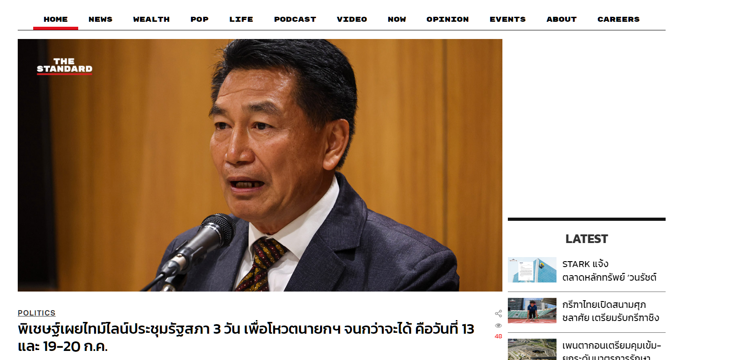

There is the navigation bar underlined the page for the user to see what page are they on right now and the line underneath the text is the same color as the one on the logo this make the website really have the theme and look professional

**2 Typography**

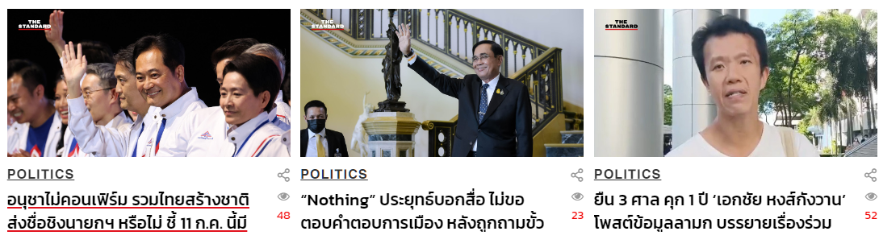

Not too much text on one card content is give user the readability

On each title under the picture user can access the news by clicking on the text this gave user an accessibility

**3 Alignment**

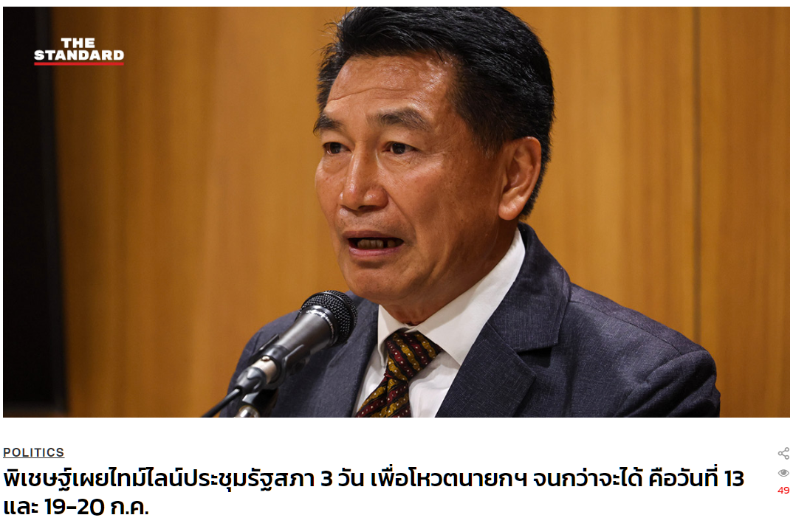

Highlighted content is actually stand out from the rest of the content-

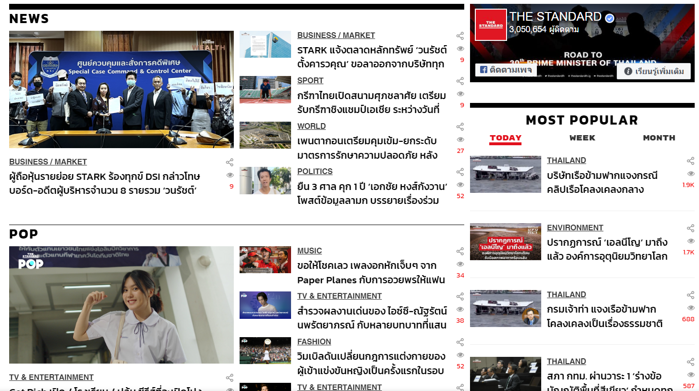

The rest of the contents are separated with lines and the title make them easy to browse for the users