Pavarisa Boonyaritchaikit 643040234-1

**1 color:**

A shopping site or any website that involves transactions should have a reliable color tone such as green,blue or purple. This site doesn’t have their main theme, it may look like the developer were aiming for a colorful rainbow look but they put so much colors in to the site that nothing really stand out also the background of the title shouldn’t be picture with too much details this will make user focus less on the title and the actual content of the page

**2 font:**

Font style 1:

Font style 2:

Font style 3:

Font style 4:

Font style 5:

Font style 6:

Using more than 3 different fonts makes a website look unstructured and unprofessional

And this site has 6 different styles of font.

**3 Item**

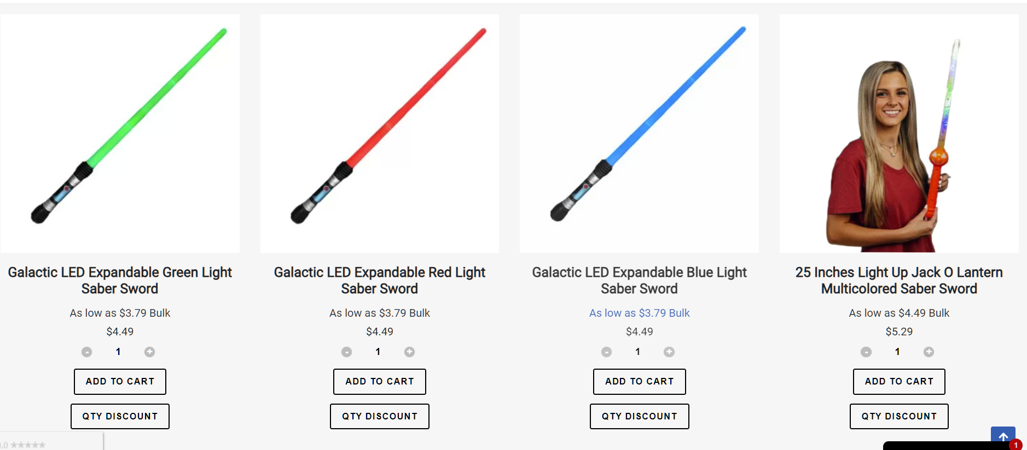

3.1 Not everything should be aligned to the center  
3.2 The ‘ADD TO CART’ button doesn’t stand out enough because there was ‘QTY DISCOUNT’ giving off the same weight as it.

3.3 the price doesn’t stand out because the font color is too light and the font size it too small