COMP 247 Group Project
KSI Fatal Collision Predictor
Part 1 Report — Data Exploration & Data Modelling
Group #8, Section #1
Team: Ali, Aboud, Ibrahim, Aidan

Table of Contents

Executive Summary
To be completed in Part 2, once modelling and evaluation results are final. In short: this project builds a classifier that predicts whether a Toronto traffic collision will result in a fatality, using the Toronto Police KSI (Killed or Seriously Injured) dataset (2006-2023, ~19,000 records).

Overview of Solution
To be expanded in Part 2. Planned approach: clean and encode the KSI dataset, handle class imbalance, train and tune logistic regression, decision tree, SVM, random forest, and neural network classifiers, select the best performer, and deploy it behind a Flask API with a simple front end for inference.

Data Exploration and Findings
Dataset: Toronto Police “Killed or Seriously Injured (KSI)” collision data, 2006–2023, 18,957 records. Downloaded as CSV from the Toronto Police Public Safety Data Portal (data.tps.ca). Field definitions from the accompanying KSI Glossary PDF. Note: the dataset is per-person, not per-collision — the same ACCNUM repeats for every person involved in a crash.
Target column: ACCLASS. Real values found in the data: Fatal, Non-Fatal Injury, Property Damage O (truncated “Property Damage Only”), and blank. Blank rows (no usable label) were dropped, leaving 18,956 labeled records. Binary target defined as 1 = Fatal, 0 = everything else. Overall fatal rate: 14.09%.

Group 1 — Location & Conditions (Aboud)
[PLACEHOLDER — pending] Columns: STREET1, STREET2, ROAD_CLASS, DISTRICT, LATITUDE, LONGITUDE, ACCLOC, TRAFFCTL, VISIBILITY, LIGHT, RDSFCOND, DIVISION, NEIGHBOURHOOD_158, HOOD_158, DATE, TIME. To include: column descriptions/types, missing data %, distributions, and relationship to ACCLASS.

Group 2 — People & Vehicles Involved (Ibrahim)
[PLACEHOLDER — pending] Columns: INVTYPE, INVAGE, INJURY, FATAL_NO, INITDIR, VEHTYPE, MANOEUVER, DRIVACT, DRIVCOND, PEDTYPE, PEDACT, PEDCOND, CYCLISTYPE, CYCACT, CYCCOND. To include: column descriptions/types, missing data %, distributions, and relationship to ACCLASS.

Group 3 — Collision-Type Flags (13 Yes/No columns)
Columns: PEDESTRIAN, CYCLIST, AUTOMOBILE, MOTORCYCLE, TRUCK, TRSN_CITY_VEH, EMERG_VEH, PASSENGER, SPEEDING, AG_DRIV, REDLIGHT, ALCOHOL, DISABILITY. Each column is “Yes” if that factor applied to the collision, blank otherwise — per the glossary, blank means “No,” not missing data. All 13 columns had 0% true missing values.
Flag | % of records = Yes | Fatal rate if Yes | Fatal rate if No
TRUCK | 6.17% | 29.17% | 13.09%
SPEEDING | 14.21% | 21.80% | 12.81%
TRSN_CITY_VEH | 6.06% | 20.56% | 13.67%
ALCOHOL | 4.26% | 18.81% | 13.87%
PEDESTRIAN | 40.56% | 18.26% | 11.24%
PASSENGER | 37.89% | 13.91% | 14.19%
MOTORCYCLE | 8.88% | 13.48% | 14.14%
REDLIGHT | 8.32% | 13.38% | 14.15%
AUTOMOBILE | 90.89% | 13.26% | 22.29%
AG_DRIV | 51.88% | 12.98% | 15.27%
DISABILITY | 2.60% | 12.60% | 14.12%
CYCLIST | 10.48% | 6.45% | 14.98%
EMERG_VEH | 0.26% | 4.08% | 14.11%

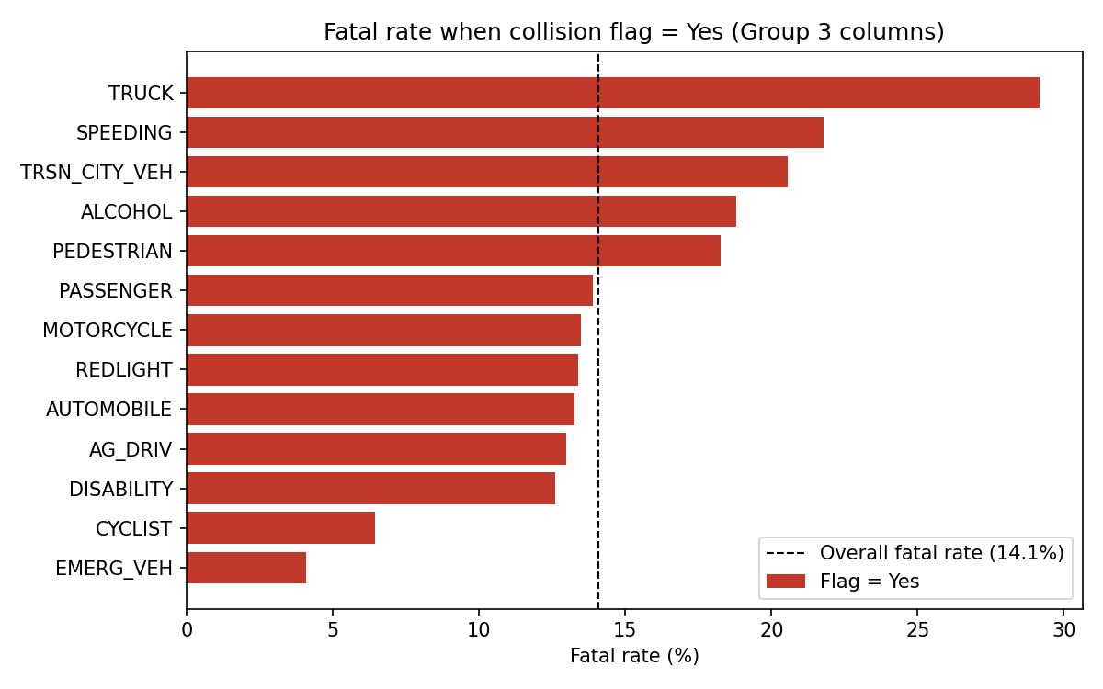

Findings: Collisions involving a truck, speeding, a transit/city vehicle, or alcohol show a noticeably higher fatal rate than the 14.09% baseline (truck collisions are more than double). Pedestrian involvement also raises the fatal rate. Cyclist and emergency-vehicle involvement show a lower fatal rate than baseline in this single-variable view — likely reflecting lower speeds or more cautious circumstances rather than cycling being inherently safer; this needs further investigation once other variables are controlled for. AUTOMOBILE is Yes for 91% of records, so its “fatal rate if No” (22.29%) is based on a small, atypical subset and should be read cautiously. These are single-variable comparisons — real feature-importance analysis happens during model building (Part 2).

Feature Selection
Dropped as identifiers or redundant, no predictive value: INDEX, ACCNUM, OBJECTID (record/event identifiers), OFFSET (location-precision detail with no standalone meaning), HOOD_140 and NEIGHBOURHOOD_140 (older duplicates of HOOD_158 / NEIGHBOURHOOD_158), and x / y (projected duplicates of LATITUDE / LONGITUDE).
Kept, pending final confirmation once Groups 1 and 2 report missing-data percentages and cardinality: all remaining columns, grouped as listed under Data Exploration above. Group 3's 13 flag columns are confirmed low-cardinality (Yes/blank) and clean — safe to one-hot encoded as-is.

Data Modelling
Cleaning strategy: rows with a blank ACCLASS (no usable label) were dropped. Identifier and redundant columns (see Feature Selection) were dropped before encoding.
Data wrangling / pipeline: built with scikit-learn's Pipeline and ColumnTransformer. Categorical columns are imputed with the most frequent value and one-hot encoded; numeric columns (LATITUDE, LONGITUDE) are median-imputed and standard-scaled. Train/test split: 80/20, stratified on the target to preserve the fatal/non-fatal ratio in both sets.
Class imbalance: the fatal class is roughly 14% of records — a real but moderate imbalance. Planned handling for Part 2: try class_weight=’balanced’ on the classifier first (simplest option); fall back to SMOTE (imbalanced-learn) if recall on the fatal class isn’t high enough.
Assumptions and constraints: (1) Property Damage Only and Non-Fatal Injury rows are both treated as the negative (non-fatal) class — to be re-confirmed as a group. (2) Location fields are deliberately offset to the nearest intersection for privacy, so exact-address-level analysis isn't possible. (3) The dataset is per-person, not per-collision, so collision-level statistics must account for repeated ACCNUM values. (4) The assignment document references 2006–2020 coverage; the portal now serves 2006–2023 (dataset updated since the assignment was written).

Next Steps (Part 2)
- Incorporate Group 1 and Group 2 exploration findings; finalize column list
- Build and tune logistic regression, decision tree, SVM, random forest, and neural network models
- Score and compare models (accuracy, precision, recall, F1, ROC curves); select best model
- Deploy the selected model as a Flask API; build a front end / test client
- Write full report (executive summary, solution overview) and prepare presentation

