GRAPHICAL APPENDIX
Full Visual Dataset for the CCSI Research Paper

"Cultural Cohesion and Social Inclusivity Index (CCSI): A Data-Driven Study of India's Civilizational Patterns"
Author: Tejas Pradip Pawar
This appendix contains all 17 research figures used during analysis. Due to IEEE page-limit constraints, only 3 visualizations were placed in the main paper. This appendix provides the complete dataset-driven graphical evidence, including historical CCSI timelines, dimensional heatmaps, and ML-based clustering diagnostics.

🔹 SECTION A — CCSI Time Series (Historical)
1️⃣ CCSI over Time – All Regions
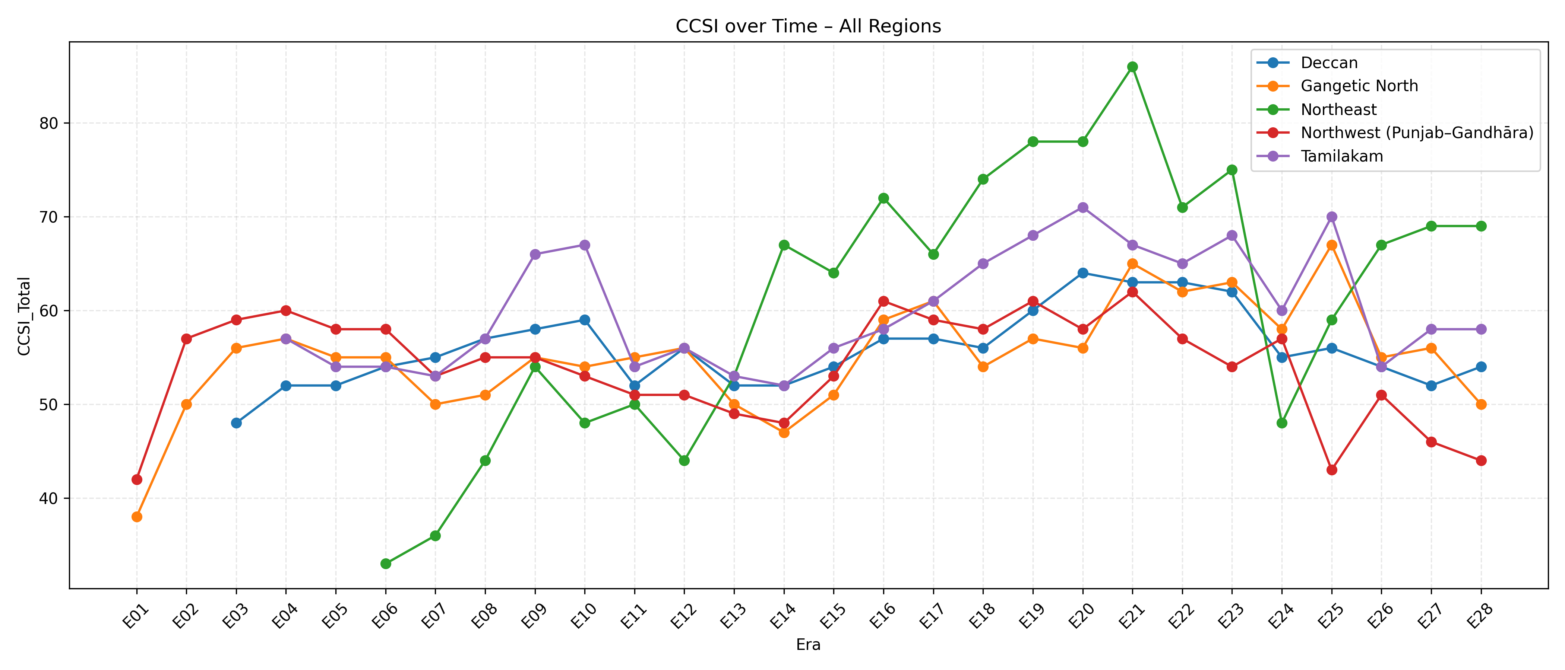
2️⃣ 3-Era Rolling Mean of CCSI – All Regions
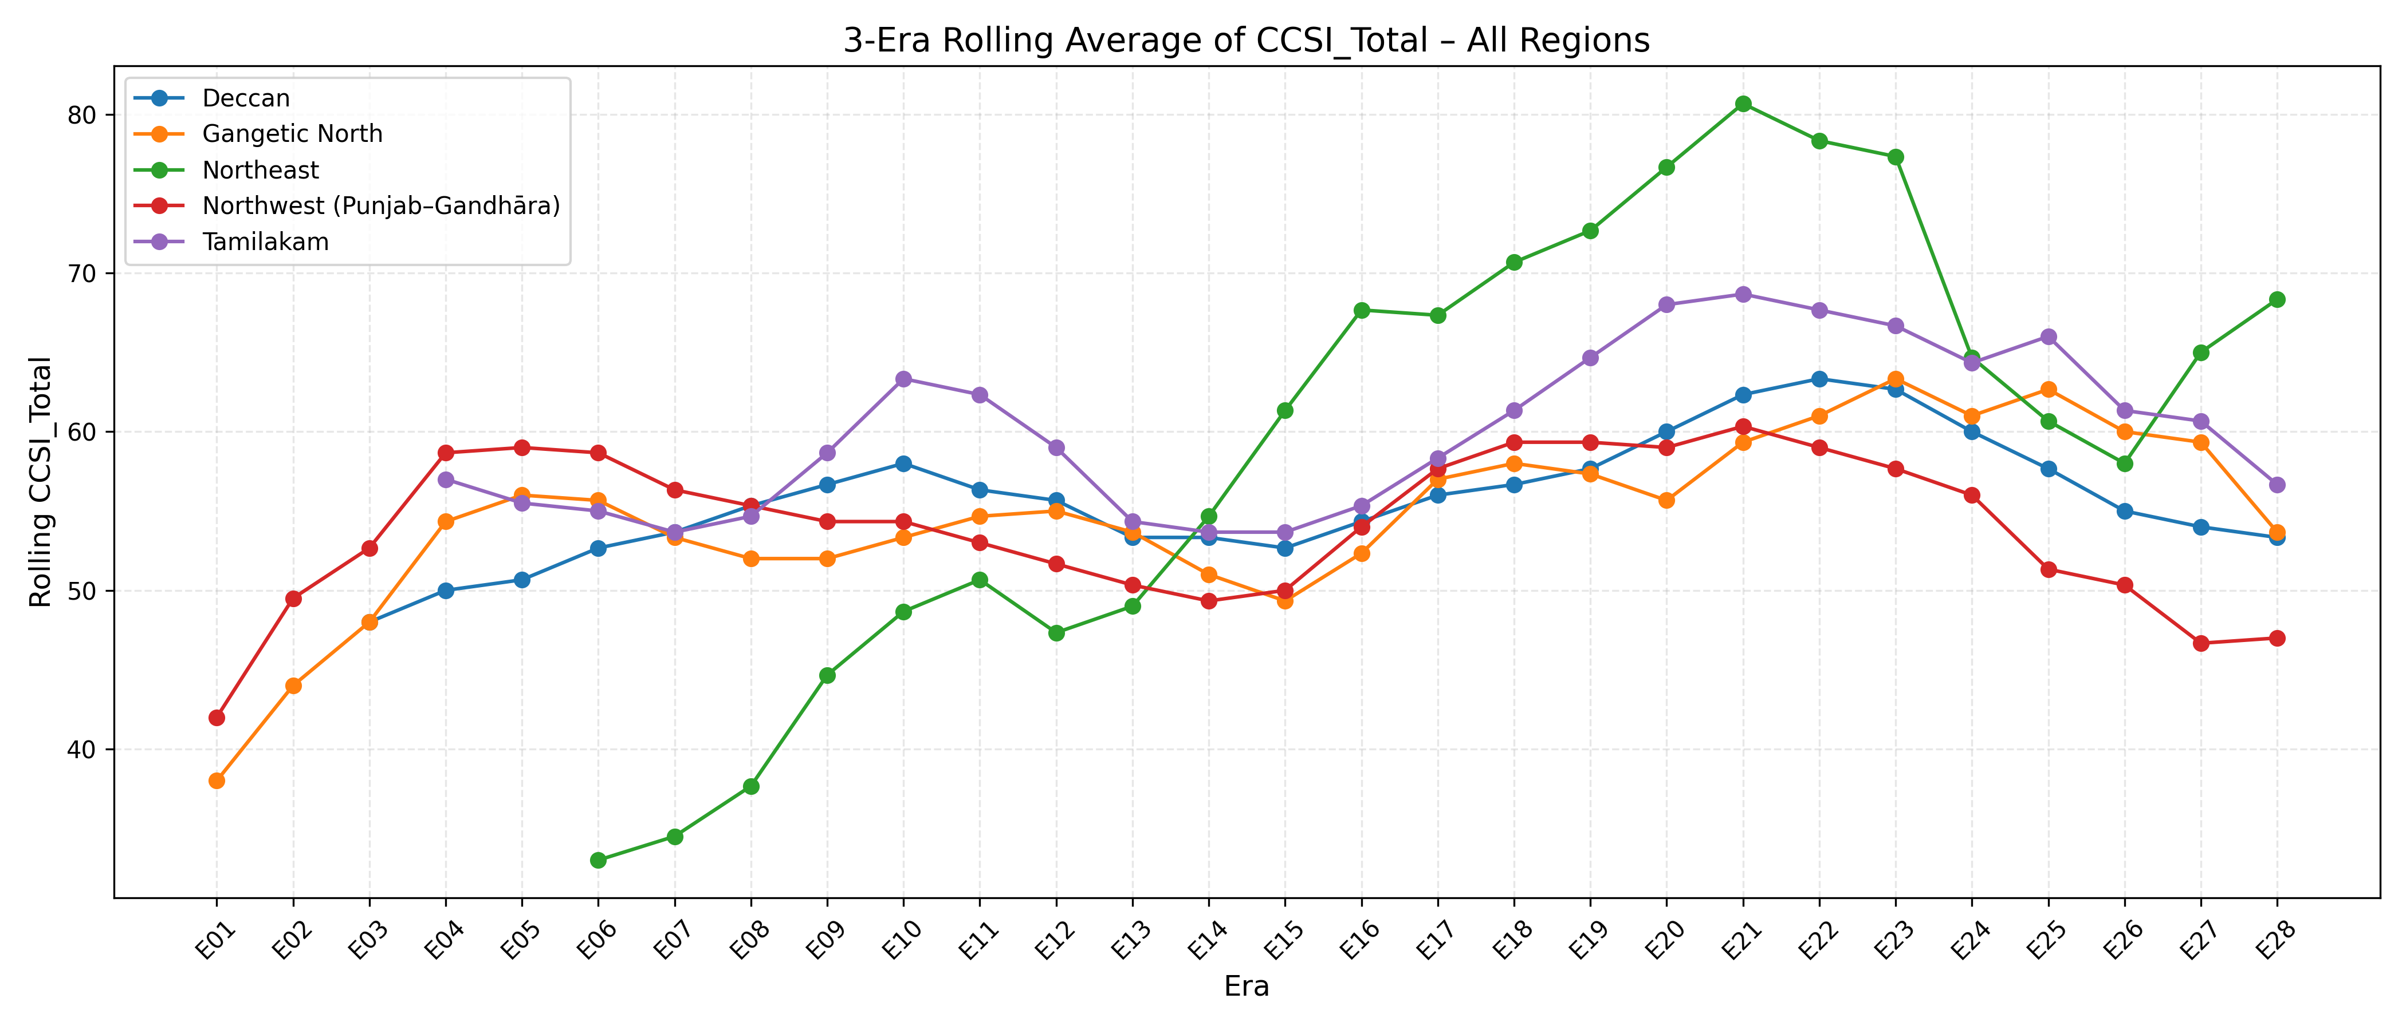
3️⃣ CCSI Evolution – Unified Timeline Plot
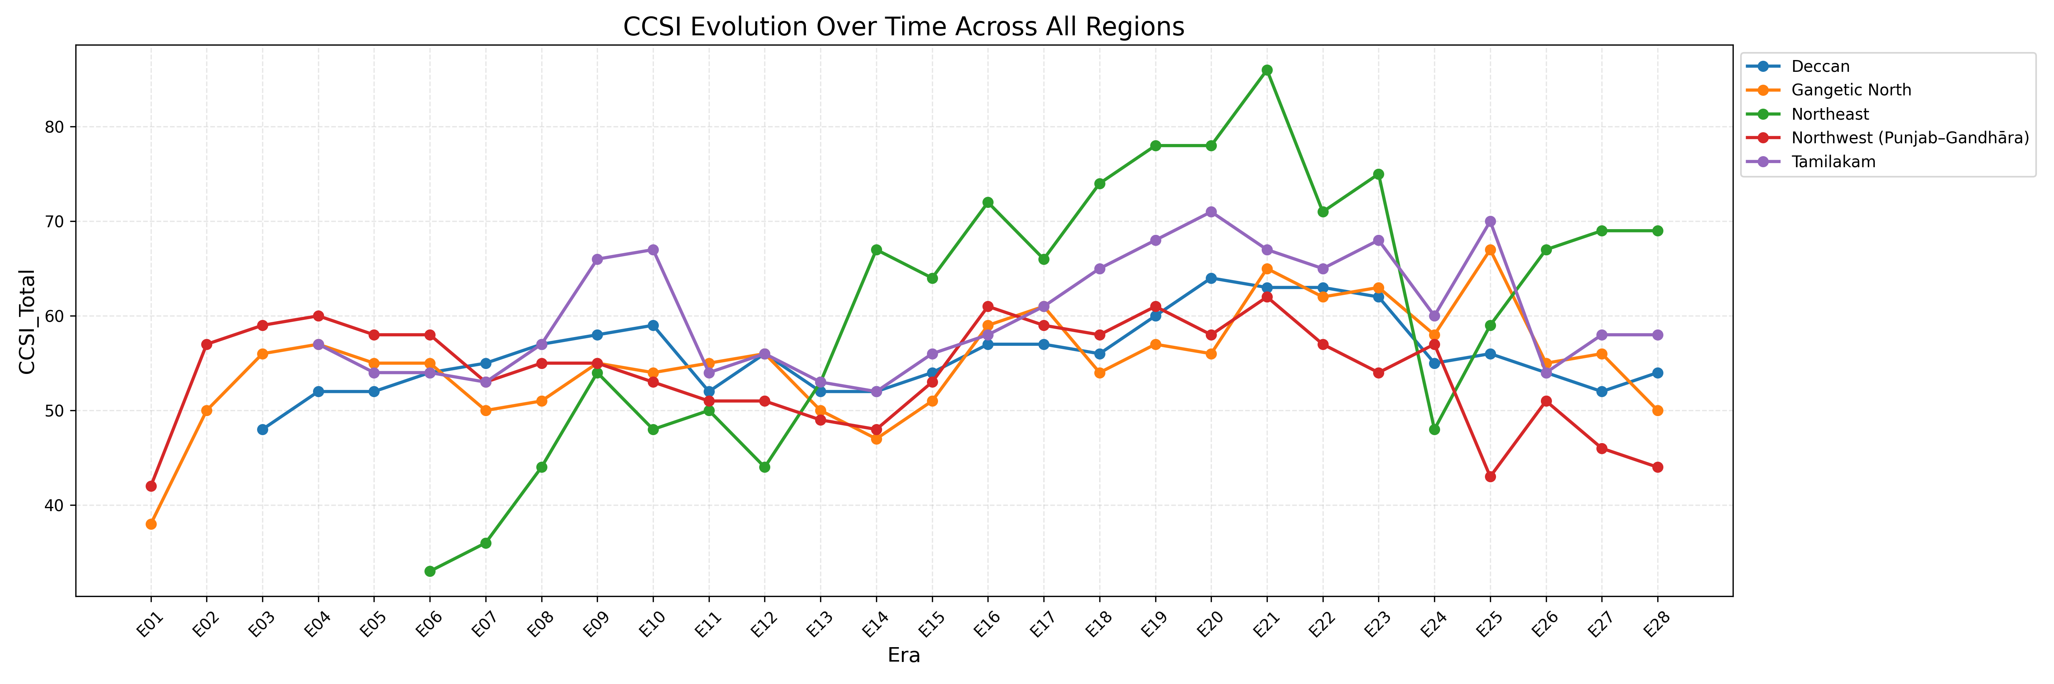

🔹 SECTION B — Region-Specific CCSI Curves
4️⃣ CCSI over Time – Deccan
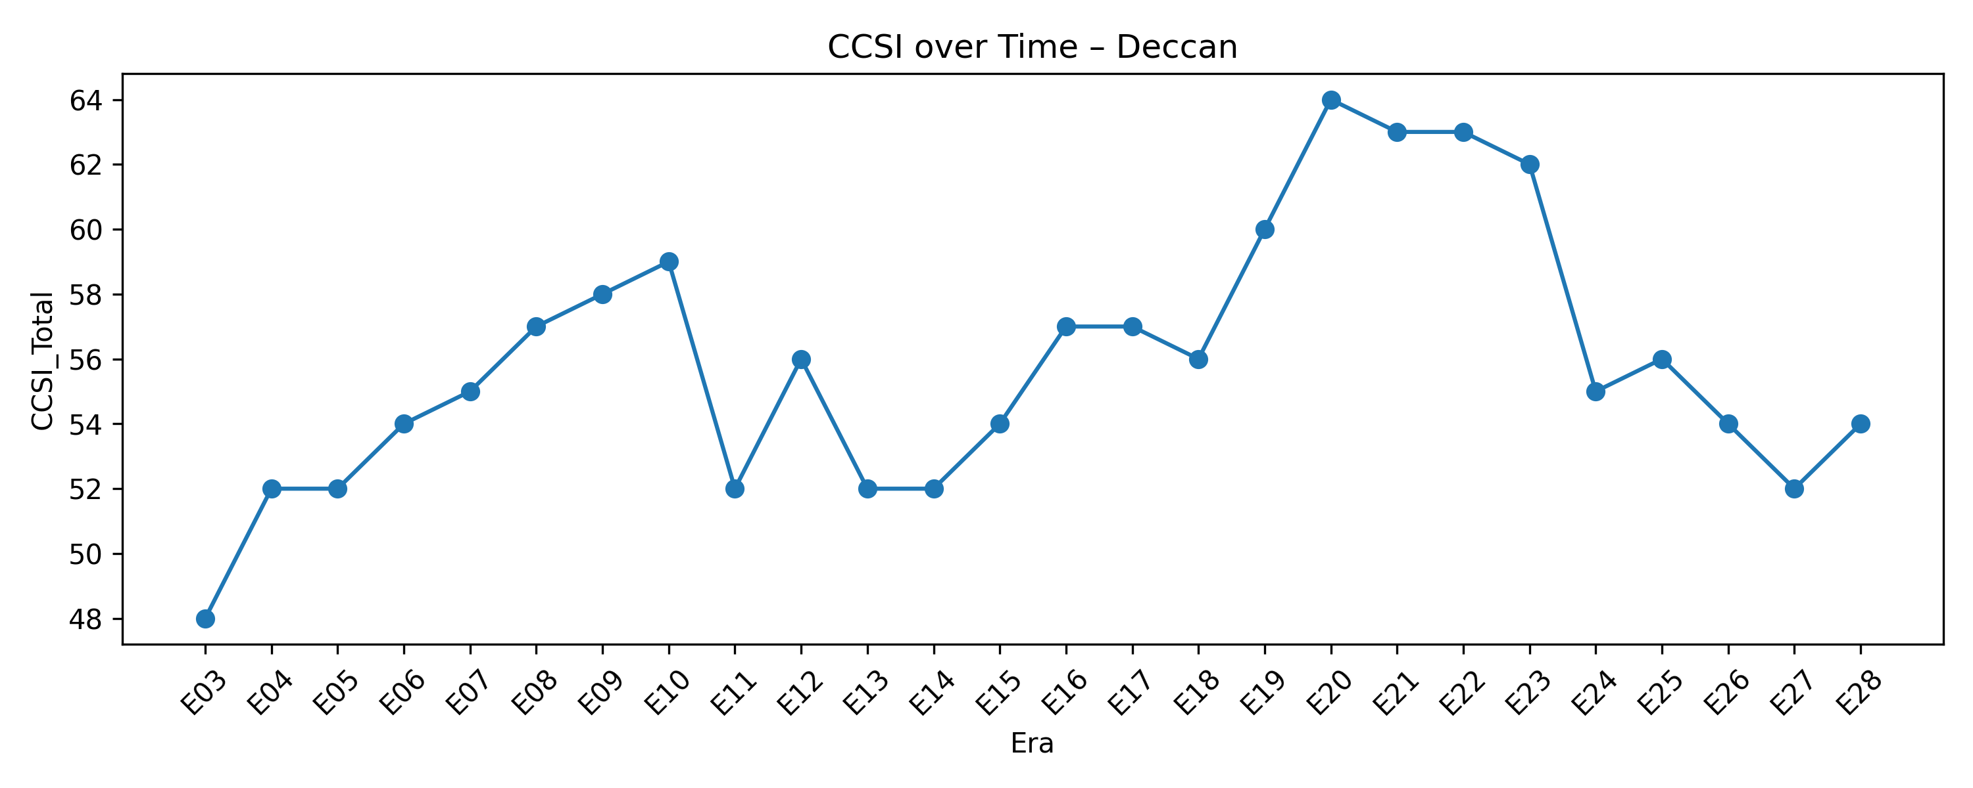
5️⃣ CCSI over Time – Gangetic North
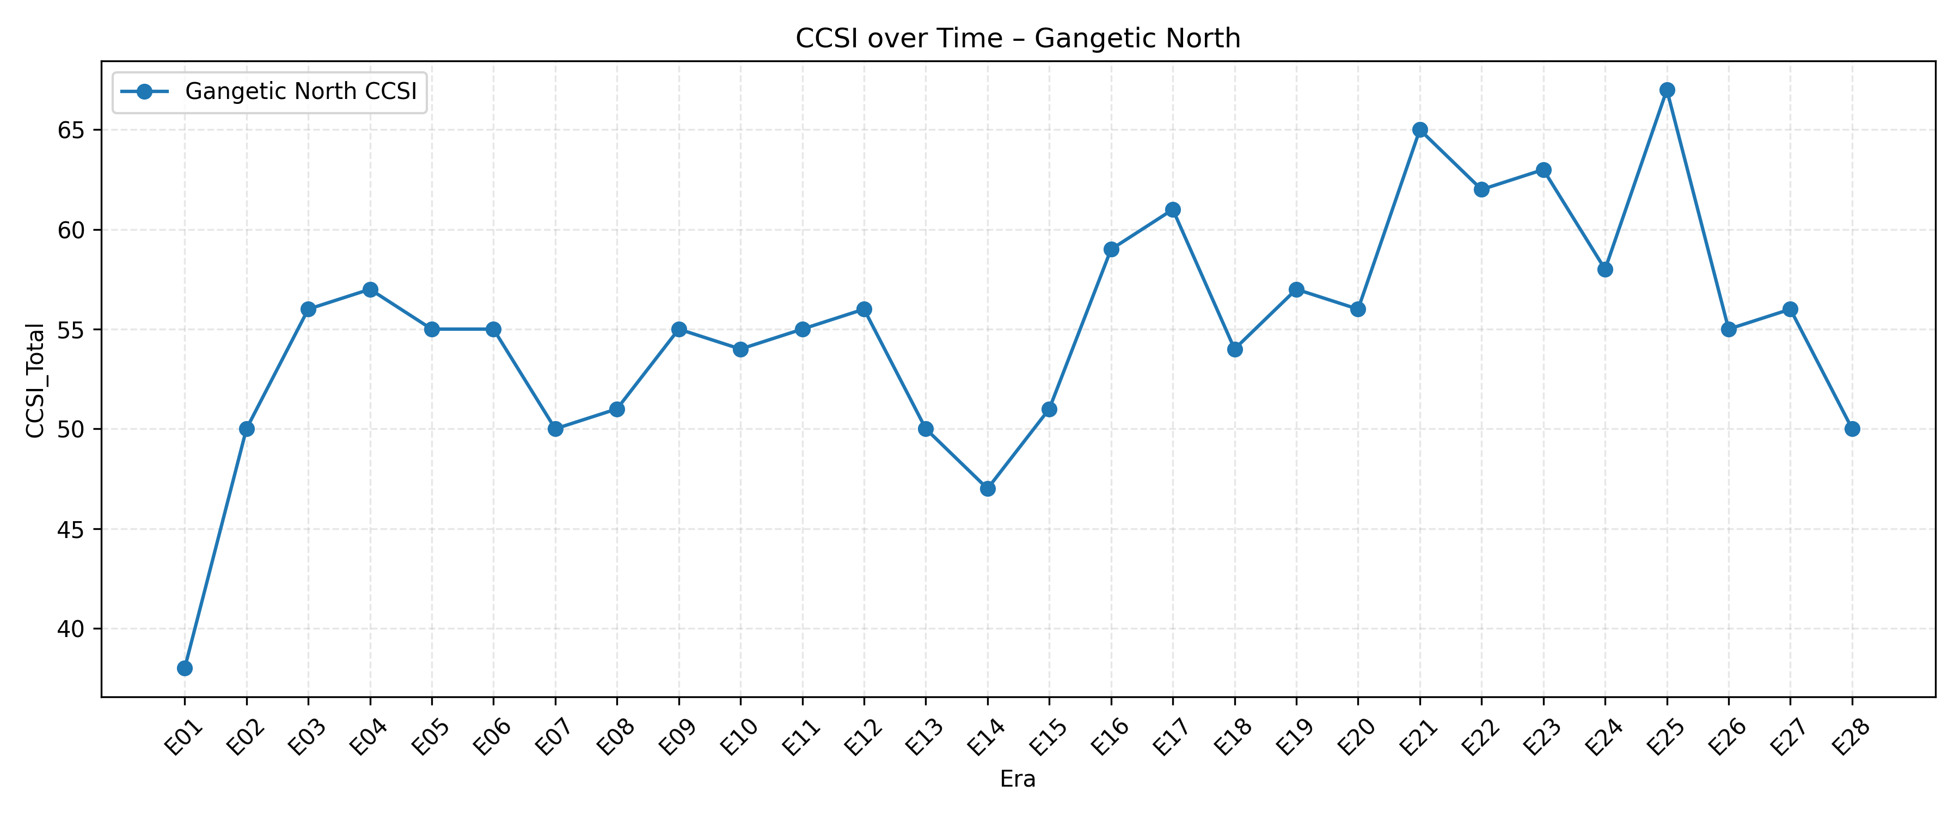
6️⃣ CCSI over Time – Northeast
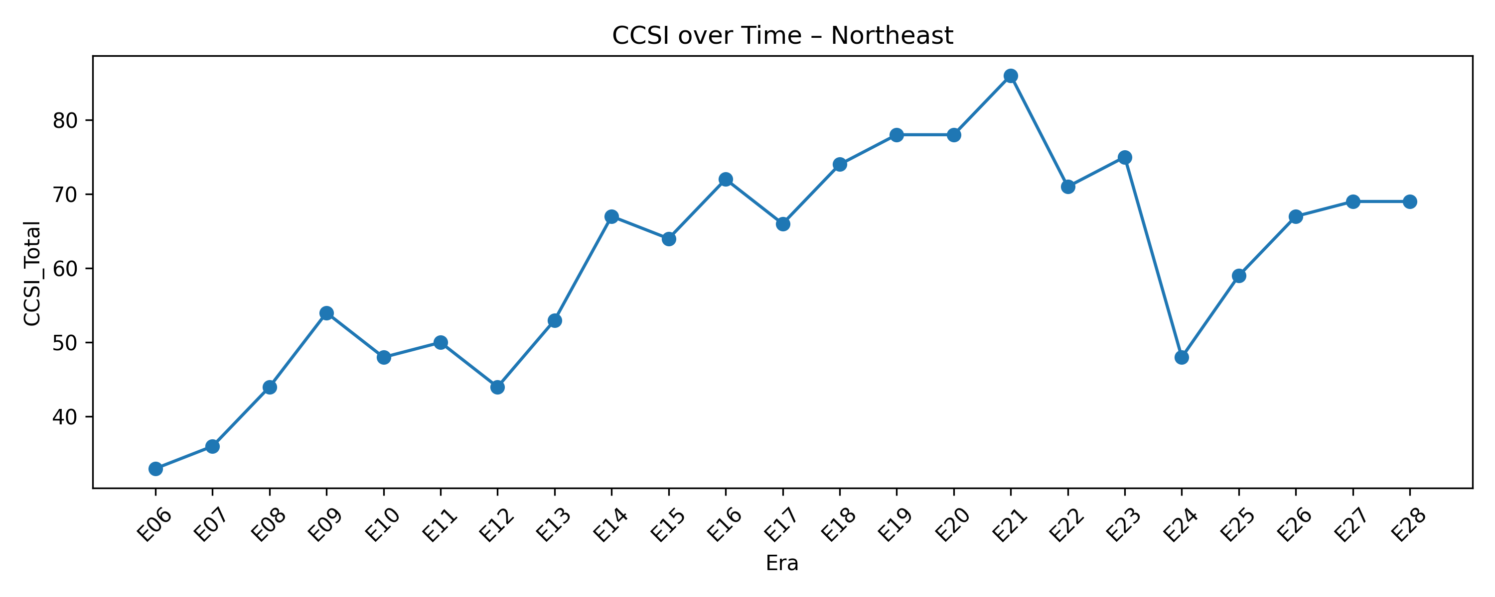
7️⃣ CCSI over Time – Northwest (Punjab–Gandhāra)
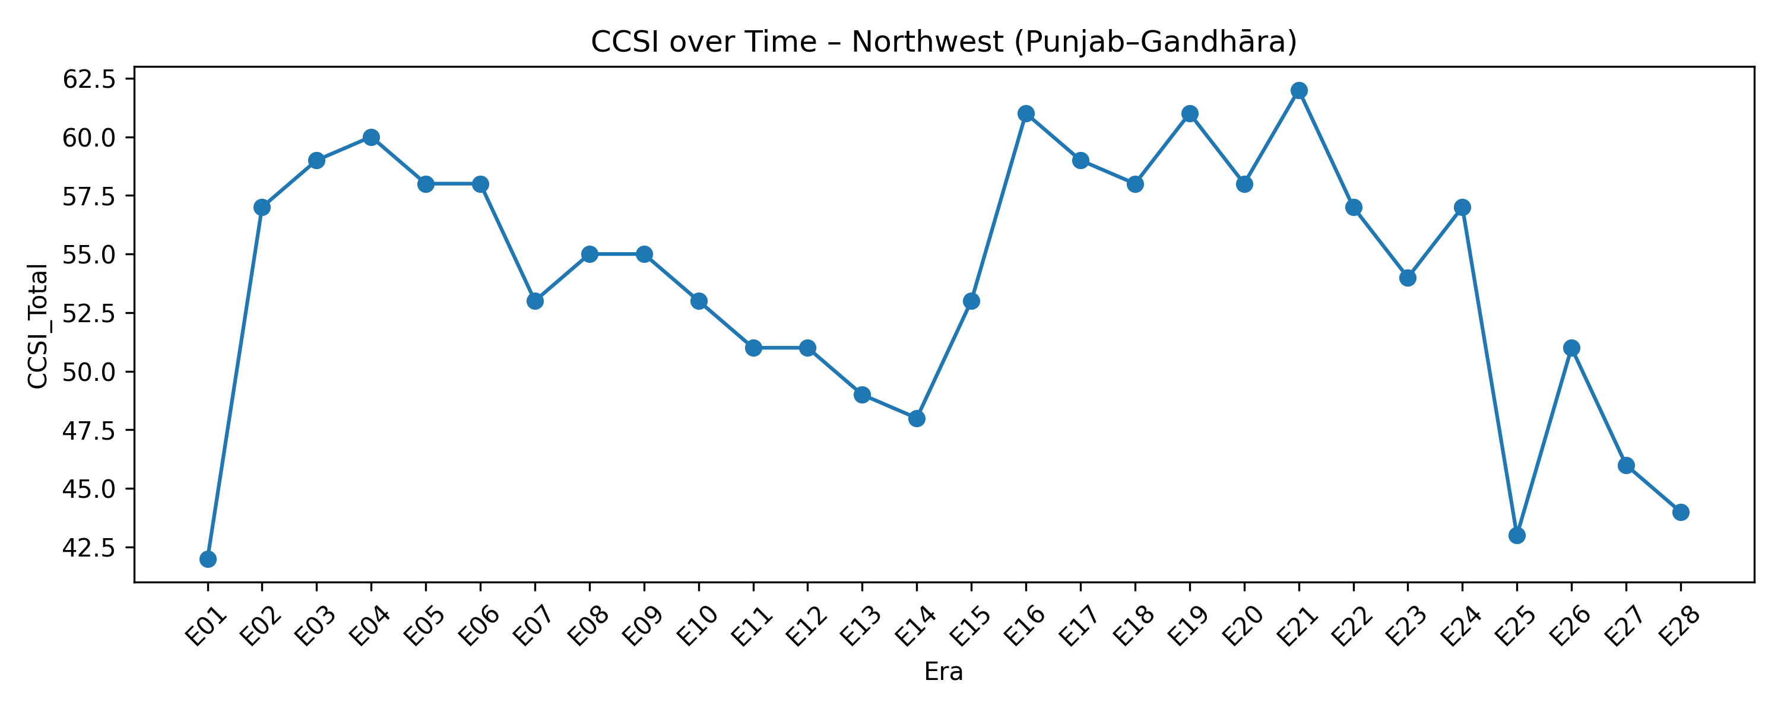
8️⃣ CCSI over Time – Tamilakam
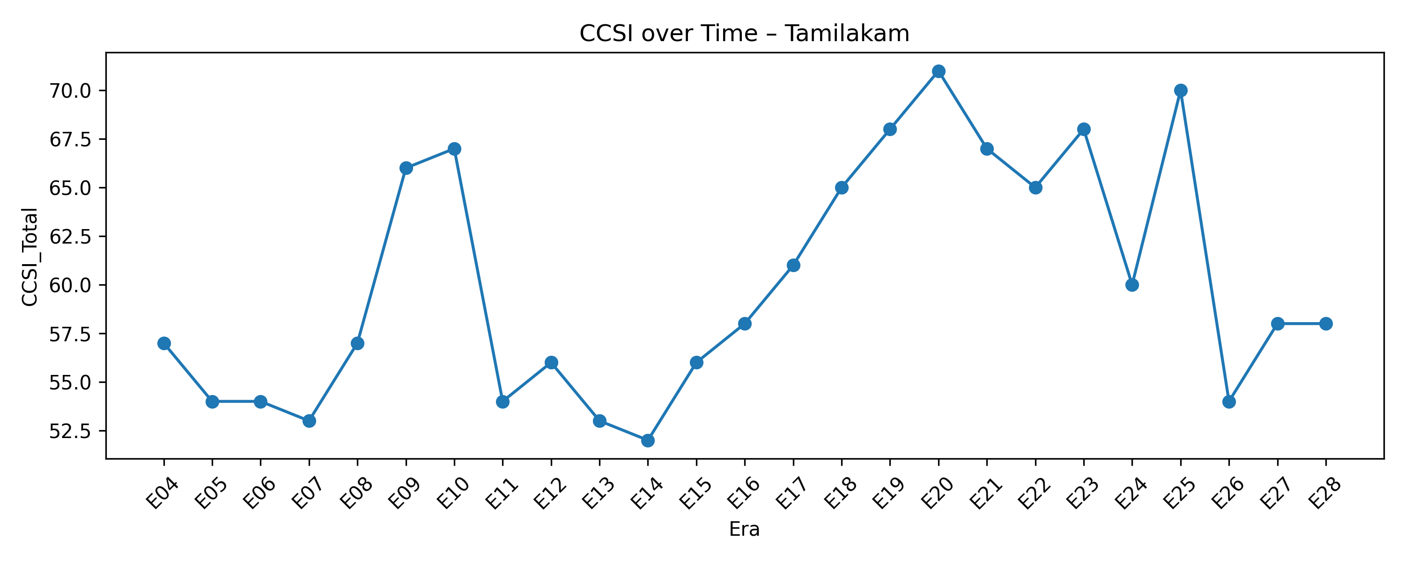

🔹 SECTION C — D1–D5 Dimension Heatmaps
9️⃣ D1-D5 Dimensional Heatmap – Deccan
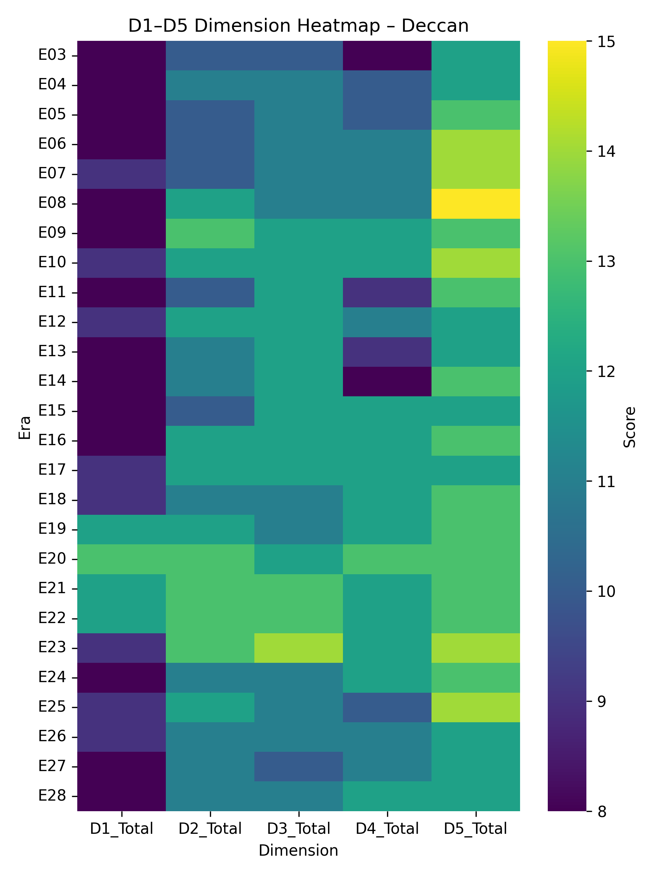
🔟 D1-D5 Dimensional Heatmap – Gangetic North
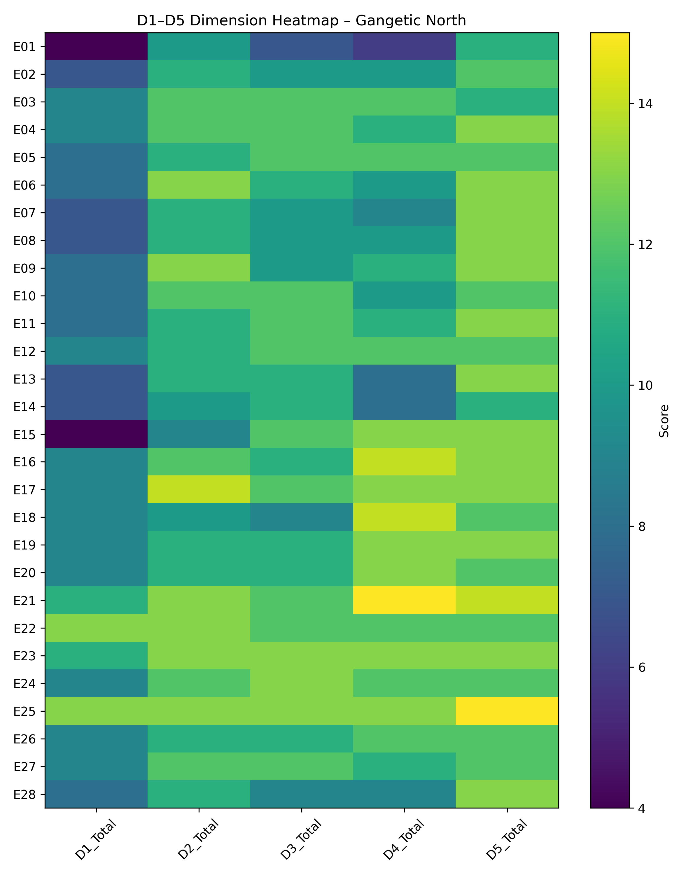
1️⃣1️⃣ D1-D5 Dimensional Heatmap – Northeast
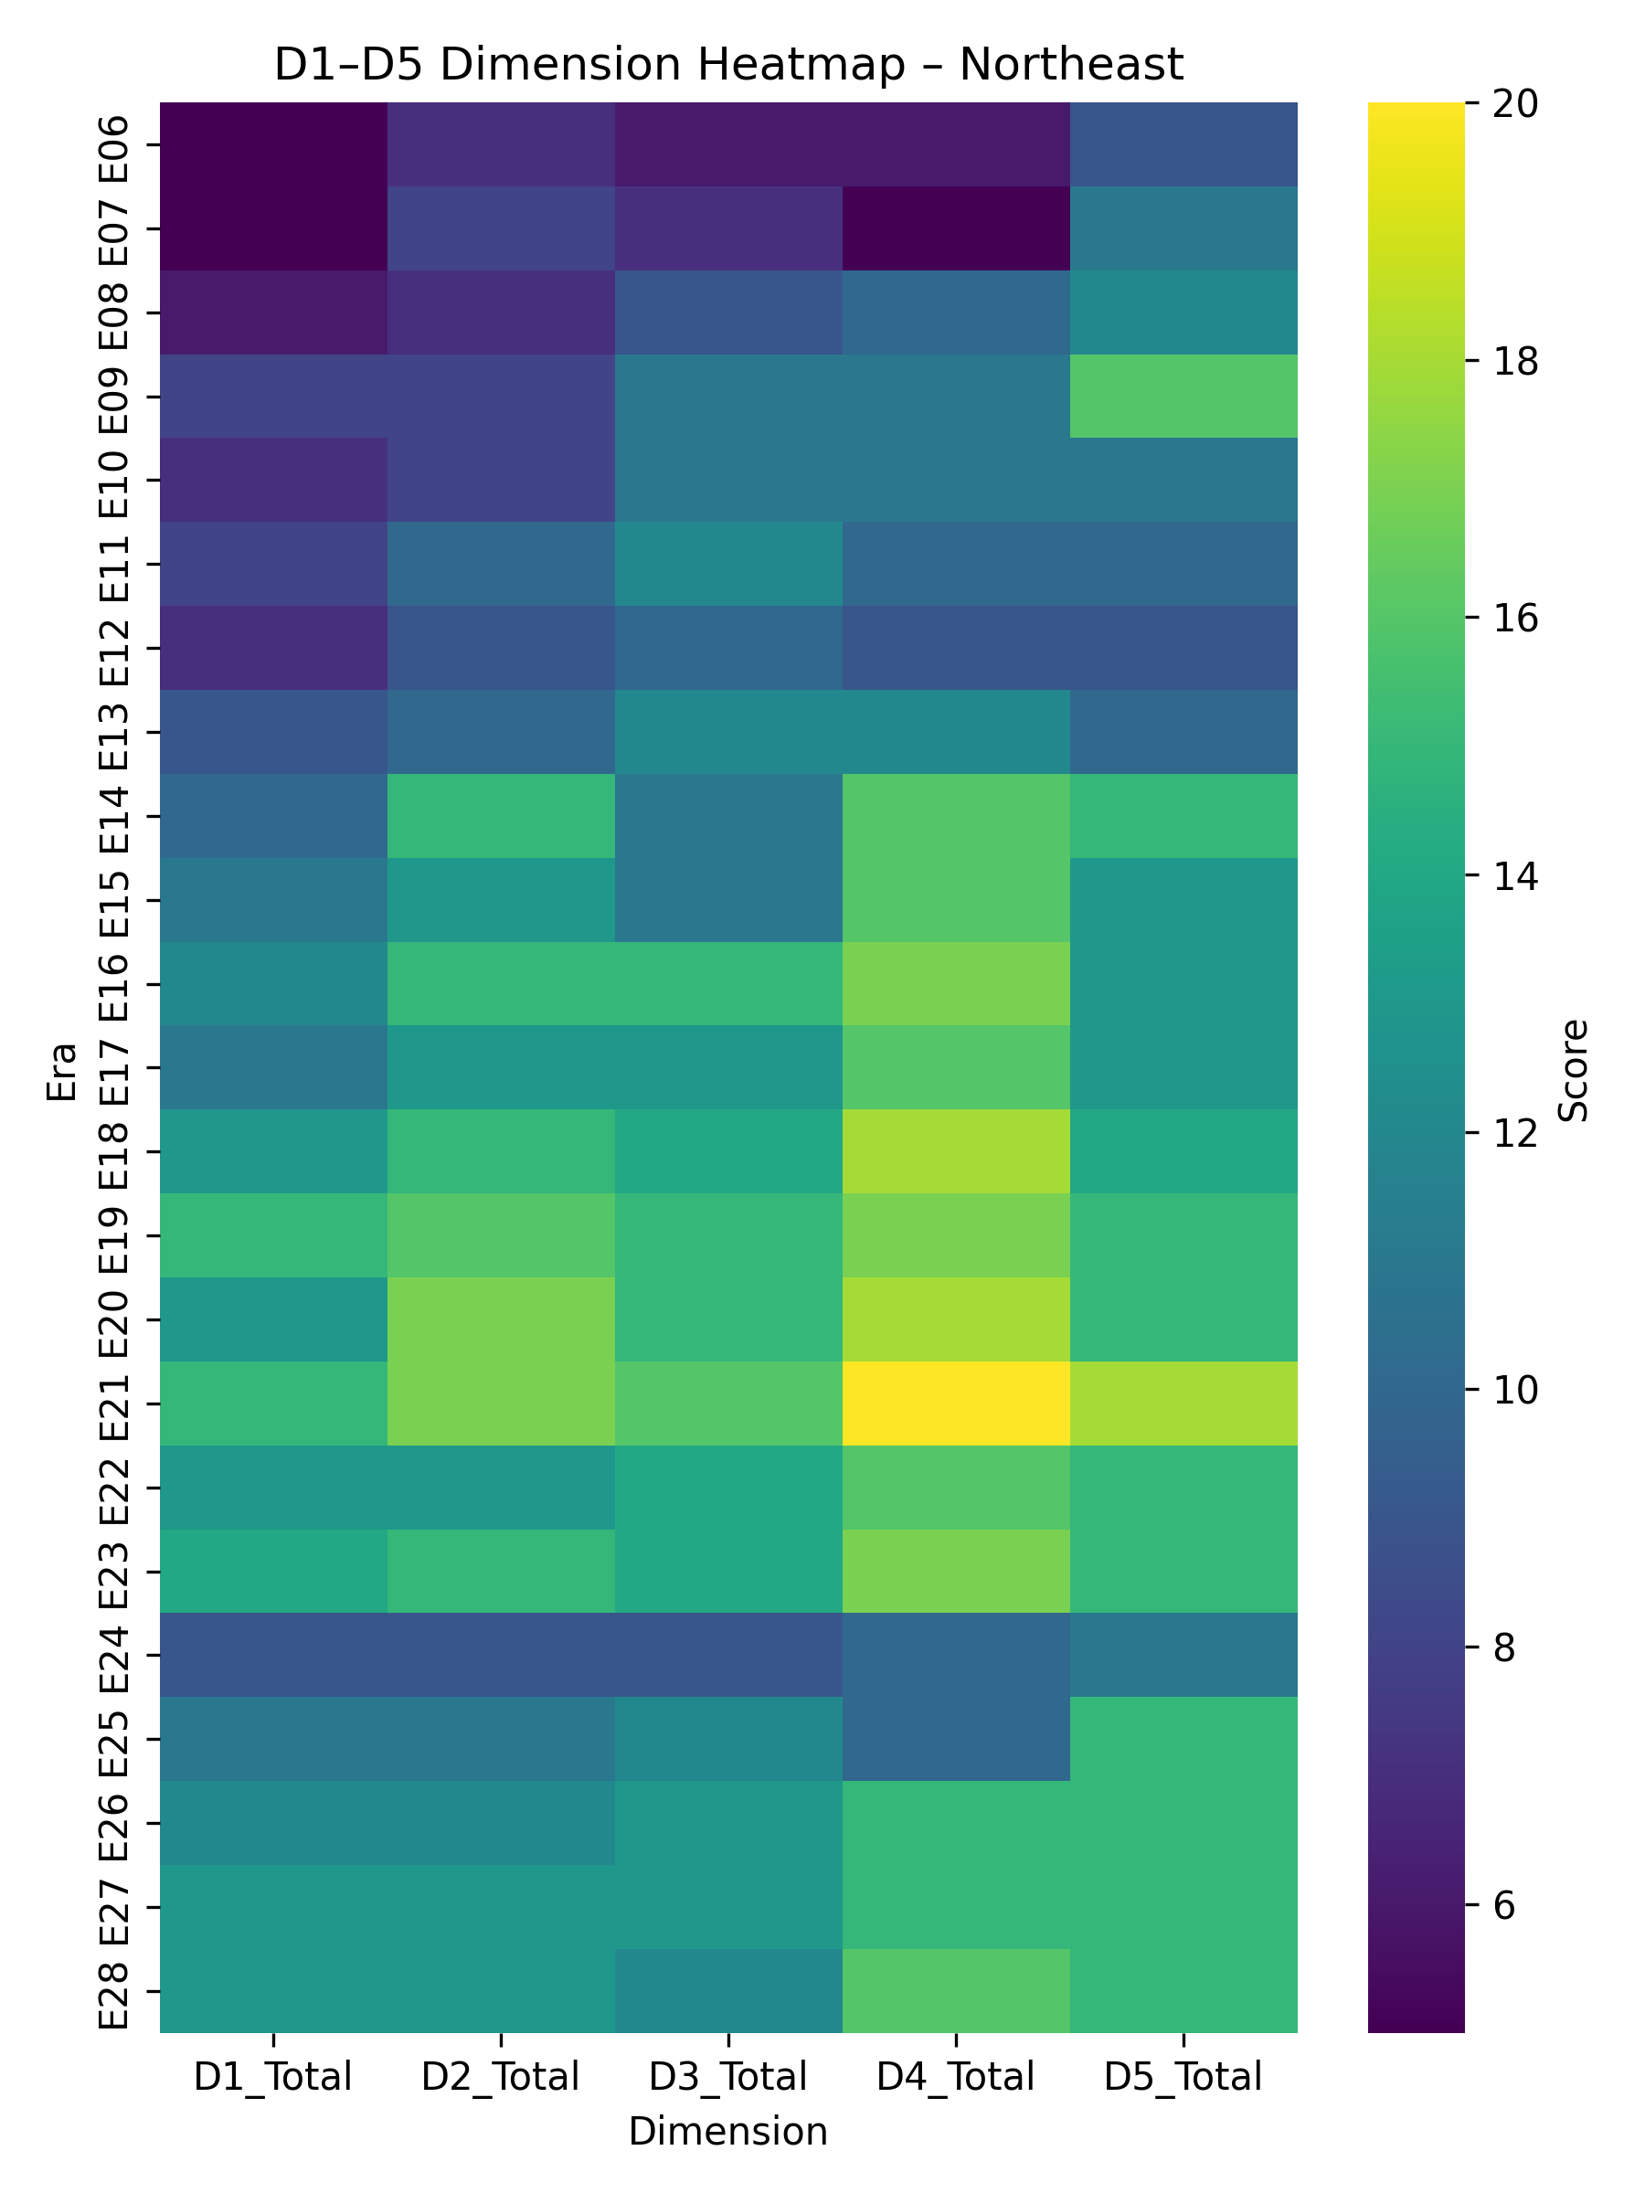
1️⃣2️⃣ D1-D5 Dimensional Heatmap – Northwest (Punjab–Gandhāra)
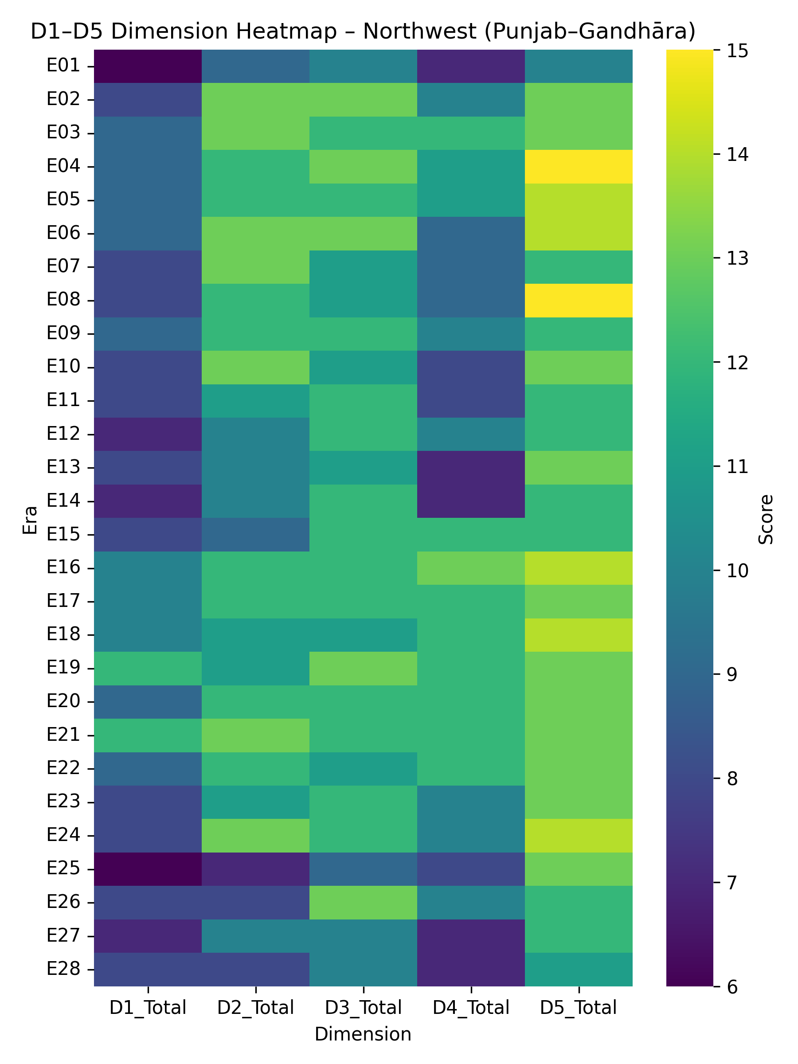
1️⃣3️⃣ D1-D5 Dimensional Heatmap – Tamilakam
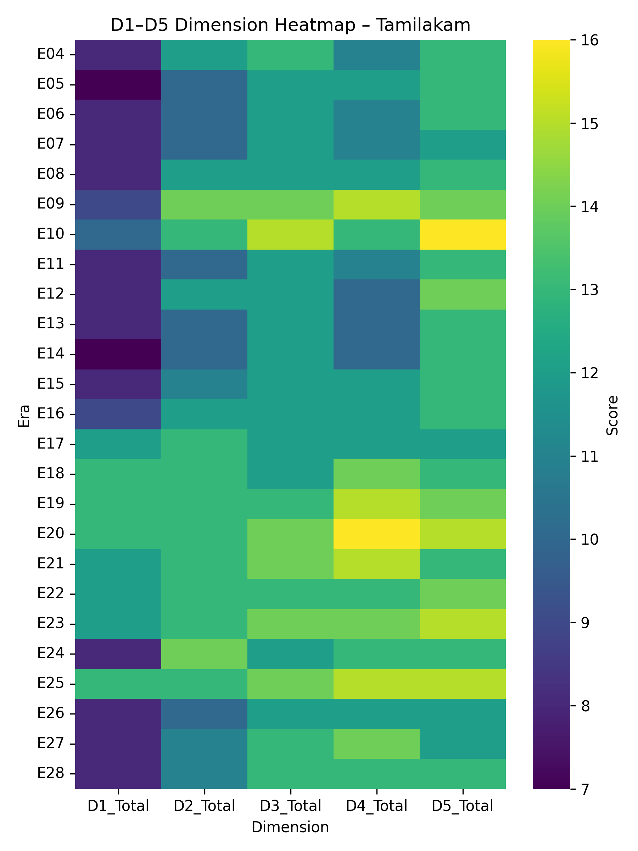

🔹 SECTION D — Machine Learning Outputs
1️⃣4️⃣ K-Means Clusters (k=4) on PCA Components (D1–D5 totals)
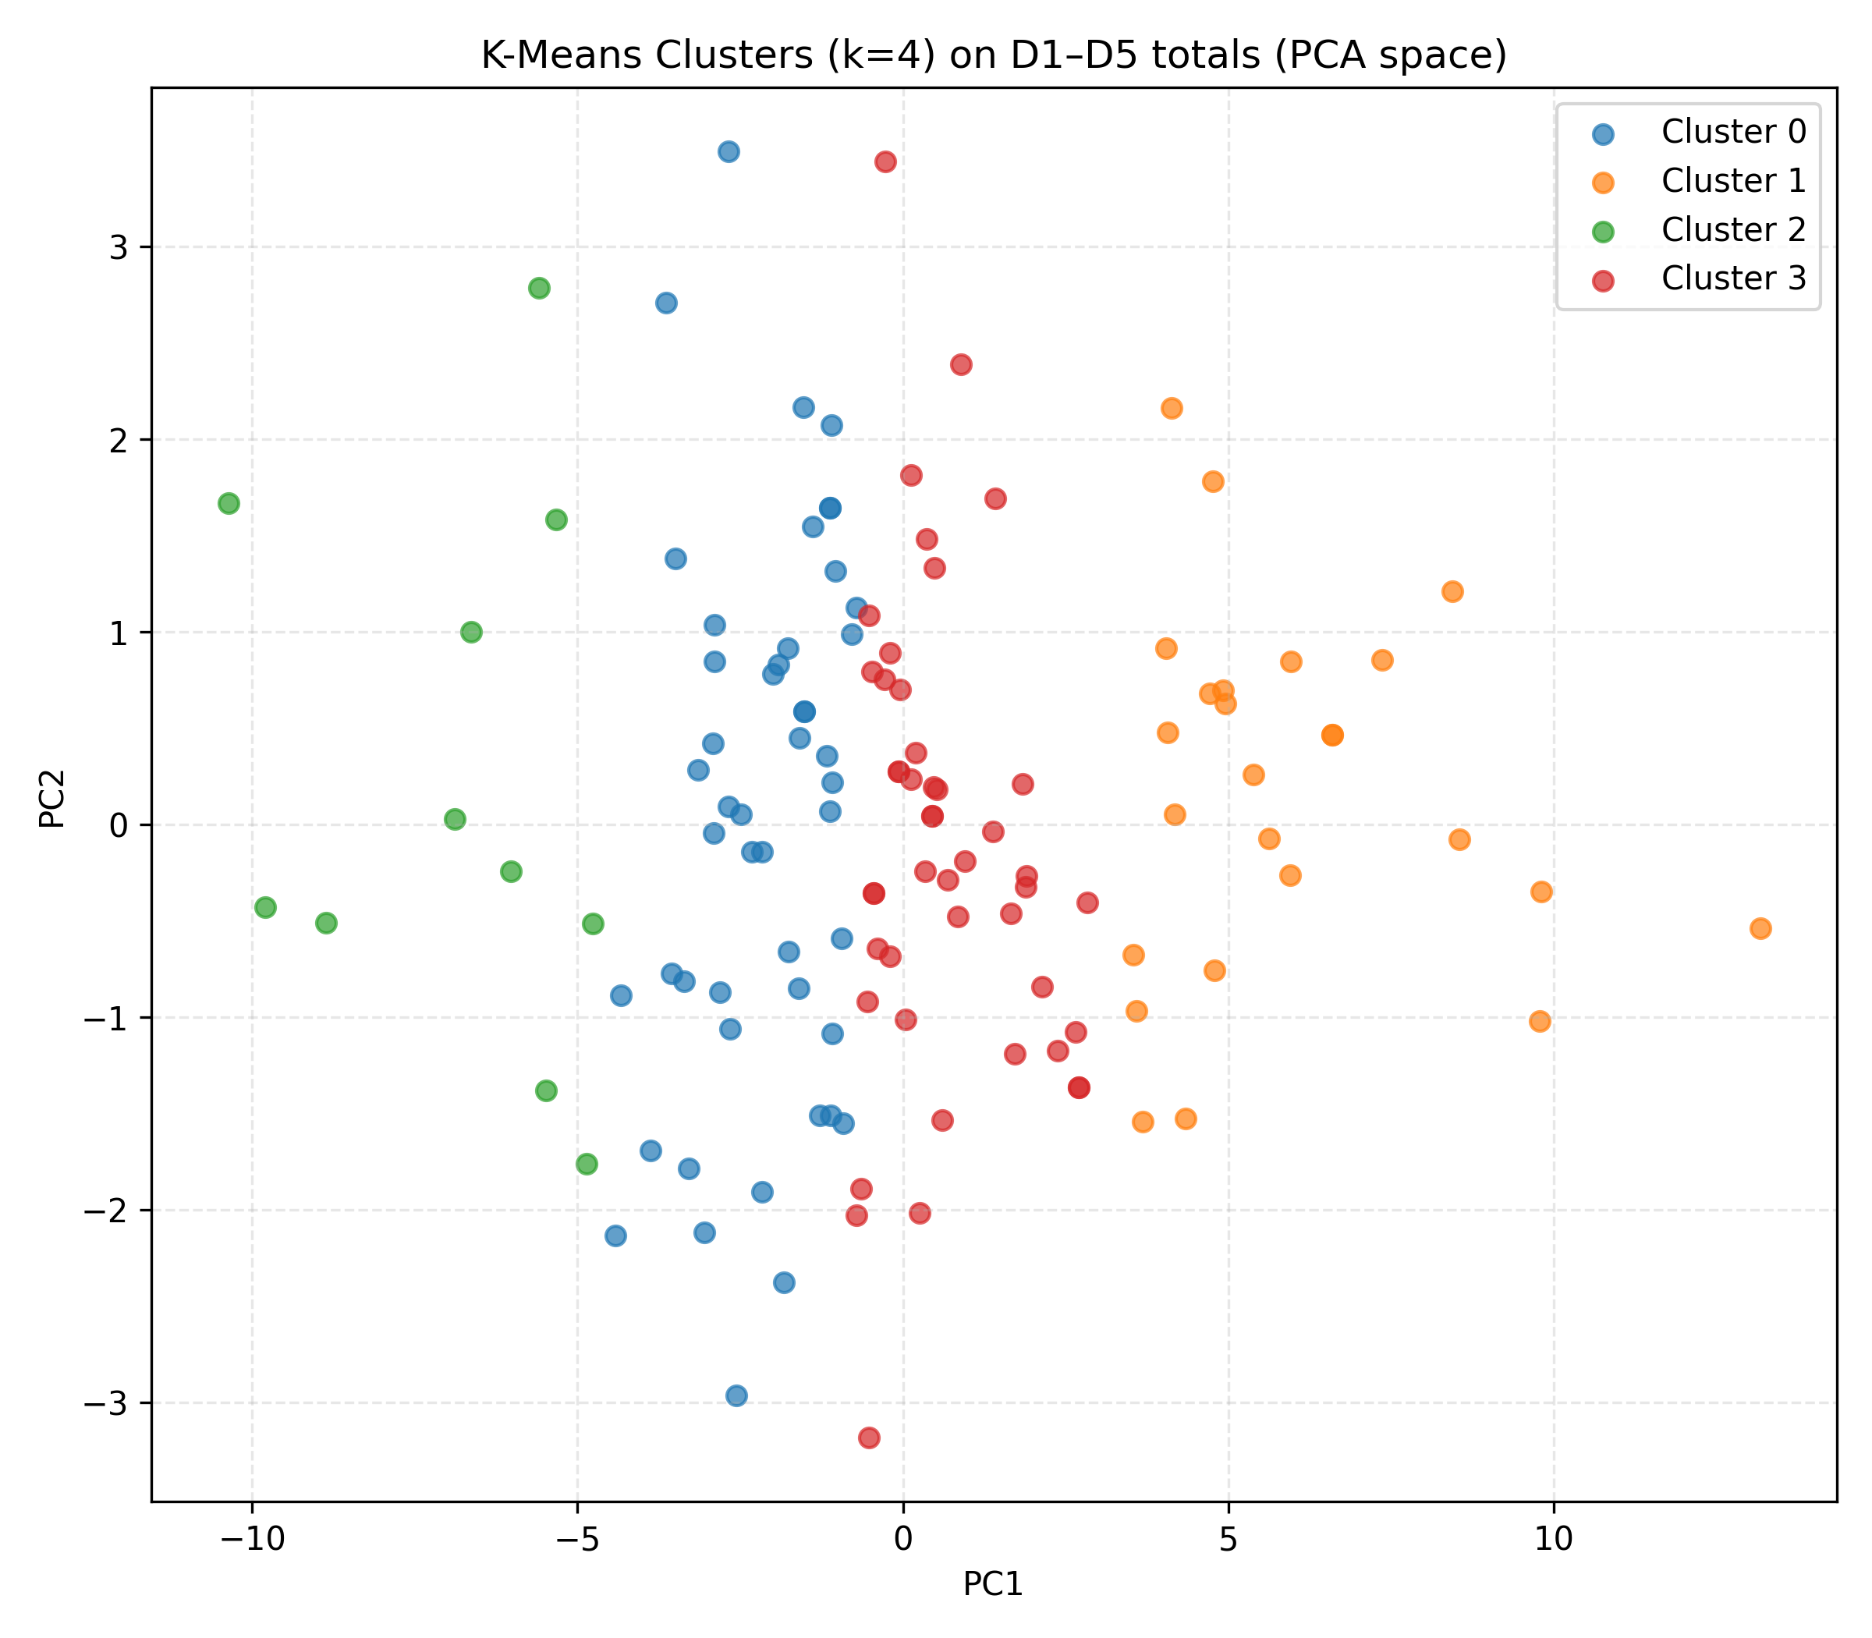
1️⃣5️⃣ PCA of D1–D5 Totals – All Eras & Regions
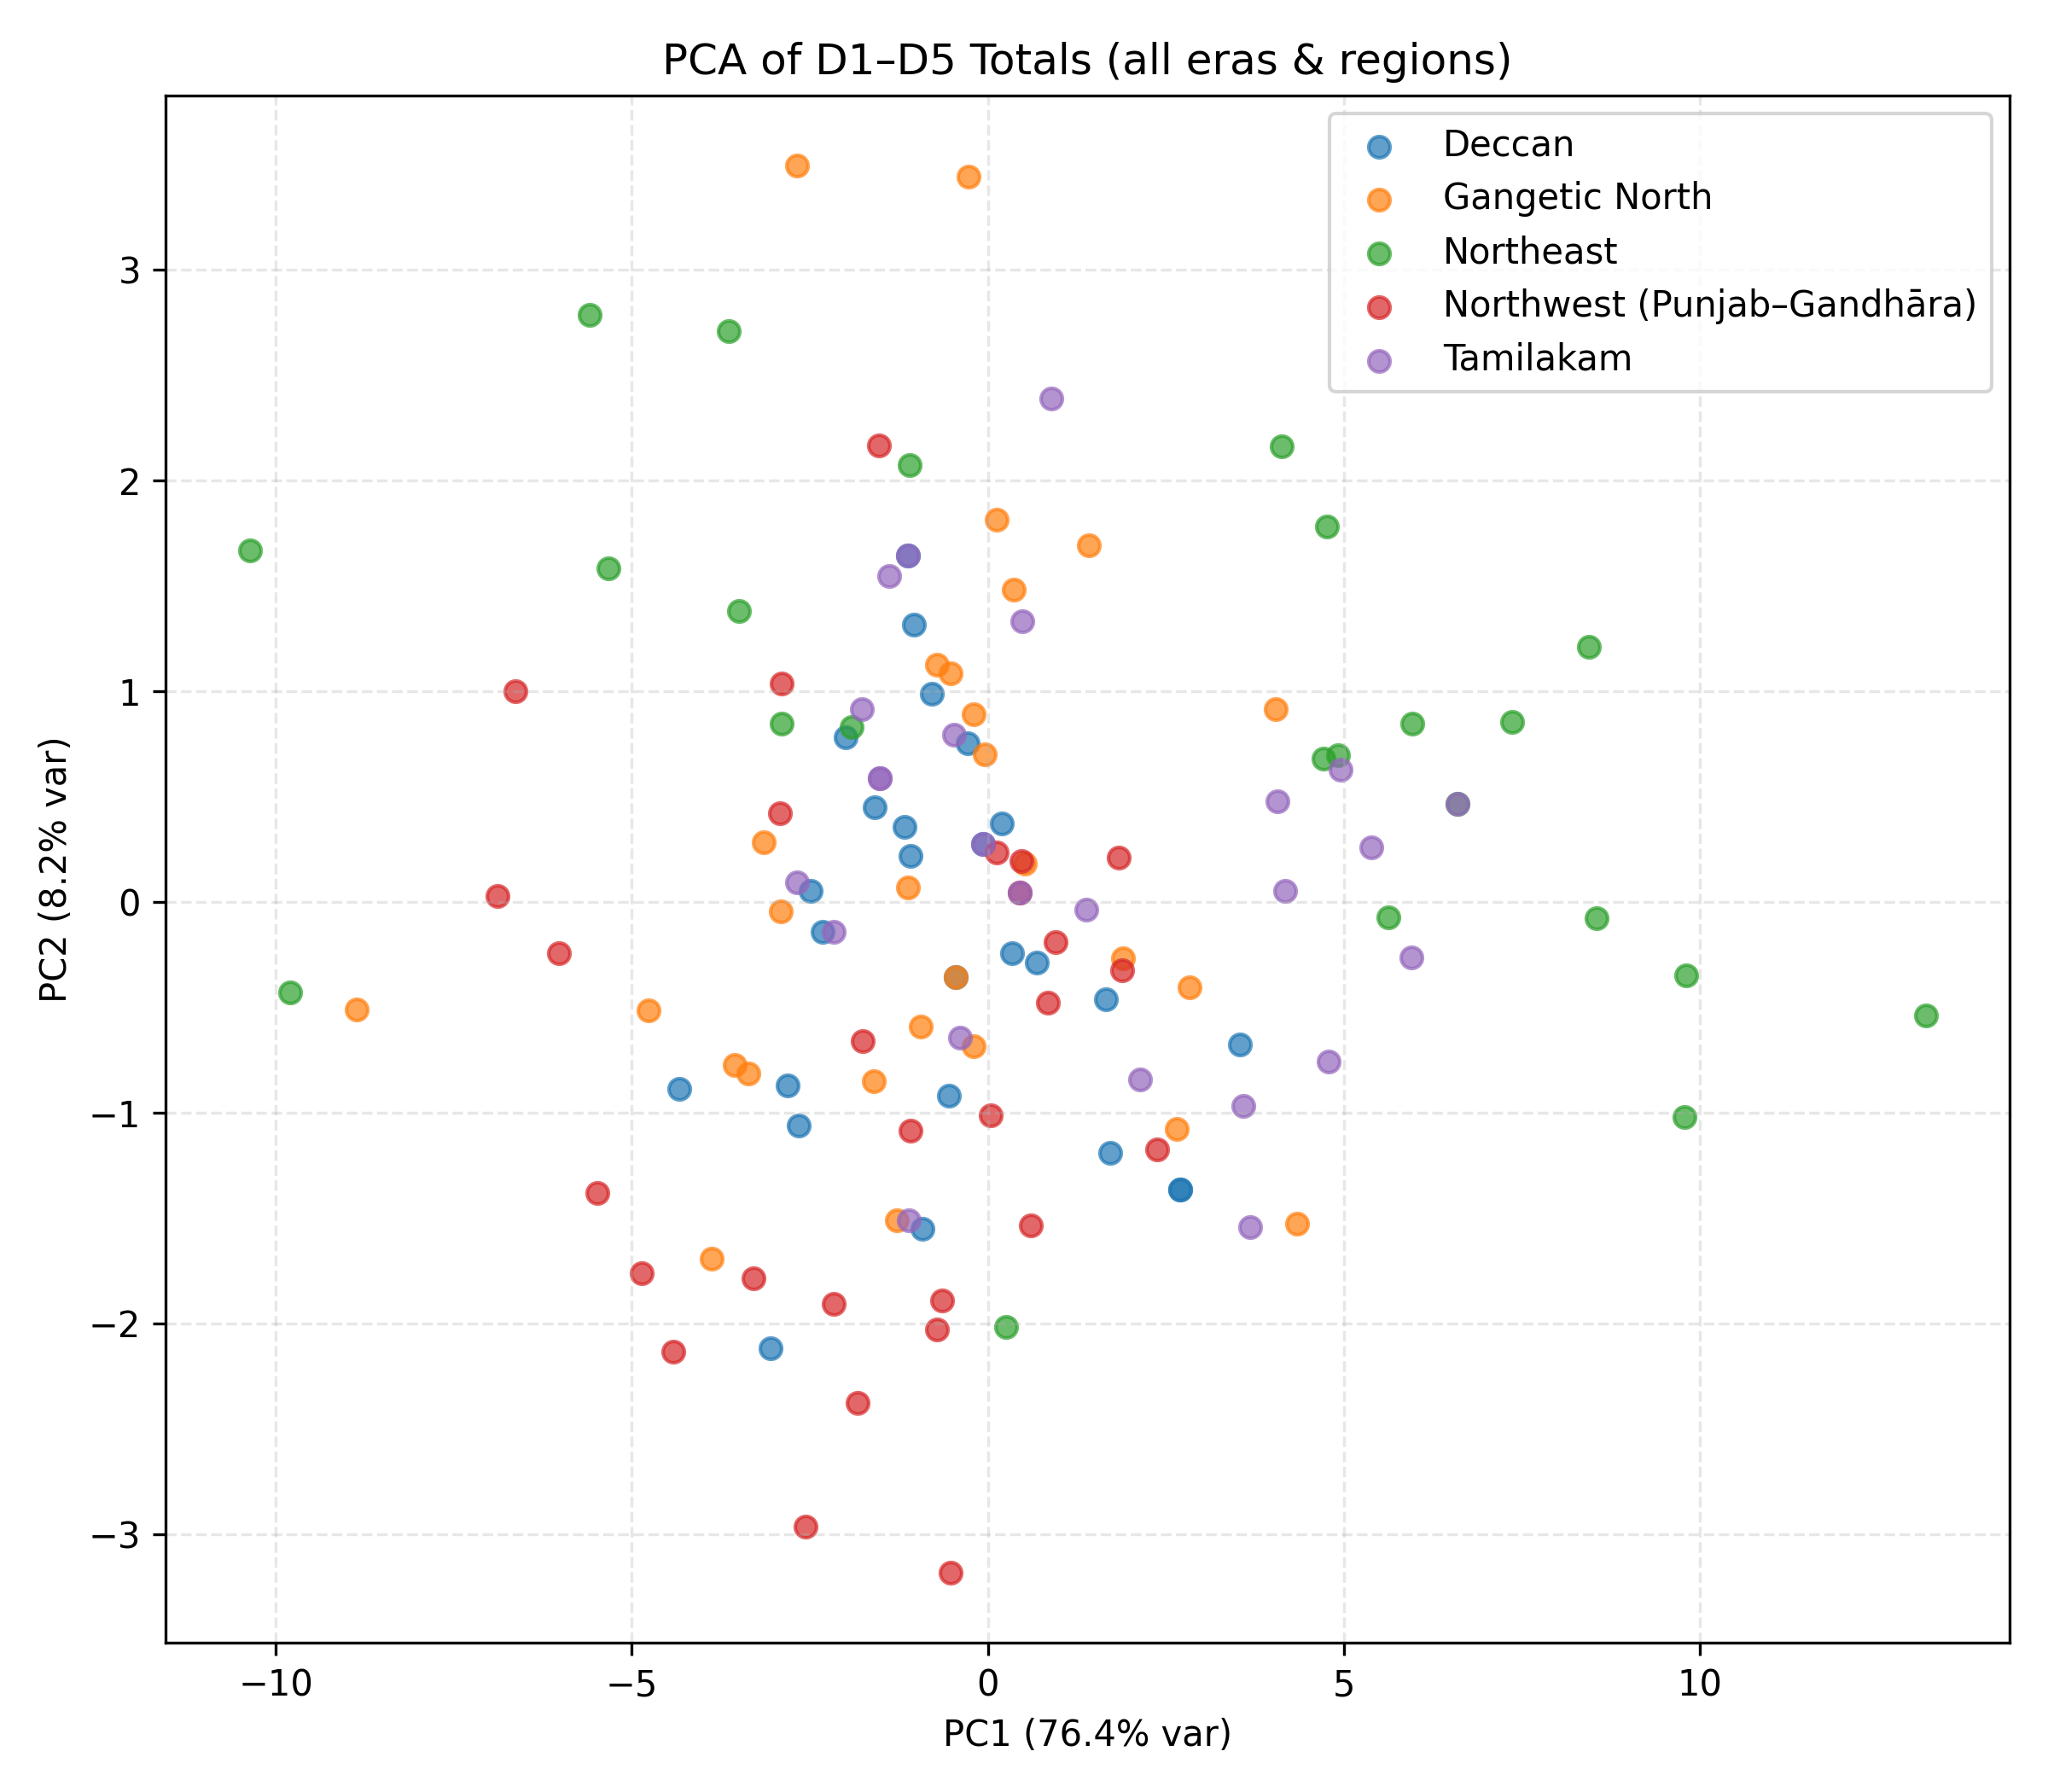
1️⃣6️⃣ PCA: K-Means with Modern Eras Highlighted
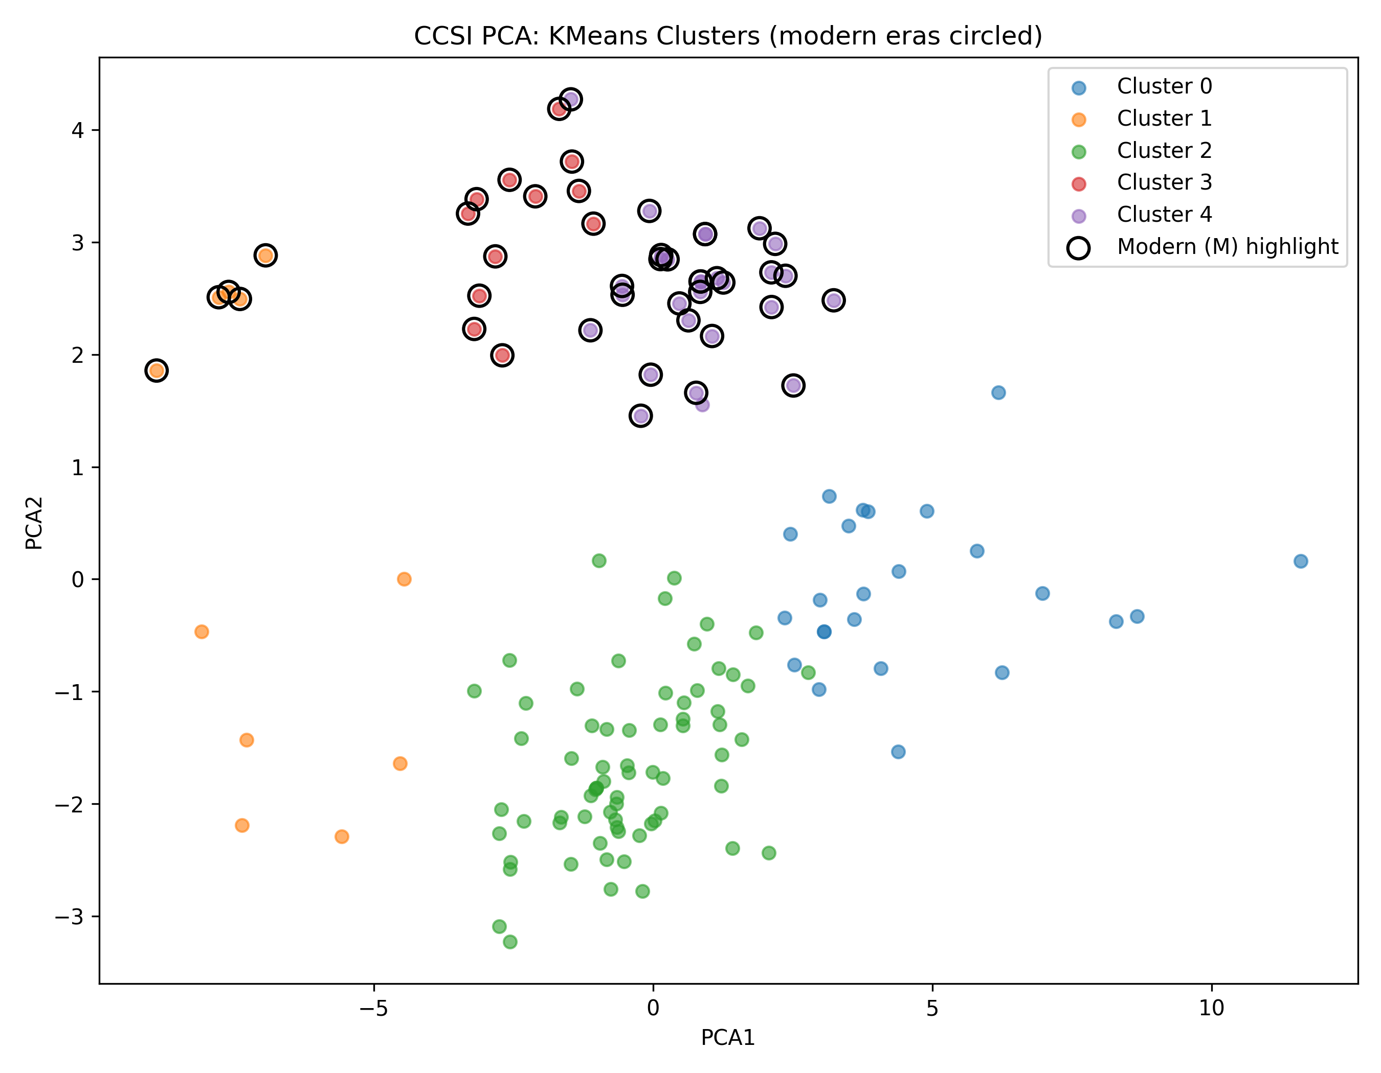
1️⃣7️⃣ PCA: Historical vs Modern Eras Separation
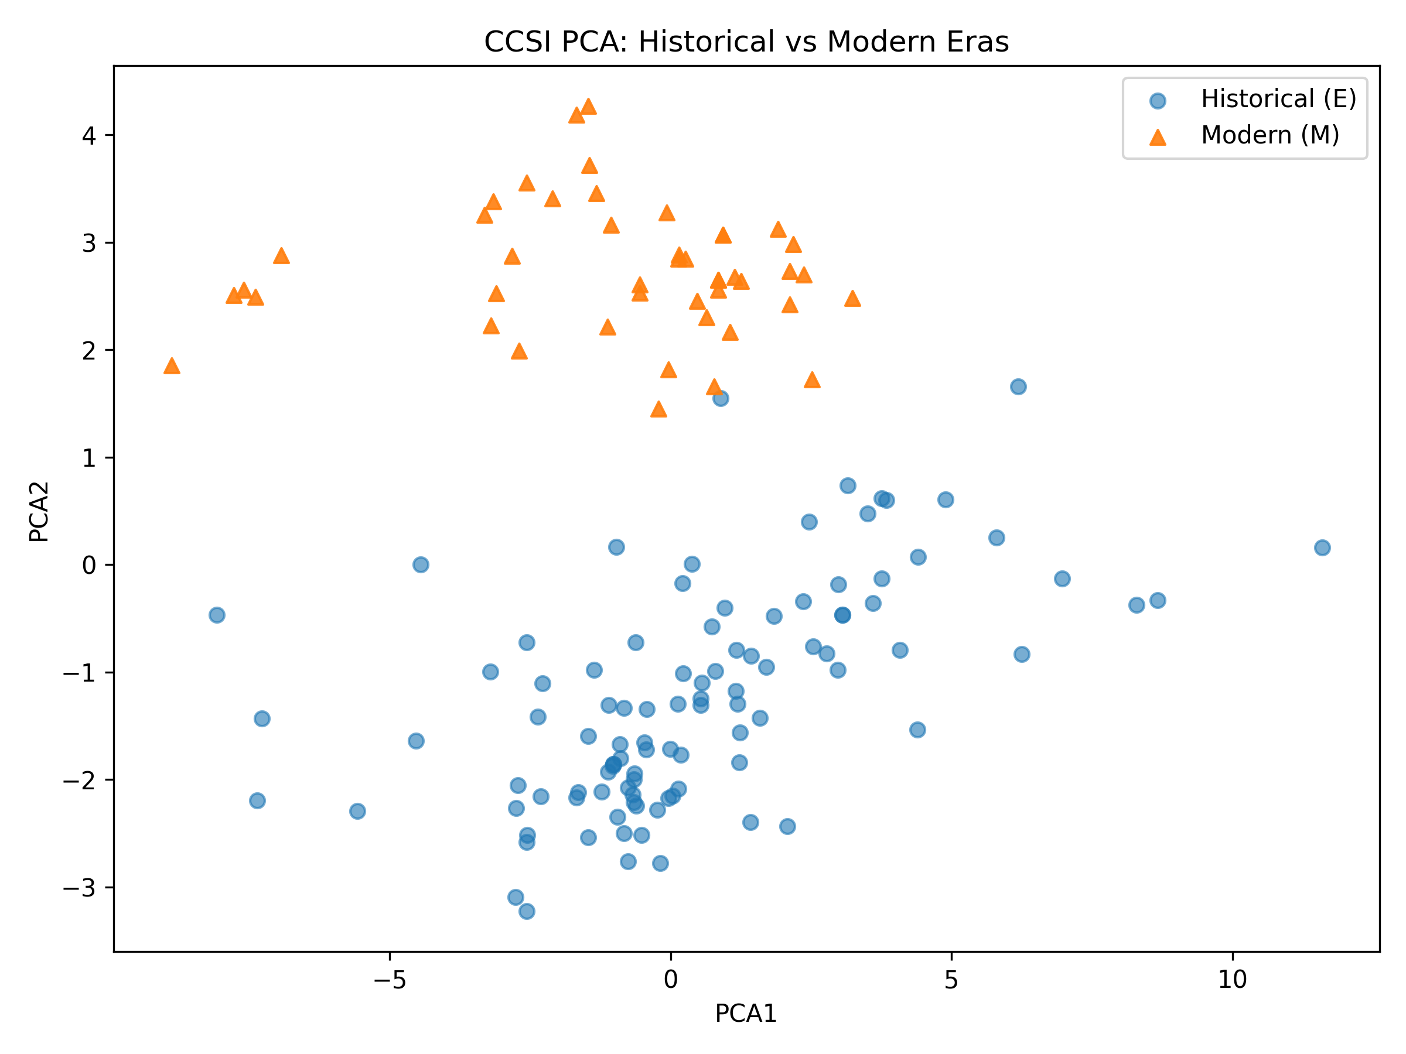

Closing Statement
This appendix is supplementary material accompanying the IEEE paper submission. It is not intended for print publication but for peer-review evaluation of dataset completeness, methodological transparency, and reproducibility of results.
All figures were generated programmatically using Python (pandas, numpy, matplotlib, seaborn, sklearn). Full code and dataset are available upon request.
— End of Graphical Appendix —

