Name: Tejas Pawar
Batch: CMPN-B
Roll No: 24102B0033

E waste_comparasion of rules of diff countries
A comprehensive breakdown of e-waste management across the United States, Canada, Mexico, Guatemala, and Panama, covering the current state of e-waste, legislation, management systems, and regional/global alignment.

High-Level Comparison
Country | E-Waste Generation | E-Waste Legislation / EPR | Management System
United States | Very High | State-level only (24 states) | Private recyclers & state PROs
Canada | High | Provincial-level (Mandatory) | Robust provincial PRO networks
Mexico | Medium | Federal EPR (Enacted Jan 2026) | Circular Management Plans
Panama | Low-Medium | General Solid Waste (Law 276) | Landfills and informal sector
Guatemala | Low | General Hazardous Waste | Informal scavenging

Visual: E-Waste Generation Level & Formal Frameworks
This chart represents the comparative data visually, mapping relative e-waste generation volumes alongside the country's respective legislative frameworks.
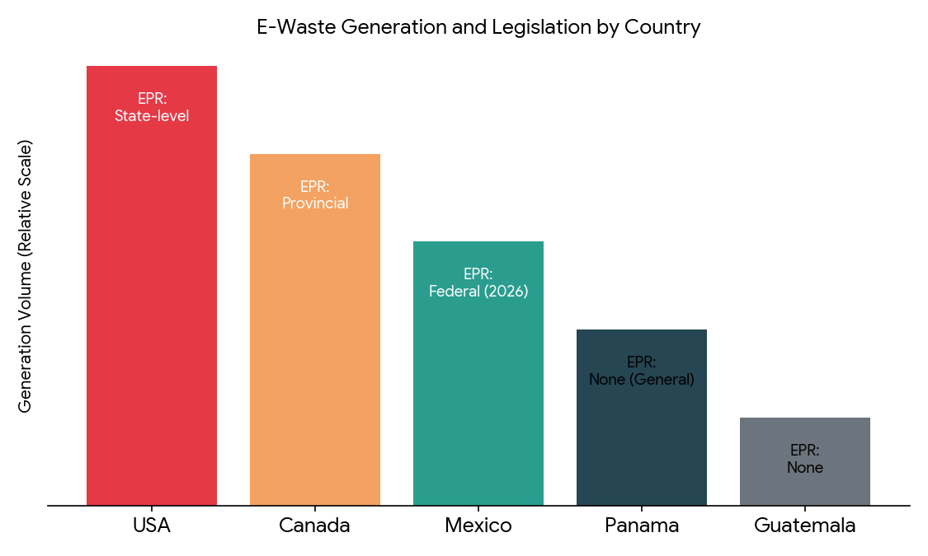

Country-by-Country Breakdown

1. The United States
- State of E-Waste: The US is one of the world's highest per-capita generators of e-waste.
- Laws & EPR: The US notably lacks a federal e-waste law or a national EPR mandate. It relies on a patchwork system where 24 individual states have passed their own electronics EPR laws.
- Management: Handled largely by private e-waste recyclers certified by programs like e-Stewards or R2. States without laws rely on local municipality efforts or landfilling.

2. Canada
- State of E-Waste: High generation rates, paired with a highly organized formal recovery infrastructure.
- Laws & EPR: Managed at the sub-national level with comprehensive provincial laws. Almost all provinces have implemented strict EPR laws driven by the Canadian Council of Ministers of the Environment.
- Management: Obligated producers join Producer Responsibility Organizations (PROs), making it free for consumers to drop off old tech and keeping formal recycling rates high.

3. Mexico
- State of E-Waste: A major manufacturing hub dealing with both post-consumer e-waste and industrial electronic scrap.
- Laws & EPR: Enacted the General Law on Circular Economy (LGEC) in January 2026, creating Mexico's first binding national EPR framework.
- Management: Producers and importers must register a 'Circular Management Plan' to transition from informal picking to a formalized, closed-loop system.

4. Panama
- State of E-Waste: Generates roughly 1.2 kg of solid waste per person/day but struggles with basic infrastructure. E-waste often ends up in open dumps.
- Laws & EPR: No specific e-waste or EPR legislation. Falls under general solid waste laws (Law 276 of 2021).
- Management: Formal e-waste recycling is tiny; relies on informal scavengers who dismantle devices, often using damaging methods like open burning.

5. Guatemala
- State of E-Waste: Low generation rate per capita but nearly 0% formal collection rate.
- Laws & EPR: Lacks targeted e-waste legislation and EPR mandates.
- Management: Relies entirely on informal waste pickers, leading to heavy metal and POP contamination in soil and water.

Regional and Global Alignment

1. The Commission for Environmental Cooperation (CEC)
Established by the US, Canada, and Mexico. They run trilateral initiatives to reduce e-waste and promote sustainable supply chains in the North American electronics sector, focusing on data sharing and circular economy.

2. The Latin American Waste Crisis (UNITAR/UNEP)
Tracks nations like Panama and Guatemala. The goal is capacity building—drafting initial e-waste specific laws and transitioning informal waste pickers into a safe, formalized economy, as 97% of Latin America's e-waste is improperly managed.

3. The Basel Convention
Global treaty controlling international movement of hazardous wastes. Canada, Mexico, Guatemala, and Panama have ratified it with national bans on e-waste imports, though enforcement in Central America remains challenging. (The US relies on bilateral agreements and OECD rules).

4. Global E-Waste Monitor (ITU)
All five countries align with ITU reporting goals to track e-waste for the UN's Sustainable Development Goals (SDGs), shifting focus from waste disposal to resource recovery and the Circular Economy.

