# include <iostream>

using namespace std;

int main() {

unsigned int x;

unsigned int y = 100;

unsigned int z = 50;

x = y - z;

cout << "Difference is: " << x << endl;

x = z - y;

cout << "\nNow difference is: " << x << endl;

return 0;

}

原因：

定义的X没有符号

# include <iostream>

using namespace std;

int main() {

int x;

unsigned int y = 100;

unsigned int z = 50;

x = y - z;

cout << "Difference is: " << x << endl;

x = z - y;

cout << "\nNow difference is: " << x << endl;

return 0;

}

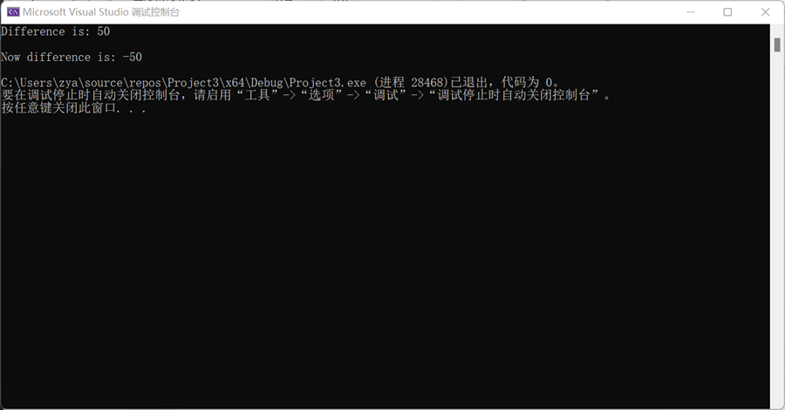

修改数据类型即可