PRIME POS & RESTAURANT MANAGEMENT SYSTEM
System Site Map & Information Architecture
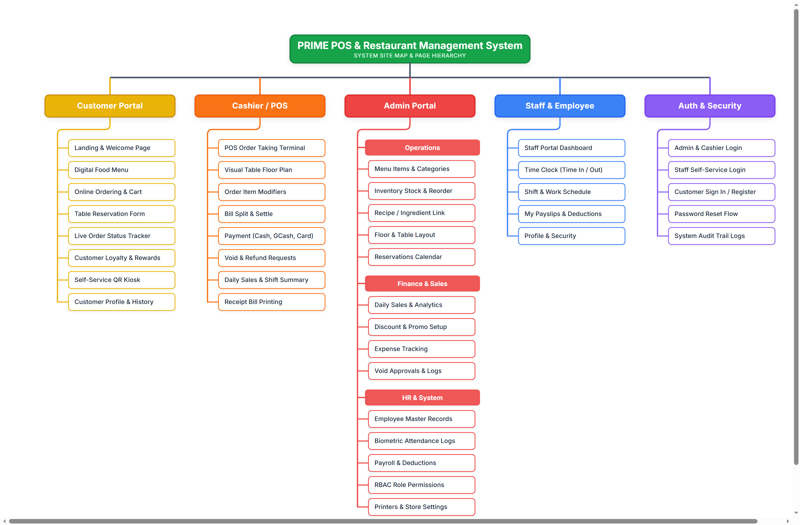

Site Map Module Breakdown
The sitemap diagram above illustrates the multi-portal navigation architecture of the PRIME system. Each portal is isolated with Role-Based Access Control (RBAC) to ensure security and efficient operations:

