# SDEV CA Report

# Introduction

This project was made with the intention to create a redesign of the Toronto Cupcakes website. It is a website for a store that has been around since August 2010. The layout of the original website is confusing and poorly designed. One of the main issues present is that the contents of the navbar and the footer nav do not match up in content. This makes finding important information such as contact details quite difficult. In our design we wanted to address this issue and many more by creating an aesthetically pleasing, and organised website that is easy to navigate.

# Preparation and Design Phase

## Personas

[Personas - SDEV CA.pptx](https://tudublin-my.sharepoint.com/:p:/g/personal/c20737009_mytudublin_ie/ET_0ylQGfSlKl89nCWvYC4oB8cB5GztFSitsIoKmETYgtw?e=xjfU7H)

## Hypotheses

* We believe that providing translations for the three most spoken languages in Canada, we will be able to cater to most of the people who will be visiting the website. This is made to cater to the personas who do not speak English, for their native language is different and need to have that accommodated.  
  This will result in an increase of international traffic.
* We believe that providing basic dietary information about cupcakes, most importantly their allergens, would help out the browser/teacher persona to make an informed decision before making an order.  
  This will lower anxiety and increase the confidence a customer feels before making the final decision. This confidence will most likely result in increased sales.
* We believe that including the contact details in the footer in clear bold writing, and have buttons that automatically scroll to it, will help customers who are less familiar with common website layouts find their way around easier. This will reduce the need to search and scroll for elderly customers who might have vision or movement impairments.
* We believe that the inclusion of an order now button at the very top of the index page might decrease the time spent on the website, resulting in quick checkout times. This will result in satisfying the need of a regular customer who might be interested in trying out new flavours and wish to have a hustle free experience.
* We believe that providing an Event bundle at the store page will help out event planners who wish to order items in bulk, with an option to pre-order. Specifying a bundle with that name will narrow down options for the customers, reducing confusion and the time spent on the website.

## Wireframes

The about us page changed in order for it to become more focused and to the point.

On the Index page, “Inspiration” section, additional icons were added so that people have a general idea of the services at first glance.

The automatic scroll function was removed due to insufficient budget.

## Hi-Fidelity Prototype and Final version

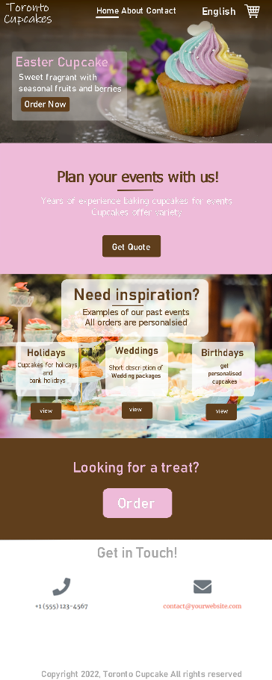

# Implementation

## i18N:

In settings.py of our project folder:  
In order to get Internationalization and localization working, we first had to specify that we wish to use them.   
We also had to set up the locale set formatting, by editing the MIDDLEWARE variable, and the context processor, by editing the TEMPLATES variable. Once these were set up, we included a list of languages, that are translated to their native languages when displayed. This was achieved by importing ‘ugettext_lazy’.   
We also routed the path to the newly created locale folder within the locale_paths variable, where the localisation settings will be stored.

In views.py of the app folder:  
We defined methods that create requests to render the html webpages.

In urls.py in the project folder:  
We imported i18n patterns so that Django my automatically add the prefix of the URL patterns that were added by the i18n_patterns function.

In urls.py of the app folder:  
We added paths to the methods from views.py to the url patterns.

In the locales folder:  
We created the files necessary in order to create the .mo and .po files that are necessary for translation.  
.po file contains the strings marked in need of a translation.  
.mo file contains the translated strings that Django can make sense of.

## C13N:

We mainly targeted a Canadian female demographic that have a high individualism score and low long-term orientation.

Power Distance:  
Canadians score low, which means that they have a more straightforward way of communication.  
To satisfy that, we use straightforward language to describe the content of the website.  
Chinese and French score low, however, score very high. This makes the need for expressing the length of the business being open and catering to events important since its then considered a well-known brand.

Individualism:  
Both Canada and France score very high but China scores very low.  
To satisfy the needs of the Canadians and the French clients, we hinted at personalisation options. We also emphasised the contact options available that would allow this.  
To satisfy the needs of the Chinese clients, we included the option to order pre-determined portions of cupcakes.

Masculinity:  
All countries in question are rather neutral but on average, lean more towards a masculine culture. This means that traditional gender roles are more integrated into their society.  
It is the main reason why we chose to use soft, feminine colours throughout the website.

Uncertainty Avoidance:  
We also made sure to address and satisfy the uncertainty avoidance of the French.  
For this reason, we designed our layout in such a way, that it would be familiar to anyone at first glance.   
We also included a section where the allergens are specified so that people are well informed before a purchase.

Long-term Orientation:  
Canadians score low while Chinese score high. We chose to satisfy the needs of the tradition-loving Canadians by including a seasonal deal that matches the current Holidays. We also put a lot of emphasis on catering for Events and Holidays to satisfy that need.

Indulgence:  
Canadians score high on indulgence.  
We tried to use key-words that would hopefully lure customers in to indulge themselves even more.