Spectral-Complexity-Gated Neural Augmentation for Parametric Bloch Spectral Clusters with Band Crossings
Manuscript draft v1.0, 28 August 2026. Numerical statements in this draft are generated only from the frozen V3 formal evidence. Author names, affiliations, ORCID identifiers, funding, CRediT roles, and the target journal style remain for the authors to supply.

Abstract
Repeated solution of parameterized partial-differential eigenproblems is expensive, while internal eigenvalue crossings make individually ordered eigenfunctions an unstable learning target. We consider the lowest rank-two spectral projector of a two-dimensional periodic Bloch–Schrödinger operator with harmonic and localized Gaussian honeycomb potentials. We propose SR-SC-NARR, a spectral-roughness-routed, symmetry-consistent neural-augmented Rayleigh–Ritz solver. A lightweight SiLU network is trained without plane-wave labels by a generalized-trace variational objective and supplies two parameter-dependent complex trial directions. At inference, a potential-only Fourier tail-energy diagnostic chooses between a tie-closed kinetic Fourier space and a symmetry-consistent neural–Fourier space. The reciprocal dictionaries obey the D6 closure associated with the implemented positive-cross kinetic metric; Fourier Hamiltonian actions are analytic, neural actions use automatic differentiation, paired orthogonalization preserves Hamiltonian consistency, and the reduced matrix is explicitly Hermitian.
The method is evaluated once on a procedurally frozen CUDA confirmation set containing 160 physical parameter points, two potential families, five parameter regimes, three archived network seeds, 11 methods and ablations, and 5,280 paired evaluations. SR-SC-NARR attains a mean rank-two projector sine error of 0.03093, a p95 of 0.10568, and a two-eigenvalue mean absolute error of 0.00984. Relative to a tie-closed kinetic Fourier control of minimum rank 25, mean projector error decreases by 28.76%; a family-by-split stratified point bootstrap gives a conditional 95% interval of [28.08%, 29.44%]. The gain is deliberately reported as conditional: all harmonic cases select the Fourier branch and match the control, whereas all Gaussian cases select the hybrid branch and reduce error by 31.75%. Relative to a complete rank-37 D6 shell, the proposed solver has 0.42% higher projector error but 12.75% lower eigenvalue error, 19.84% lower latency, and trial rank 25–27. These results support a conditional neural-augmentation and Pareto claim, not universal neural superiority or routing generalization between the two observed spectral endpoints.
Keywords: neural PDE eigensolver; Bloch–Schrödinger equation; spectral projector; eigenvalue crossing; Rayleigh–Ritz; Fourier spectral method; scientific machine learning

1. Introduction
Neural PDE solvers aim to amortize repeated differential-equation solves by learning a function or operator family rather than solving each parameter instance from scratch. Variational neural solvers such as Deep Ritz [16] and neural operators [17] provide complementary examples of this shift from a single discretized solution to a learned function-space approximation. Physics-informed neural networks (PINNs) introduced a widely used residual-based realization of this idea [1], and conditional PINNs extended it to parameterized classes of problems [2]. Differential eigenproblems are harder than ordinary initial-boundary-value problems: the eigenvalues are unknown, the homogeneous residual admits the zero function, multiple states require normalization and orthogonality, and eigenvectors cease to be unique at multiplicities.
The last issue is central for Bloch band structures. Two-dimensional honeycomb operators may possess conical Dirac crossings at Brillouin-zone vertices [11]. Around an internal crossing, a globally ordered “band 1 eigenfunction” and “band 2 eigenfunction” may swap or rotate. Penalizing the difference between individually labeled eigenvectors then confuses a basis convention with a physical error. If the two-dimensional low-energy cluster remains separated from the third state, however, its spectral projector is still well-defined. Parameter-dependent eigenspace theory therefore motivates learning the cluster rather than its individual columns [7,15].
Several neighboring works supply important ingredients. Trace and Ky Fan objectives enable joint computation of multiple eigenpairs [3]. Rayleigh-quotient neural eigensolvers can combine energy minimization and Gram–Schmidt orthogonalization [4]. Neural trial subspaces can be followed by a Galerkin solve [5]. Shape Space Spectra treats multiplicity through dynamic mode reordering [6], and supervised Grassmann regression learns parameter-to-subspace maps [8]. Classical reduced-basis methods address repeated band-structure and multiple-eigenspace calculations [9,10,12]. These works establish that trace minimization, neural subspaces, Fourier bases, and Rayleigh–Ritz are not individually new.
The open practical question addressed here is narrower. A label-free neural coarse space may help when a compact analytic Fourier dictionary under-resolves a spectrally rich potential, but neural automatic differentiation is unnecessary when a small Fourier space is already adequate. We ask:
- Can a basis-invariant neural coarse space improve a symmetry-consistent low-rank Fourier Ritz solver at internal Bloch crossings?
- Can a diagnostic computed only from the potential decide when to invoke neural augmentation without reading reference projectors or test errors?
- Does the resulting solver remain competitive with a stronger, higher-rank Fourier control under a one-shot, hash-bound evaluation protocol?
The contributions are:
- Crossing-aware PDE target. Training and evaluation target the lowest rank-two subspace and projector, making the formulation invariant to phases, permutations, and internal unitary rotations.
- Symmetry-consistent trial spaces. Reciprocal dictionaries use the D6 closure consistent with the kinetic quadratic form (m_1^{2+m_2}2+m_1m_2). Kinetic-energy boundary ties are retained, preventing arbitrary truncation of degenerate multiplets.
- Label-free conditional neural augmentation. A potential Fourier tail-energy ratio routes each query to a pure Fourier or neural–Fourier trial space. The diagnostic uses no eigensolution labels.
- Operator-consistent compact solve. Analytic Fourier Hamiltonian actions, automatic differentiation of only two neural directions, detached cell-quadrature normalization, paired transformations of ((W,HW)), and an explicitly Hermitian Ritz matrix produce the final cluster.
- Audited evidence. A disjoint pilot, an independent cutoff/grid convergence audit, and a single procedurally frozen 160-point CUDA confirmation preserve suite, reference, checkpoint, source, row, and evidence hashes.
The main empirical conclusion is intentionally conditional. The formal set contains two separated spectral-complexity endpoints: the harmonic family always routes to Fourier and the Gaussian family always routes to the hybrid. The experiment validates safe endpoint selection and a stable neural gain on the rich endpoint; it does not establish interpolation around the threshold or universal routing across unseen potential families.

2. Related Work

2.1 Neural PDE and eigenvalue solvers
Standard PINNs minimize differential residuals, boundary conditions, initial conditions, and optional observations [1]. Eigenvalue versions must additionally avoid trivial solutions and represent normalization, orthogonality, and eigenvalue order. Jin et al. used physics-informed networks to discover multiple quantum eigenstates without supervised wavefunction labels [14]. Kovacs et al. showed that a conditional physics-informed network can represent a parameterized class of eigenproblems [2]. These methods establish label-free neural eigenanalysis but do not by themselves remove the discontinuity of individually ordered states at an internal crossing.
Wang and Xie compute several eigenpairs jointly with tensor neural networks and a trace objective [3]. Rowan et al. combine Rayleigh quotients and Gram–Schmidt for engineering eigenproblems [4]. Their principles motivate our generalized-trace initializer and orthogonality treatment. Our primary claim is not superiority to the original implementations: the formal Wang–Xie result in this study is a transparent formula-level Bloch adaptation, not an official author-code reproduction.

2.2 Neural trial spaces and parameterized eigenspaces
Dai, Fan, and Sheng construct neural trial functions and solve a Galerkin eigenproblem inside the learned subspace [5]. This is the closest journal-level structural neighbor to our hybrid compact solve. The present method differs through a single parameter-conditioned coarse network, an internally crossing Bloch projector target, an analytic D6 Fourier dictionary, a potential-only route, and paired Hamiltonian assembly. The Dai-style adaptation used here converges poorly and is reported for transparency; it is not the central evidence for the proposed method.
Chang et al. learn spectra over parameterized shape families and dynamically reorder modes at multiplicities [6]. Fanaskov et al. directly regress parameterized subspaces on a Grassmannian but use precomputed subspace labels [8]. We instead train from the operator and evaluate the projector. Grubišić et al. analyze parameter-dependent eigenspaces under external isolation [7], supporting the use of a cluster target even when the internal gap closes. Recent subspace-approximation theory provides an additional numerical-analysis perspective [18], while Dölz and Ebert treat uncertainty in eigenspaces of higher multiplicity [21]. Deep Eigenspace Network is a particularly close recent preprint because it learns parameter-to-eigenspace maps and uses Ritz postprocessing, but it relies on precomputed supervision and studies a different non-self-adjoint setting [22].

2.3 Bloch model reduction and periodic quantum networks
Reduced bases have long been used for repeated band-structure calculations [9]. Horger et al. develop simultaneous reduced-basis approximation for parameterized multiple eigenvalues [10]. Haasdonk et al. combine full-order, reduced-order, and machine-learning components with certification [12], illustrating why a hybrid solver should be assessed through accuracy, cost, and reliability rather than neural forward time alone. Hsu et al. demonstrated equation-driven neural band-structure learning in two-dimensional periodic quantum systems [13]. Fefferman and Weinstein provide the mathematical setting for honeycomb potentials and Dirac points [11]. Data-driven reduced-order modeling has also been applied directly to parameterized PDE eigenvalue problems [20], and neural networks have accelerated classical iterations for nonlinear Schrödinger eigenproblems [19]. These works reinforce the need to state exactly which part of a hybrid online solve is learned and which part remains numerical.
The novelty boundary is consequently specific: we claim a corrected, basis-invariant, spectral-complexity-gated combination and its controlled evidence. We do not claim the invention of Ky Fan principles, projectors, Fourier spectral discretization, Gram–Schmidt, Galerkin projection, or Rayleigh–Ritz.

3. Problem Formulation

3.1 Two-dimensional Bloch eigenproblem
Let the periodic cell be $Ω=[0,2π)^{2}$. For Bloch wavevector $k=(k_{1},k_{2})$ and potential parameters $μ$, consider
$$H_{k,μ}u_{j}=\left[\frac{1}{2}(−i∇+k)^{T}G(−i∇+k)+V_{μ}(x)\right]u_{j}=E_{j}u_{j}, G=\left[\begin{matrix}1 & 1/2 \\ 1/2 & 1\end{matrix}\right],$$
with periodic function and first-derivative boundary conditions. A reciprocal mode $m=(m_{1},m_{2})∈Z^{2}$ has kinetic energy
$$T(m,k)=\frac{1}{2}\left[(m_{1}+k_{1})^{2}+(m_{2}+k_{2})^{2}+(m_{1}+k_{1})(m_{2}+k_{2})\right].$$
The harmonic honeycomb family is
$$V_{a,δ}^{H}(x,y)=a[cosx+cosy+cos(x−y)]+δ[sinx−siny−sin(x−y)].$$
The training ranges are $a∈[0.20,0.80]$, $δ∈[−0.08,0.08]$, and $k_{1},k_{2}∈[0.28,0.38]$.
The localized family consists of two periodically repeated Gaussian sublattices. With centers $c_{1}=(0,0)$, $c_{2}=(2π/3,4π/3)$, weights $w_{1}=1$, $w_{2}=1+δ$, and periodic images $n∈\{−1,0,1\}^{2}$,
Va,σ,δG(x)=−aℓ=12wℓn​exp​−23σ2d12+d22−d1d2, d=x−cℓ−2πn.
Its training ranges are $a∈[1,4]$, $σ∈[0.18,0.35]$, $δ∈[−0.08,0.08]$, with the same Bloch box. Strict-OOD evaluation extends the Bloch coordinates to $k_{1}∈[0.20,0.28]$, $k_{2}∈[0.38,0.45]$ and widens the potential ranges.

3.2 Spectral-cluster target
Let $U_{2}(k,μ)$ denote the span of the two lowest eigenstates and let $P_{2}$ be its orthogonal projector. The internal gap $E_{2}−E_{1}$ may vanish. We require external isolation from the unwanted spectrum through $E_{3}−E_{2}>0$. If $Q$ and $Q_{⋆}$ are orthonormal predicted and reference bases, the primary metric is
$$e_{proj}(Q,Q_{⋆})=\sqrt{\frac{2−{\left\|Q^{*}Q_{⋆}\right\|}_{F}^{2}}{2}}.$$
It is the root-mean-square sine of the two principal angles and is invariant to all unitary changes of basis inside either rank-two space. We also report the mean absolute error of the lowest two Ritz eigenvalues, residual RMS, p95 and maximum projector error, orthogonality, raw Ritz Hermiticity defect, trial rank, latency, and peak memory.

4. SR-SC-NARR

4.1 Label-free neural coarse space
Separate family-specific networks receive periodic features
$$[sinx,cosx,siny,cosy,k,μ]$$
and output real and imaginary parts of two complex periodic functions. The MLP has three hidden layers of width 64 with SiLU activations. A fixed low-energy anchor near the K point is added with scale 0.1. For raw columns $Z_{θ}$, define
$$B_{θ}=Z_{θ}^{*}Z_{θ}, A_{θ}=Z_{θ}^{*}HZ_{θ}.$$
The training loss is the regularized generalized trace
$$L_{trace}=Tr​\left[(B_{θ}+{10}^{−6}I)^{−1}A_{θ}\right].$$
No PWE eigenvector, projector, or ordered band label enters training. Adam uses learning rate (10^{-3}), four parameter instances and 256 shifted periodic points per step, for 665 steps. Three archived checkpoints use seeds 42, 137, and 251. At evaluation, complex modified Gram–Schmidt retracts the raw output to a rank-two neural basis $Q_{θ}$.

4.2 D6-consistent Fourier spaces and tie closure
For the positive-cross kinetic metric, the complete D6 shell of radius $s$ is
$$S_{s}=\{(m_{1},m_{2})∈Z^{2}:max(|m_{1}|,|m_{2}|,|m_{1}+m_{2}|)≤s\}.$$
It contains 7, 19, and 37 modes for (s=1,2,3). The plus sign is essential: it is the shell closure compatible with $m_{1}^{2}+m_{2}^{2}+m_{1}m_{2}$.
For a nominal kinetic rank $r$, modes from $S_{4}$ are sorted by $T(m,k)$. If the boundary energy is $T_{r}$, every mode satisfying
$$T(m,k)≤T_{r}+{10}^{−7}max(1,|T_{r}|)$$
is retained. This tie closure avoids cutting an exact kinetic multiplet. The nominal rank-25 dictionary therefore has actual rank 25 or 27 on the formal set.

4.3 Potential-only spectral routing
On the 65 by 65 periodic grid, let ${\hat{V}}_{m}$ be the discrete Fourier coefficients of the potential. The routing statistic is
ρ(V)=m∉S1​|Vm|2m​|Vm|2.
The threshold is frozen at 0.1. If $ρ≤0.1$, the solver uses the tie-closed minimum-rank-25 kinetic Fourier dictionary. If $ρ>0.1$, it forms a hybrid dictionary from $S_{2}∪K_{21}(k)$ and appends the two neural directions. Redundant Fourier columns are rejected during orthogonalization, yielding formal trial ranks 25–27. The route reads only the input potential; it does not evaluate either candidate against a reference solution.

4.4 Analytic and automatic-differentiation Hamiltonian actions
For a plane wave $ϕ_{m}(x)=e^{im⋅x}$,
$$Hϕ_{m}=[T(m,k)+V_{μ}(x)]ϕ_{m},$$
so the Fourier Hamiltonian columns are analytic. Automatic differentiation is used only for the two neural columns. During modified Gram–Schmidt, the equal-weight cell-quadrature projection coefficients and normalization are treated as constants with respect to spatial coordinates. Every linear operation applied to a trial column $w$ is simultaneously applied to its Hamiltonian column $Hw$. This paired construction preserves $H(cw)=cHw$ numerically and avoids nonlocal cross-grid derivative terms.
Let the accepted paired columns be ((W,HW)). The reduced matrix is explicitly Hermitianized,
$$A_{W}=\frac{1}{2}[W^{*}(HW)+(W^{*}(HW))^{*}].$$
Its two lowest eigenvectors are mapped back through $W$ and retracted to obtain the final basis.

4.5 Algorithm
Input: (k, μ), family-specific archived network, grid X
1. Evaluate Vμ(X) and the tail ratio ρ(Vμ).
2. If ρ ≤ 0.1:
construct tie-closed kinetic Fourier dictionary K25(k);
assemble (W, HW) analytically.
Else:
evaluate and orthonormalize the two neural directions Qθ;
construct S2 ∪ K21(k);
append analytic Fourier pairs to (Qθ, HQθ).
3. Apply paired modified Gram–Schmidt with detached cell-quadrature scalars.
4. Form the explicitly Hermitian compact Ritz matrix.
5. Return its lowest rank-two Ritz subspace and Ritz eigenvalues.
The online cost is $O(Nr^{2}+r^{3})$ after the column actions, where $N={65}^{2}$ and $r∈[25,27]$. Neural second derivatives are paid only on the hybrid route. The formal timing also includes the current FFT-based routing diagnostic.

5. Experimental Protocol

5.1 Separation of development and confirmation
An external audit found that a superseded V2 implementation combined the positive-cross kinetic metric with a negative-cross reciprocal-shell convention. V3 corrected the D6 closure, detached paired normalization, explicitly Hermitianized the reduced matrix, replaced an asymmetric rank-21 Fourier control by tie-closed kinetic controls, and created a new disjoint evaluation. Old V2/Q3 numbers are retained only as historical provenance and are not combined with the results in this paper.
A 24-point V3 engineering pilot was used to finalize code, route, controls, and gates. The code and pilot were committed before the formal suite was generated. The 160-point suite, reference cache, physical-point digest, source fingerprint, and convergence evidence were then committed separately. The formal set was opened once in a clean CUDA checkout. A global marker prevents a second formal opening.

5.2 Confirmation set
Each potential family contributes 80 points: 16 IID-hidden, 16 exact-cluster, 24 near-cluster, 16 strict-OOD, and 8 gap-scan points. Exact points have internal gap below ${10}^{−3}$, near points below $2×{10}^{−2}$, and every point has external gap above ${10}^{−2}$. Three checkpoint seeds and 11 methods are evaluated at every point, producing $160×3×11=5,280$ unique rows.
References use a float64 D6 plane-wave expansion with cutoff 24 and rank 3, evaluated on a 65 by 65 grid. An independent audit compares cutoffs 20, 24, and 28 and directly resamples solver projectors between grid sizes 65 and 97.

5.3 Comparisons and ablations
The matrix contains:
- the archived long-anchor neural solver;
- neural augmentation with D6 shell 1 and shell 2;
- fixed neural–Fourier rank-about-25 and routed SR-SC-NARR;
- D6 shell-2 rank 19;
- tie-closed kinetic Fourier controls of nominal rank 21 and 25;
- complete D6 shell-3 rank 37;
- formula-level Bloch adaptations of Wang–Xie trace [3] and Dai Galerkin [5].
The strongest evidence for the neural claim is the comparison with kinetic Fourier-25, fixed hybrid, and shell-3. The two literature adaptations provide context but are not official reproductions.

5.4 Statistical and hardware protocol
The primary interval is a 2,000-sample bootstrap stratified over the ten family-by-split cells. Within each point, errors are first averaged over the three archived seeds; physical points are then resampled with replacement inside each stratum. The resulting interval is conditional on those three checkpoints and does not estimate uncertainty over arbitrary retraining seeds.
Formal evaluation used one NVIDIA A10 with 23.82 GB reported memory, PyTorch 2.10.0+cu128, CUDA 12.8, and driver 550.54.15. Method order was deterministically rotated by point and seed to reduce timing-order bias. Peak allocated and reserved memory were 1.24 and 1.26 GB.
The protocol follows recent calls for broad PDE benchmarks [23], strong classical baselines and honest runtime claims [24], and explicit protection against test leakage in machine-learning-based science [25].

6. Results

6.1 Overall and split performance
Table 1. Formal projector and eigenvalue results. Lower is better.
Method | Overall | Near | Strict OOD | Gap scan | Eigenvalue MAE | p95 | Latency (ms)
SR-SC-NARR | 0.030929 | 0.029007 | 0.035618 | 0.030391 | 0.009837 | 0.105683 | 176.64
Kinetic Fourier ≥25 | 0.043425 | 0.041291 | 0.050231 | 0.043054 | 0.015996 | 0.146571 | 105.55
D6 shell 3, rank 37 | 0.030799 | 0.028538 | 0.034598 | 0.030762 | 0.011275 | 0.110973 | 220.37
Fixed neural–Fourier 25 | 0.031784 | — | — | — | 0.009890 | 0.105683 | 134.81
D6 shell 2, rank 19 | 0.073476 | 0.067746 | 0.083663 | 0.074778 | 0.023261 | 0.212103 | 61.24
Long-anchor neural | 0.139905 | 0.089580 | 0.228525 | 0.183825 | 0.022595 | 0.325521 | 1.27
Wang–Xie adapted | 0.132717 | 0.088125 | 0.211824 | 0.182409 | 0.018248 | 0.304959 | 1.10
Dai adapted | 0.432885 | 0.422582 | 0.440783 | 0.471568 | 0.110026 | 0.654799 | 130.33
SR-SC-NARR lowers mean projector error relative to kinetic Fourier-25 by 28.76%. The stratified point-bootstrap interval is [28.08%, 29.44%]. All five splits are non-regressive relative to the control. The proposed p95 and maximum are 0.10568 and 0.16686.
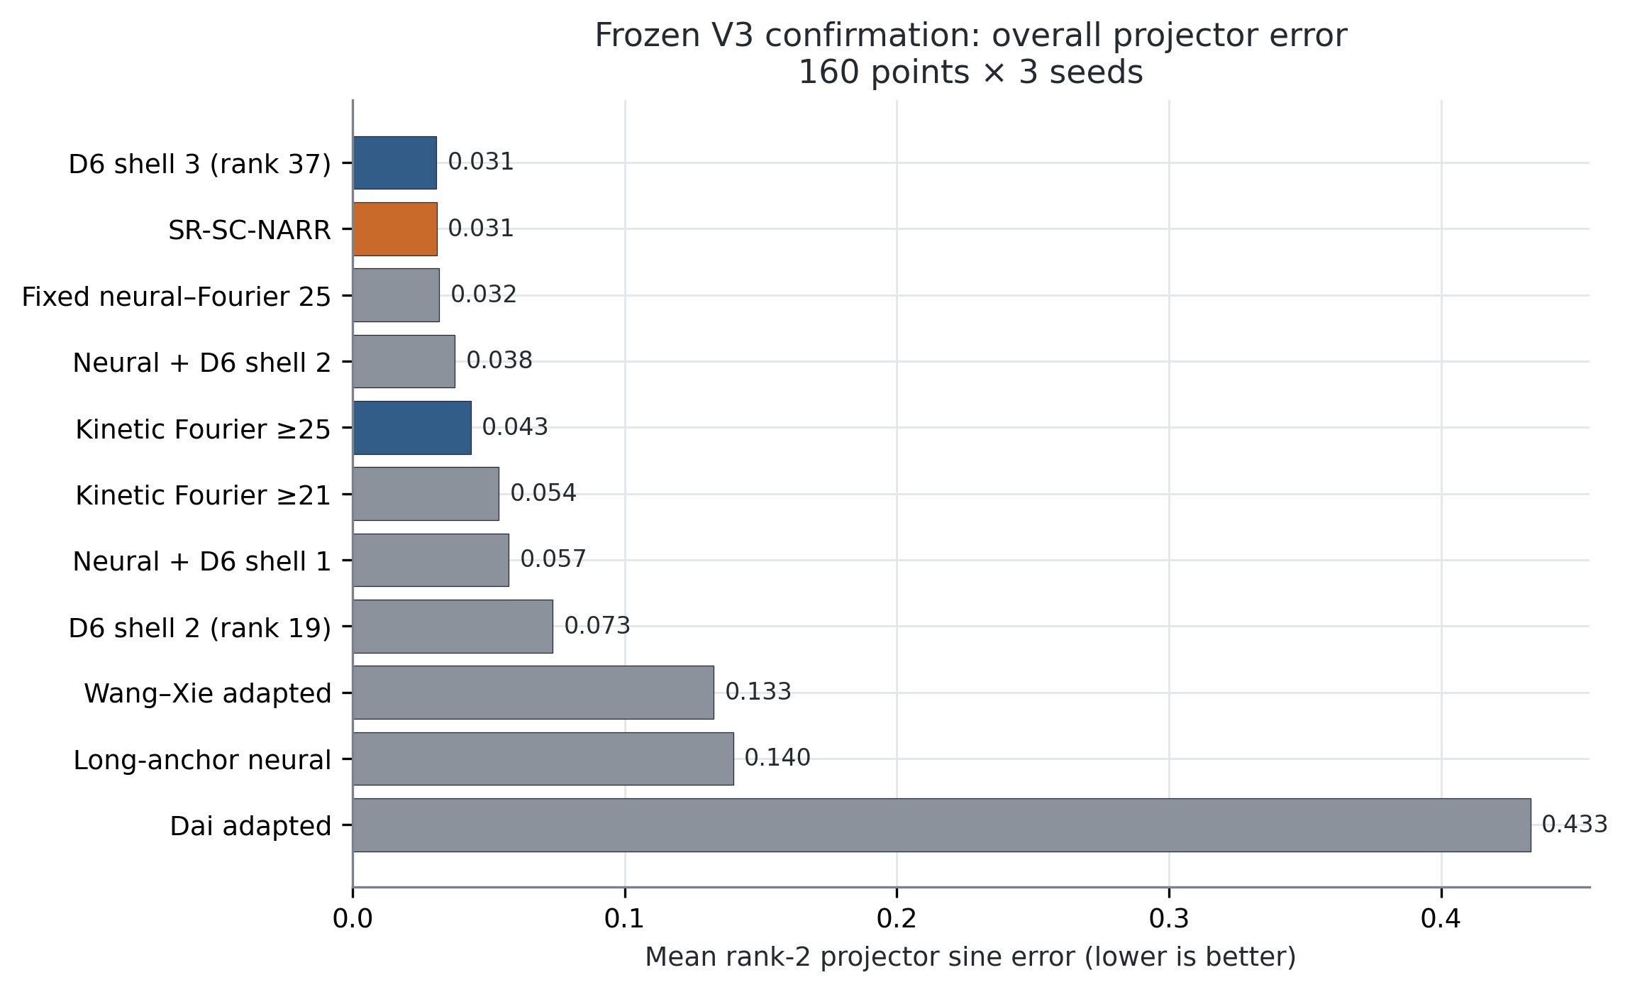
Figure 1. Overall formal projector error for 11 methods and ablations.
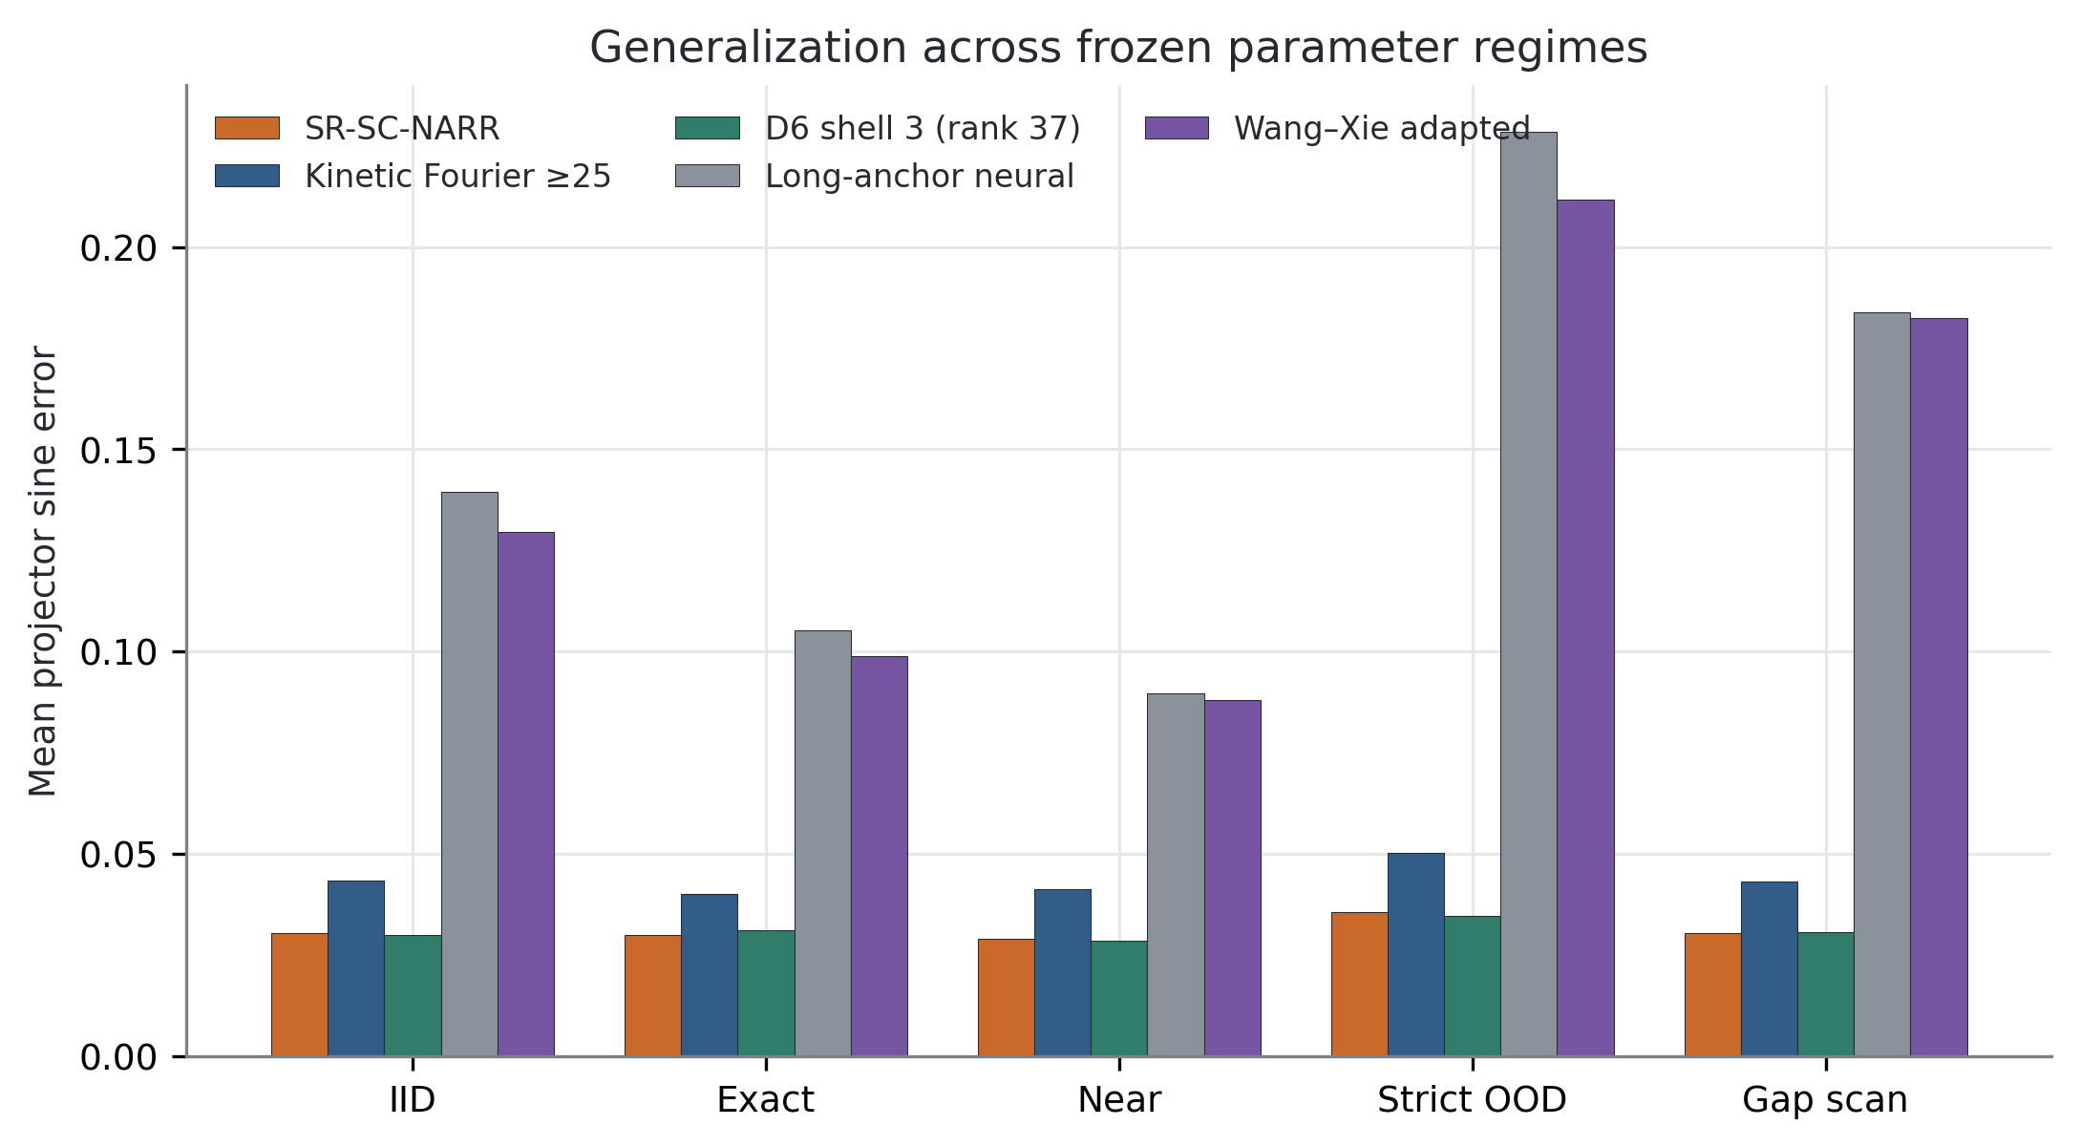
Figure 2. Error across IID, exact, near, strict-OOD, and gap-scan regimes.

6.2 The gain is conditional on potential spectral complexity
Table 2. Family-specific mean results.
Family | Method | Projector error | Eigenvalue MAE | Latency (ms)
Harmonic | SR-SC-NARR | 0.008120 | 0.000345 | 159.76
Harmonic | Kinetic Fourier ≥25 | 0.008120 | 0.000345 | 104.72
Harmonic | D6 shell 3 | 0.003370 | 0.000080 | 220.46
Harmonic | Fixed hybrid | 0.009831 | 0.000451 | 132.42
Gaussian | SR-SC-NARR | 0.053737 | 0.019329 | 193.53
Gaussian | Kinetic Fourier ≥25 | 0.078729 | 0.031646 | 106.39
Gaussian | D6 shell 3 | 0.058228 | 0.022470 | 220.27
Gaussian | Fixed hybrid | 0.053737 | 0.019329 | 137.20
All 80 harmonic points have $ρ≪0.1$, take the Fourier route, and exactly match the kinetic Fourier control. All 80 Gaussian points have $ρ∈[0.807,0.964]$, take the hybrid route, and reduce error by 31.75%. The Gaussian improvements for seeds 42, 137, and 251 are 30.5%, 32.6%, and 32.1%. Thus three of six family-by-seed cells are strict wins and all six are non-regressions.
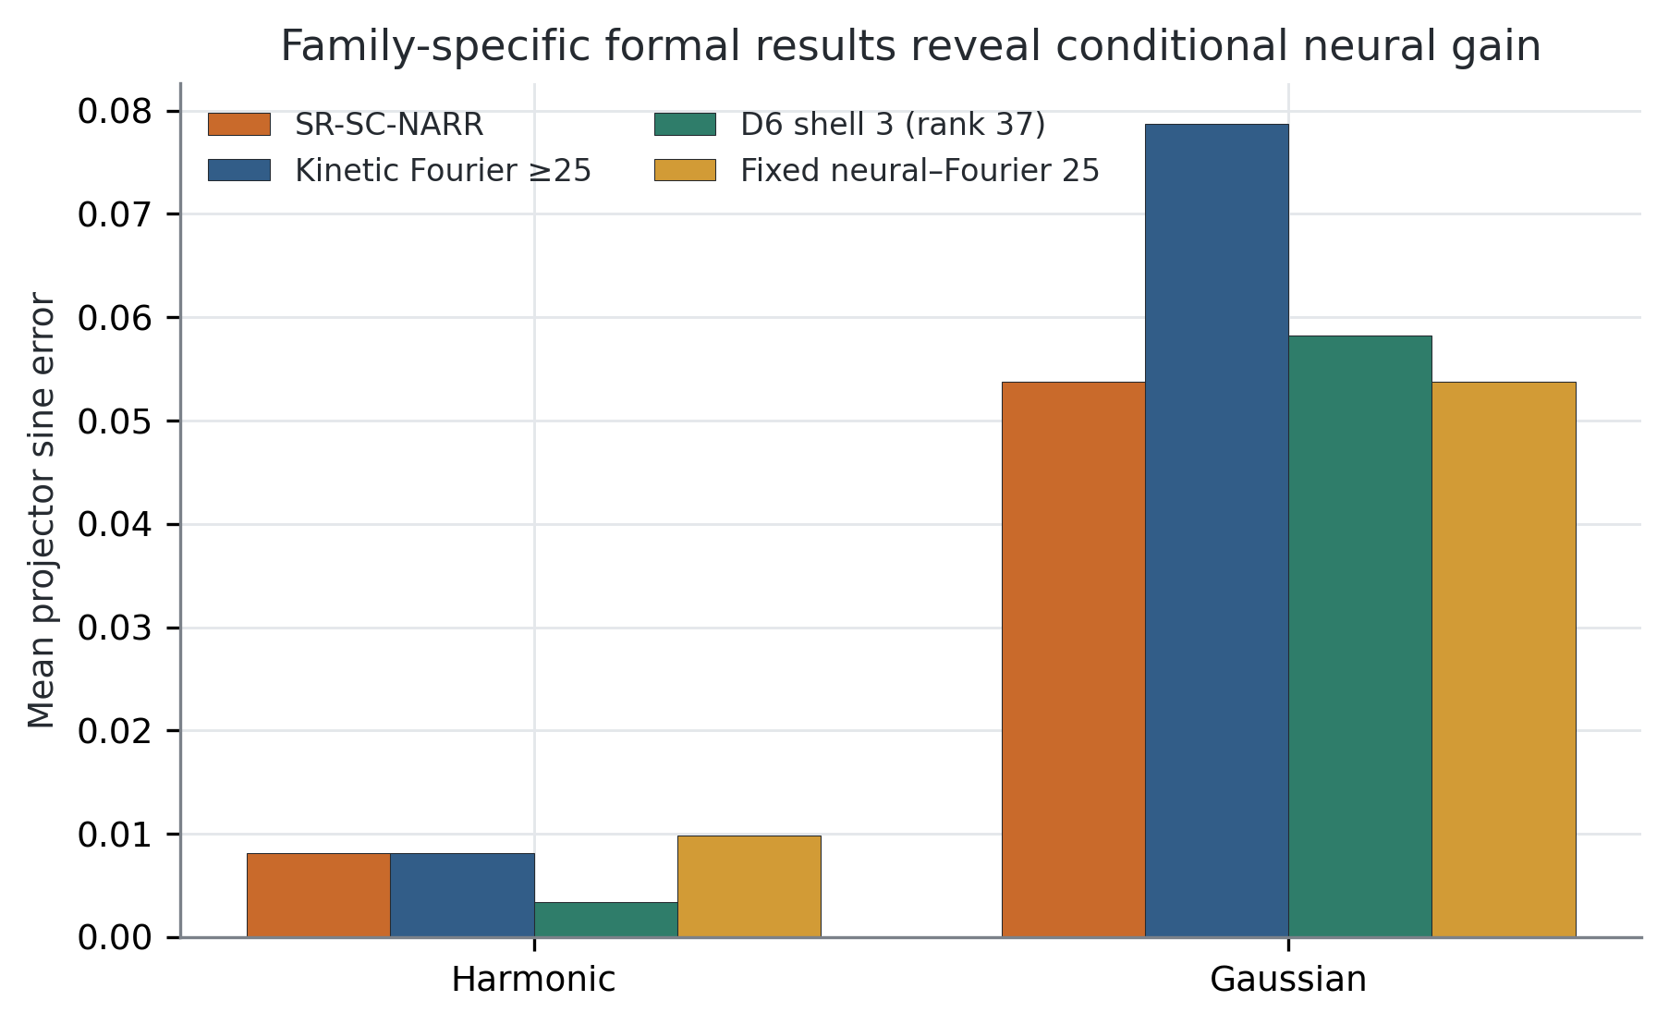
Figure 3. Family-specific formal results; the aggregate gain comes from the spectrally rich Gaussian endpoint.
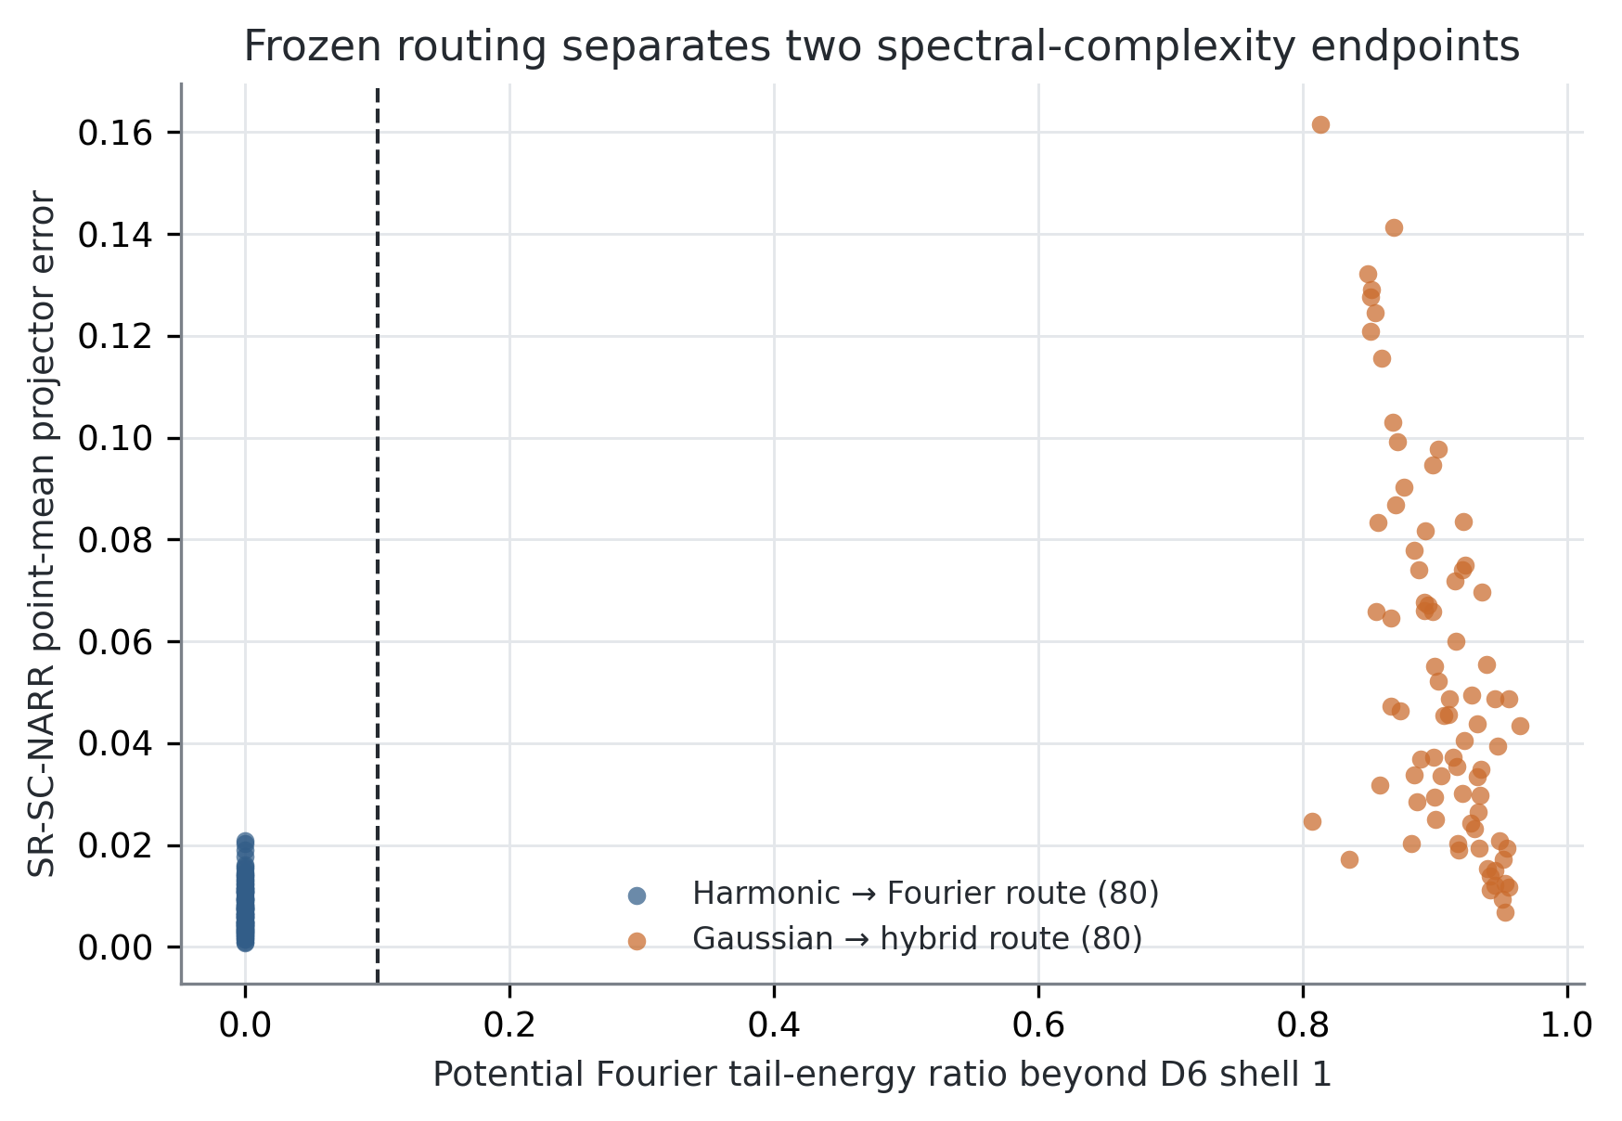
Figure 4. The formal set contains two separated tail-ratio endpoints and no samples near the frozen 0.1 threshold.

6.3 Routing ablation and cost
Pure kinetic Fourier-25 attains 0.04342 at 105.55 ms. Always using the hybrid improves error to 0.03178 but costs 134.81 ms. Routing improves aggregate error by a further 2.69% to 0.03093 because it avoids the inferior hybrid on harmonic cases, but current tail-ratio computation increases latency to 176.64 ms. The router is therefore a non-regressive conditional selector, not a speedup in the present implementation.
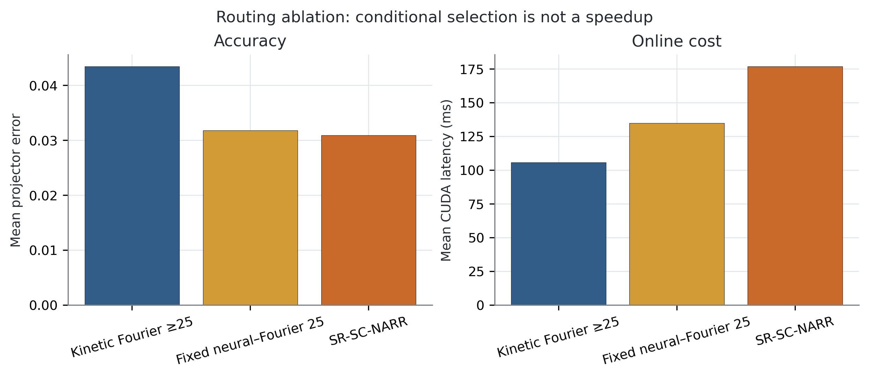
Figure 5. Routing ablation: conditional selection improves aggregate accuracy but adds online diagnostic cost.

6.4 Higher-rank Fourier context
Complete D6 shell-3 has slightly lower projector error than SR-SC-NARR: 0.030799 versus 0.030929, a 0.42% difference. The proposed method nevertheless has 12.75% lower eigenvalue MAE, 19.84% lower latency, and trial rank 25–27 rather than 37. On Gaussian cases, it also has 7.71% lower projector error than shell-3. This is a Pareto trade-off, not unconditional dominance in projector accuracy or execution time.
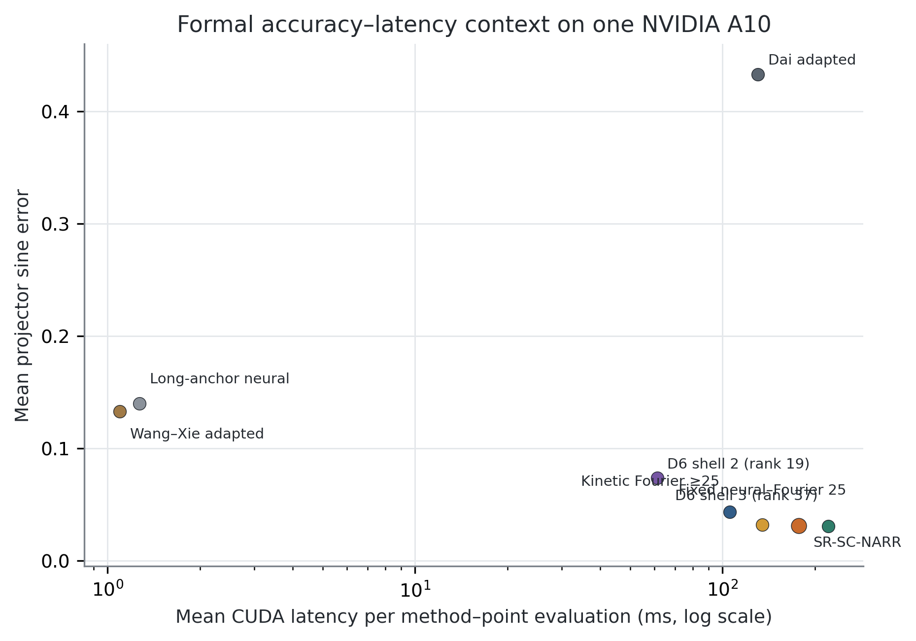
Figure 6. Accuracy-latency context on the formal A10 system.

6.5 Crossings and internal-gap behavior
The minimum external gap over the formal set is 0.01917. Exact-cluster gaps are numerically near zero, while near-cluster gaps remain below the preregistered bound. The projector metric remains defined throughout. Figure 7 plots error against the internal gap without assigning identities to the individual bands.
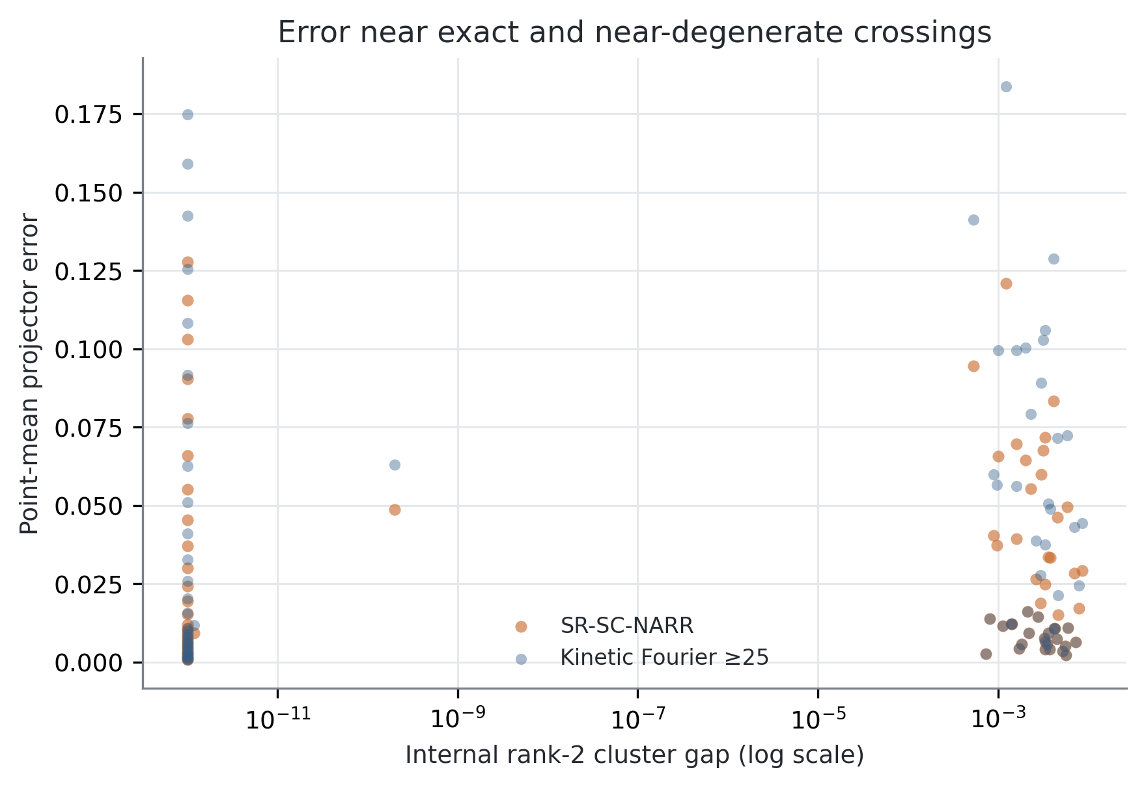
Figure 7. Point-mean projector error across exact and near-degenerate cases.

6.6 Numerical integrity
Table 3. Independent numerical checks.
Check | Observed | Frozen threshold
Reference projector, cutoff 24→28 | $1.51×{10}^{−6}$​ | $<{10}^{−3}$​
Reference eigenvalue, cutoff 24→28 | $6.95×{10}^{−10}$​ | $<{10}^{−5}$​
Solver projector, grid 65→97 | $2.10×{10}^{−4}$​ | $<{10}^{−3}$​
Solver eigenvalue, grid 65→97 | $4.77×{10}^{−7}$​ | $<{10}^{−4}$​
Proposed maximum raw Hermiticity defect | $7.13×{10}^{−6}$​ | $<{10}^{−4}$​
Maximum orthogonality error | $2.47×{10}^{−7}$​ | $<{10}^{−4}$​
Minimum external gap | 0.01917 | $>{10}^{−2}$​
The all-method maximum Hermiticity defect is larger because the poorly converged Dai adaptation reaches 0.00259. The formal gate correctly applies the Hermiticity threshold to the proposed method, not to unrelated baseline failure.

7. Discussion

7.1 Why a projector target is appropriate
At a crossing, individually ordered eigenvectors are not a continuous physical observable. A rank-two projector removes arbitrary phase, ordering, and internal rotation. External spectral isolation, rather than a positive internal gap, is the relevant stability condition. The network only needs to supply useful directions near the low-energy invariant space; the compact Ritz solve then uses the operator to select the final cluster.

7.2 Division of labor
The formal results reveal a clear division. Smooth harmonic potentials are already represented well by the tie-closed kinetic dictionary, so neural augmentation should be avoided. Localized Gaussian wells contain substantial Fourier energy outside the first shell; two learned parameter-dependent directions improve a compact analytic space. This mechanism is more precise than saying that a neural network “solves the PDE better” in every regime.

7.3 What the router has and has not established
The route is label-free and successfully avoids regression at the two observed endpoints. It has not been validated on potentials with $ρ$ close to 0.1, and route and family are perfectly confounded in the formal set. A continuous roughness sweep or a third intermediate-complexity family is therefore the most important external validation for future work. The frozen threshold must not be retuned on such a supplement.

7.4 Relation to neighboring methods
Wang–Xie [3] establishes joint trace-based neural eigenanalysis; Dai et al. [5] establish neural trial subspaces followed by Galerkin extraction; Chang et al. [6] address multiplicity over parameterized shape families; Fanaskov et al. [8] regress parameterized subspaces with labels; and Pau [9] applies reduced bases to repeated band calculations. SR-SC-NARR differs through the joint use of a label-free parameter network, a fixed-rank projector target at internal crossings, D6 and tie-closed analytic dictionaries, potential-only conditional augmentation, paired operator assembly, and a one-shot confirmation with a strong rank-37 Fourier context.

8. Limitations and Threats to Validity
The formal benchmark contains two potential families but only two well-separated spectral-tail regimes. It does not prove interpolation around the routing threshold or transfer to an unseen family. The method addresses only the lowest rank-two cluster on a two-dimensional periodic cell; higher clusters, three-dimensional crystals, and nonperiodic boundaries remain open.
The routing diagnostic adds approximately 42 ms relative to fixed hybrid and 71 ms relative to Fourier-25 on the formal system. A fused or precomputed diagnostic is needed before claiming a routing speed advantage. Formal latency is the mean of the randomized one-pass evaluation matrix; a dedicated repeated microbenchmark and component-level profiler would strengthen hardware claims.
The bootstrap interval resamples physical points and is conditional on three archived checkpoint seeds. It is not a population interval over arbitrary retraining randomness. Wang–Xie and Dai results are formula-level adaptations, not official author-code reproductions. The Dai adaptation converges poorly, so it is contextual rather than decisive evidence.
The formal experiment used PyTorch 2.10.0 although the development requirement originally pinned the 2.8 series. Full tests passed on the formal environment and source/checkpoint/reference hashes were unchanged, but the exact software version must be reported for reproducibility.
Internal-validity safeguards include a disjoint pilot, method and gate freezing before test generation, a clean CUDA opening, a single-use marker, complete identity and finite-value audits, independent cutoff/grid convergence, and an evidence archive binding source, suite, reference, manifest, marker, rows, summary, gate, and provenance.

9. Conclusion
We introduced SR-SC-NARR, a conditional neural-augmented Rayleigh–Ritz solver for the lowest spectral cluster of a parameterized two-dimensional Bloch–Schrödinger PDE. The method combines a label-free generalized-trace network with D6-consistent, tie-closed Fourier trial spaces and a potential-only spectral-tail diagnostic. It predicts a rank-two projector rather than separately ordered bands and remains meaningful at internal crossings.
On a single procedurally frozen 160-point CUDA confirmation, the solver reduces mean projector error by 28.76% relative to minimum-rank-25 kinetic Fourier, with a conditional 95% interval of [28.08%, 29.44%]. The gain comes entirely from the spectrally rich Gaussian family; the harmonic family safely falls back to Fourier. Relative to rank-37 shell-3, the proposed method is a lower-rank, lower-eigenvalue-error, lower-latency Pareto alternative with nearly identical mean projector accuracy. The evidence supports journal submission under a conditional neural-augmentation claim. The clearest route toward a stronger general algorithm claim is a preregistered, fixed-threshold roughness sweep spanning the empty interval between the two formal spectral endpoints.

Reproducibility and Data Availability
Code, frozen suites, the reference cache, raw rows, summaries, gates, provenance, figures, and evidence archives are maintained at https://github.com/Lazywords2006/PINN-PDE. The formal evidence SHA-256 is 108a4b042549ead58f7b13f42b6ace4685e93a4e8a54e9563b044c03c29ad78c. The formal suite is permanently closed and must not be rerun or used for threshold tuning.

Ethics, Conflict of Interest, Funding, and AI Disclosure
This work involves no human participants, animals, personal data, or clinical decisions. The authors declare no known conflict of interest, subject to confirmation by the final author list. Funding information has not yet been supplied. Generative AI assisted with code review, document organization, and language editing; the authors remain responsible for the mathematics, citations, software, experiments, numerical values, and final manuscript.

References
[1] M. Raissi, P. Perdikaris, and G. E. Karniadakis, “Physics-informed neural networks: A deep learning framework for solving forward and inverse problems involving nonlinear partial differential equations,” Journal of Computational Physics, 378, 686–707, 2019. https://doi.org/10.1016/j.jcp.2018.10.045
[2] A. Kovacs et al., “Conditional physics informed neural networks,” Communications in Nonlinear Science and Numerical Simulation, 104, 106041, 2022. https://doi.org/10.1016/j.cnsns.2021.106041
[3] Y. Wang and H. Xie, “Computing multi-eigenpairs of high-dimensional eigenvalue problems using tensor neural networks,” Journal of Computational Physics, 506, 112928, 2024. https://doi.org/10.1016/j.jcp.2024.112928
[4] C. Rowan, J. Evans, K. Maute, and A. Doostan, “Solving engineering eigenvalue problems with neural networks using the Rayleigh quotient,” International Journal for Numerical Methods in Engineering, 126, e70209, 2025. https://doi.org/10.1002/nme.70209
[5] X. Dai, Y. Fan, and Z. Sheng, “Subspace method based on neural networks for solving eigenvalue problems,” Communications in Nonlinear Science and Numerical Simulation, 161, 110060, 2026. https://doi.org/10.1016/j.cnsns.2026.110060
[6] Y. Chang et al., “Shape Space Spectra,” ACM Transactions on Graphics, 44(4), 1–16, 2025. https://doi.org/10.1145/3731148
[7] L. Grubišić, M. Saarikangas, and H. Hakula, “Stochastic collocation method for computing eigenspaces of parameter-dependent operators,” Numerische Mathematik, 153, 85–110, 2023. https://doi.org/10.1007/s00211-022-01339-3
[8] V. Fanaskov et al., “Deep Learning for Subspace Regression,” International Conference on Learning Representations, 2026. https://openreview.net/forum?id=HF60Lu1Maj
[9] G. S. H. Pau, “Reduced-basis method for band structure calculations,” Physical Review E, 76, 046704, 2007. https://doi.org/10.1103/PhysRevE.76.046704
[10] T. Horger, B. Wohlmuth, and T. Dickopf, “Simultaneous reduced basis approximation of parameterized elliptic eigenvalue problems,” ESAIM: M2AN, 51(2), 443–465, 2017. https://doi.org/10.1051/m2an/2016025
[11] C. L. Fefferman and M. I. Weinstein, “Honeycomb lattice potentials and Dirac points,” Journal of the American Mathematical Society, 25(4), 1169–1220, 2012. https://doi.org/10.1090/S0894-0347-2012-00745-0
[12] B. Haasdonk et al., “A new certified hierarchical and adaptive RB-ML-ROM surrogate model for parametrized PDEs,” SIAM Journal on Scientific Computing, 45(3), A1039–A1065, 2023. https://doi.org/10.1137/22M1493318
[13] C. Hsu et al., “Equation-driven neural networks for periodic quantum systems,” NeurIPS Workshop on Machine Learning and the Physical Sciences, 2024. https://neurips.cc/virtual/2024/99978
[14] H. Jin, M. Mattheakis, and P. Protopapas, “Physics-Informed Neural Networks for Quantum Eigenvalue Problems,” International Joint Conference on Neural Networks, 2022. https://doi.org/10.1109/IJCNN55064.2022.9891944
[15] C. Davis and W. M. Kahan, “The rotation of eigenvectors by a perturbation. III,” SIAM Journal on Numerical Analysis, 7(1), 1–46, 1970. https://doi.org/10.1137/0707001
[16] W. E and B. Yu, “The Deep Ritz Method: A Deep Learning-Based Numerical Algorithm for Solving Variational Problems,” Communications in Mathematics and Statistics, 6(1), 1–12, 2018. https://doi.org/10.1007/s40304-018-0127-z
[17] N. Kovachki et al., “Neural Operator: Learning Maps Between Function Spaces With Applications to PDEs,” Journal of Machine Learning Research, 24(89), 1–97, 2023. https://jmlr.org/papers/v24/21-1524.html
[18] S. W. Cheung, Y. Choi, S. W. Chung, J.-L. Fattebert, C. Kendrick, and D. Osei-Kuffuor, “Theory and numerics of subspace approximation of eigenvalue problems,” Applied Mathematics and Computation, 511, 129722, 2026. https://doi.org/10.1016/j.amc.2025.129722
[19] D. Peterseim, J.-F. Pietschmann, J. Püschel, and K. Rueß, “Neural network acceleration of iterative methods for nonlinear Schrödinger eigenvalue problems,” Journal of Computational and Applied Mathematics, 485, 117414, 2026. https://doi.org/10.1016/j.cam.2026.117414
[20] F. Bertrand, D. Boffi, and A. Halim, “Data-driven reduced order modeling for parametric PDE eigenvalue problems using Gaussian process regression,” Journal of Computational Physics, 495, 112503, 2023. https://doi.org/10.1016/j.jcp.2023.112503
[21] J. Dölz and D. Ebert, “On Uncertainty Quantification of Eigenvalues and Eigenspaces with Higher Multiplicity,” SIAM Journal on Numerical Analysis, 62(1), 422–451, 2024. https://doi.org/10.1137/22M1529324
[22] H. Li, J. Sun, and Z. Zhang, “Deep Eigenspace Network for Parametric Non-Self-Adjoint Eigenvalue Problems,” arXiv:2512.20058, 2026. https://arxiv.org/abs/2512.20058
[23] Z. Hao et al., “PINNacle: A Comprehensive Benchmark of Physics-Informed Neural Networks for Solving PDEs,” Advances in Neural Information Processing Systems 37, 76721–76774, 2024. https://doi.org/10.52202/079017-2442
[24] N. McGreivy and A. Hakim, “Weak baselines and reporting biases lead to overoptimism in machine learning for fluid-related partial differential equations,” Nature Machine Intelligence, 6(10), 1256–1269, 2024. https://doi.org/10.1038/s42256-024-00897-5
[25] S. Kapoor and A. Narayanan, “Leakage and the reproducibility crisis in machine-learning-based science,” Patterns, 4(9), 100804, 2023. https://doi.org/10.1016/j.patter.2023.100804

