A Basis-Invariant Neural-Augmented Rayleigh-Ritz Solver for Parametric Bloch Spectral Clusters with Eigenvalue Crossings
[Author Name(s)]

[Department, Institution, City, Country]

Corresponding author: [Name, email, ORCID]

Manuscript type: Original Article

Abstract
Parameterized Bloch eigenproblems require repeated PDE solves, while internal band crossings make individually ordered eigenfunctions discontinuous. We propose a basis-invariant neural-augmented Rayleigh–Ritz solver for the lowest rank-two spectral cluster of a two-dimensional periodic Bloch–Schrödinger equation. A lightweight SiLU multilayer perceptron learns a label-free neural coarse space through a generalized-trace objective. At inference, this space is augmented by the complete second hexagonal Fourier shell. Automatic differentiation is used only for the two neural columns; Hamiltonian actions on 19 plane waves are assembled analytically, and paired orthogonalization produces a compact Ritz problem. A one-shot frozen test contains 640 parameter points, two honeycomb potential families, three checkpoint seeds, ten methods, and 19,200 paired evaluations. The proposed solver attains an overall projector error of 0.04532, compared with 0.14719 for a compute-matched long-anchor network and 0.13697 for a same-rank Fourier-only control. Its improvement over long-anchor is 69.19%, with a point-clustered 95% interval of [67.66%, 70.75%]. On a separate 160-point journal-baseline supplement, P2 attains 0.04728 versus 0.13114 for a Wang–Xie trace adaptation, an improvement of 63.78% with a 95% interval of [59.58%, 67.88%], and wins all six family-by-seed comparisons. The results support a reproducible accuracy-cost trade-off at internal crossings. The method is a hybrid neural numerical eigensolver rather than a conventional residual PINN or a purely Fourier solver.
Keywords: neural PDE solver; parametric eigenproblem; Bloch–Schrödinger equation; spectral cluster; Rayleigh–Ritz; basis invariance; scientific machine learning

1. Introduction
Physics-informed neural networks incorporate differential equations, boundary conditions, or variational principles into network training, enabling approximation with few or no solution labels [1]. Their appeal is especially strong for parameterized problems: one trained model can serve many operator instances. Conditional PINNs have demonstrated this idea for classes of eigenvalue problems [2]. Differential eigenproblems, however, introduce complications absent from standard initial-boundary-value problems. A solver must avoid the trivial zero function, identify multiple eigenstates, enforce normalization and orthogonality, and remain meaningful at multiplicities and crossings.
Bloch–Schrödinger operators with two-dimensional honeycomb potentials can exhibit conical Dirac crossings at vertices of the Brillouin zone [11]. At such a crossing, separate labels for the first and second bands do not define a globally continuous target. Their eigenvectors may also undergo arbitrary unitary rotations within the degenerate eigenspace. Regressing ordered eigenfunctions or minimizing separate residuals can therefore mistake a representational choice for a physical solution. In contrast, if the lowest two states remain separated from the third state by an external spectral gap, their rank-two eigenspace and spectral projector remain well-defined [7].
Several existing lines of work supply components of a solution. Wang and Xie used tensor neural networks and a trace objective to compute multiple eigenpairs jointly [3]. Rowan et al. combined Rayleigh quotients with Gram–Schmidt orthogonalization for engineering eigenproblems [4]. Dai et al. constructed neural trial subspaces and solved a projected Galerkin eigenproblem [5]. Parameterized neural eigenanalysis has also been studied through dynamic mode reordering in Shape Space Spectra [6], supervised Grassmannian subspace regression [8], and equation-driven networks for periodic quantum systems [13]. Classical reduced-basis methods have long addressed Bloch band structures [9] and parameter-dependent multiple eigenspaces [10]. Consequently, this work does not claim Ky Fan principles, trace objectives, Fourier bases, Galerkin projection, or Rayleigh–Ritz as standalone inventions.
We address a narrower question: can a lightweight, label-free parameter network supply an amortized coarse space for an internally crossing Bloch cluster, and can a fixed analytic Fourier shell correct that space without turning inference into a full high-cutoff plane-wave solve? The contributions are as follows.
Contribution 1 — Crossing-aware target. The lowest two Bloch states are formulated as a rank-two projector-learning problem. Training, refinement, and evaluation are insensitive to column permutations, phases, and unitary rotations within the target cluster. Contribution 2 — Neural-analytic trial space. A compact trial space combines a label-free neural coarse basis with the complete second hexagonal Fourier shell. A same-rank Fourier-only control isolates the contribution of the neural component. Contribution 3 — Paired fast assembly. Hamiltonian assembly is split by column type. Only the two neural columns use automatic differentiation. The 19 Fourier columns use an analytic action. The same orthogonalization transform is applied to each pair $(w,Hw)$. Contribution 4 — Frozen evidence protocol. Evaluation uses an independent pilot, a one-shot frozen test, and a disjoint journal-baseline supplement, with clustered bootstrap intervals, timing, and hash-bound evidence auditing.
The claims in this draft are limited to this combined mechanism and the archived benchmarks. The supplement contains formula-level Bloch adaptations of Dai et al. and Wang and Xie; they are not represented as official reproductions of the authors’ software.

2. Related Work

2.1 Neural PDE and eigenvalue solvers
Conventional PINNs minimize pointwise differential residuals together with boundary, initial, and optional data terms [1]. Eigenproblems complicate this construction because eigenvalues are unknown, the zero function satisfies a homogeneous residual, and multiple states require normalization and orthogonality. Jin et al. introduced unsupervised neural quantum eigensolvers with normalization and orthogonality losses [14]. Kovacs et al. extended conditional PINNs so that one network covered a class of eigenproblems [2]. These studies establish the feasibility of label-free neural eigenanalysis, but individually represented states may still be discontinuous at crossings.
Wang and Xie optimized multiple eigenpairs together using tensor neural networks and a trace objective [3], showing that joint subspace-style optimization can avoid some limitations of serial deflation. Rowan et al. demonstrated that Rayleigh quotient minimization and Gram–Schmidt provide a simple, reliable combination for continuous engineering eigenproblems [4]. These works motivate our variational coarse network. They do not, however, evaluate a single parameter network that predicts a fixed-rank low-energy projector through internal Bloch crossings.

2.2 Neural subspaces, Galerkin projection, and parametric eigenspaces
Dai, Fan, and Sheng train neural basis functions and project an eigenproblem onto their span [5]. This is the closest journal method to the present solver and must be treated as a direct baseline. Our setting differs in its parameterized Bloch cluster, physical anchor, closed reciprocal shell, analytic Fourier Hamiltonian, and paired orthogonalization. Whether these differences produce a consistent advantage has been examined with an independent formula-level Bloch adaptation. The remaining gap to an official author implementation is acknowledged as a limitation.
Shape Space Spectra uses a neural field across continuously parameterized shape families and dynamically reorders individual eigenfunctions at multiplicities [6]. We avoid assigning an identity within the cluster and directly evaluate the rank-two projector. Fanaskov et al. formulate parameter-to-subspace prediction as supervised Grassmann regression [8], whereas our training loss does not access plane-wave projector labels. Grubišić et al. show that an externally isolated parametric eigenspace can retain regular parameter dependence in the presence of internal crossings [7], supporting the cluster rather than bandwise formulation used here.

2.3 Bloch reduced bases and periodic quantum networks
Pau applied reduced bases to repeated band-structure calculations [9]. Horger et al. developed simultaneous reduced-basis approximation for parameterized elliptic eigenproblems and emphasized parameter-dependent multiplicity and error estimation [10]. Hsu et al. trained equation-driven networks for band structures and wavefunctions in two-dimensional periodic quantum systems [13]. Haasdonk et al. built a hierarchical full-order, reduced-order, and machine-learning chain with a posteriori certification [12], reinforcing the need to report accuracy, cost, and reliability for hybrid neural numerical solvers rather than neural forward time alone. Together these papers place the present study at the intersection of neural PDE solvers, amortized eigenspaces, and band-structure model reduction. They also narrow the novelty claim: the contribution must be the complete crossing-aware neural-plus-analytic mechanism and its controlled validation, not the use of a honeycomb potential or Fourier basis alone.

3. Problem Formulation

3.1 Bloch–Schrödinger eigenproblem
On the periodic cell $Ω=[0,2π)^{2}$, we consider
$$H_{k,μ}u_{j}=\left[\frac{1}{2}(−i∇+k)^{T}G(−i∇+k)+V_{μ}(x)\right]u_{j}=E_{j}u_{j},$$
with periodic function and first-derivative boundary conditions. For reciprocal mode $m=(m_{1},m_{2})$, the implemented kinetic energy is
$$T(m,k)=\frac{1}{2}\left[(m_{1}+k_{1})^{2}+(m_{2}+k_{2})^{2}+(m_{1}+k_{1})(m_{2}+k_{2})\right].$$
The harmonic honeycomb family is
$$V_{a,δ}(x,y)=a[cosx+cosy+cos(x−y)]+δ[sinx−siny−sin(x−y)],$$
where $a∈[0.2,0.8]$ and $δ∈[−0.08,0.08]$. The Gaussian honeycomb family contains two periodically repeated Gaussian sublattices and is parameterized by amplitude $a∈[1,4]$, width $σ∈[0.18,0.35]$, and imbalance $δ∈[−0.08,0.08]$. For both families, the training box uses $k_{x},k_{y}∈[0.28,0.38]$.

3.2 Cluster target and error metric
Let $U_{2}(k,μ)$ denote the span of the two lowest eigenstates and let $P_{2}$ be its orthogonal projector. The internal gap $E_{2}−E_{1}$ may vanish, but the external gap $E_{3}−E_{2}$ should remain positive. Given predicted and reference bases $Q$ and $Q_{⋆}$, the primary metric is the root-mean-square sine of their principal angles,
$$e_{proj}=\sqrt{\frac{2−{\left\|Q^{*}Q_{⋆}\right\|}_{F}^{2}}{2}}.$$
This is equivalently a normalized Frobenius discrepancy between the rank-two projectors. It is invariant to column order, complex phase, and unitary rotation within either basis.
Reference solutions are generated by a float64 plane-wave expansion (PWE) with cutoff 24 and rank 3, then evaluated on a 33 by 33 periodic grid. PWE eigenvectors and projectors are used only for testing and audit, never as labels for the variational neural training.

4. Method

4.1 Label-free neural coarse space
The network input is
$$[sinx,cosx,siny,cosy,k,μ].$$
Three width-64 SiLU hidden layers output real and imaginary components of two complex periodic functions. The harmonic and Gaussian networks contain 9,156 and 9,220 trainable parameters, respectively. A fixed combination of low-energy plane waves near the K point supplies a physical anchor, and the MLP learns an additive correction. Training uses Adam with learning rate ${10}^{−3}$, four parameter instances per batch, and 256 shifted periodic grid points per instance. The final long-anchor checkpoints were trained for 665 steps with seeds 42, 137, and 251.
For a raw trial matrix $Z_{θ}$, define
$$B_{θ}=Z_{θ}^{*}Z_{θ}, A_{θ}=Z_{θ}^{*}HZ_{θ}.$$
The label-free objective is the generalized trace
$$L_{trace}=Tr(B_{θ}^{−1}A_{θ}).$$
No reference eigenvector, projector, or band label enters the loss. Complex modified Gram–Schmidt under equal-weight cell quadrature produces the neural coarse basis $Q_{θ}$ for evaluation and refinement.

4.2 Complete second-shell augmentation
Define the closed hexagonal reciprocal dictionary
$$M_{2}=\{(m_{1},m_{2})∈Z^{2}:max(|m_{1}|,|m_{2}|,|m_{1}−m_{2}|)≤2\}.$$
It contains 19 plane waves $ϕ_{m}(x)=e^{im⋅x}$. The augmented trial matrix is
$$W=[Q_{θ},\{ϕ_{m}:m∈M_{2}\}].$$
Each analytic column is projected against previously accepted columns. Directions with projected norm below ${10}^{−5}$ are rejected. The complete configuration normally yields a 21-dimensional space. Because augmentation operates on the span, any unitary rotation of the two neural columns leaves the final trial space unchanged.

4.3 Analytic Hamiltonian action and paired orthogonalization
PyTorch automatic differentiation is used to calculate $HQ_{θ}$ for the two neural columns. For a plane wave,
$$Hϕ_{m}=\left[T(m,k)+V_{μ}(x)\right]ϕ_{m},$$
so all 19 analytic columns avoid second-order autograd graphs. During orthogonalization, every complex linear transformation applied to a trial vector $w$ is also applied to $Hw$. This produces a paired basis $(\hat{W},H\hat{W})$, preserves the linear Hamiltonian relation, and removes the need to differentiate the augmented basis again.

4.4 Compact Ritz extraction
The reduced Hermitian matrix is
$$A_{W}={\hat{W}}^{*}H\hat{W}.$$
Its two lowest Ritz vectors are mapped back to the function grid to obtain the final rank-two basis. P2 adds no learned parameters and never reads the reference projector at inference. The pipeline is
$$(x,k,μ)\overset{\text{label-free SiLU MLP}}{→}Q_{θ}\overset{+M_{2}}{→}\hat{W}\overset{\text{paired }(W,HW)}{→}A_{W}\overset{\text{Ritz}}{→}{\hat{U}}_{2}.$$
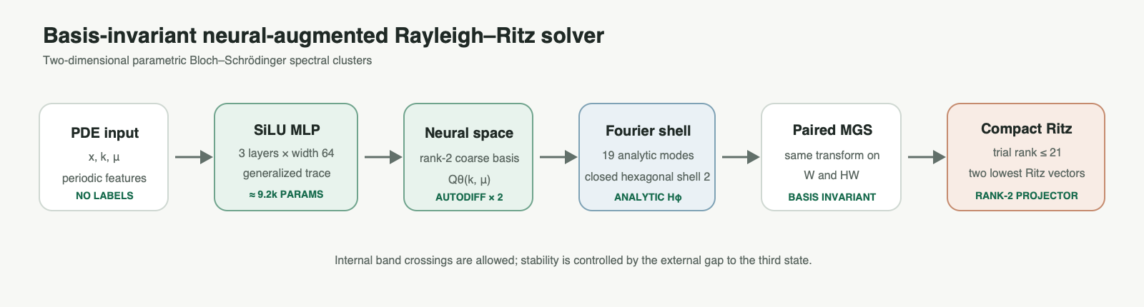
P2 method pipeline
Figure 1. Basis-invariant neural-augmented Rayleigh–Ritz pipeline.

4.5 External-gap stability
Let $U$ be the exact lowest rank-two invariant subspace, $Q$ an orthonormal Ritz basis, $M=Q^{*}HQ$, and $R=HQ−QM$. If the approximate Ritz spectrum is separated from the unwanted spectrum by
$$δ=dist(σ(M),σ(H|_{U^{⟂}}))>0,$$
then the Hermitian invariant-subspace residual bound [15] gives
$$e_{proj}≤\frac{{\left\|R\right\|}_{F}}{\sqrt{2} δ}.$$
The separation concerns the target cluster and the third state; it does not require a positive internal gap between the first two eigenvalues. The bound therefore remains meaningful at an internal Dirac crossing. The reported residual RMS is normalized over grid points, rank, and real/imaginary components and must be rescaled before insertion into this Frobenius-norm bound.

4.6 Complexity and amortization
For $N$ grid points, $M=19$ analytic modes, and trial rank $r≤21$, the online stage contains two neural Hamiltonian evaluations, $O(NM)$ analytic Fourier actions, $O(Nr^{2})$ paired orthogonalization, and an $O(r^{3})$ Ritz solve. The MLP linear layers require approximately 19.5 million FLOPs on the 33 by 33 grid. End-to-end FLOPs for second-order automatic differentiation depend on the backend, so measured wall time is reported instead of an unverified total. Archived timings give an approximate system-level training break-even of 206–354 repeated parameter queries.

5. Experimental Design

5.1 Development and freezing protocol
The low-frequency ROM studied in P5 was stopped because a compute-matched long-anchor network performed better near crossings and the ROM regressed on gap scans. P0 showed that failures were detectable, but P1 risk routing could not exceed the accuracy of its two endpoint subspaces and was also stopped. An initial outer-shell P2 probe improved near-crossing points but failed frozen gap and efficiency criteria. Only after the complete-shell method passed every preregistered gate on a new 96-point pilot, with two families and three seeds, was the 640-point frozen test opened once. It is now permanently closed.

5.2 Splits and comparisons
The frozen test contains 192 IID points, 64 exact-cluster points, 128 near-cluster points, 128 strict-OOD points, and 128 gap-scan points. Each family contributes 320 points. Ten methods are evaluated for three checkpoint seeds at every point, yielding 19,200 rows.
The comparison matrix contains unanchored trace, anchor, wide anchor, long anchor, static low-frequency ROM, high-frequency ROM, neural plus shell 1, neural plus outer shell 2, the proposed complete-shell method, and a Fourier-only rank-21 control. This is a controlled internal matrix. A second, disjoint suite evaluates explicit Bloch adaptations of Wang–Xie [3] and Dai [5].

5.3 Statistics and hardware
The primary confidence intervals use 2,000 bootstrap samples clustered by the 640 physical parameter points. All checkpoint seeds associated with a point are resampled together. Formal evaluation ran on an NVIDIA RTX 5090 D with 32 GB memory, PyTorch 2.8.0+cu128, and CUDA 12.8. Latency uses ten warmups followed by 100 repetitions. The PWE reference was timed on the CPU of the same server. This comparison represents system-level wall time, not a device-matched kernel benchmark.

5.4 Journal-baseline supplement
The supplementary suite contains 160 parameter points disjoint from all earlier decision sets, with 80 points per potential family and coverage of IID, exact-cluster, near-cluster, strict-OOD, and gap-scan regimes. Wang–Xie trace and rank-six Dai-style neural-subspace Galerkin adaptations are trained for 1,500 steps with three seeds under the same sampling and collocation budget. This budget exceeds the 665 steps used by the P2 neural initializer. All methods use the same cutoff-24 reference. The matrix contains 1,440 rows and uses 2,000 point-clustered bootstrap samples.

6. Results

6.1 Main comparison
Table 1. Frozen-final rank-two projector sine error (lower is better).
Method | Overall | Near | Gap scan
Unanchored trace | 0.19784 | 0.14589 | 0.21830
Anchor | 0.15650 | 0.10505 | 0.14050
Wide anchor | 0.15243 | 0.10020 | 0.15111
Long anchor | 0.14719 | 0.08924 | 0.15938
Static low-ROM | 0.15054 | 0.09542 | 0.14946
High-frequency ROM | 0.15531 | 0.10299 | 0.14809
Neural + shell 1 | 0.06172 | 0.04513 | 0.05768
Neural + outer shell 2 | 0.13410 | 0.07849 | 0.15656
Neural + complete shell 2 | 0.04532 | 0.03903 | 0.04389
Fourier-only rank 21 | 0.13697 | 0.12249 | 0.13700
The complete-shell solver gives the lowest error overall, near crossings, and on gap scans. Its overall improvement over long-anchor is 69.19%, with a point-clustered 95% interval of [67.66%, 70.75%]. The near-crossing improvement is 56.28%, with a 95% interval of [53.24%, 59.22%]. Both intervals remain far from zero.
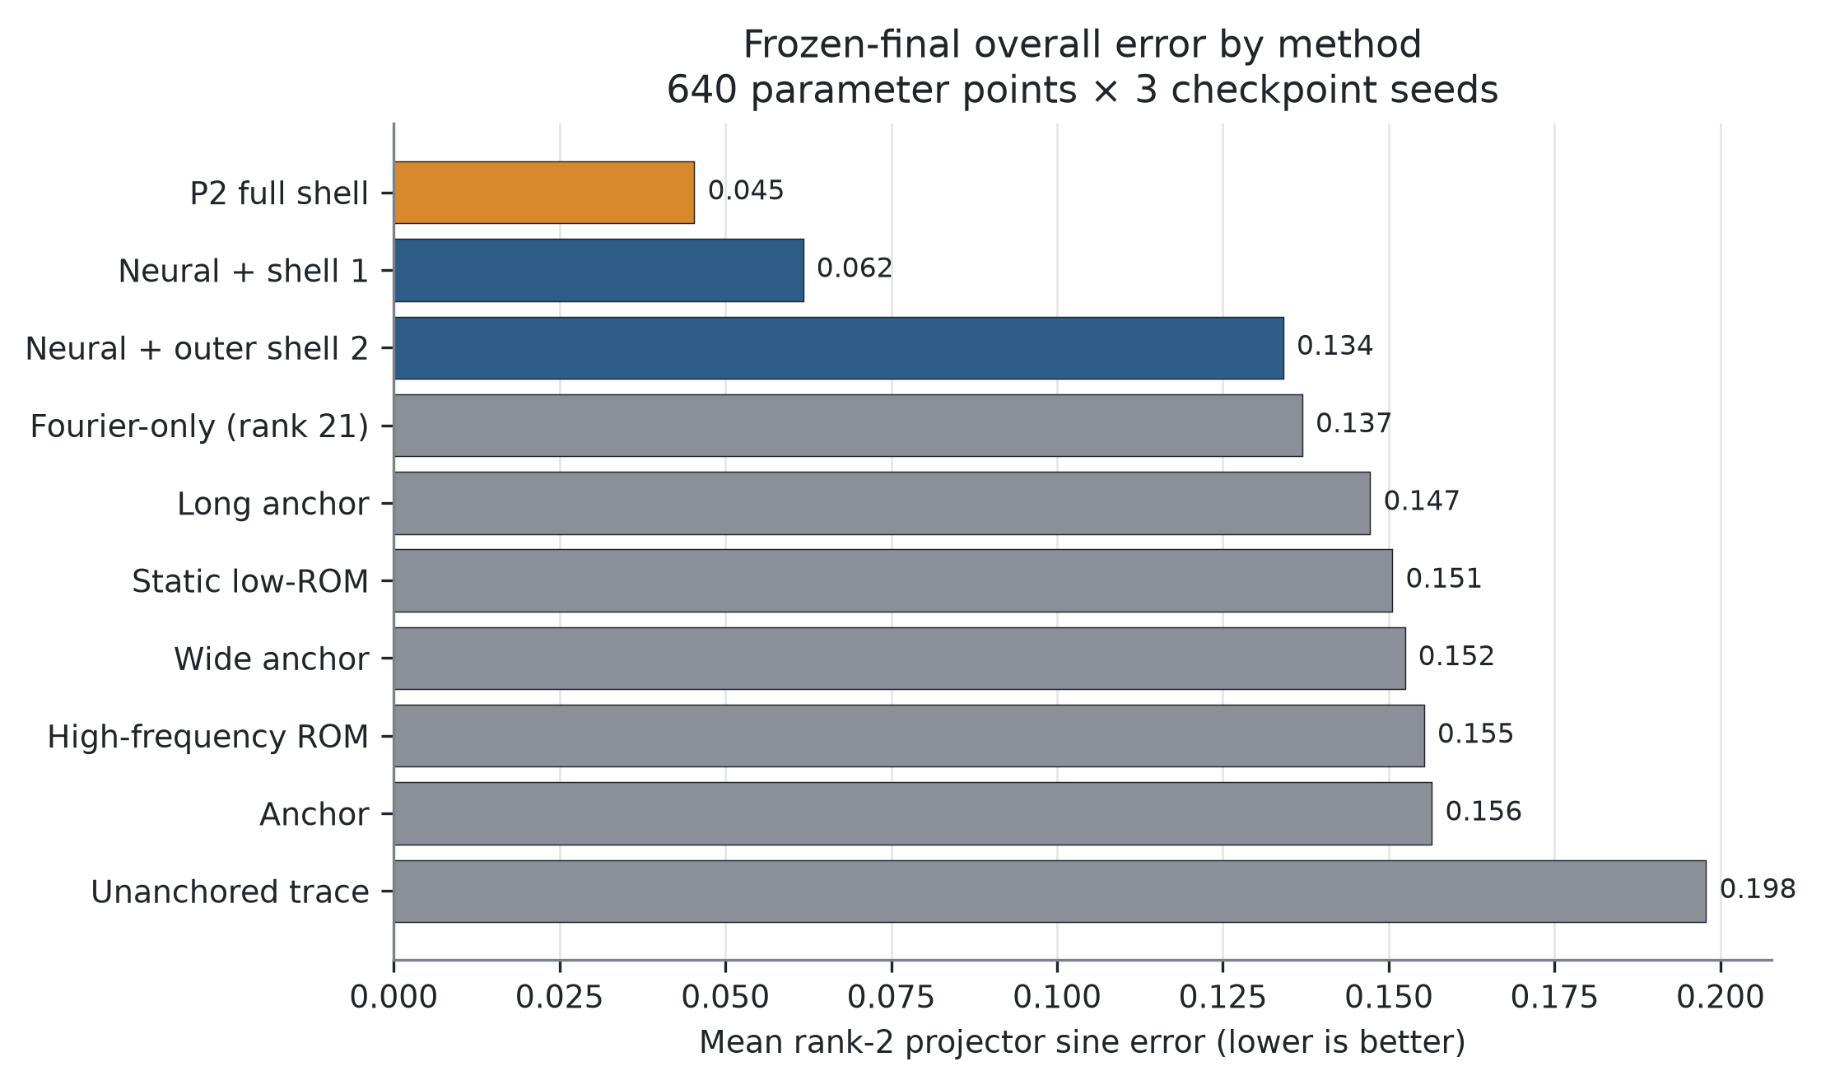
Frozen-final overall method comparison
Figure 2. Overall projector error for the ten frozen-final methods. Lower is better.

6.2 Parameter regimes and potential families
Errors on IID, exact-cluster, near-cluster, strict-OOD, and gap-scan points are 0.04383, 0.04220, 0.03903, 0.05685, and 0.04389. Long-anchor reaches 0.22921 on strict OOD, indicating that the gain is not confined to points selected around the crossing.
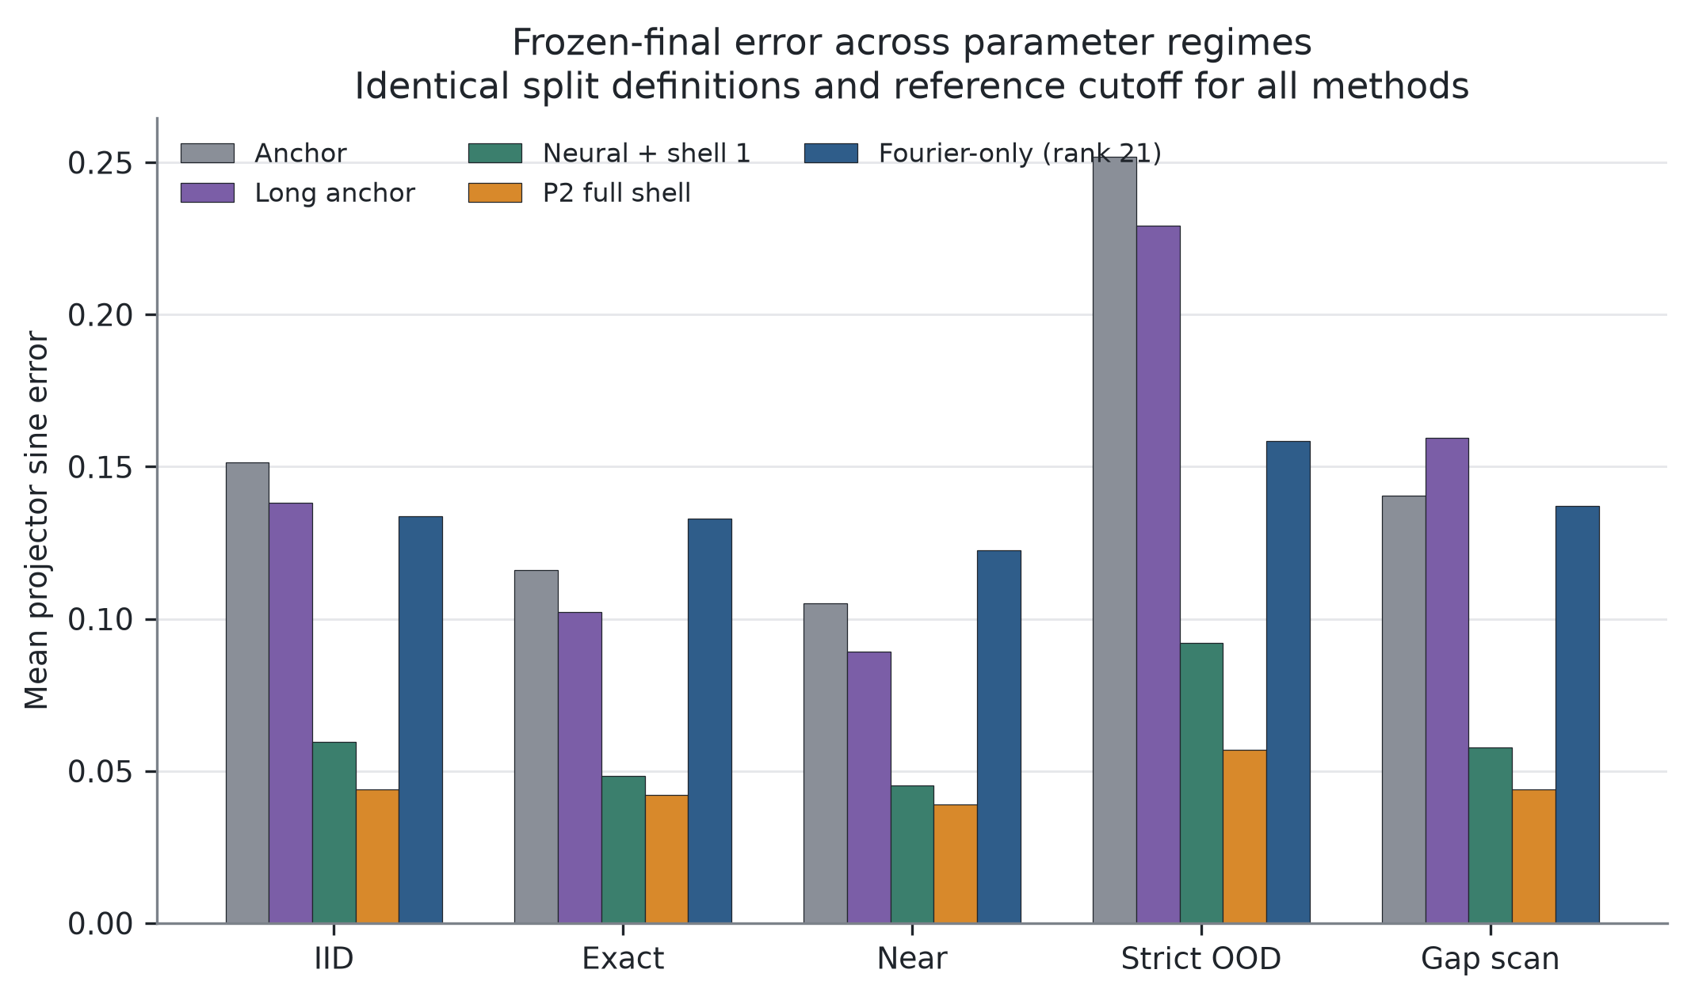
Projector error across five parameter regimes
Figure 3. Projector error across IID, exact-cluster, near-cluster, strict-OOD, and gap-scan regimes.
For harmonic near-cluster points, error decreases from 0.06508 to 0.03037. For the Gaussian family, it decreases from 0.11340 to 0.04770. The proposed solver wins all six family-by-checkpoint-seed comparisons. Overall errors across the three seeds are 0.04384, 0.04559, and 0.04654, with a standard deviation of 0.00137. Maximum orthogonality error is $3.12×{10}^{−7}$.
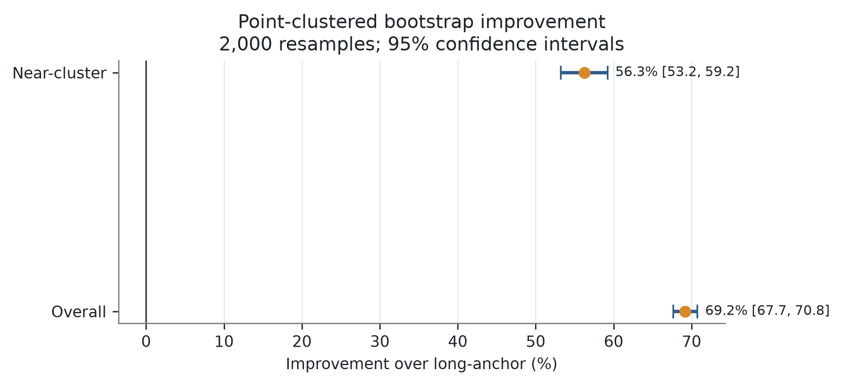
Point-clustered bootstrap intervals
Figure 4. Point-clustered bootstrap intervals for improvement over the long-anchor baseline.

6.3 Ablation evidence
The Fourier-only rank-21 control has overall error 0.13697, compared with 0.04532 for the proposed method. A fixed dictionary of equal nominal rank therefore does not explain the improvement. The parameter-dependent neural directions are essential. Shell 1 reaches 0.06172, and completing shell 2 reduces error to 0.04532. Adding only the outer second shell yields 0.13410, showing that the closed low-to-second-order reciprocal space is substantially more effective than an isolated outer ring.
All three shell variants reuse the same long-anchor checkpoints. Their differences arise from the inference-time trial space and Ritz extraction, not additional network training, learned parameters, or post-final tuning.

6.4 Efficiency
Mean inference time is 107.81 ms per parameter and the 95th percentile is 121.90 ms. The same-server cutoff-24 CPU PWE solve takes 313.44 ms on average, giving a ratio of 0.344. A neural forward pass alone remains close to 1 ms, so the proposed solver is not a cost-free correction. It occupies an intermediate accuracy-latency point between a fast neural surrogate and a high-accuracy direct eigensolve.
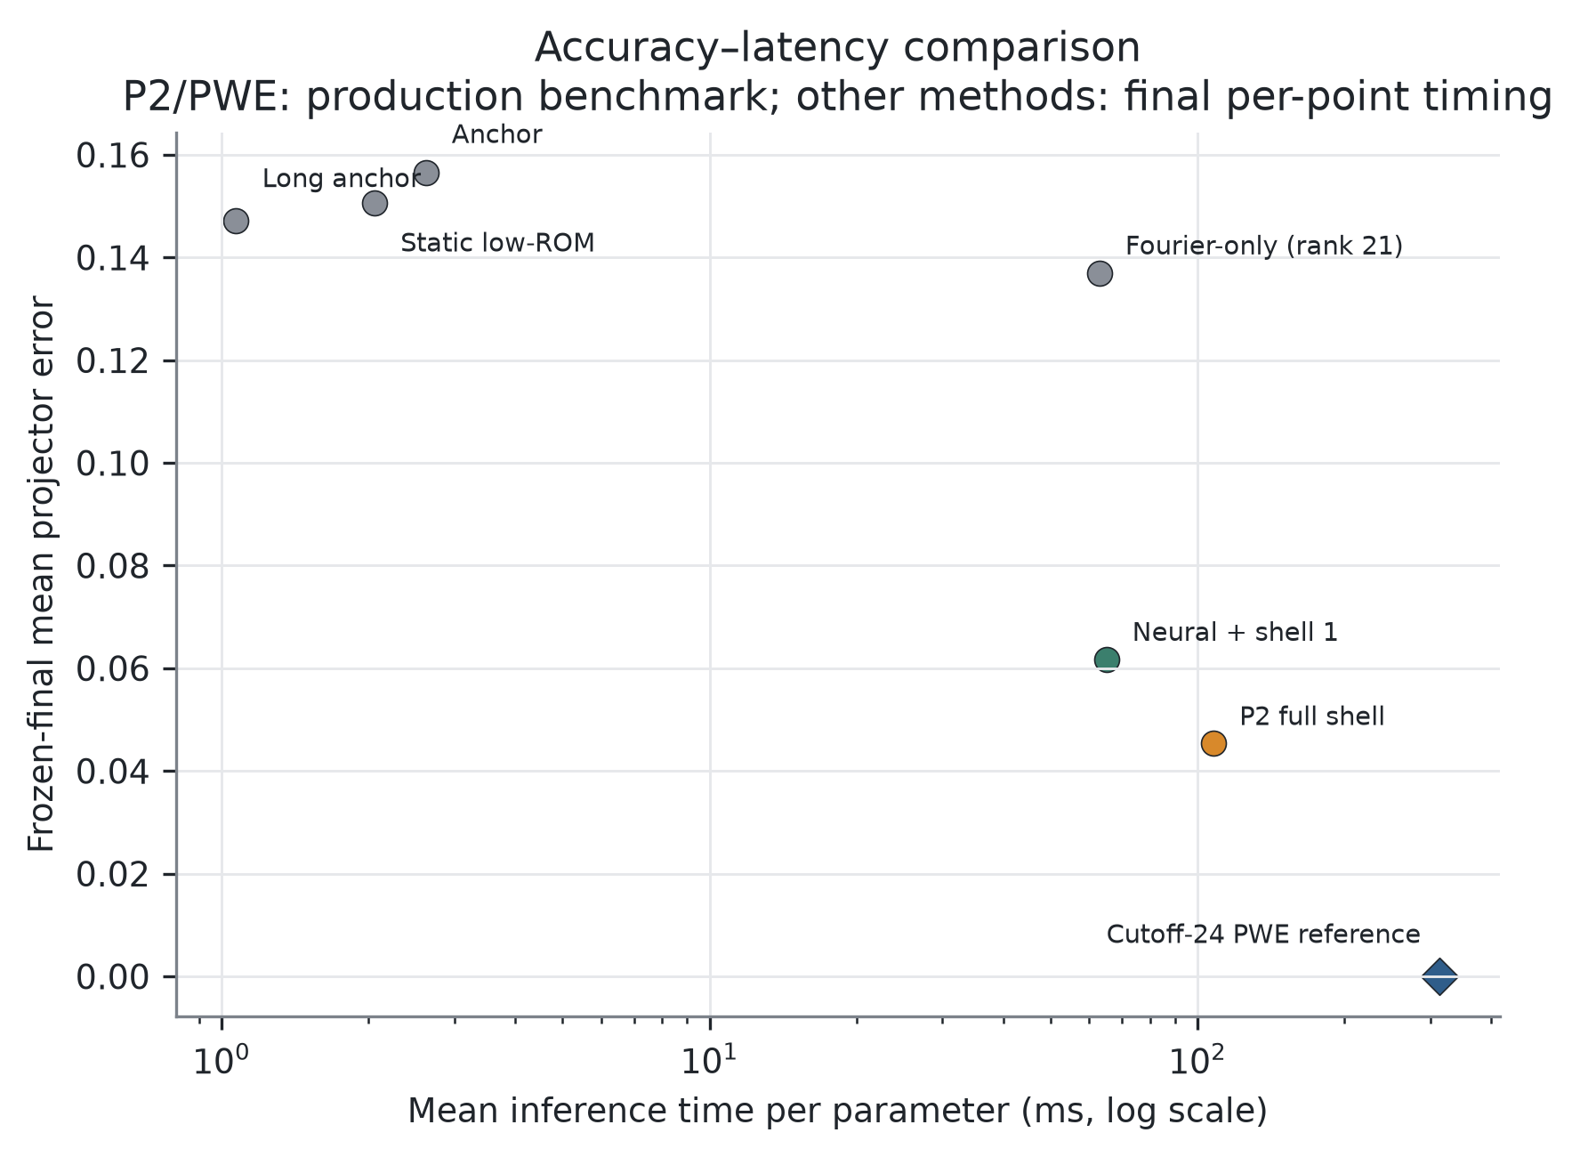
Accuracy-latency comparison
Figure 5. Accuracy-latency comparison. P2 lies between a single neural forward pass and the cutoff-24 reference solve.

6.5 Independent journal-baseline supplement
Table 2. Independent supplement results on 160 parameter points (lower is better).
Method | Overall | Near | Gap scan | Strict OOD
P2 full shell | 0.04728 | 0.03804 | 0.06727 | 0.05796
Wang–Xie trace adapted | 0.13114 | 0.09056 | 0.15110 | 0.21776
Dai Galerkin adapted | 0.43367 | 0.42376 | 0.47148 | 0.43758
P2 improves over the Wang–Xie adaptation by 63.78%, with a 95% interval of [59.58%, 67.88%], and over the Dai adaptation by 89.08%, with an interval of [88.10%, 90.01%]. It wins all six family-by-seed comparisons against both baselines. Mean latencies for P2, Wang–Xie, and Dai are 193.75, 2.47, and 205.56 ms, respectively. The Wang–Xie adaptation is therefore substantially faster but less accurate, whereas P2 and the Dai adaptation occupy a similar latency range.
The Dai adaptation converges poorly in the present parameterized Bloch setting. This result does not establish that the method of Dai et al. is ineffective. The strongest nearest-neighbor evidence is the stable P2 advantage over the parameter-matched Wang–Xie trace adaptation despite its larger training budget.

7. Discussion

7.1 Why the cluster formulation helps
Bandwise prediction turns a physically nonunique basis choice into a learning target. At a Dirac crossing, that choice can swap or rotate abruptly. Projector-based training and evaluation remove this artificial discontinuity. External spectral isolation keeps the target subspace meaningful, while the network only needs to place a compact trial space near it. Rayleigh–Ritz then selects the lowest-energy directions using the operator itself.

7.2 Division of labor between neural and numerical components
The neural network learns parameter-dependent low-energy directions that a small fixed Fourier dictionary does not capture uniformly. The analytic shell supplies structured correction directions, and the reduced Ritz solve restores operator consistency. This division explains why both pure neural and pure rank-21 Fourier controls underperform their combination. The scientific claim is therefore a controlled hybrid mechanism, not the replacement of classical numerical analysis by a neural network.

7.3 Relation to the closest literature
Wang and Xie [3] established trace-based neural computation of multiple eigenpairs. Dai et al. [5] established a neural-subspace-plus-Galerkin eigensolver. Chang et al. [6] addressed multiplicity and mode switching over parameterized families. Pau [9] applied reduced bases to band structures. The present method differs through the simultaneous use of a label-free Bloch parameter network, a rank-two projector target at internal crossings, an orthogonal-complement closed hexagonal shell, paired $(W,HW)$ transformations, and a frozen near/gap/OOD evaluation with a same-rank control.
The independent supplement shows a stable P2 advantage over a Wang–Xie trace adaptation in the same Bloch framework. Formula-level adaptations are not official author implementations, and the poor convergence of the Dai adaptation cannot support a claim of universal superiority to Dai et al. [5].

8. Limitations and Threats to Validity
The study covers two honeycomb potential families and only the lowest rank-two cluster. The results do not directly extend to higher-rank clusters, three-dimensional crystals, or nonperiodic boundary conditions. The supplement contains formula-level Bloch adaptations rather than official author-code reproductions, and the convergence of the Dai adaptation limits its comparative strength. The P2-to-PWE timing uses a GPU method and CPU reference and must be interpreted as a system configuration rather than a hardware-independent speedup. The manuscript provides symbolic complexity, neural-forward FLOPs, a break-even estimate, and an external-gap residual bound, but it does not yet contain profiler-based end-to-end hardware FLOPs for second-order automatic differentiation. Three formal training seeds are supported by clustered bootstrap statistics and six of six family-seed wins, but additional seeds may still be useful in supplementary experiments. The frozen test itself must not be rerun.
Internal-validity safeguards include a single final opening after an independent pilot, SHA-256 bindings for suites, references, checkpoints, source, and evidence packages, complete identity audits of 19,200 final rows and 1,440 supplementary rows, and independent local aggregation. The supplement verifies 89 manifest files in both remote and local audits.

9. Conclusion
We developed a basis-invariant neural-augmented Rayleigh–Ritz solver for an internally crossing spectral cluster of a two-dimensional parametric Bloch–Schrödinger PDE. A label-free SiLU network provides a parameter-dependent rank-two coarse space. A complete second hexagonal Fourier shell, analytic Hamiltonian actions, and a compact Ritz problem refine that space without accessing test projectors. Frozen evaluation reduces overall projector error from 0.14719 for the strongest pure neural baseline to 0.04532, with consistent gains across both potential families, all five parameter regimes, and every family-seed pairing.
The evidence supports the classification of this work as a genuine neural PDE eigensolver and is sufficient for journal submission preparation. It provides a strong Q4 foundation, while the independent journal-baseline supplement creates a realistic but not guaranteed Q3 opportunity. The target-journal package and publication-ready method diagram are complete. Optional CUDA profiler counts should be added only if requested; the frozen test and supplement remain closed.

Data Availability
Source code, frozen benchmarks, CSV/JSON outputs, evidence hashes, and figure-generation scripts are intended for public release before publication. The development repository is https://github.com/Lazywords2006/PINN-PDE. The frozen-final evidence SHA-256 is c653d0eddab018741312741f6db46f023a20812306d574b66947bbb42af25095.

Ethics Declaration
This work did not involve human participants, animals, or personal data.

Author Contributions (CRediT; pending author confirmation)
Conceptualization, methodology, software, validation, data curation, visualization, writing, and project-administration roles will be assigned after the author list is finalized.

Conflict of Interest
The authors declare no known conflict of interest. This statement must be reconfirmed by every author before submission.

Funding
No funding information has been provided. The final manuscript will list the actual grants or state that the work received no specific external funding.

AI-Assistance Disclosure
Generative AI assisted with document organization, language editing, and construction of the code evidence index. The authors remain responsible for verifying all mathematics, citations, experimental values, statistical claims, and final prose. The disclosure will be adapted to the policy of the selected journal.

References
[1] M. Raissi, P. Perdikaris, and G. E. Karniadakis, “Physics-informed neural networks: A deep learning framework for solving forward and inverse problems involving nonlinear partial differential equations,” Journal of Computational Physics, vol. 378, pp. 686–707, 2019. https://doi.org/10.1016/j.jcp.2018.10.045
[2] A. Kovacs et al., “Conditional physics informed neural networks,” Communications in Nonlinear Science and Numerical Simulation, vol. 104, 106041, 2022. https://doi.org/10.1016/j.cnsns.2021.106041
[3] Y. Wang and H. Xie, “Computing multi-eigenpairs of high-dimensional eigenvalue problems using tensor neural networks,” Journal of Computational Physics, vol. 506, 112928, 2024. https://doi.org/10.1016/j.jcp.2024.112928
[4] C. Rowan, J. Evans, K. Maute, and A. Doostan, “Solving engineering eigenvalue problems with neural networks using the Rayleigh quotient,” International Journal for Numerical Methods in Engineering, vol. 126, no. 24, e70209, 2025. https://doi.org/10.1002/nme.70209
[5] X. Dai, Y. Fan, and Z. Sheng, “Subspace method based on neural networks for solving eigenvalue problems,” Communications in Nonlinear Science and Numerical Simulation, vol. 161, 110060, 2026. https://doi.org/10.1016/j.cnsns.2026.110060
[6] Y. Chang, O. Benchekroun, M. M. Chiaramonte, P. Y. Chen, and E. Grinspun, “Shape Space Spectra,” ACM Transactions on Graphics, vol. 44, no. 4, pp. 1–16, 2025. https://doi.org/10.1145/3731148
[7] L. Grubišić, M. Saarikangas, and H. Hakula, “Stochastic collocation method for computing eigenspaces of parameter-dependent operators,” Numerische Mathematik, vol. 153, pp. 85–110, 2023. https://doi.org/10.1007/s00211-022-01339-3
[8] V. Fanaskov, V. Trifonov, A. Rudikov, E. Muravleva, and I. Oseledets, “Deep Learning for Subspace Regression,” in International Conference on Learning Representations (ICLR), 2026. https://openreview.net/forum?id=HF60Lu1Maj
[9] G. S. H. Pau, “Reduced-basis method for band structure calculations,” Physical Review E, vol. 76, 046704, 2007. https://doi.org/10.1103/PhysRevE.76.046704
[10] T. Horger, B. Wohlmuth, and T. Dickopf, “Simultaneous reduced basis approximation of parameterized elliptic eigenvalue problems,” ESAIM: Mathematical Modelling and Numerical Analysis, vol. 51, no. 2, pp. 443–465, 2017. https://doi.org/10.1051/m2an/2016025
[11] C. L. Fefferman and M. I. Weinstein, “Honeycomb lattice potentials and Dirac points,” Journal of the American Mathematical Society, vol. 25, no. 4, pp. 1169–1220, 2012. https://doi.org/10.1090/S0894-0347-2012-00745-0
[12] B. Haasdonk, H. Kleikamp, M. Ohlberger, F. Schindler, and T. Wenzel, “A new certified hierarchical and adaptive RB-ML-ROM surrogate model for parametrized PDEs,” SIAM Journal on Scientific Computing, vol. 45, no. 3, pp. A1039–A1065, 2023. https://doi.org/10.1137/22M1493318
[13] C. Hsu, M. Mattheakis, G. R. Schleder, and D. T. Larson, “Equation-driven neural networks for periodic quantum systems,” NeurIPS 2024 Workshop on Machine Learning and the Physical Sciences, 2024. https://neurips.cc/virtual/2024/99978
[14] H. Jin, M. Mattheakis, and P. Protopapas, “Physics-Informed Neural Networks for Quantum Eigenvalue Problems,” in 2022 International Joint Conference on Neural Networks (IJCNN), 2022. https://doi.org/10.1109/IJCNN55064.2022.9891944
[15] C. Davis and W. M. Kahan, “The rotation of eigenvectors by a perturbation. III,” SIAM Journal on Numerical Analysis, vol. 7, no. 1, pp. 1–46, 1970. https://doi.org/10.1137/0707001

