SIRIBAN, Jan Latrell T.

WMA – 4B

INSTRUCTIONS. Read the steps first before doing them.

1. Create a GitHub account (10 Points) 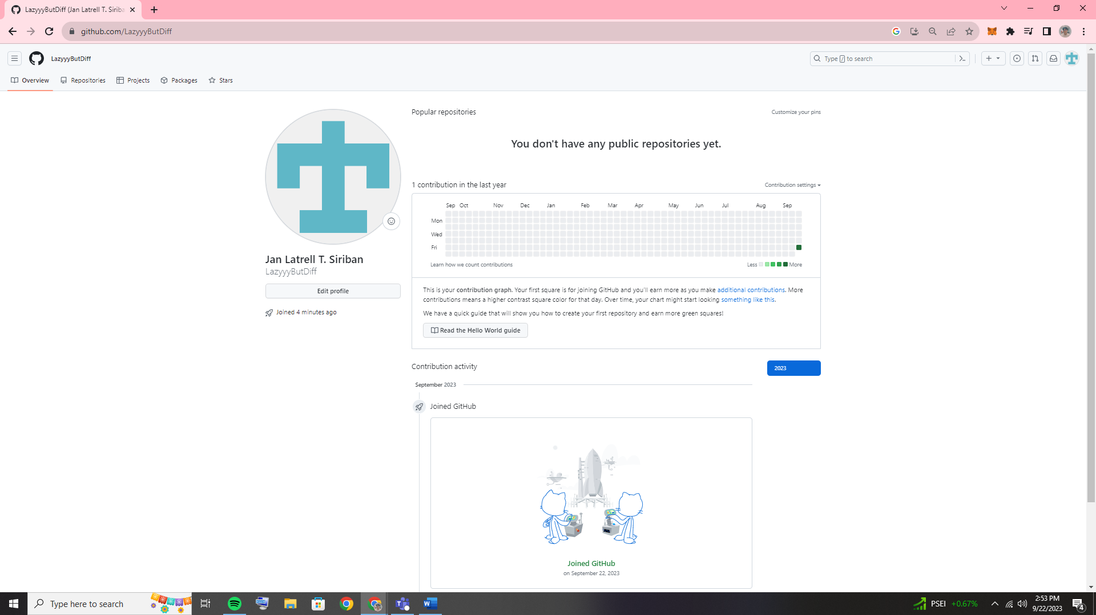
2. On your account, create a repository name Lastname_Firstname_Year&Section (2 Points)

- Your repository should be public (1 Point)

- Add a short description (1 Point)

- Note: Check “Inititalize this repository with a README” (1 Point) 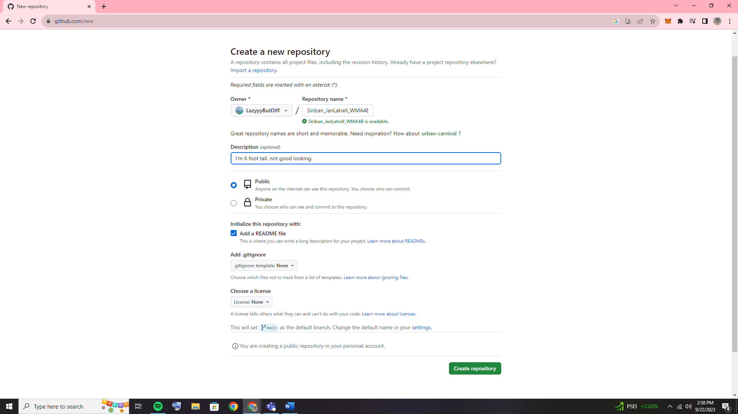

1. On the left side, click the “Branch”

- On the right side, click “New Branch”

- Branch name should be “September 22 2023 IPT2 Activity” (5 Points)

- Note: Do not change the source

- Then Create (5 Points) 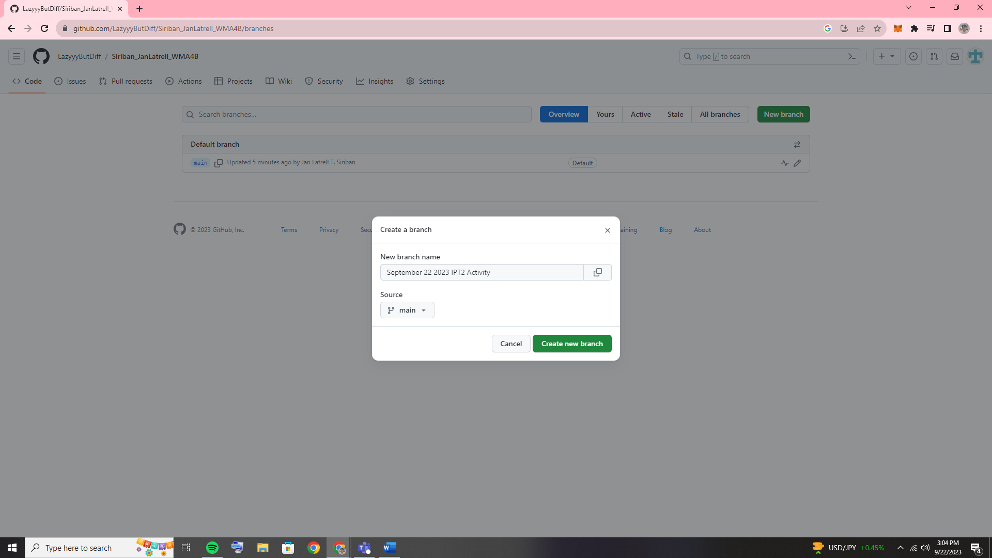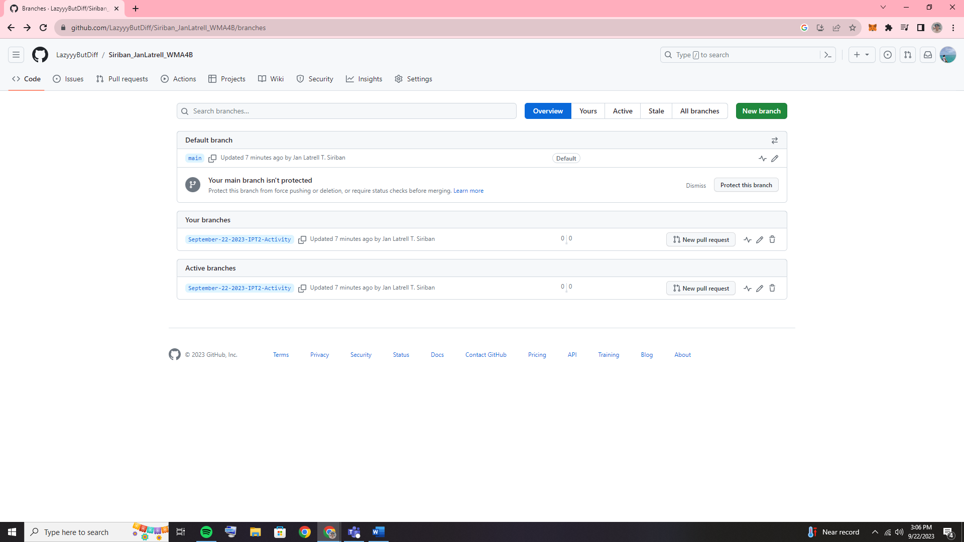

1. Under the September 22 2023 IPT2 Activity

- On the right side, click the “Add file”

- Then upload the document file of your activity. (3 Points)

- File name should be Lastname_Firstname_DateOfTheActivity_Year&Section (2 Points)