PART I The Decision Quality Framework

**1** The Power of Decisions

• Decisions shape our lives and our business successes.

• We make decisions all the time and feel that we are already good at it, but that is an illusion.

• Humans are not wired to achieve DQ. We naturally fall into satisficing and then rationalize whatever decisions we make, convincing ourselves that they are good decisions.

• The difference between satisficing and making the best choice is huge. If we satisfice, we leave a lot of value on the table. That value can be ours if we improve our decision making.

• The DQ framework provides the key to making better decisions.

• Decision skills can be learned.

• Because we have to make decisions in the face of uncertainty, we have to distinguish between good decisions and good outcomes.

• Decisions must be judged according to what the decision maker considers when making the decision, not on the basis of what happens afterward.

• We must be able to determine the quality of a decision at the time we make it, not by judging its outcome. Hindsight is too late.

2 **The** **Requirements** **for** Decision **Quality**

• A high-quality decision has a 100% quality rating for each of the six requirements for DQ.

• The six requirements for DQ are: (1) an appropriate frame; (2) creative alternatives; (3) relevant and reliable information; (4) clear values and tradeoffs; (5) sound reasoning; and (6) commitment to action.

• The quality of a decision is only as good as its weakest link. • Before making a choice, a decision maker should judge the quality of each requirement and determine whether the value of more effort outweighs the cost (in both time and resources). DQ is achieved when all six requirements are at 100%, which means additional effort is not worth the cost.

• The six requirements make it possible to judge the quality of a decision at the time it is made.

• The human mind is not wired to achieve DQ without a careful effort.

3 Getting to Decision Quality

• Declaring the need for decisions is a conscious and deliberate act of leadership, and it triggers action.

• A decision agenda provides a map of a systematic workflow for significant and strategic decisions.

• A good decision process must recognize DQ as its destination.

• Decision traps and biases may be encountered on the journey to DQ.

• Complexity and inherent difficulties tempt people to simplify, take shortcuts, and be satisfied with quick, good enough choices. Doing so leaves value on the table.

• The best way to avoid decision traps and biases is through awareness of the common biases and a disciplined pursuit of the DQ requirements.

• A decision process should be tailored to the nature of the decision: its magnitude (quick, significant, or strategic), complexity (organizational and analytical), content challenges, and likely decision traps.

• The DQ Appraisal Cycle, using the requirements of decision quality as an iterative checklist, can be tailored for problems with limited magnitude and low complexity.

• The Dialogue Decision Process, a structured interaction between a decision board and a project team, is an effective approach for complex strategic decisions.

• Complex and difficult strategic decisions are best addressed with the help of a decision professional.

PART II The Six Requirements for DQ

4 The Appropriate Frame

• Framing answers the question, “What problem are we trying to solve?”

• The three components of framing are purpose, perspective, and scope.

• Proper framing prevents solving the wrong problem. It also makes decision-making efforts quicker and easier.

• Common mistakes include plunging in with no conscious frame, falling victim to the comfort-zone megabias, or framing the problem too narrowly.

• Decision makers have responsibility to judge the frame’s quality and improve it as needed.

5 Creative Alternatives

• The value of a decision can be no greater than the value of the best available alternative. Developing a good set of alternatives is critical.

• Good alternatives are creative, span the range of possibilities, are significantly different from one another, are reasonable contenders for selection, are compelling and feasible, yet manageable in number.

• Settling for good enough leaves enormous value on the table.

• A strategy table builds on the focus on category from the decision hierarchy and clarifies the choices that logically define each alternative.

• Conflicting points of view and out-of-the-box thinking play important roles when identifying and improving alternatives.

• Decision makers have responsibility to define a high-quality set of alternatives now, before further work is done to evaluate that set.

6 Relevant and Reliable Information

• All decisions are future-oriented, but there are no facts from the future. Facts and data from the past and present must be translated into judgments about the future.

• Decisions about the uncertain future must be approached in terms of possibilities and probabilities. Possibilities define the potential outcomes that might happen in the future. Probabilities represent our best judgments about the likelihoods of the different outcomes.

• To avoid information overload, we should gather information that is directly related to our alternatives and the value we seek. A decision tree can guide us in that quest.

• Decision trees represent the sequence of decisions and uncertainties, showing the possible outcomes and probabilities for each.

• Decision makers need information that is both relevant and reliable to make good decisions.

• Information is relevant when it helps us anticipate the value outcomes that may arise after an alternative is chosen, and when sensitivity analysis shows it to be a key driver of value during sound reasoning.

• Information is reliable when it is trustworthy and unbiased.

7 Clear Values and Tradeoffs

• In decisions, values are what we care about when comparing alternatives.

• For most businesses, the ultimate direct value is shareholder value—the economic value of the enterprise—and is usually measured using the net present value of future cash flows, or NPV.

• When more than one value is at stake, tradeoffs may be necessary. • Decisions can be simplified by using even swaps to convert all values, including intangibles, to a common unit (such as dollars).

• Discounting should only be used to account for time preferences, not differences in risk.

• Certain equivalents, which account for risk appetite, can be used if potential losses are at least 5% of a company’s shareholder value. Otherwise, we should use expected values for decision making.

8 Sound Reasoning

• Sound reasoning reveals the choice that gives us the most of what we truly want, taking into account what we can do (our alternatives) and what we know (our information), given our framing of the problem or opportunity.

• Significant decisions that are not overly complex can usually be solved with paper, pencil, and simple math by sketching decision trees and collecting the information needed to roll them back. (A spreadsheet model isn’t needed for a four-hour decision.)

• Many strategic decisions require the power of decision tools. When complexity and uncertainty are high, these tools help decision makers compare the alternatives.

• A relevance diagram identifies the many factors and interrelationships that generate the value of alternatives.

• A decision model calculates the value outcome for any combination of input estimates.

• A tornado diagram summarizes sensitivity analysis to show how each uncertain factor contributes to the uncertainty in the final value. • A flying bar diagram summarizes the range of value outcomes for each alternative.

• A decision professional is trained in facilitative leadership skills and the use of the analytical tools for solving complex decision situations.

• Sound reasoning seeks insight and clarity, using an iterative process and the appropriate tools to reach simplicity on the other side of complexity.

9 Commitment to Action

• Knowing what to do—the best alternative—is only an intention until we really do it.

• True value creation requires both a decision and its implementation. The decision identifies potential value; implementation transforms it into real value.

• A conscious commitment to action is a shift in mindset—from the world of thought to the world of action.

• The discipline and skills of execution differ significantly from decision skills.

• Participation in the decision process builds a sense of ownership of the decision.

• When implementers understand why one alternative was chosen and why others were rejected, the implementation process will be smoother and faster.

• With an understanding of why the chosen alternative adds value, implementation leaders will be able to make value-preserving execution decisions, even when challenges arise.

• Many “execution failures” are actually decision failures that show up during execution.

PART III How to Achieve DQ

10 Biases and Traps in Decision Making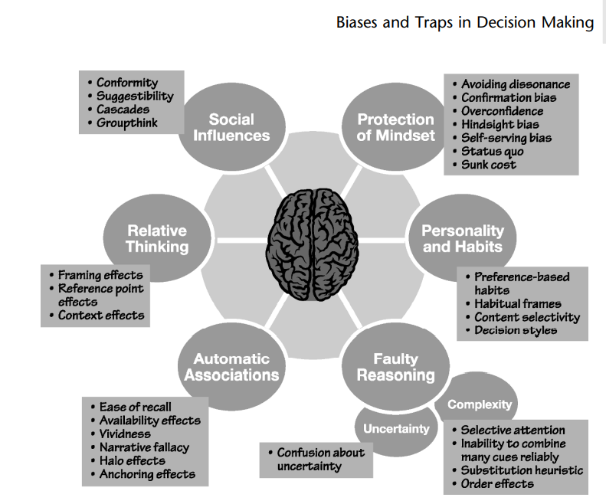

11 Megabiases that Undermine DQ

The five megabiases discussed here are serious impediments to organizations working to improve their decision making. Megabiases destroy DQ, so it pays to avoid them. The first line of defense is awareness and recognition of their damage potential. Of course, the specifics of what to do next depend on a decision’s context and the megabiases to be avoided. In general, once the conscious decision is made to prevent megabiases, Systems 1, 2, and 3 can be engaged to change habits of mind, install new mindware, and reach out for data, experts, tools and processes—particularly decision processes. The following chapters describe decision processes designed specifically to avoid biases and megabiases on the journey to reach the DQ destination.

12 Achieving Quality in Strategic Decisions

Because of its design, using the DDP for strategic decisions will mitigate the five megabiases.

1. The first DDP phase focuses specifically on the decision’s frame, fostering dialogue to offset the narrow framing megabias.
2. Because it addresses requirements for DQ in a systematic and integrated fashion, a DDP approach creates true DQ instead of the illusion of DQ.
3. The agreements formed through a successful DDP are based on quality in the DQ requirements, so there is little danger of falling into the agreement trap of alignment around a low-quality choice.
4. Consciously building quality in each DQ requirement, including clarifying the frame up front, helps to offsets the comfort zone megabias of working on a familiar problem rather than the actual problem. Also, decision tools are used to focus effort on the factors that matter, not just on those that are well understood.
5. By shifting away from a competition between advocates and approvers, the DDP avoids the advocacy/approval myth and sets up a collaborative search for maximum value in a competition between alternatives. People are much better at making relative comparisons than absolute judgments, so comparing a set of alternatives is easier than trying to poke holes in a single proposal advocated by a defensive team.

* The DDP’s structure also offers other advantages. Involving the right people in the right way, and having them participate in timely dialogues throughout the process, allows the organization to get the decision right the first time. It saves the time that would otherwise be lost in a late reframing or a last-minute addition of a new alternative. The time required of decision makers is limited and focused on making sure that DQ is achieved. Agreements are based on clear deliverables that are reviewed and revised in short purposeful discussions. The process can be tailored to fit any strategic situation, and it gives decision makers the opportunity to integrate strong leadership with effective collaboration to reach higher-quality decisions.

13 Achieving Quality in Significant Decisions

Robin’s story illustrates how we can apply the DQ Appraisal Cycle to reach the destination of DQ in significant decisions, at the same time avoiding biases and traps along the way. The starting point is a frame that avoids the narrow framing megabias.

Next is a first pass through all the DQ requirements. Then, an assessment of the quality for each DQ requirement—the slider scale—shows where further work is needed to strengthen the quality of any weak requirements. Additional rounds of iteration are used to bring all DQ requirements up to 100%, and then it’s time to make the decision.

The final test before committing to action on a significant decision is making sure that the head and the heart are aligned. In the end, the decision should make sense and feel right. The DQ Appraisal Cycle can get us there for significant decisions.

PART IV The Journey to DQ

Organizations that want to build ODQ typically start as Chevron did: with a few application projects and some training. Individuals who want to champion DQ in their organizations look for a decision maker with a tough, high-visibility decision problem. This difficult application project serves as a testing ground for DQ, giving decision makers a chance to see DQ concepts in action, adding value to the decision. For this first application, it’s important to work with a decision professional deeply versed in DQ methodology. Success with that project, in combination with some training of key decision makers and project team members, sets the stage for broader application of DQ and greater value through better decision making. The organization can monitor its evolution on the ODQ maturity curve and track its success on achieving the components of ODQ.

This book provides the understanding needed to advance one’s journey to DQ. It explains the important distinction between good decisions and good outcomes. It presents the six requirements for DQ—an appropriate frame, creative alternatives, and so forth. The goal is to reach 100%—the point where it isn’t worth the time or resources to do more—on each requirement. Once we have reached 100% on all six requirements, we can make the decision with confidence, knowing that regardless of the eventual outcome, we have achieved DQ. DQ gives us peace of mind in the face of uncertainty.

On the journey, complexity and uncertainty will surely test our mettle as decision makers. The tools offered in various chapters—the decision hierarchy, decision tree, relevance diagram, tornado diagram, and others—help us navigate the complexity and uncertainty of significant and strategic choices. Just as challenging are the biases that each of us brings to the effort. These misconceptions distort our perceptions and color our judgments. We might think to ourselves:

• “I’m already a great decision maker. I should just follow my instincts.”

• “The first option we thought of is good enough. Let’s go with it and be decisive.”

• “Everyone agrees on Alternative C, so that’s obviously the best choice.”

If we are seduced by any of these thoughts, our decision will not be high quality, but if we boost our awareness and take the preventative actions outlined in this book, we can avoid the many decision traps on our journey.

An important prevention is using one of the processes designed to get us to our destination of DQ. The DQ Appraisal Cycle is a fast, iterative process, ideal for making our many significant decisions. The Dialogue Decision Process (DDP) is a systematic, deliberative dialogue between decision makers and project team members, building alignment among stakeholders across the organization. Decision professionals routinely apply the DDP to good effect in companies facing high-risk, big-bet strategic decisions. When the right people are involved in the DDP, we achieve clarity on the best choice, and we build the commitment that avoids the decision failures that so often show up in execution.