3.3 Building a Web Page

This section will guide you to:

Develop a static web page with the following topics:

* Content Types, Body, Titles, Text, and Links
* Images, List Groups
* Header and Footer
* Text alignment
* Cards, Tables
* Buttons, Badges
* Glyphicons

This guide has three subsections, namely:

3.3.1 Building a static web page in your code editor

3.3.2 Viewing the results in your local browser

3.3.3 Pushing the code to Github repositories

**Step 3.3.1:** Building a static web page in your code editor

* Open Visual Studio Code and create a new file to type the code in
* Right clickon the **File menu** of the code editor -> Select *New File*
* Enter the below code resolving the warning and errors due to compatibility-related issues
* Right clickon the **File menu** of the code editor -> Select *Save as* -> Enter the filename (index.html) -> Click *Save*

**<!DOCTYPE html>**

**<html lang="en">**

**<head>**

**<title>Web Development Blog</title>**

**<meta charset="utf-8">**

**<meta name="viewport" content="width=device-width, initial-scale=1">**

**<link rel="stylesheet" href="https://stackpath.bootstrapcdn.com/bootstrap/4.2.3/css/bootstrap.min.css" integrity="sha384-MCw98/SFnGE8fJT3GXwEOngsV7Zt27NXFoaoApmYm81iuXoPkFOJwJ8ERdknLPMO" crossorigin="anonymous">**

**</head>**

**<body>**

**<div class="page-header">**

**<h1>Introduction to Bootstrap</h1>**

**<img src="https://images.pexels.com/photos/326424/pexels-photo-326424.jpeg" class="img-fluid w-100 p-3" alt="Responsive image">**

**</div>**

**<div class=“container-fluid”>**

**<p> Get started with <mark>Bootstrap</mark>, the world’s most popular framework for building responsive, mobile-first sites, with Bootstrap <abbr title="Content Delivery Network">CDN</abbr> and a template starter page. </p>**

**<p>According to the official website, Bootstrap is the most popular HTML, CSS, and JS framework for developing responsive, mobile first projects on the web. Sounds great! Now how do I use it? It would be easy to send you over to their Getting Started page and call it a day. Their setup guide is indeed a host of useful information — links to CDNs, explanations on how to install with Bower, npm, and Composer, information on integration with Autoprefixer and LESS, a bunch of templates, licenses, and translations — but you could read this blog here instead for a better and easier understanding.</p>**

**<span class="glyphicon glyphicon-pencil"></span>**

**<p class="text-center">The list below shows the different version of Bootstrap so far. <span class="glyphicon glyphicon-list-alt"></span></p>**

**<ul class="list-group">**

**<li class="list-group-item">v1.x</li>**

**<li class="list-group-item">v2.x</li>**

**<li class="list-group-item">v3.x</li>**

**<li class="list-group-item">v4.x</li>**

**</ul>**

**<p class="text-center bg-info"> The main features of bootstrap is, it is very simple and easy to use, huge JavaScript plugins are available, easily design mobile friendly website.</p>**

**</div>**

**<div class="container-fluid">**

**<h2></h2>**

**<table class="table table-bordered table-striped">**

**<thead>**

**<tr >**

**<th>Features of Bootstrap</th>**

**</tr>**

**</thead>**

**<tbody>**

**<tr>**

**<td>Easy to Use</td>**

**</tr>**

**<tr>**

**<td>Mobile Friendly</td>**

**</tr>**

**<tr>**

**<td>Prestyled Components</td>**

**</tr>**

**</tbody>**

**</table>**

**</div>**

**<div class="container-fluid"**

**<p class="text-left">Lets take a look at the components of bootstrap:</p>**

**<h1>CSS<span class="badge badge-secondary">Quoted</span></h1>**

**<p class="text-justify">Copy-paste the stylesheet link into your head before all other stylesheets to load our CSS.</p>**

**<h2>JS <span class="badge badge-secondary">Quoted</span></h2>**

**<p class="text-justify">Many of our components require the use of JavaScript to function. Specifically, they require jQuery, Popper.js, and our own JavaScript plugins. Place the following scripts near the end of your pages, right before the closing bodytag, to enable them. jQuery must come first, then Popper.js, and then our JavaScript plugins.We use jQuery’s slim build, but the full version is also supported.</p>**

**</div>**

**<div class="card">**

**<div class="card-header">Author</div>**

**<div class="card-body">The article was contributed by katesmith12</div>**

**<a href="https://www.sitesbay.com/bootstrap/bootstrap-features-of-bootstrap" class="card-footer btn btn-outline-primary stretched-link">View References</a>**

**</div>**

**<!-- Footer -->**

**<footer class="page-footer font-small indigo">**

**<!-- Copyright -->**

**<div class="footer-copyright text-center py-3">This is the footer section where you can put the address and copyright details. © 2018 Copyright:**

**<a href="https://simplilearn.net/"> Simplilearn</a>**

**</div>**

**<!-- Copyright -->**

**</footer>**

**<!-- Footer -->**

**<script src="https://code.jquery.com/jquery-3.3.2.slim.min.js" integrity="sha384-q8i/X+965DzO0rT7abK41JStQIAqVgRVzpbzo5smXKp4YfRvH+8abtTE1Pi6jizo" crossorigin="anonymous"></script>**

**<script src="https://stackpath.bootstrapcdn.com/bootstrap/4.2.3/js/bootstrap.min.js" integrity="sha384-ChfqqxuZUCnJSK3+MXmPNIyE6ZbWh2IMqE241rYiqJxyMiZ6OW/JmZQ5stwEULTy" crossorigin="anonymous"></script>**

**</body>**

**</html>**

**Step 3.3.2:** Viewing the results in your local browser

* Go to Extensions and download **Live Server**
* *[Right click]* on the **index.html** file of the project
* Select *Open with Live Server*

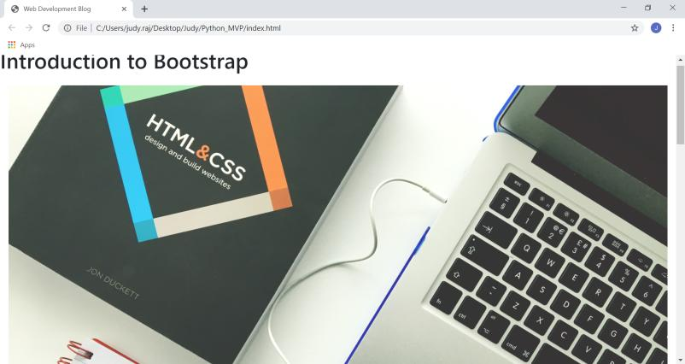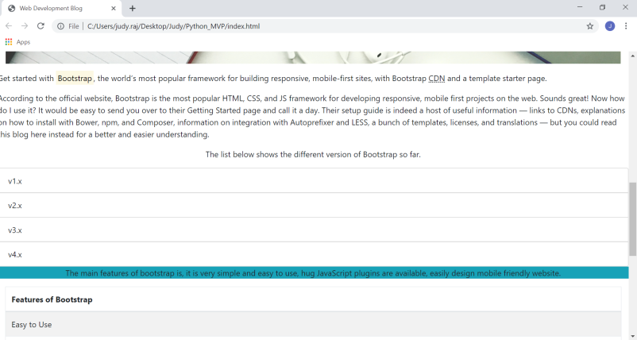

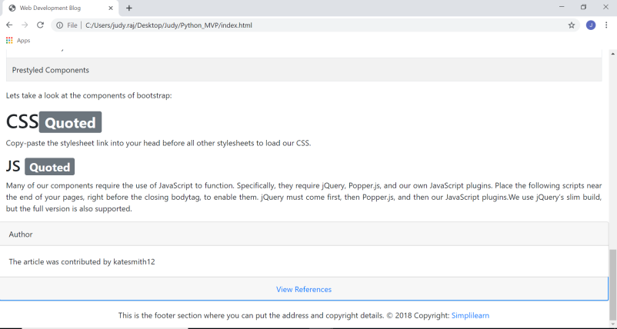

**Step 3.3.3:** Pushing the code to your GitHub repositories

Open your command prompt and navigate to the folder where you have created your files

cd <folder path>

Initialize your repository using the following command:

git init

Add all the files to your git repository using the following command:

git add . 

Commit the changes using the following command:

git commit . -m “Changes have been committed.”

Push the files to the folder you initially created using the following command:

git push -u origin master