2.1 Bootstrapping Angular Application

This section will guide you to:

* Create and work with a responsive navigation bar which will get hidden once you change the size of the browser.

This guide has four subsections, namely:

2.1.1 Configuring the Angular application and installing bootstrap

2.1.2 Creating a header component

2.1.3 Creating a navigation bar using bootstrap classes

2.1.4 Pushing the code to GitHub repositories

**Step 2.1.1:** Configuring the Angular application and installing bootstrap

* Node.js and Angular are already installed in your lab. (Refer MEAN: Lab Guide - Phase 2)
* Open terminal
* Install bootstrap by running below command:

**npm install --save bootstrap**

* Create a folder named **Angular Demos** on the desktop of your lab
* Go to the Angular Demos folder. Create a new project using a command: ***ng new* <your_app_name>** (**angCare** is used in this example). Choose the appropriate options according to your requirements

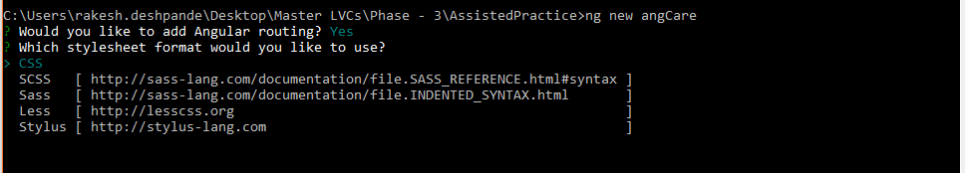

* Type the following commands

***cd* <your_app_name>**

***ng serve***

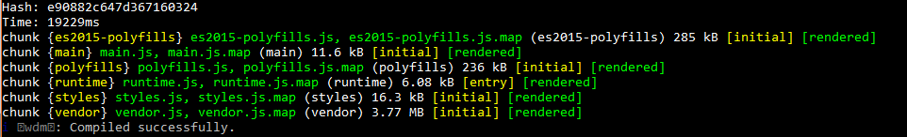

**Step 2.1.2:** Creating a header component

* Open Visual Studio Code
* Navigate to your project folder
* Go to **Terminal**. Select **New Terminal**
* Go to **angCare**
* Run the below command to create a header component

**ng g c header**

**Step 2.1.3:** Creating a navigation bar using bootstrap classes

* Add the below code in **styles.css**

import "../node_modules/bootstrap/dist/css/bootstrap.css"

* Go to angCare/src/app/app.cpmponenet.html
* Add the below code in **app.component.html**

<app-header></app-header>

* Go to angCare/src/app/header/header.cpmponenet.html
* Add the below code in **header.component.ts**

import { Component, OnInit } from '@angular/core';

@Component({

selector: 'app-header',

template: `

<nav class="navbar navbar-expand-lg navbar-light bg-light">

<button class="navbar-toggler" type="button" (click)="toggleNavbar()" data-toggle="collapse" data-target="#navbarTogglerDemo01" aria-controls="navbarTogglerDemo01" aria-expanded="false" aria-label="Toggle navigation">

<span class="navbar-toggler-icon"></span>

</button>

<div class="collapse navbar-collapse" id="navbarTogglerDemo01" [ngClass]="{ 'show': navbarOpen }">

<a class="navbar-brand" href="#">Hidden brand</a>

<ul class="navbar-nav mr-auto mt-2 mt-lg-0">

<li class="nav-item active">

<a class="nav-link" href="#">Home <span class="sr-only">(current)</span></a>

</li>

<li class="nav-item">

<a class="nav-link" href="#">Link</a>

</li>

<li class="nav-item">

<a class="nav-link disabled" href="#">Disabled</a>

</li>

</ul>

<form class="form-inline my-2 my-lg-0">

<input class="form-control mr-sm-2" type="search" placeholder="Search" aria-label="Search">

<button class="btn btn-outline-success my-2 my-sm-0" type="submit">Search</button>

</form>

</div>

</nav>

`,

styles: []

})

export class HeaderComponent implements OnInit {

constructor() { }

ngOnInit() {

}

navbarOpen = false;

toggleNavbar() {

this.navbarOpen = !this.navbarOpen;

}

}

* Add the below code in **index.html**

<!doctype html>

<html lang="en">

<head>

<meta charset="utf-8">

<title>Navbar</title>

<base href="/">

<meta name="viewport" content="width=device-width, initial-scale=1">

<link rel="icon" type="image/x-icon" href="favicon.ico">

</head>

<body>

<div class="container-fluid"></div>

<div>

<app-root></app-root>

</div>

</body>

</html>

* Run the application using below command and open **localhost:4200** in your browser:

**ng serve**

**Step 2.1.4:** Pushing the code to GitHub repositories

Open your command prompt and navigate to the folder where you have created your files

**cd <folder path>**

Initialize your repository using the following command:

**git init**

Add all the files to your git repository using the following command:

**git add .**

Commit the changes using the following command:

**git commit . -m “Changes have been com**

mitted.”

Push the files to the folder you initially created using the following command:

**git push -u origin master**