2.3 Data Interactions



This section will guide you to:

* Set up Angular and run the basic template
* Create child components
* Respond to user interactions

This guide has four subsections, namely:

2.3.1 Configuring the Angular application

2.3.2 Responding to user inputs and clicks

2.3.3 Adding bootstrap to the Angular application

2.3.4 Pushing the code to GitHub repositories

**Step 2.3.1:** Configuring the Angular application

* Node.js and Angular are already installed in your lab. (Refer MEAN: Lab Guide - Phase 2)
* Open the Angular terminal
* Create a new folder using mkdir folder_name using a terminal
* Go to the created folder using cd command
* Create a new project using the command ***ng new* <your_app_name>** (**angCare** is used in this example). Choose the appropriate options according to your requirement.

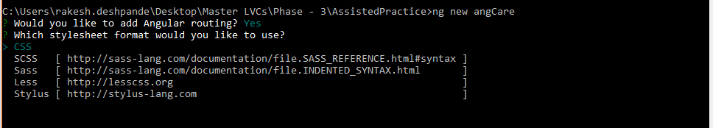

* ***cd* <your_app_name>**
* ***ng serve***

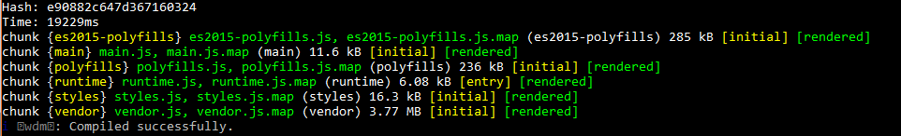

**Step 2.3.2:** Responding to user inputs and clicks

* You need an IDE to work on your Angular application. To download and install the Visual Studio Code IDE on your local system, visit the given link <https://code.visualstudio.com/>.
* For your practice, you need not download it as Visual Studio Code is already installed in your lab. (Refer MEAN: LAb Guide - Phase 2)
* Open the IDE and import the project by following the steps mentioned below:
* Click on **File** 🡪 **Open Folder** and provide the path where you have installed your Angular application.
* Click **Terminal** 🡪 **New Terminal** to open the terminal of the IDE.
* Navigate through the **app** folder of the application and execute the commands mentioned below:
  + ***ng g c signup***
  + ***ng g c signin***

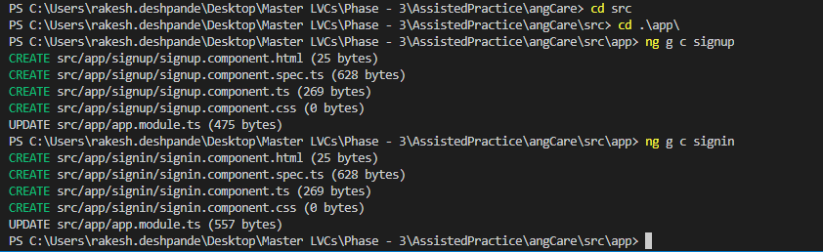

* Go to /src/app/app.component.html
* Open the **app.component.html** available in the **app** folder of the Angular application. Replace all the codes available in the file to the source code mentioned below:

<!DOCTYPE html>

<html>

<head>

<meta charset="utf-8">

<meta http-equiv="X-UA-Compatible" content="IE=edge">

<title>Page Title</title>

</head>

<body>

<p style="text-align: center;font-size: 30px"> Hello <input type="text" placeholder="Your name" (input)="ontyping($event)"/>, Welcome to the <b>angCare!</b></p>

<p style="text-align: center;font-size: 20px">Hello {{name}}<br>I am Joe, your personal assistant! I will guide you further...</p>

<div style="text-align:left;padding: 20px">

<p> Click on Sign up to create your account with angCare: <button (click)="signup()">Sign up with {{title}}</button> : {{status}}</p>

<p> Click on Sign up to create your account with angCare: <button>Sign In </button></p>

</div>

</body>

</html>

<router-outlet></router-outlet>

* Go to /src/app/app.component.ts
* Open the **app.component.ts** file and replace only the source code available in **AppComponent** class with the following source code:

export class AppComponent {

title = 'angCare';

status = 'You haven\'t signed up yet';

name = '';

ontyping(event:Event) {

this.name = (<HTMLInputElement>event.target).value;

}

signup() {

this.status = 'Oops! We are working on it!';

}

}

* Use **ctrl+s** to save the changes. Tthe Angular application will automatically load.
* You can type your name in the *input* section of the page. You will notice that your name appears right after **Hello** on the page. If you click on **Sign up with angCare** button, it changes the text from **you haven’t signed up yet** to **Oops! We are working on it!**

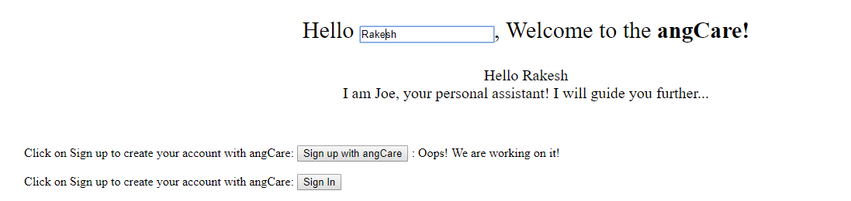

**Step 2.3.3**: Adding bootstrap to the Angular application

* Execute the **npm install** **bootstrap@3.3.7** **--save** in the terminal. Once the installation is complete, add the line mentioned below in the **angular.json** file in the **styles** section:

"node_modules/bootstrap/dist/css/bootstrap.min.css"

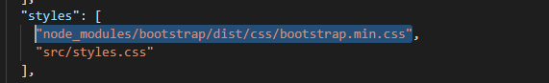

* Rerun the Angular application using **ng serve** to implement the changes.
* Go to **app.component.html** file and add a bootstrap class to the button **Sign up with angCare.**



* Run the application to see if Bootstrap is implemented.

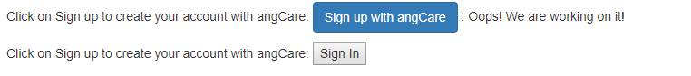

**Step 2.3.4:** Pushing the code to GitHub repositories

Open your command prompt and navigate to the folder where you have created your files

**cd <folder path>**

Initialize your repository using the following command:

**git init**

Add all the files to your git repository using the following command:

**git add .**

Commit the changes using the following command:

**git commit . -m “Changes have been committed.”**

Push the files to the folder you initially created using the following command:

**git push -u origin master**