4.4 Handle User Inputs

This section will guide you to:

* Handle user inputs on the Node.js environment

This guide has four subsections, namely:

4.4.1 Creating a package in the app

4.4.2 Writing a program to handle user inputs

4.4.3 Executing the written program

4.4.4 Pushing the codes to your GitHub repositories

**Step 4.4.1:** Creating a package in the app

* Open a folder named **TypeScript Demos** in Visual Studio Code
* Create a file with userinputs .js extension

**Step 4.4.2:** Writing a program to handle user inputs

console.log("\nTaking inputs from user");

var readline1 = require('readline-sync');

var name = readline1.question("\nWhat is your name?");

var readline2 = require('readline-sync');

var age = readline2.question("What is your age?");

var readline3 = require('readline-sync');

var email = readline3.question("What is your email address?");

var readline4 = require('readline-sync');

var message = readline4.question("Give us a feedback message: ");

console.log("\nOutput after taking inputs from user");

console.log("Hi " + name + ", You have successfully signed in!");

console.log("You are "+age+" is used for verification purpose");

console.log("You have logged in with the email address: "+email+"");

console.log("This is your message: "+message+"");

console.log("");

console.log("");

console.log("Your message will be sent. Are your sure?");

var choice = readline4.question("Select YES(y) or NO(n): ");

if(choice=='y'){

console.log("Your message is sent successfully");

} else if(choice=='n'){

console.log("Your message is terminated");

}else {

console.log("Oops, Please try again!");

}

**Step 4.4.3:** Executing the written program

* By typing *node userinputs.js* command in a terminal,you will get the output:

* If you select yes, your output is:

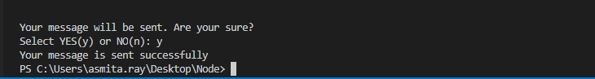

* If you select no, your output is:

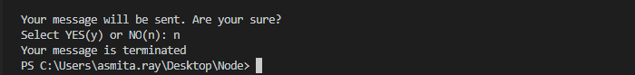

**Step 4.4.4:** Pushing the codes to your GitHub repositories

Open your command prompt and navigate to the folder where you have created your files.

cd <folder path>

Initialize your repository using the following command:

git init

Add all the files to your git repository using the following command:

git add . 

Commit the changes using the following command:

git commit . -m “Changes have been committed.”

Push the files to the folder you initially created using the following command:

git push -u origin master