2.1 CRUD Operations and Middleware

This section will guide you to:

* Perform CRUD and insert operations with MongoDB using NodeJS and Express

This guide has mainly six subsections, namely:

2.1.1 Creating a new NodeJS project

2.1.2 Installing express-handlebars

2.1.3 Creating controller

2.1.4 Creating views

2.1.5 Creating model

2.1.6 Pushing code to GitHub repositories

*You should have a basic understanding of the MongoDB database.*

*MongoDB and Visual Studio Code are already installed in your system. (Refer MEAN: Lab Guide - Phase 3)*

**Step 2.1.1:** Creating a new NodeJS project

* Open the terminal and create a folder with the name **NodeMongo** using **mkdir NodeMongo** command
* Run the below command to install node dependencies to the project folder

**npm install**

**npm init**

**Step 2.1.2:** Install express-handlebars

* Run the below command to install express-handlebars:

**npm install --save express express-handlebars mongoose body-parser nodemon**

**Step 2.1.3:** Creating Controller

* Open Visual Studio Code
* In the root directory (NodeMongo), create **index.js** and add the code given below:

const connection = require("./models");

const express = require("express");

const application = express();

const path = require("path");

const expresshandlebars = require("express-handlebars");

const bodyparser = require("body-parser");

const PeopleController = require("./controllers/people");

application.use(bodyparser.urlencoded({

extended:true

}));

application.set('views', path.join(__dirname, "/views/"));

application.engine("hbs", expresshandlebars({

extname:"hbs",

defaultLayout:"mainlayout",

layoutsDir: __dirname + "/views/layouts"

}));

application.set("view engine", "hbs");

application.get("/", (req, res)=>{

//res.send("<h1>Hello</h1>");

res.render("index",{});

});

application.use("/people", PeopleController);

application.listen('3000');

* In the project folder, create a new folder with the name **controllers.**
* Create a new file under **controllers** with the name **people.js**  and add the code given below:

const express=require("express");

const mongoose=require("mongoose");

const router=express.Router();

const PeopleModel = mongoose.model("People");

router.get("/add", (req, res)=>{

res.render("add");

});

router.post("/add", (req, res)=>{

var people = new PeopleModel();

people.fname = req.body.fname;

people.salary = req.body.salary;

people.mno = req.body.mno;

people.save((err, doc)=>{

if(!err){

res.redirect("/people/list");

}else {

res.send("Error Occured");

}

});

//res.render("add");

});

router.get("/list", (req, res)=>{

//Getting

PeopleModel.find((err, docs)=>{

if(!err){

console.log(docs);

res.render("list", {data: docs});

}

})

});

module.exports = router;

**Step 2.1.4:** Creating views

* Create a folder inside the root directory with name **views**
* Create a file named **index.js** and add the code given below:

**Welcome to Simplilearn..!!**

* Create **list.hbs** and add the code given below:

<h1>

Simplilearn Employee

</h1>

<table>

<tr>

<th>Name</th>

<th>Salary</th>

<th>Contact</th>

</tr>

{{#each data}}

<tr>

<td>{{this.fname}}</td>

<td>{{this.salary}}</td>

<td>{{this.mno}}</td>

</tr>

{{/each}}

</table>

* Create **add.hbs** and add the code given below:

<form action="/people/add" method="POST">

<p>

<label>First Name:</label><input value="" name="fname" /><br/><br/>

<label>Salary:</label><input value="" name="salary" /><br/><br/>

<label>Contact:</label><input value="" name="mno" /><br/><br/>

<button type="submit">Add People</button>

</p>

</form>

* Create a folder with the name **layouts** under views.
* Create **mainlayout.hbs** under **layouts** and add the code given below:

<div id="main-layout">

{{{body}}}

</div>

**Step 2.1.5:** Creating a model

* Create a folder in the root directory named as **models.**
* Create **index.js** under **models** and add the below code:

const mongoose = require('mongoose');

mongoose.connect('mongodb://localhost:27017/Simplilearn',{ useNewUrlParser: true }, (error)=>{

if(!error){

console.log("Connected Yippee..!!");

}else{

console.log("Error connecting to database.");

}

});

const course = require("./people.model");

* Create **people.model.js** under **models** and add the below code:

const mongoose = require('mongoose');

const Schema = mongoose.Schema;

let PeopleSchema = new Schema({

fname: {

type: String,

required: true,

max: 100

},

salary: {

type: Number,

required: true

},

mno: {

type: Number,

required: true

}

});

// Export the model

module.exports = mongoose.model('People', PeopleSchema);

* You should get the below output for **localhost:3000**:

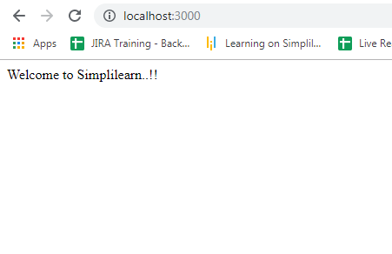

* You should get the below output for **localhost:3000/people/add**:

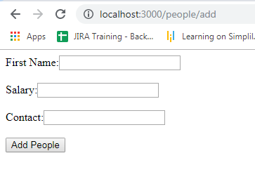

* You should get the below output for **localhost:3000/people/list**:

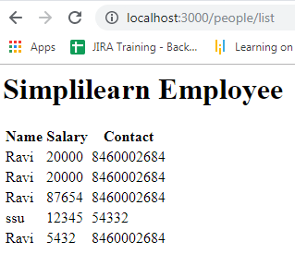

**Step 2.1.6:** Pushing the code to your GitHub repositories

Open your command prompt and navigate to the folder where you have created your files.

cd <folder path>

Initialize your repository using the following command:

git init

Add all the files to your git repository using the following command:

git add .

Commit the changes using the following command:

git commit . -m “Changes have been committed.”

Push the files to the folder you initially created using the following command:

git push -u origin master