3.2 Document Store Example

This section will guide you to:

* Create a MongoDB database using command prompt
* Display the collections present in the created database

This lab has four subsections, namely:

* + 1. Setting up MongoDB server and shell
    2. Writing a program to create a database, create a collection, and add data to the created collection of the database
    3. Writing a command to display the data present in the created collection in the database
    4. Pushing the code to GitHub repositories
* *MongoDB is already installed in your lab. (Refer MEAN: Lab Guide - Phase 3)*

**Step 3.2.1:** Setting up MongoDB server and shell

* Open the terminal
* Type **sudo service mongod start** to start the MongoDB server
* Type **sudo service mongod status** to check the status of the MongoDB server

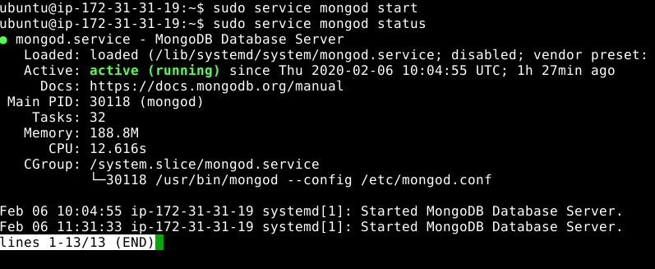

* Type ctrl + c to exit the status
* Type **mongo --quiet** to start the mongo shell

**Step 3.2.2:** Writing a program to create a database, create a collection, and add data to the created collection of the database

* Create an **employee’s** database using **use employees** command
* Insert the values in the **empData** collection of database using **db.empData.insertOne()** command
* Write the code below resolving the syntactical errors

> use employees

> db.empData.insertOne({"name" : "Jeon", "email" : "[jeon123@gmail.com](mailto:jeon123@gmail.com)", "contact": "9000000012", "salary" : 25000, "isVerified" : true})

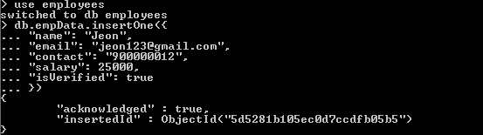

**Step 3.2.3:** Writing a command to display the data present in the created collection in the database

* Display the values in the empData collection using **db.empData.find()** command
* To get the simpler format of the values, use **db.empData.find().pretty()** command

> db.empData.find()

> db.empData.find().pretty()

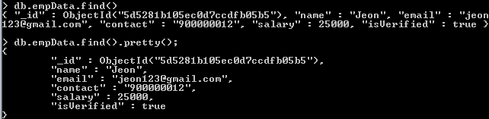

**Step 3.2.4:** Pushing the code to GitHub repositories

Open your command prompt and navigate to the folder where you have created your files.

cd <folder path>

Initialize your repository using the following command:

git init

Add all the files to your git repository using the following command:

git add .

Commit the changes using the following command:

git commit . -m “Changes have been committed.”

Push the files to the folder you initially created using the following command:

git push -u origin master