3.1 Setting Up MongoDB

This section will guide you to:

* Set up MongoDB on your local system

This lab has four subsections, namely:

* + 1. Downloading the MongoDB MSI installer package
    2. Installing MongoDB with the installation wizard
    3. Creating a data folder to store databases
    4. Setting up shortcuts for Mongo and Mongod
* *MongoDB is already installed in your lab. (Refer MEAN: Lab Guide - Phase 3)*
* If you want to install MongoDB on your local system, follow the given steps:

**Step 3.1.1:** Downloading the MongoDB MSI installer package

* Go to <https://www.mongodb.com/download-center/community>, go to **Server**, and download the current version of MongoDB

* Select the **MSI package** and operating system you want to work on

**Step 3.1.2:** Installing MongoDB with the installation wizard

* Go to your **Downloads** folder and double click on the .msi package you have just downloaded for MongoDB. This will launch the installation wizard

* Click on **Next** to start the installation

* Accept the **License Agreement** and click on **Next**

* Select the **Complete** setup type

* Select **Run service as Network Service user** and make a note of the data directory. We will need this later.

* Deselect the **Install MongoDB Compass** checkbox and click on **Next**

* Click on **Install** to start the installation

* Click on **Finish** to complete the installation

**Step 3.1.3:** Creating a data folder to store databases

* Go to the C drive and create a **data** folder
* Create a folder called **db** inside the **data** folder

**Step 3.1.4:** Setting up shortcuts for Mongo and Mongod

* Open your command prompt
* Change the directory to **C:\Program Files\MongoDB\Server\4.0\bin**
* Type **mongod**. This will start our Mongo server

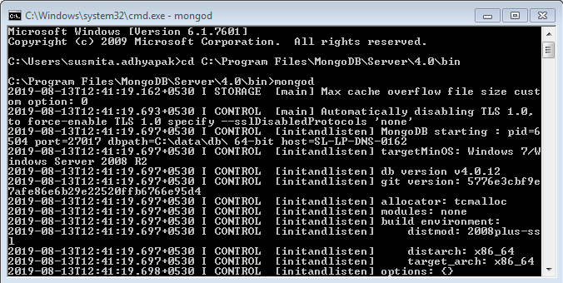

* Open another command prompt
* Change the directory to **C:\Program Files\MongoDB\Server\4.0\bin**
* Type **mongo**. This command will open the Mongo Shell

