4.1 Create Compound, Sparse, and Unique Indexes

This section will guide you to:

* Create a MongoDB database using command prompt
* Write a program to create compound, sparse, and unique indexes

This lab has three subsections, namely:

* + 1. Setting up MongoDB server and shell
    2. Writing a program to create compound, sparse, and unique indexes
    3. Pushing the code to GitHub repositories
* *MongoDB is already installed in your lab. (Refer MEAN: Lab Guide - Phase 3)*

**Step 4.1.1:** Setting up MongoDB server and shell

* Open the terminal
* Type **sudo service mongod start** to start the MongoDB server
* Type **sudo service mongod status** to check the status of the MongoDB server

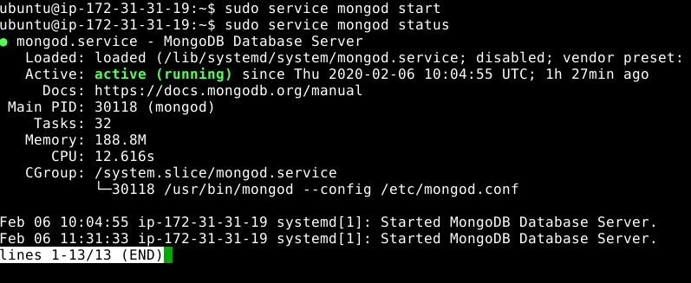

* Type ctrl + c to exit the status
* Type **mongo --quiet** to start the mongo shell

**Step 4.1.2:** Writing a program to create compound, sparse, and unique indexes

* Create a **customer’s** database using **use customers** command
* Write the given code below by resolving the syntactical errors

> show dbs

> use customers

> db.items.createIndex( { "item": 1, available: 1} )

> db.items.createIndex( { "category": 1}, {sparse: true, background: true} )

> db.items.createIndex( { "item": 1}, {unique: true} )

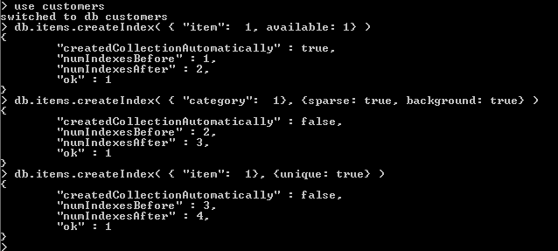

**Step 4.1.3:** Pushing the code to GitHub repositories

Open your command prompt and navigate to the folder where you have created your files.

cd <folder path>

Initialize your repository using the following command:

git init

Add all the files to your git repository using the following command:

git add .

Commit the changes using the following command:

git commit . -m “Changes have been committed.”

Push the files to the folder you initially created using the following command:

git push -u origin master