4.3 Retrieval of Index

This section will guide you to:

* Create a MongoDB database using command prompt
* Write a program to retrieve indexes for a collection and a database

This lab has three subsections, namely:

* + 1. Setting up MongoDB server and shell
    2. Writing a program to retrieve indexes for a collection and a database
    3. Pushing the code to GitHub repositories
* *MongoDB is already installed in your lab. (Refer MEAN: Lab Guide - Phase 3)*

**Step 4.3.1:** Setting up MongoDB server and shell

* Open the terminal
* Type **sudo service mongod start** to start the MongoDB server
* Type **sudo service mongod status** to check the status of the MongoDB server

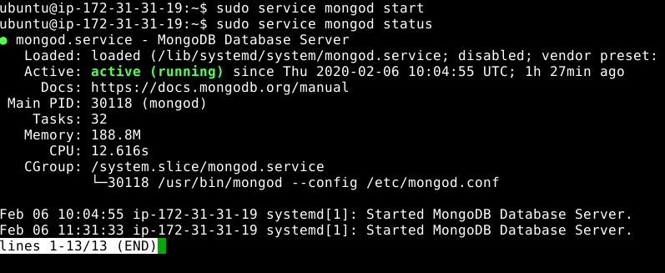

* Type ctrl + c to exit the status
* Type **mongo --quiet** to start the mongo shell

**Step 4.3.2:** Writing a program to retrieve indexes for a collection and a database

* Select customer’s database using **use customers** command
* Write the given code below by resolving the syntactical errors

> show dbs

> use customers

> db.items.getIndexes()

> db.customer_info.getIndexes()

> db.customer_info.createIndex({"item": "Text"}, {name: "item_index"} )

> db.getCollectionNames().forEach(function(collection) { indexes = db[collection].getIndexes(); print("Indexes for " + collection + ":"); printjson(indexes); });

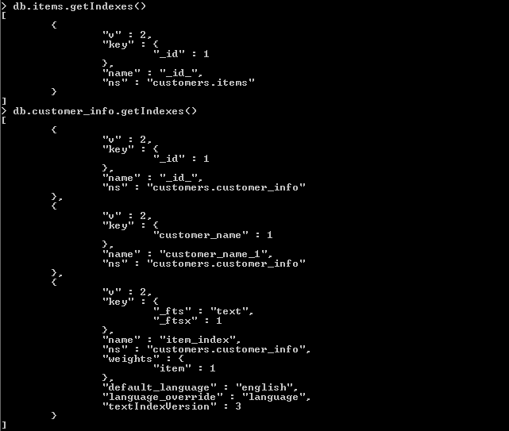

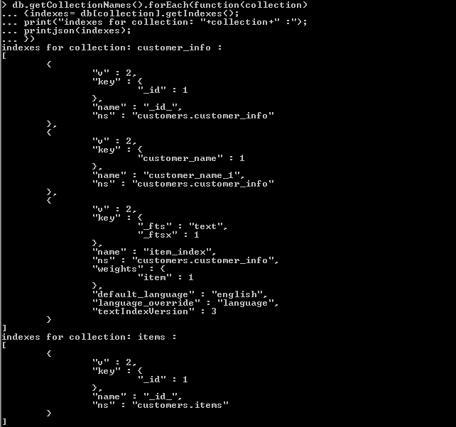

**Step 4.3.3:** Pushing the code to GitHub repositories

Open your command prompt and navigate to the folder where you have created your files.

cd <folder path>

Initialize your repository using the following command:

git init

Add all the files to your git repository using the following command:

git add .

Commit the changes using the following command:

git commit . -m “Changes have been committed.”

Push the files to the folder you initially created using the following command:

git push -u origin master