4.4 Aggregation Operations

This section will guide you to:

* Create a MongoDB database using command prompt
* Write a program to demonstrate aggregation operations

This lab has three subsections, namely:

* + 1. Setting up MongoDB server and shell
    2. Writing a program to perform aggregation operations on MongoDB
    3. Pushing the code to GitHub repositories
* *MongoDB is already installed in your lab. (Refer MEAN: Lab Guide - Phase 3)*

**Step 4.4.1:** Setting up MongoDB server and shell

* Open the terminal
* Type **sudo service mongod start** to start the MongoDB server
* Type **sudo service mongod status** to check the status of the MongoDB server

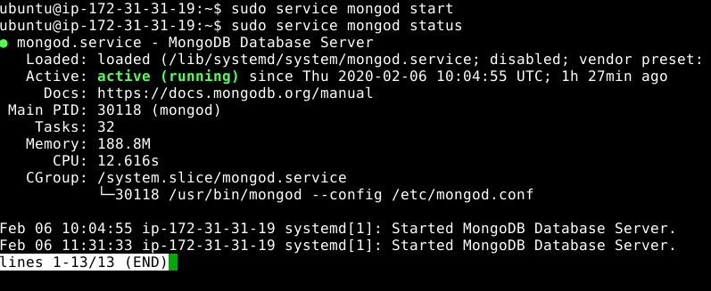

* Type ctrl + c to exit the status
* Type **mongo --quiet** to start the mongo shell

**Step 4.4.2:** Writing a program to perform aggregation operations on MongoDB

* Create a database using **use schoolData** command
* Write the given code below by resolving the syntactical errors

> show dbs

> use schoolData

> db.items.getIndexes()

> db.student_info.insertMany([{"Roll_No": 1, "First_Name": "Alex", "Last_Name": "Johnson", "Gender": "Male", "Age": 13}, {"Roll_No": 2, "First_Name": "Annie", "Last_Name": "Jackson", "Gender": "Female", "Age": 14}, {"Roll_No": 3, "First_Name": "Emily", "Last_Name": "Graham", "Gender": "Female", "Age": 15}, {"Roll_No": 4, "First_Name": "Dexter", "Last_Name": "Haley", "Gender": "Male", "Age": 14}, {"Roll_No": 5, "First_Name": "Noah", "Last_Name": "Lee", "Gender": "Male", "Age": 13}])

> db.student_info.aggregate([{$group: {_id: "$Gender",result: {$sum: 1}}}])

> db.student_info.distinct("First_Name")

> db.student_info.count()

> db.student_info.count({"Age": 13})

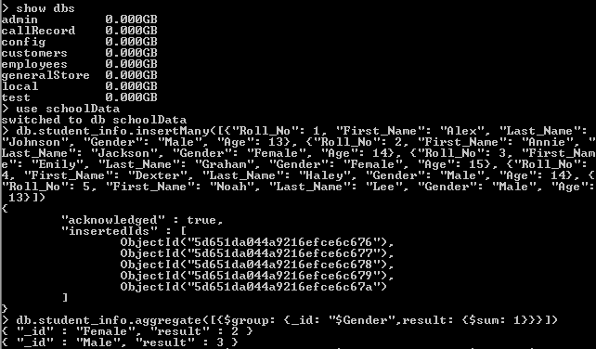







**Step 4.4.3:** Pushing the code to GitHub repositories

Open your command prompt and navigate to the folder where you have created your files.

cd <folder path>

Initialize your repository using the following command:

git init

Add all the files to your git repository using the following command:

git add .

Commit the changes using the following command:

git commit . -m “Changes have been committed.”

Push the files to the folder you initially created using the following command:

git push -u origin master