4.5 Use of Group Functions

This section will guide you to:

* Use a database created in MongoDB using command prompt
* Write a program to demonstrate how to use group functions in MongoDB

This lab has three subsections, namely:

* + 1. Setting up MongoDB server and shell
    2. Writing a program to use group functions in MongoDB
    3. Pushing the code to GitHub repositories
* *MongoDB is already installed in your lab. (Refer MEAN: Lab Guide - Phase 3)*

**Step 4.5.1:** Setting up MongoDB server and shell

* Open the terminal
* Type **sudo service mongod start** to start the MongoDB server
* Type **sudo service mongod status** to check the status of the MongoDB server

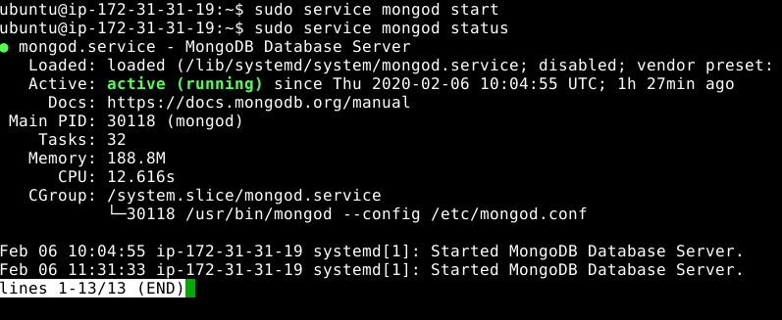

* Type ctrl + c to exit the status
* Type **mongo --quiet** to start the mongo shell

**Step 4.5.2:** Writing a program to use group functions in MongoDB

* Select schoolData database which we had created in the previous assisted practice using **use schoolData** command
* Write the given code below by resolving the syntactical errors

> show dbs

> use schoolData

> db.student_info.find().pretty()

> db.student_info.aggregate([{$group: {_id: "$Gender", MaxAge: {$max: "$Age"}}}])

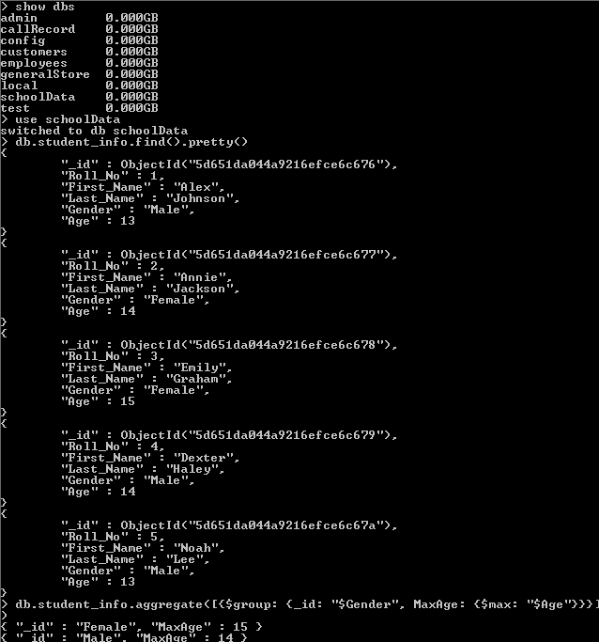

**Step 4.5.3:** Pushing the code to GitHub repositories

Open your command prompt and navigate to the folder where you have created your files.

cd <folder path>

Initialize your repository using the following command:

git init

Add all the files to your git repository using the following command:

git add .

Commit the changes using the following command:

git commit . -m “Changes have been committed.”

Push the files to the folder you initially created using the following command:

git push -u origin master