4.7 Check a Replica Set Status

This section will guide you to:

* Start a replica set

This lab has three subsections, namely:

* + 1. Creating directories in C drive
    2. Setting up replica sets
    3. Connecting to Mongo shell
    4. Pushing the code to GitHub repositories
* *MongoDB is already installed in your lab. (Refer MEAN: Lab Guide - Phase 3)*

**Step 4.7.1:** Creating directories in C drive

* Create directories 1 and 2 using **mkdir 1** and **mkdir 2** commands

**Step 4.7.2:** Setting up replica sets

* Open the terminal
* Type **mongod --port 27018 --dbpath /home/ubuntu/1 --replSet rs0**

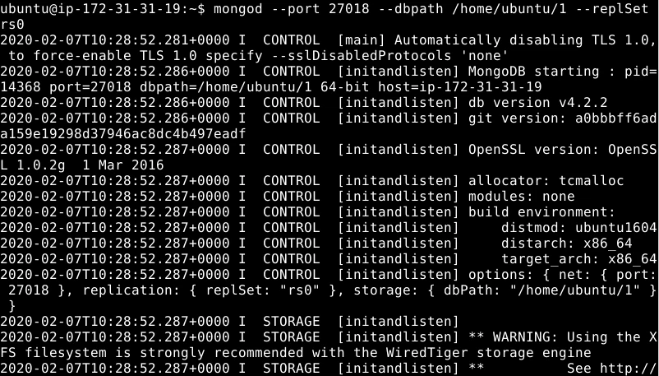

* Open another terminal
* Type **mongod --port 27019 --dbpath /home/ubuntu/2 --replSet rs0**

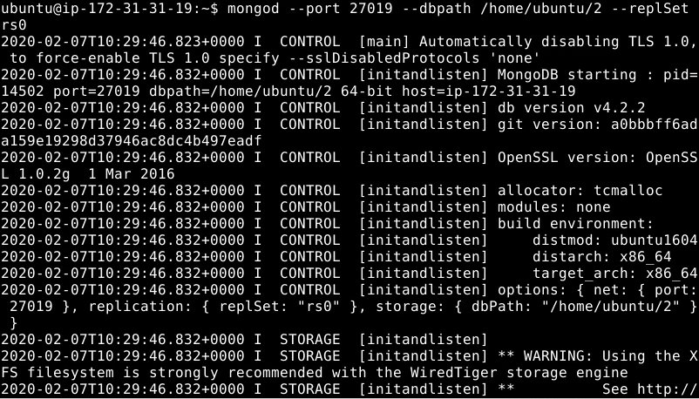

**Step 4.7.3:** Connecting to MongoDB shell

* Open another terminal
* Type **mongo --port 27018**

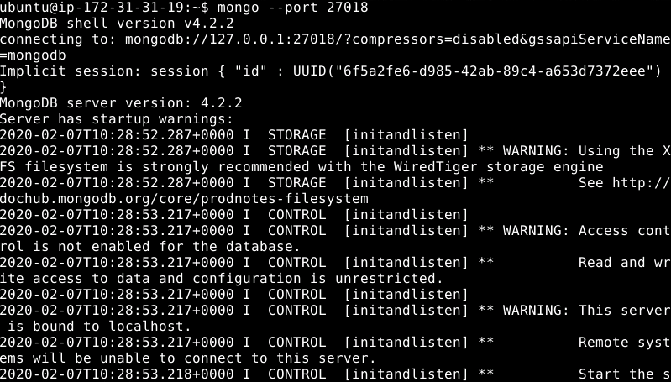

* Type **rsconf= {_id: "rs0", members: [ {_id:0, host: "localhost:27018"}, {_id: 1, host: "localhost:27019"}]}**
* Type **rs.initiate(rsconf)**

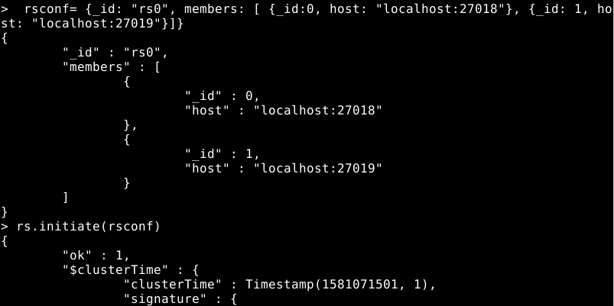

* Type **rs.status()** to check the status of Replica set

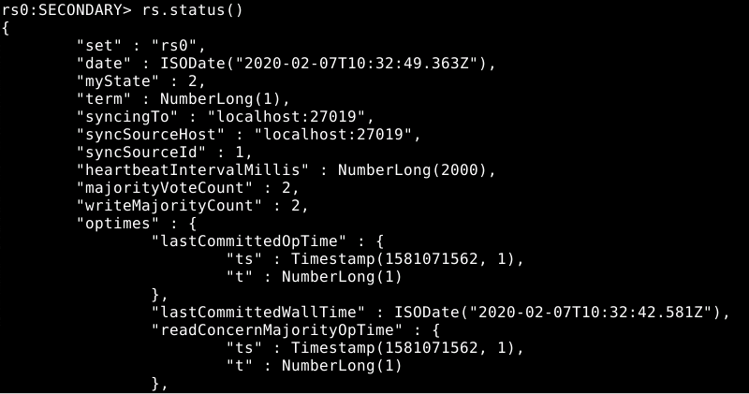

* Type **rs.printReplicationInfo()** to print the oplog information

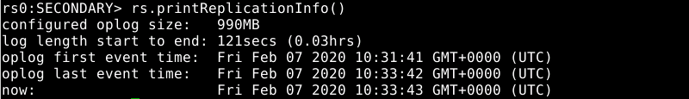

* Type **rs.printSlaveReplicationInfo()** to print the slave information



* Type **rs.slaveOk ()**
* Type **db.isMaster()**

**Step 4.7.4:** Pushing the code to GitHub repositories

Open your command prompt and navigate to the folder where you have created your files.

cd <folder path>

Initialize your repository using the following command:

git init

Add all the files to your git repository using the following command:

git add .

Commit the changes using the following command:

git commit . -m “Changes have been committed.”

Push the files to the folder you initially created using the following command:

git push -u origin master