4.8 Creating a Shard Cluster and Deploy the Sharded Cluster

This section will guide you to:

* Create a shard cluster
* Deploy a sharded cluster

This lab has four subsections, namely:

4.8.1 Creating directories at C drive

4.8.2 Starting config server instances

4.8.3 Connecting to Mongo shell

4.8.4 Pushing the code to GitHub repositories

* *MongoDB is already installed in your lab. (Refer MEAN: Lab Guide - Phase 3)*

**Step 4.8.1:** Creating directories at C drive

* Create directories configdb1 and configdb2 using **mkdir configdb1** and **mkdir configdb2** commands

**Step 4.8.2:** Starting config server instances

* Open terminal
* Type **mongod --configsvr --replSet rs1 --dbpath /home/ubuntu/configdb1 --port 27019**

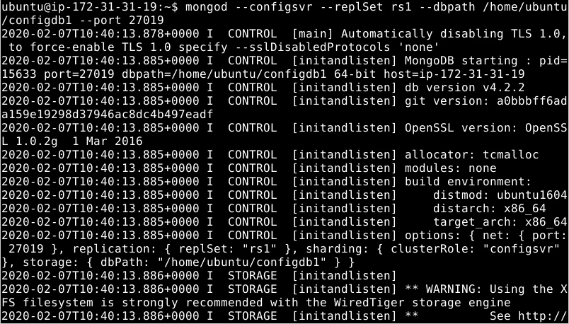

* Open another terminal
* Type **mongod --configsvr --replSet rs1 --dbpath /home/ubuntu/configdb2 --port 27020**

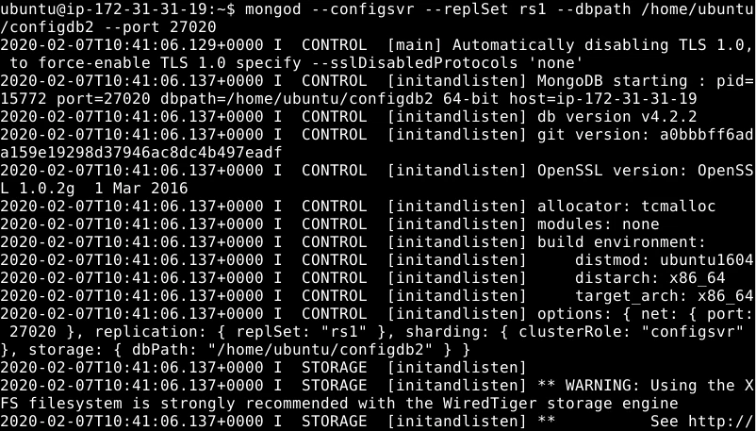

**Step 4.8.3:** Connecting to Mongo shell

* Open another terminal
* Type **mongo --port 27019**

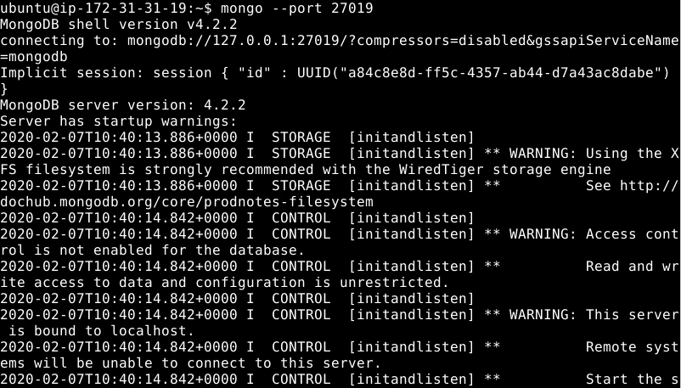

* Type **rs.initiate({_id: "rs1",members: [{ _id: 0, host : "localhost:27019" }, { _id: 1, host : "localhost:27020" }]})**

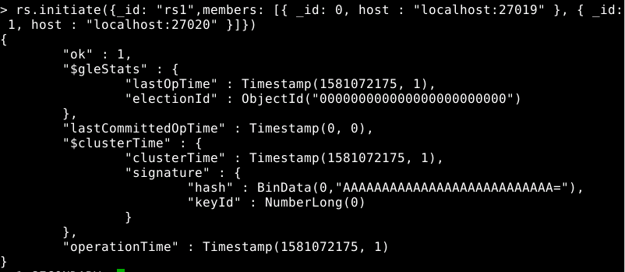

* Open another terminal
* Type **mongos --configdb "rs1"/localhost:27019 --port 27019**

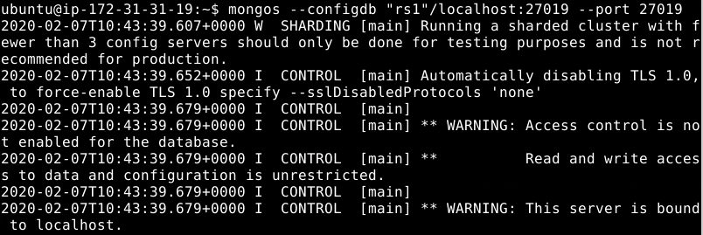

* Go to the previous terminal where you ran **mongo --port 27019** command
* Type **sh.status()**

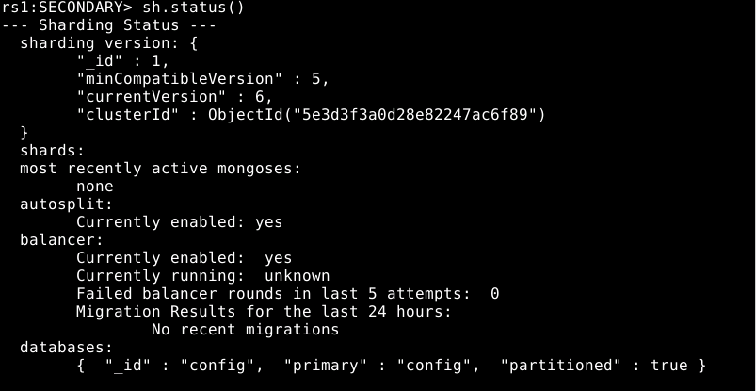

**Step 4.8.4:** Pushing the code to GitHub repositories

Open your command prompt and navigate to the folder where you have created your files.

cd <folder path>

Initialize your repository using the following command:

git init

Add all the files to your git repository using the following command:

git add .

Commit the changes using the following command:

git commit . -m “Changes have been committed.”

Push the files to the folder you initially created using the following command:

git push -u origin master