2.2 Testing Models

This section will guide you to:

* Test models

This lab has three subsections, namely:

* + 1. Creating a recipe model
    2. Refactoring the code
    3. Pushing the code to GitHub repositories

**Step 2.2.1:** Creating a recipe model

**Step 2.2.1.1:** Writing the tests

* Open Visual Studio Code
* Open jasmine-standalone-2.3.4 folder
* Go to the **spec** folder
* Create a new **recipeModelSpec.js** file
* Write the code given below in the command prompt:

*describe("A recipe",function(){*

*it("should exist", function(){*

*expect(app.Models.Recipe).toBeDefined();*

*});*

*});*

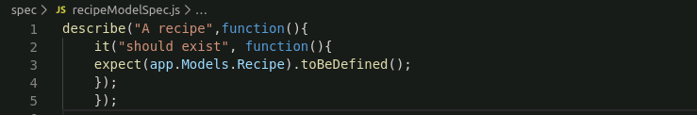

* Save the created file
* To make sure that the SpecRunner knows about the newly added spec file, open SpecRunner.html file
* Remove the source files and spec files from the SpecRunner.html file
* Copy and paste the command given below:

<script src="spec/recipeModelSpec.js"></script>

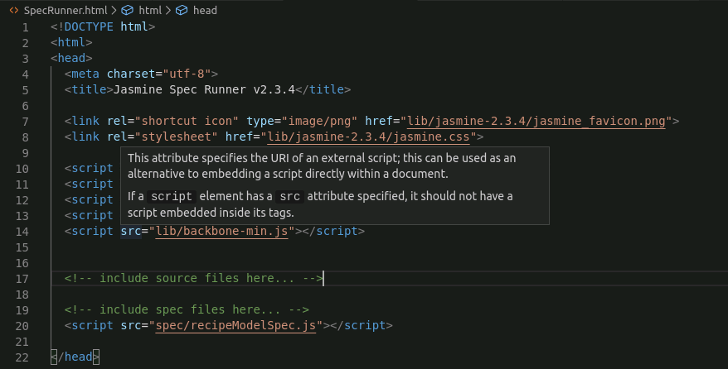

* Save the file

**Step 2.2.1.2:** Running the tests

* Open SpecRunner.html file in browser by copy-pasting the path of SpecRunner.html

/home/ubuntu/Desktop/jasmine-standalone-2.3.4/SpecRunner.html

* The test will fail

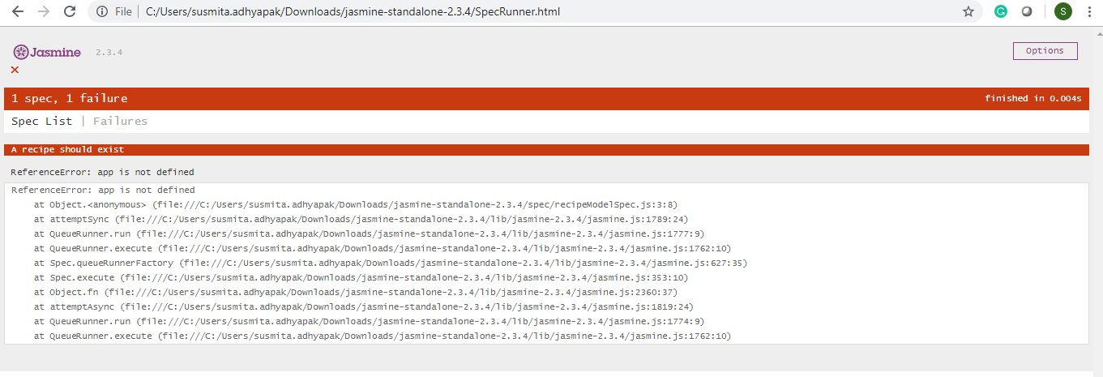

**Step 2.2.1.3:** Adding a source file

* Go to src directory and create a **recipeModel.js** file
* Write the following code in the file:

*var app= window.app || {};*

*app.Models=app.Models || {};*

*app.Models.Recipe=Backbone.Model.extend({});*

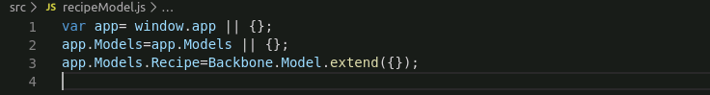

* Save the created file
* Open SpecRunner.html file with Notepad
* Copy and paste the command given below:

<script src="src/recipeModel.js"></script>

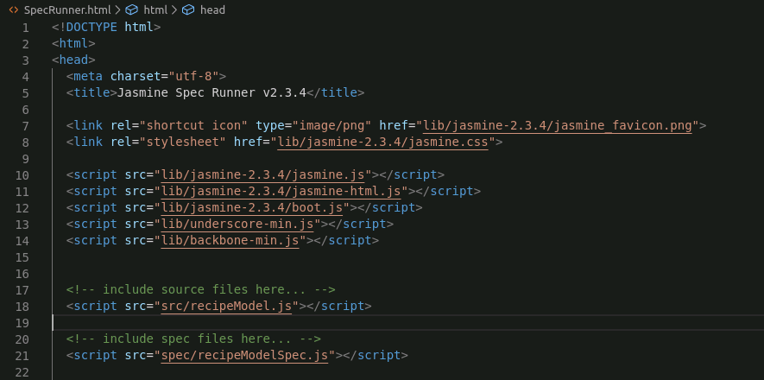

* Save the file

**Step 2.2.1.1:** Running the tests

* Open SpecRunner.html file in browser by copy-pasting the path of SpecRunner.html

/home/ubuntu/Desktop/jasmine-standalone-2.3.4/SpecRunner.html

* The test will pass

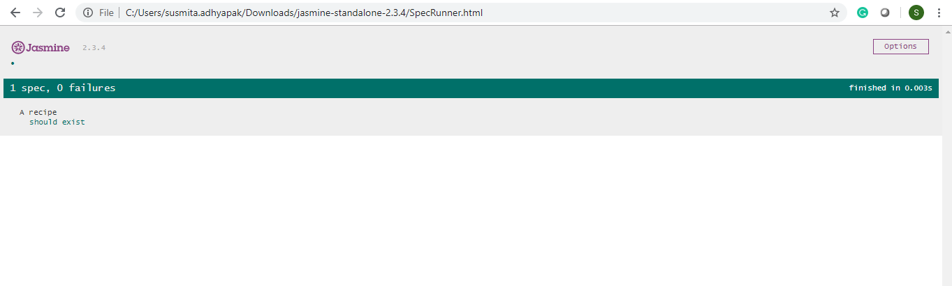

**Step 2.2.2:** Refactoring the code

**Step 2.2.2.1:** Modifying the spec file

* Go to the spec folder
* Modify the **recipeModelSpec.js** file
* Write the code given below in the file:

*describe("A recipe",function(){*

*it("should exist", function(){*

*expect(app.Models.Recipe).toBeDefined();*

*});*

*it("should have certain defaults",function(){*

*var recipe=new app.Models.Recipe();*

*expect(recipe.get("name")).toEqual("Unnamed");*

*expect(recipe.get("rating")).toEqual(0);*

*});*

*});*

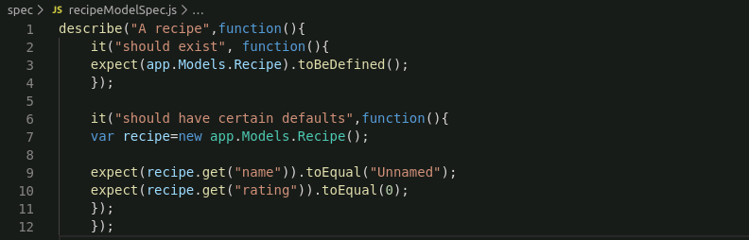

* Save the created file
* Open SpecRunner.html file in browser by copy-pasting the path of SpecRunner.html

/home/ubuntu/Desktop/jasmine-standalone-2.3.4/SpecRunner.html

* The test will fail, because we have not declared the default properties as a function

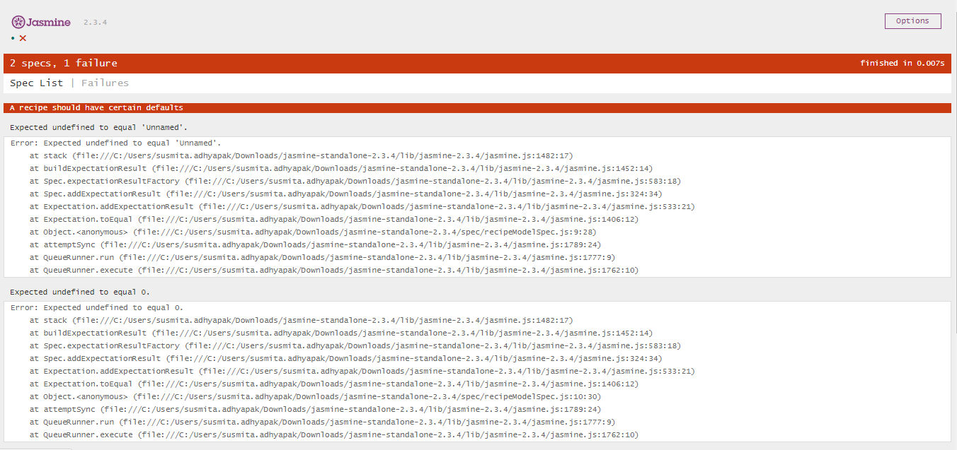

**Step 2.2.2.2:** Modifying src file

* Go to the src folder and modify the **recipeModel.js** file
* Write the following code in the file:

*var app= window.app || {};*

*app.Models=app.Models || {};*

*app.Models.Recipe=Backbone.Model.extend({*

*defaults: function(){*

*return{*

*name: ”Unnamed”,*

*rating: 0*

*};*

*}*

*});*

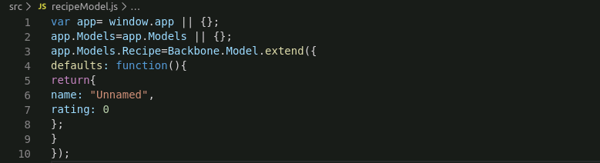

* Save the created file

**Step 2.2.2.1:** Running the tests

* Open SpecRunner.html file in browser by copy-pasting the path of SpecRunner.html in browser

/home/ubuntu/Desktop/jasmine-standalone-2.3.4/SpecRunner.html

* The test will pass

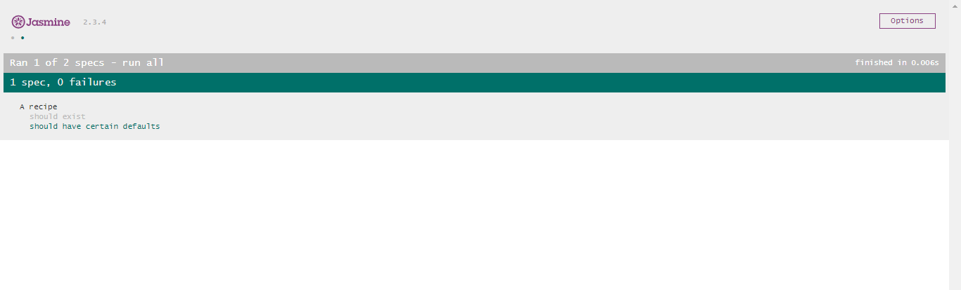

**Step 2.2.3:** Pushing the code to GitHub repositories

Open your command prompt and navigate to the folder where you have created your files.

cd <folder path>

Initialize your repository using the following command:

git init

Add all the files to your git repository using the following command:

git add . 

Commit the changes using the following command:

git commit . -m “Changes have been committed.”

Push the files to the folder you created initially using the following command:

git push -u origin master