3.1 Grunt Installation and Configuration

This section will guide you to:

* Install and set up Grunt in your system

This lab has five subsections, namely:

3.1.1 Installing Node js

3.1.2 Installing Visual Studio Code

3.1.3 Installing Grunt CLI

3.1.4 Configuring Gruntfile.js and package.json file

3.1.5 Pushing the code to your GitHub repositories

**Step 3.1.1:** Installing Node js

* Please refer to the Lab guide with the name **MEAN: Lab Guide - Phase 4.**

**Step 3.1.2:** Installing Visual Studio Code

* Please refer to the Lab guide with the name **MEAN: Lab Guide - Phase 4.**

**Step 3.1.3:**  Installing Grunt CLI

* Open the command line and type in the following command:

**npm install -g grunt-cli**

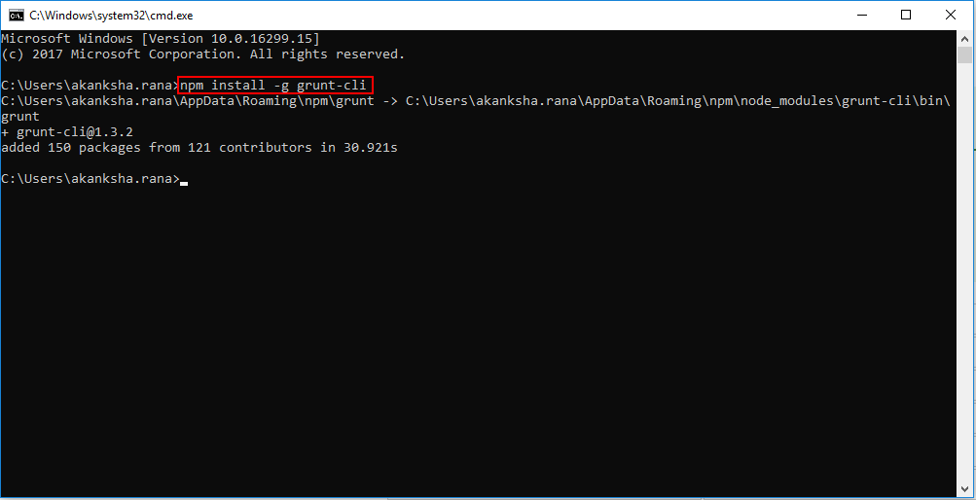

**Step 3.1.4:** Configuring gruntfile.js and package.json file

* Create a folder in your system to store all your project files. Navigate to that folder via command line and type in the following command:

**cd <path of the folder>**

**npm init**

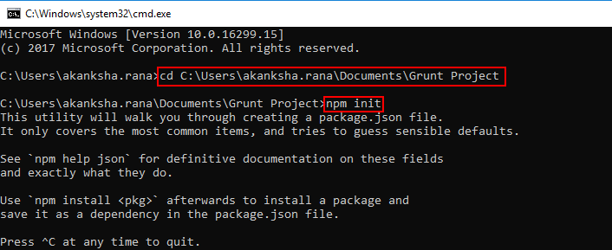

* npm init command will create the **package.json** file in your project folder. Once you open package.json file in Netbeans IDE, this is how it will look:
* Provide the Package name then press enter. Press enter again after the version is displayed, then provide the description of the project.

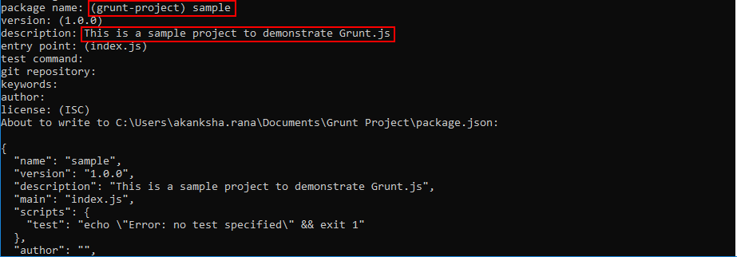

* Keep pressing **enter** for the rest of the fields and type in **yes** when prompted with “Is this ok?” text.
* Type in the following command:

**npm install grunt --save-dev**

* You will notice that package.json file has been created in your project folder.
* Create a javascript file under the project folder with the name **gruntfile.js**
* Copy and paste the following code in the **gruntfile.js** file and save it.

**module.exports = function(grunt) {**

**grunt.initConfig({**

**pkg: grunt.file.readJSON('package.json'),**

**});**

**};**

**Step 3.1.5:** Pushing the code to your GitHub repositories

Open your command prompt and navigate to the folder where you have created your files.

**cd <folder path>**

Initialize your repository using the following command:

**git init**

Add all the files to your git repository using the following command:

**git add .**

Commit the changes using the following command:

**git commit . -m “Changes have been committed.”**

Push the files to the folder you created initially using the following command:

**git push -u origin master**