3.3 Testing with Grunt Plugins



This section will guide you to:

* Perform testing with Grunt plugins

This lab has three subsections, namely:

3.3.1 Unit testing with QUnit

3.3.2 Behavior testing with Behat

3.3.3 Pushing the code to your GitHub repositories

**Step 3.3.1:** Unit testing with QUnit

* Install and set up QUnit using the following commands in your command-line interface:

**cd <path of the root project folder>**

**npm install qunit --save-dev**

**npm install grunt-contrib-qunit --save-dev**

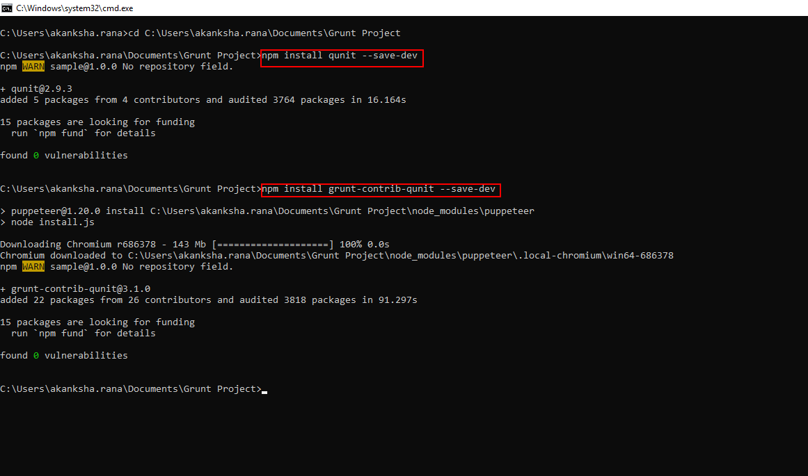

* Create a folder named **tests** in your root project folder. Create two new files in the tests folder named index.html and tests.js. Copy and paste the following content in the respective files:

**index.html:**

**<!DOCTYPE html>**

**<html>**

**<head>**

**<meta charset="utf-8">**

**<title>QUnit Example</title>**

**<link rel="stylesheet" href="//code.jquery.com/qunit/qunit-1.19.0.css">**

**</head>**

**<body>**

**<div id="qunit"></div>**

**<div id="qunit-fixture"></div>**

**<script src="//code.jquery.com/qunit/qunit-1.18.0.js"></script>**

**<script src="test.js"></script>**

**</body>**

**</html>**

**tests.js:**

**QUnit.test("hello test", function( assert ) {**

**assert.ok(1 == "1", "Passed!");**

**});**

* Copy and paste the following code snippet in the gruntfile.js file as shown in the screenshot below:

**qunit: {**

**all: {**

**options: {**

**urls: [**

**‘http://localhost:8000’**

**]**

**}**

**}**

**},**

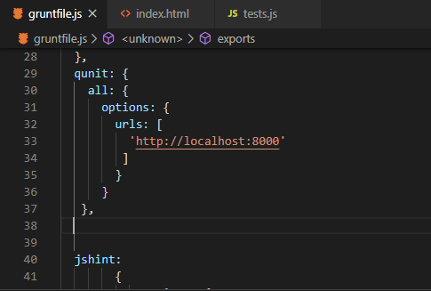

* Install grunt-contrib-connect using the following command:

**npm install grunt-contrib-connect --save-dev**

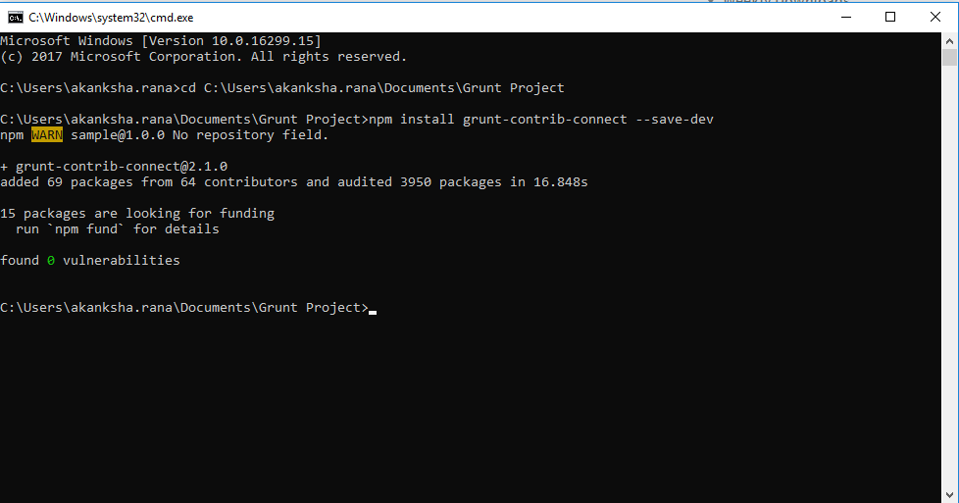

* Add the following code snippet in the gruntfile.js file as shown in the screenshot below:

**connect: {**

**server: {**

**options: {**

**port: 8000,**

**base: 'tests/', keepalive: true, }**

**}**

**}**

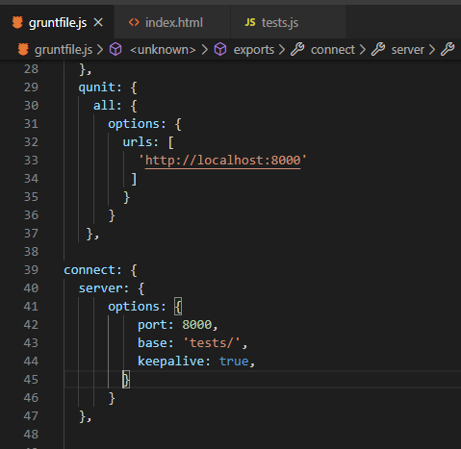

* Click on the **Terminal** option on the top menu and click on **Run Task**. Select **qunit.**

**Step 3.3.2:** Behavior testing with Behat

* Install the Behat plugin using the following command in the command-line interface:

**npm install grunt-behat**

* To verify the installation, check that the behat version is mentioned in package.json file
* Add the following code snippet in the gruntfie.js file as shown in the screenshot below:

**behat: {**

**test: {**

**options: {**

**output: true,**

**failOnUndefined: true,**

**failOnFailed: true**

**},**

**cmd: 'node_modules/grunt-behat/bin',**

**features: 'features/',**

**flags: '-f pretty'**

**}},**

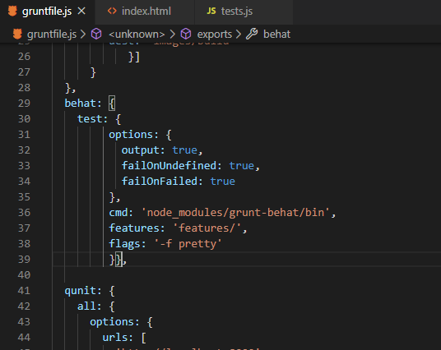

* Click on thr **Terminal** option on the top menu and click on **Run Task**. Select **behat.**.

**Step 3.3.3:** Pushing the code to your GitHub repositories

Open your command prompt and navigate to the folder where you have created your files.

**cd <folder path>**

Initialize your repository using the following command:

**git init**

Add all the files to your git repository using the following command:

**git add .**

Commit the changes using the following command:

**git commit . -m “Changes have been committed.”**

Push the files to the folder you created initially using the following command:

**git push -u origin master**