4.1 Build a Custom Docker Image



This section will guide you to**:**

* Build a custom Docker image using a custom Dockerfile and deploy it on Docker host.

This guide has three subsections, namely**:**

4.1.1 Demonstrating Clone Git repository

4.1.2 Performing Docker Build

4.1.3 Pushing the code to the GitHub repositories

* *Docker is already installed in your lab. (Refer MEAN: Lab Guide - Phase 4)*

**Step 4.1.1:** Demonstrating Clone Git repository

* Open the terminal
* Clone the Git repository on a Docker host using the given command below:

**git clone** [**https://github.com/Anuj1990/Docker.git**](https://github.com/Anuj1990/Docker.git)

**Step 4.1.2:** PerformingDocker Build

* Proceed with the docker build command to build a custom docker image.

**cd Docker**

**docker build -t phpcode . -f Dockerfile**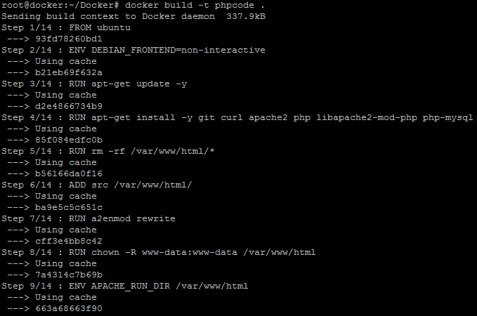

* Once the image is built, check the image using docker run command and then run it to initialize custom container on Docker host.

**docker images**

**docker run -d -p 80:80 -- name phpcode phpcode**

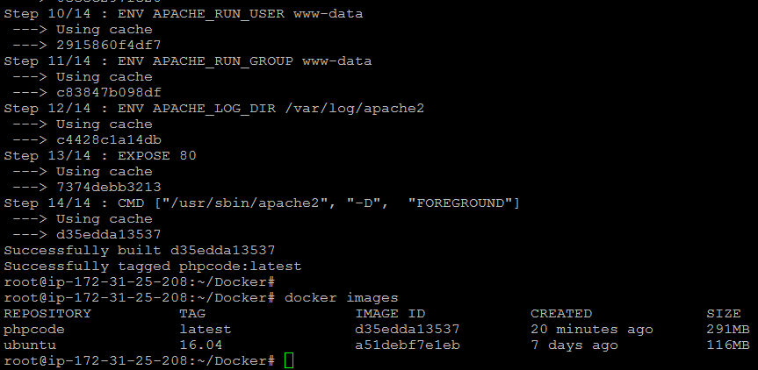

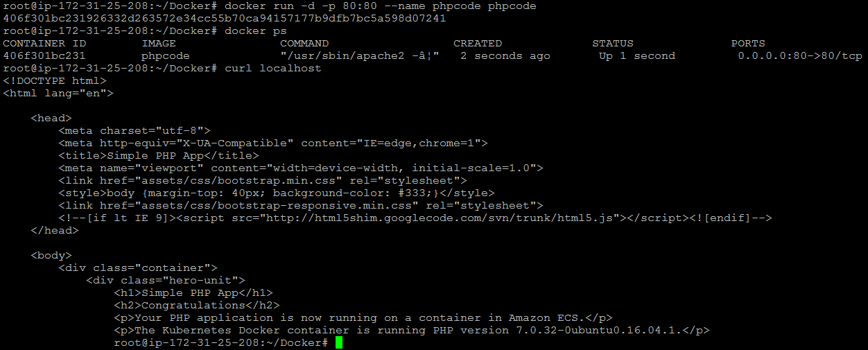

* Once the container is up and running, validate the connectivity using the **curl** command to see if **php code** is running on port 80 or not.

**Step 4.1.3:** Pushing the code to GitHub repositories

Open your command prompt and navigate to the folder where you have created your files.

cd <folder path>

Initialize your repository using the following command:

git init

Add all the files to your git repository using the following command:

git add . 

Commit the changes using the following command:

git commit . -m “Changes have been committed.”

Push the files to the folder you created initially using the following command:

git push -u origin master