4.3 Container Deployment Using Docker Swarm



This section will guide you to**:**

* Deploy a Docker container on Docker swarm for orchestration.

This guide has four subsections, namely**:**

4.3.1 Setting up a Docker instance

4.3.2 Building a custom Docker image to be deployed

4.3.3 Initializing a Docker swarm cluster and deploying a container to the cluster

4.3.4 Pushing the code to the GitHub repositories

* *Docker is already installed in your lab. (Refer MEAN: Lab Guide - Phase 4)*

**Step 4.3.1:** Setting up a Docker instance

* Before proceeding with a Docker swarm cluster, we need to install Docker on our server.
* Open the terminal.
* Please follow the set of commands given below to install Docker on Ubuntu server.

**sudo** **apt install docker.io**

**docker version**

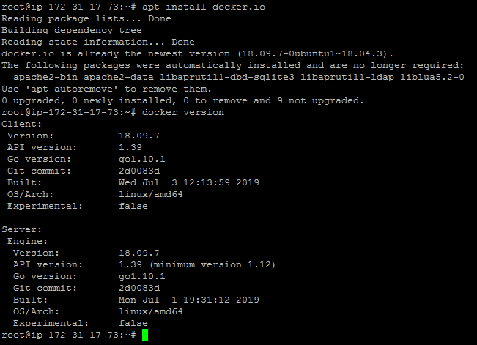

**Step 4.3.2:** Building a custom Docker image to be deployed

* First, clone the Git repository on Docker host using the below command:

**git clone** [**https://github.com/Anuj1990/Docker.git**](https://github.com/Anuj1990/Docker.git)

* Run with docker build command to build a custom Docker image

**cd Docker**

**docker build -t phpcode .** 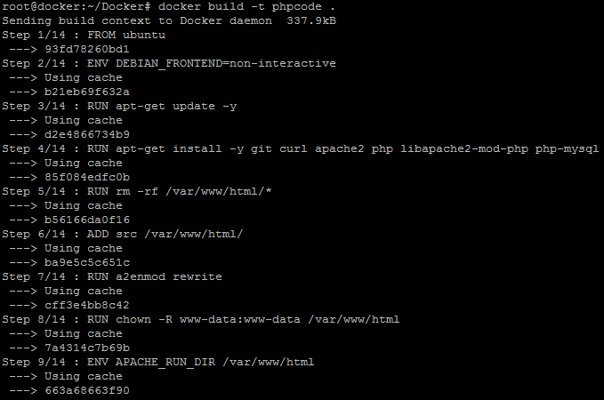

* Once the image is built, check if it is built properly or not. You can see a Docker image entry using Docker images command:

**docker images**

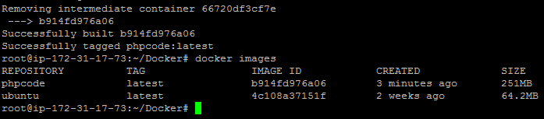

**Step 4.3.3:** Initializing a Docker swarm cluster and deploying a container to the cluster

* First, we need to initialize Docker swarm using the set of commands given below:

**docker swarm init**

**docker node ls**

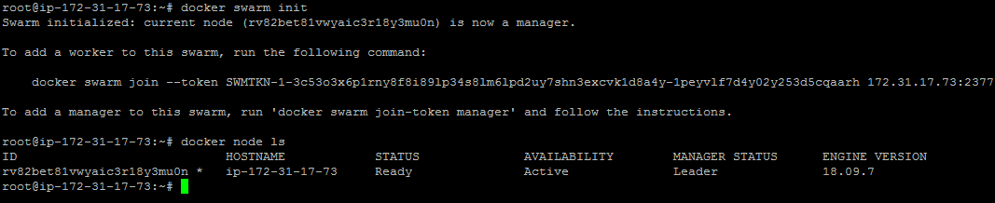

* Once the node is configured, deploy the custom Docker image on the Docker swarm cluster following the process shown below:

**docker service create -p 80:80 --name webserver phpcode**

**docker service ls**

**curl localhost**

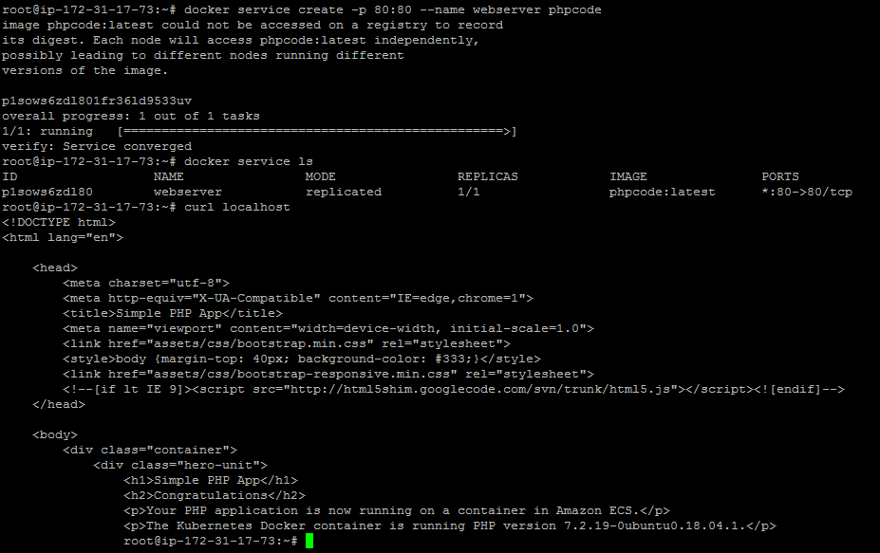

**Step 4.3.4:** Pushing the code to GitHub repositories

Open your command prompt and navigate to the folder where you have created your files.

cd <folder path>

Initialize your repository using the following command:

git init

Add all the files to your git repository using the following command:

git add . 

Commit the changes using the following command:

git commit . -m “Changes have been committed.”

Push the files to the folder you created initially using the following command:

git push -u origin master