4.8 Docker CE



This section will guide you to**:**

* Install Docker Community Edition, also known as Docker CE.

This guide has two subsections, namely**:**

4.8.1 Docker CE Installation

4.8.2 Pushing the code to GitHub repositories

* *Docker is already installed in your lab. (Refer MEAN: Lab Guide - Phase 4)*

**Step 4.8.1:** Docker CE Installation

* Open the terminal
* Install Docker CE on your Ubuntu server. Follow the series of steps mentioned below to install Docker CE on Ubuntu server:

**sudo apt update**

**sudo apt-get install apt-transport-https ca-certificates software-properties-common**

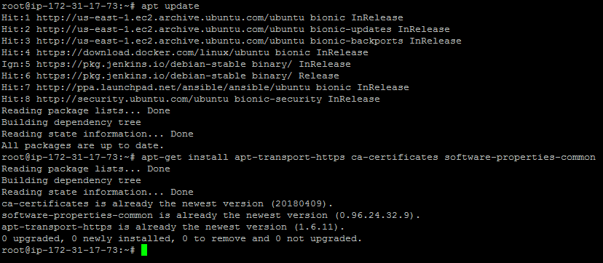

* Add Docker’s official GPG key to your Ubuntu server using the steps below. Also, add a stable repository so that we can download Docker CE package for installation.

**sudo curl -fsSL https://download.docker.com/linux/ubuntu/gpg | sudo apt-key add -**

**add-apt-repository "deb [arch=amd64] https://download.docker.com/linux/ubuntu $(lsb_release -cs) stable"**

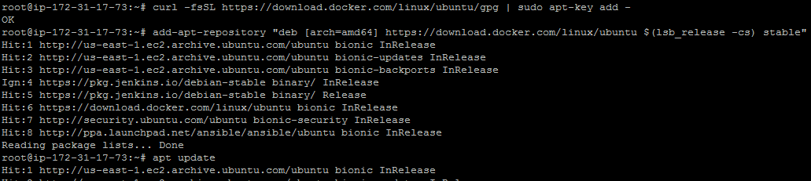

* Install the latest version of Docker CE and containerd.io using the commands below:

**sudo apt-get install docker-ce docker-ce-cli containerd.io**

**docker version**

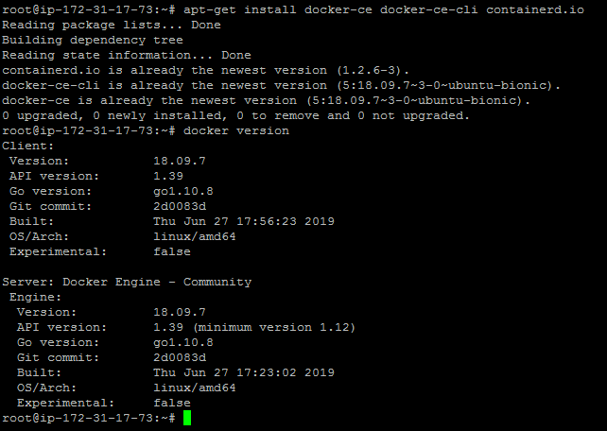

* Once Docker CE is installed, run sample Docker image so that we can test the Docker CE installation.
* We can run multiple Docker containers using Docker CE. Follow the command below to test the sample Docker image:

**docker run hello-world**

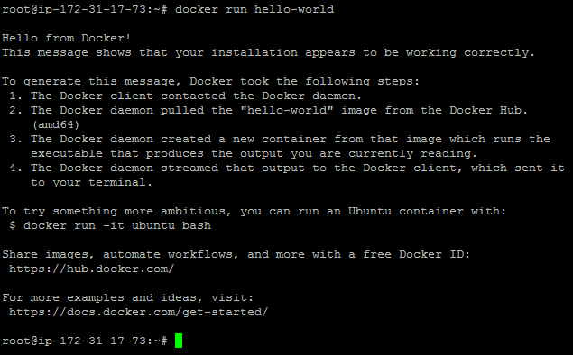

**Step 4.8.2:** Pushing the code to GitHub repositories

Open your command prompt and navigate to the folder where you have created your files.

cd <folder path>

Initialize your repository using the following command:

git init

Add all the files to your git repository using the following command:

git add . 

Commit the changes using the following command:

git commit . -m “Changes have been committed.”

Push the files to the folder you created initially using the following command:

git push -u origin master