5.3 Launch an Instance in a Placement Group



This section will guide you to:

* Launch an instance in a placement group

This lab has two subsections, namely:

5.3.1 Creating a placement group

5.3.2 Launching an instance in the placement group

5.3.3 Pushing the code to your GitHub repositories

**Step 5.3.1:** Creating a placement group

* Click on *Create Placement Group*

# 

* Provide a name and strategy

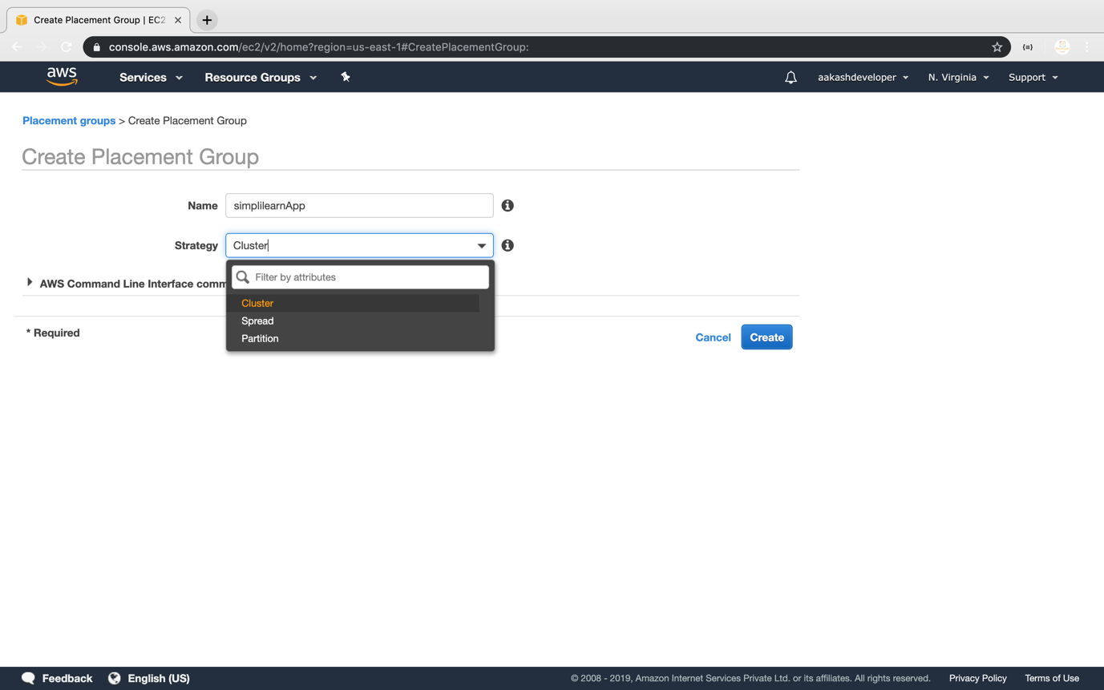

**Step 5.3.2:** Launching an instance in the placement group

* Launch the new EC2 instance

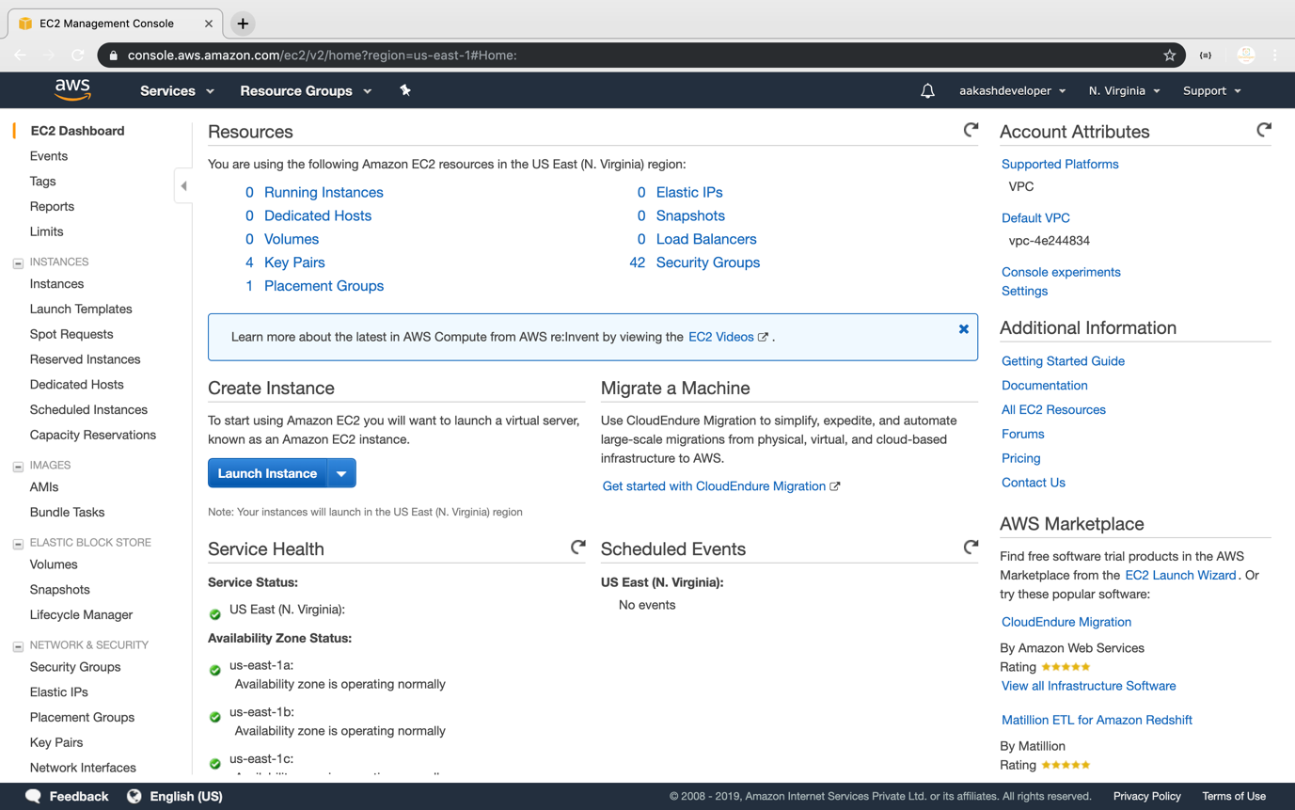

* Select the placement group

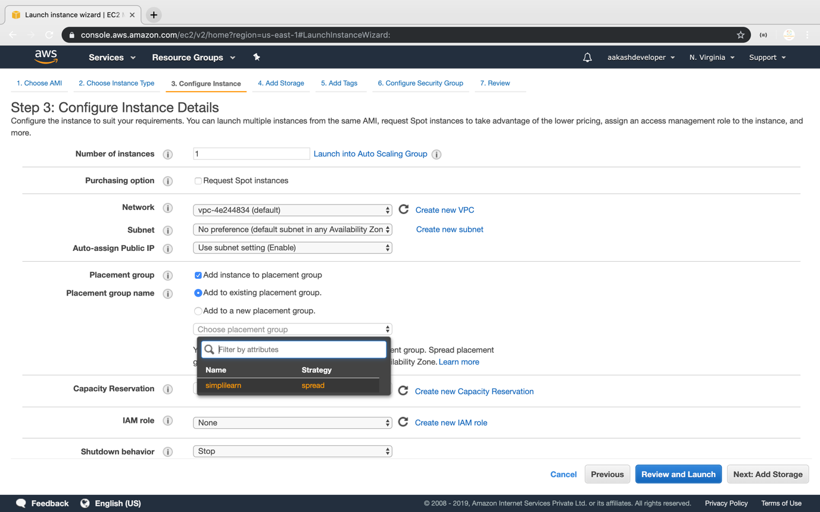

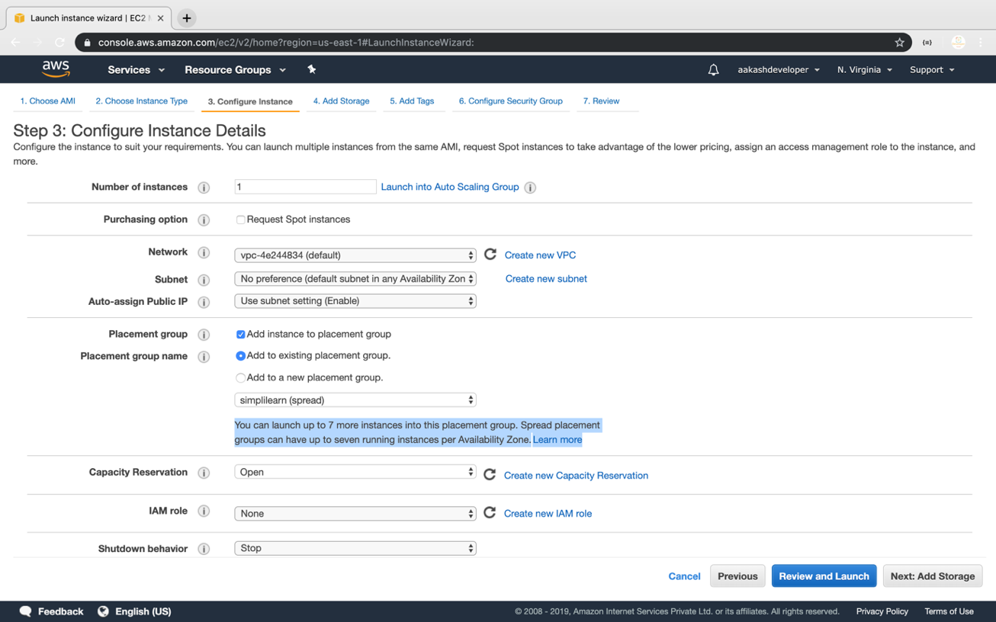

* Verify the placement group of the instance

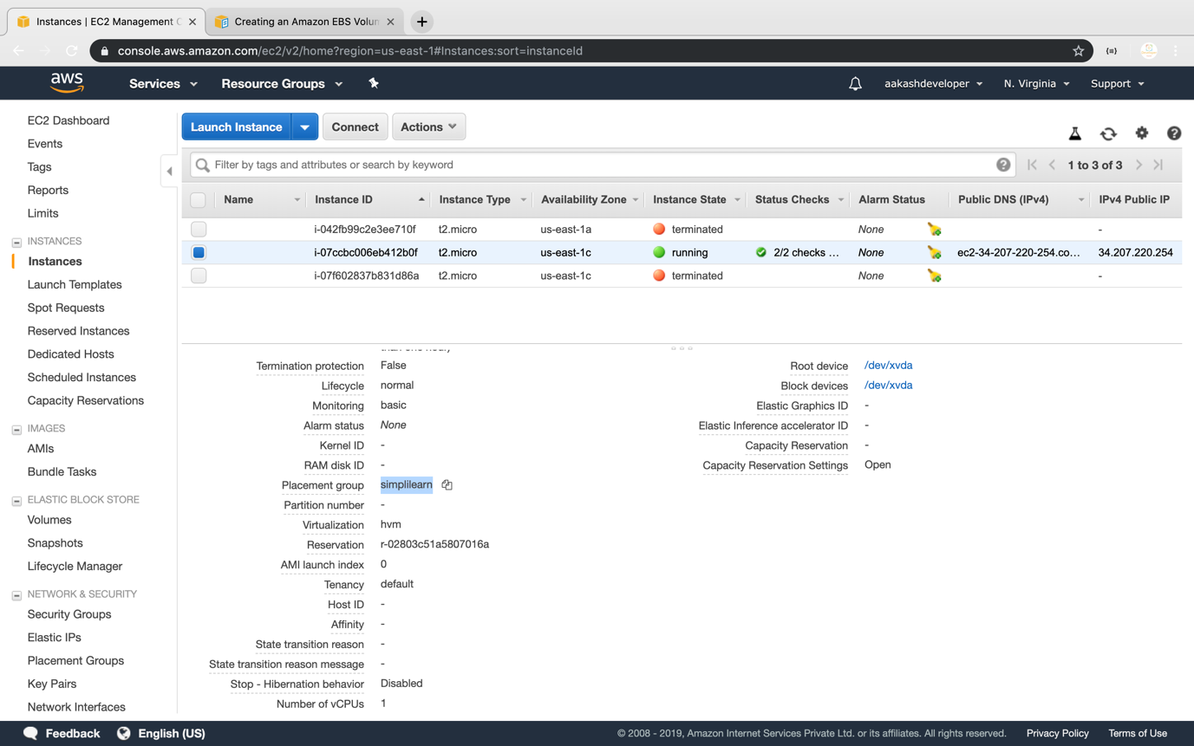

**Step 5.3.3:** Pushing the code to your GitHub repositories

Open your command prompt and navigate to the folder where you have created your files.

cd <folder path>

Initialize your repository using the following command:

git init

Add all the files to your git repository using the following command:

git add .

Commit the changes using the following command:

git commit -m “Changes have been committed.”

Push the files to the folder you created initially using the following command:

git push -u origin master