5.4 Create an EBS Volume



This section will guide you to:

* Change the volume size of an instance

This guide has five subsections, namely:

5.4.1 Selecting the **volume** tab in the EC2 dashboard

5.4.2 Creating a new volume by clicking on **Create**

5.4.3 Selecting the volume type according to the project requirement

5.4.4 Creating a new volume by specifying the size and defining the zone

5.4.5 Verifying the new volume created on the volume console and its availability

5.4.6 Pushing the code to your GitHub repositories

**Step 5.4.1:** Selecting the **volume** tab in the EC2 dashboard

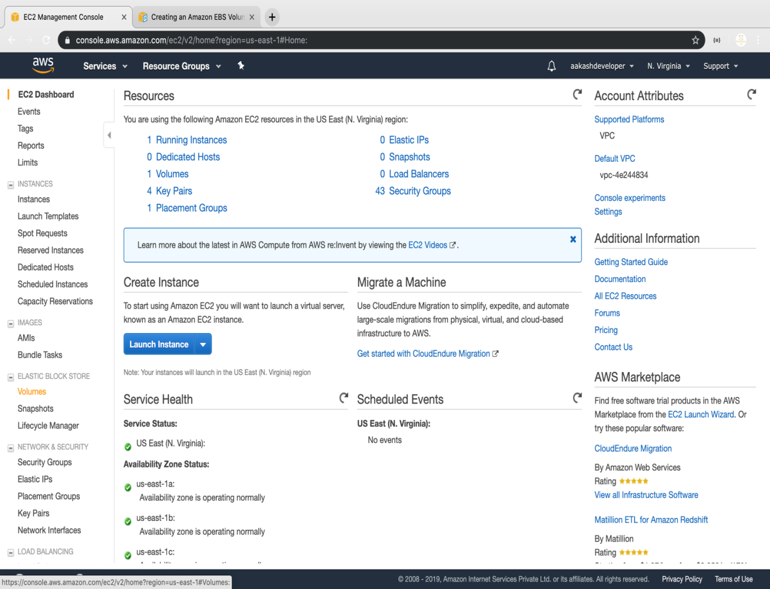

**Step 5.4.2:** Creating a new volume by clicking on **Create**

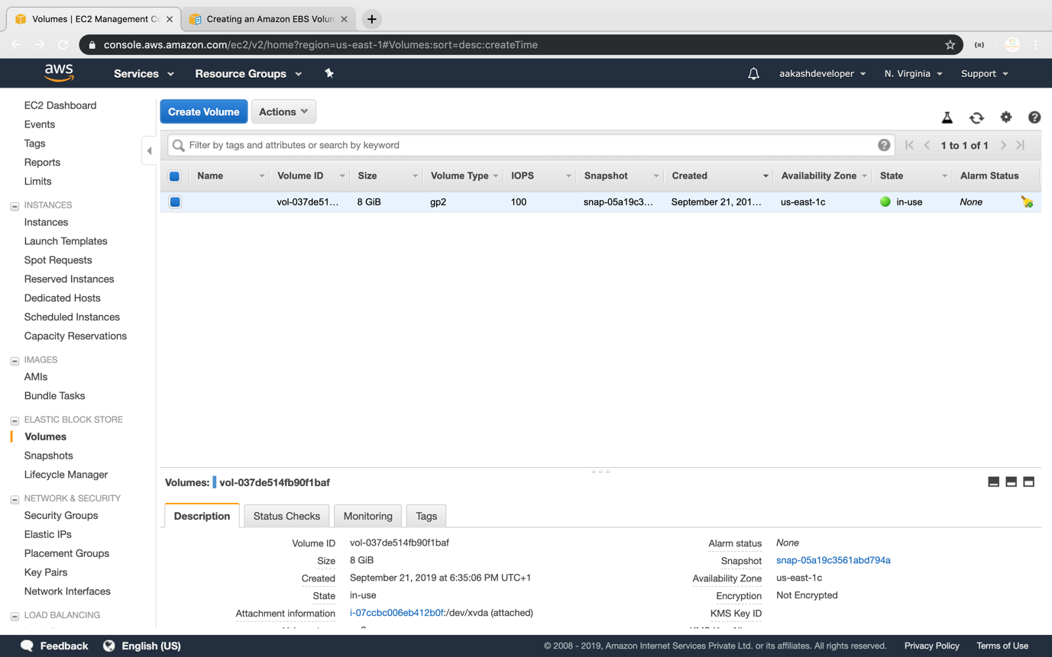

**Step 5.4.3:** Selecting the volume type according to the project requirement

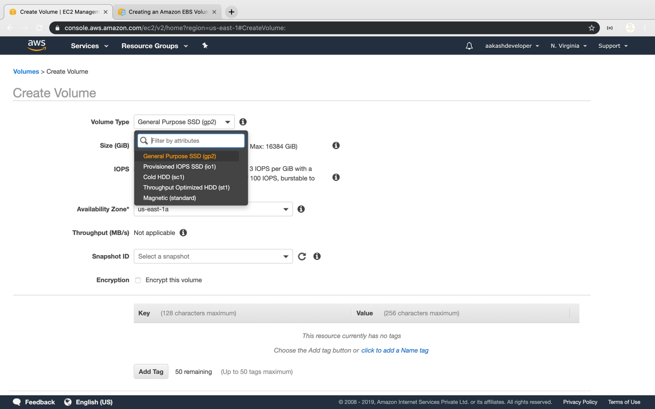

**Step 5.4.4:** Creating a new volume by specifying the size and defining the zone

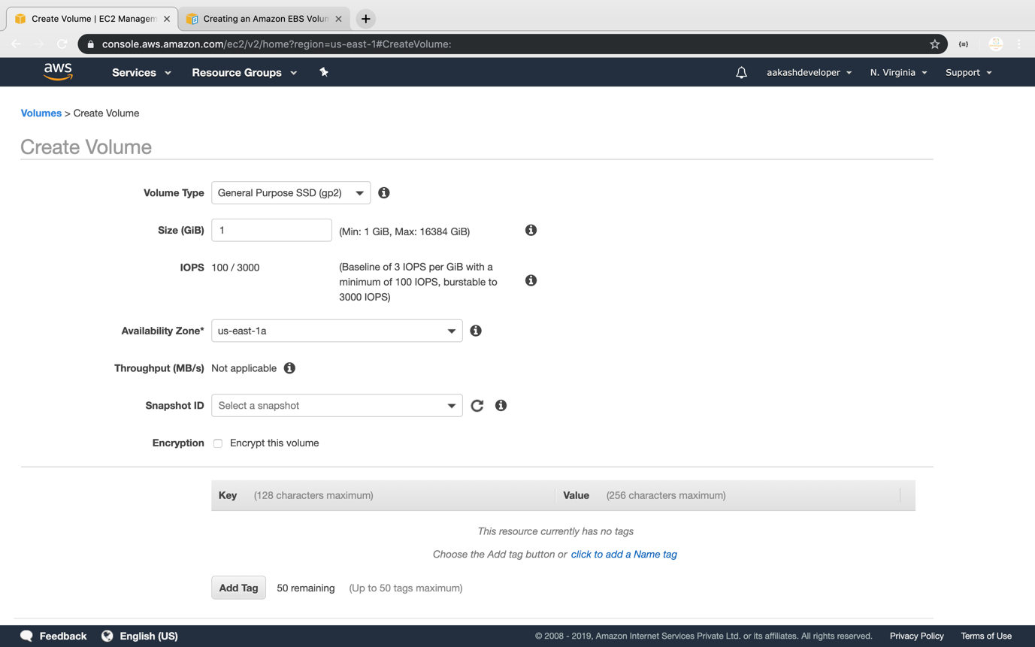

**Step 5.4.5:** Verifying the new volume created on the volume console and its availability

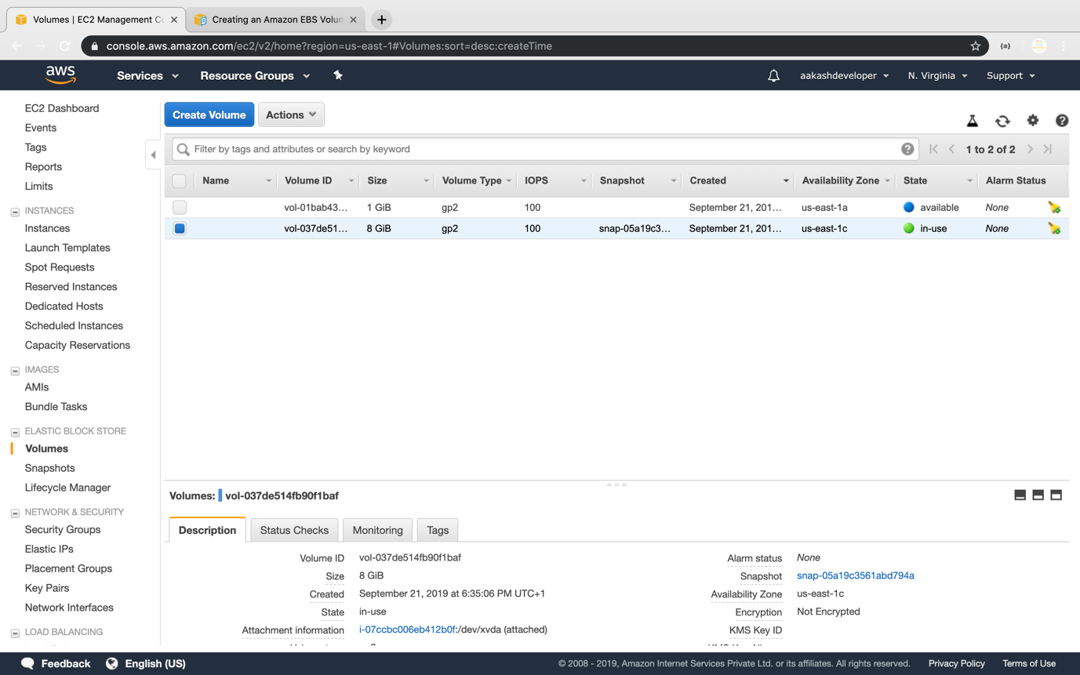

**Step 5.4.6:** Pushing the code to your GitHub repositories

Open your command prompt and navigate to the folder where you have created your files.

cd <folder path>

Initialize your repository using the following command:

git init

Add all the files to your git repository using the following command:

git add .

Commit the changes using the following command:

git commit -m “Changes have been committed.”

Push the files to the folder you created initially using the following command:

git push -u origin master