5.5 Format and Mount an EBS Volume



This section will guide you to:

* Format and mount an EBS volume

This lab has three subsections, namely:

5.5.1 Attaching an existing EBS volume

5.5.2 Mounting the EBS volume

5.5.3 Unmounting the EBS volume

5.5.4 Pushing the code to your GitHub repositories

**Step 5.5.1:** Attaching an existing EBS volume

* Select an existing volume and click on *Attach Volume*
* Select the instance

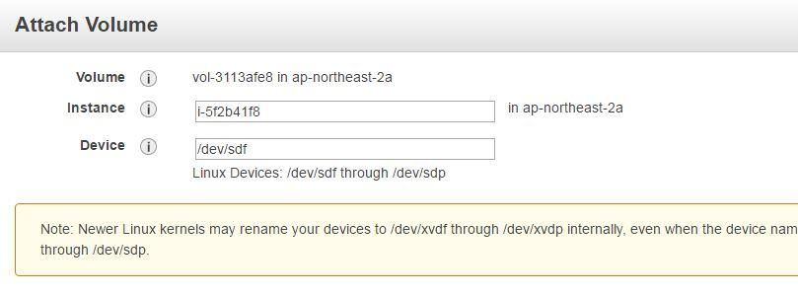

**Step 5.5.2:** Mounting the EBS volume

* Login to your EC2 instance and list the available disks using the following command:

*ldblk*

* Use the following command to check if the volume has any data:

*sudo file -s /dev/xvdf*

* Use the following command to format the volume to ext4 filesystem:

*sudo mkfs -t ext4 /dev/xvdf*

* Use the following command to create a directory to mount the volume:

*sudo mkdir /newvolume*

* Use the following command to mount the volume:

*sudo mount /dev/xvdf /newvolume/*

* Check the disk space using the following command:

*cd /newvolume*

*df -h .*

**Step 5.5.3:** Unmounting the EBS volume

* Use the following command to unmount the volume:

*umount /dev/xvdf*

**Step 5.5.4:** Pushing the code to your GitHub repositories

Open your command prompt and navigate to the folder where you have created your files.

cd <folder path>

Initialize your repository using the following command:

git init

Add all the files to your git repository using the following command:

git add .

Commit the changes using the following command:

git commit -m “Changes have been committed.”

Push the files to the folder you created initially using the following command:

git push -u origin master