5.6 Detach an EBS Volume

This section will guide you to:

* Detach an EBS volume from an instance

This lab has two subsections, namely:

5.6.1 Selecting the EBS volume you want to detach

5.6.2 Detaching the volume

5.6.3 Pushing the code to your GitHub repositories

**Step 5.6.1:** Selecting the EBS volume you want to detach

* Choose the bucket

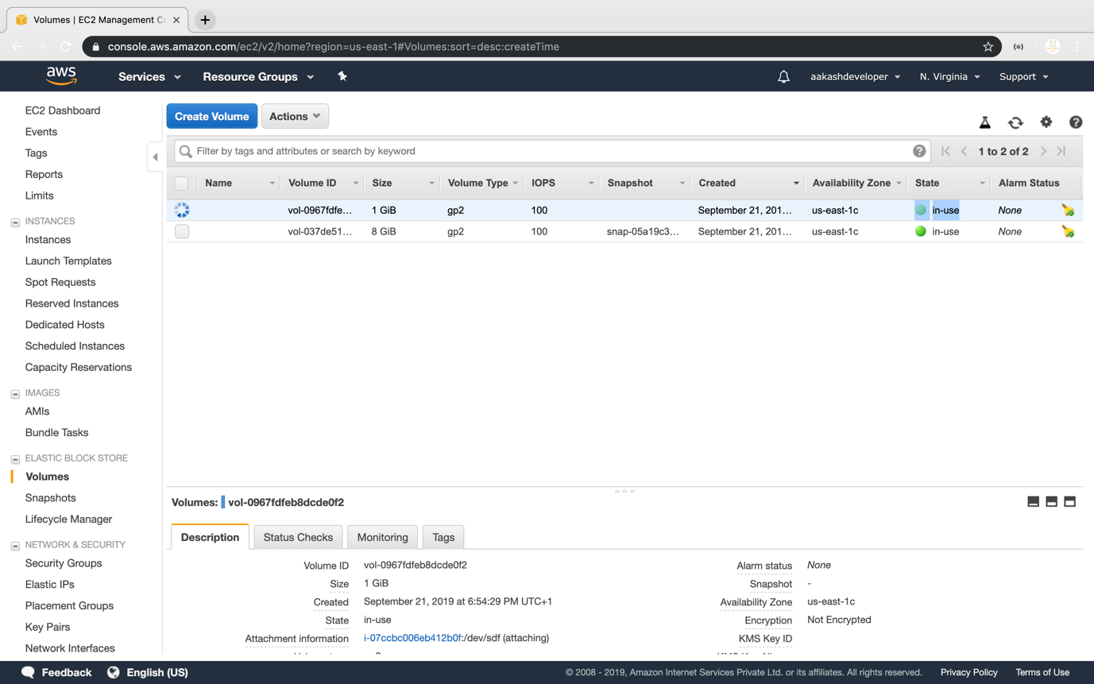

* Select *Detach Volume* option

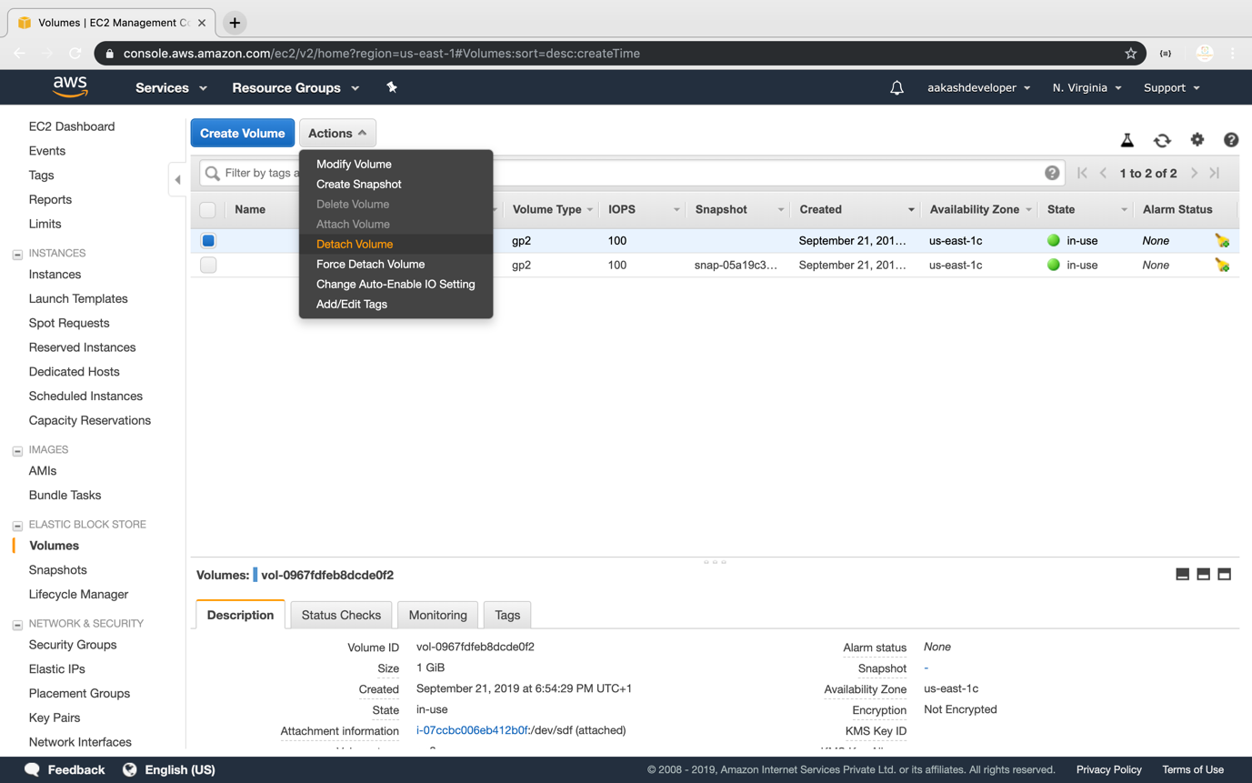

**Step 5.6.2:** Detaching the volume

* Select *Yes* once the confirmation pop-up appears

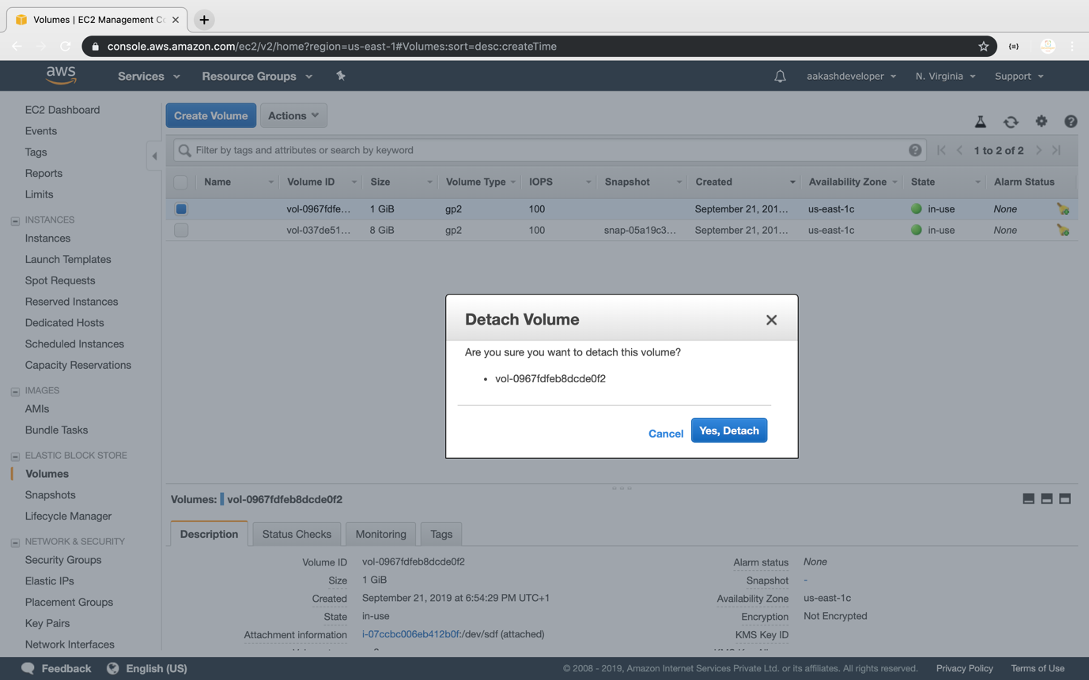

* Once detached, the volume will be labeled as *Available*

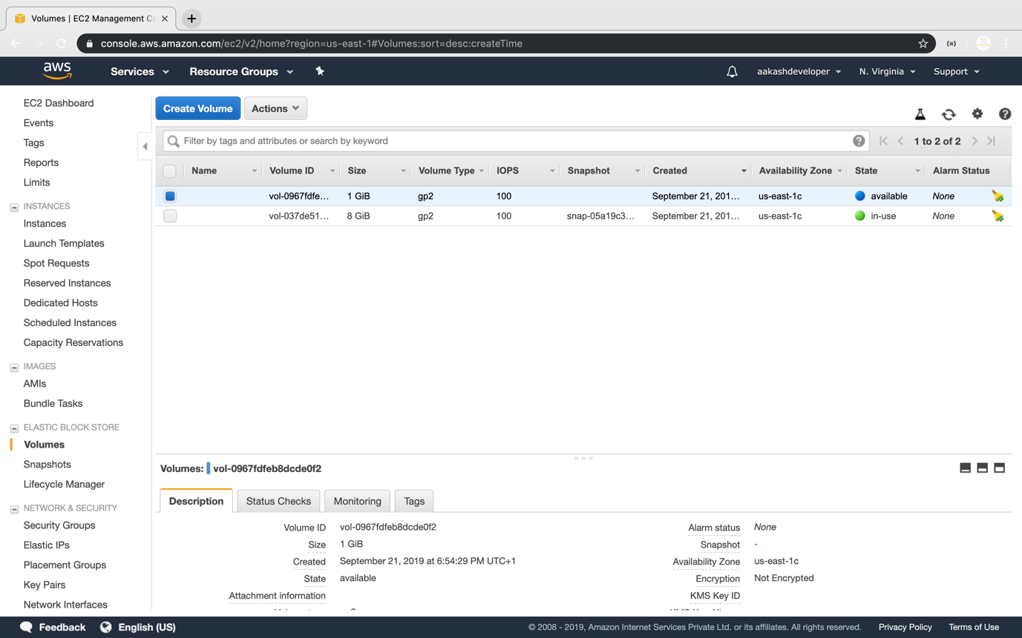

**Step 5.6.3:** Pushing the code to your GitHub repositories

Open your command prompt and navigate to the folder where you have created your files.

cd <folder path>

Initialize your repository using the following command:

git init

Add all the files to your git repository using the following command:

git add .

Commit the changes using the following command:

git commit -m “Changes have been committed.”

Push the files to the folder you created initially using the following command:

git push -u origin master