5.7 Delete an EBS Volume

This section will guide you to:

* Delete an EBS volume

This lab has two subsections, namely:

5.7.1 Selecting the EBS volume you want to delete

5.7.2 Deleting the volume

5.7.3 Pushing the code to your GitHub repositories

**Step 5.7.1:** Selecting the EBS volume you want to delete

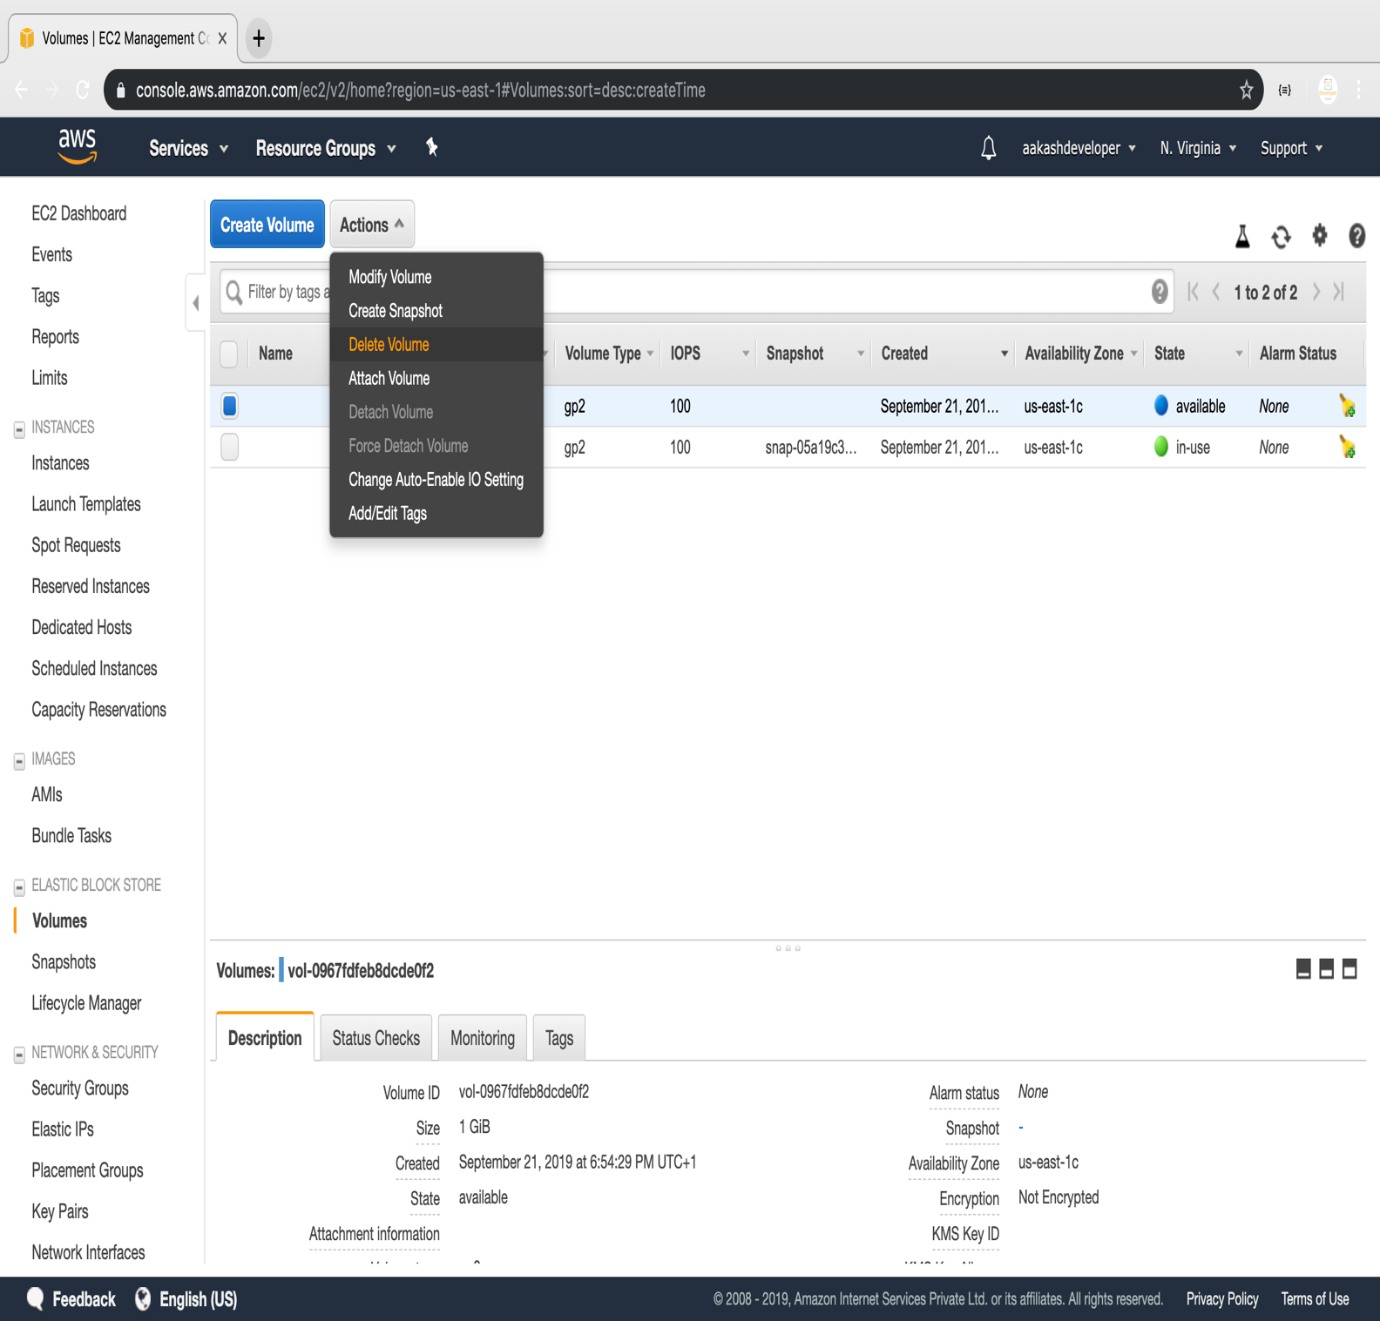

**Step 5.7.2:** Deleting the volume

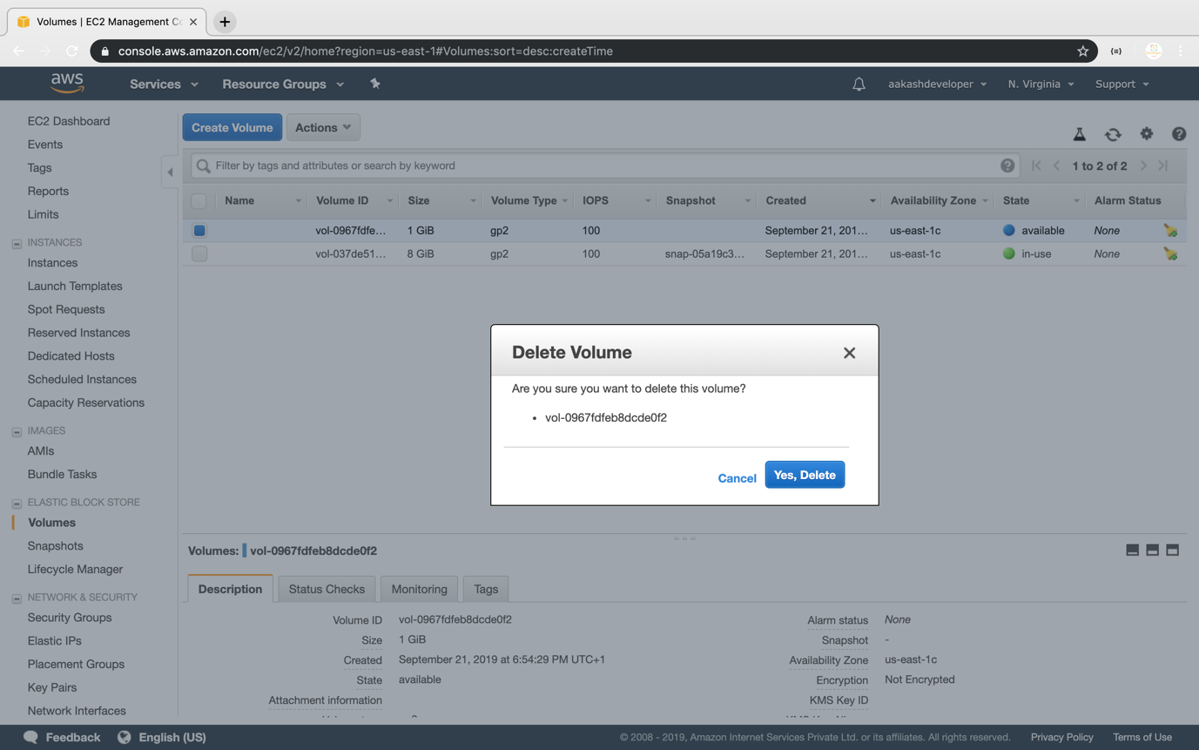

**Step 5.7.3:** Pushing the code to your GitHub repositories

Open your command prompt and navigate to the folder where you have created your files.

cd <folder path>

Initialize your repository using the following command:

git init

Add all the files to your git repository using the following command:

git add .

Commit the changes using the following command:

git commit -m “Changes have been committed.”

Push the files to the folder you created initially using the following command:

git push -u origin master