5.8 Create an EBS Snapshot

This section will guide you to:

* Create an EBS snapshot

This lab has one subsection, namely:

5.8.1 Creating an EBS snapshot

5.8.2 Pushing the code to your GitHub repositories

**Step 5.8.1:** Creating an EBS snapshot

* Select *Volume* in EC2 dashboard
* Click on *Action* -> *Create Snapshot*

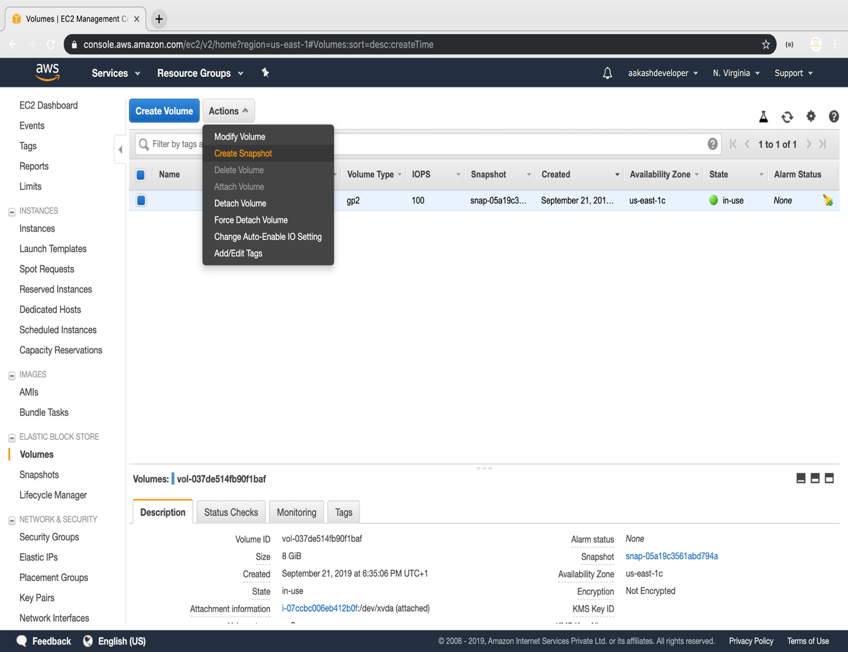

* Add snapshot name, key, and value

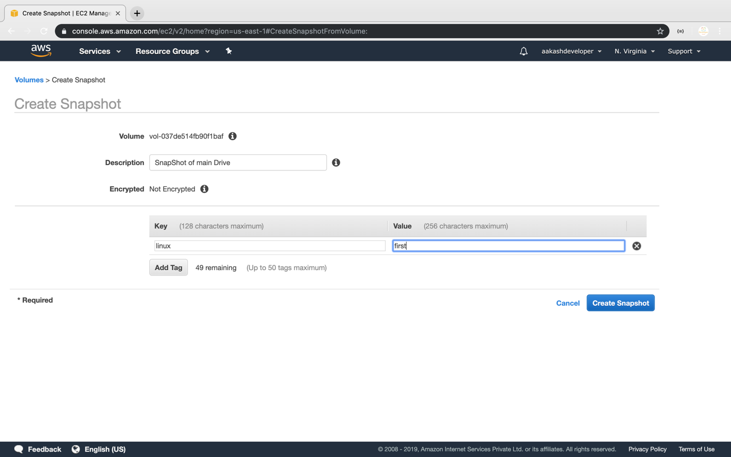

* To view snapshots, you need to navigate to **EC2 dashboard** available on the panel on the left. Click on **snapshot** to view all available snapshots.

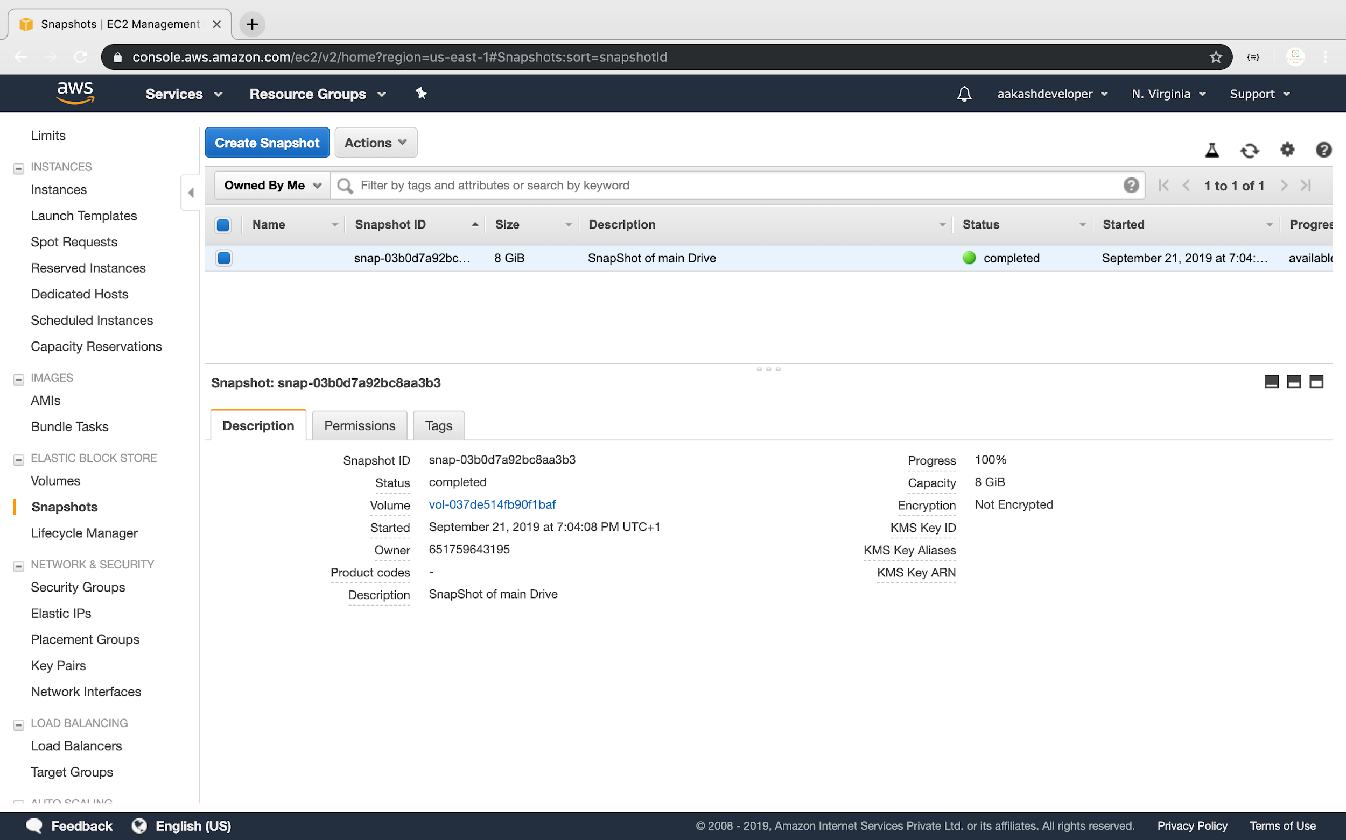

**Step 5.8.2:** Pushing the code to your GitHub repositories

Open your command prompt and navigate to the folder where you have created your files.

cd <folder path>

Initialize your repository using the following command:

git init

Add all the files to your git repository using the following command:

git add .

Commit the changes using the following command:

git commit -m “Changes have been committed.”

Push the files to the folder you created initially using the following command:

git push -u origin master