5.9 Initialize a Volume Restored from a Snapshot on Linux

This section will guide you to:

* Initialize a volume restored from a snapshot

This lab has two subsections, namely:

5.9.1 Selecting the snapshot

5.9.2 Restoring volume from the snapshot

5.9.3 Pushing the code to your GitHub repositories

**Step 5.9.1:** Selecting the snapshot

* Go to EC2 dashboard in EBS and click on *Snapshot*

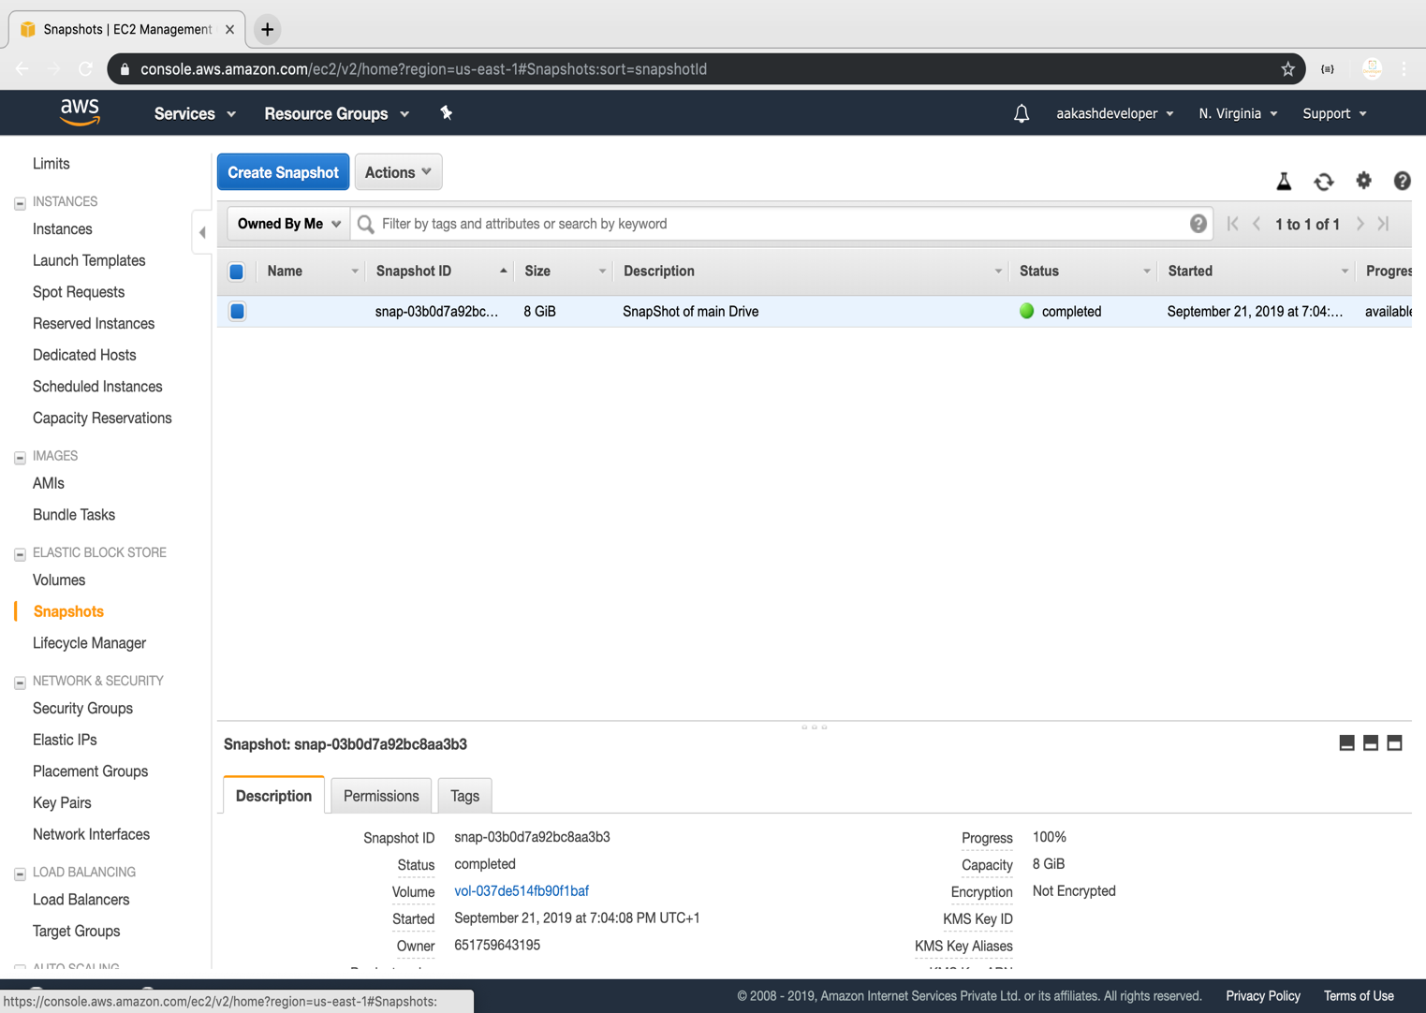

**Step 5.9.2:** Restoring volume from the snapshot

* Select the snapshot and click on *Action*

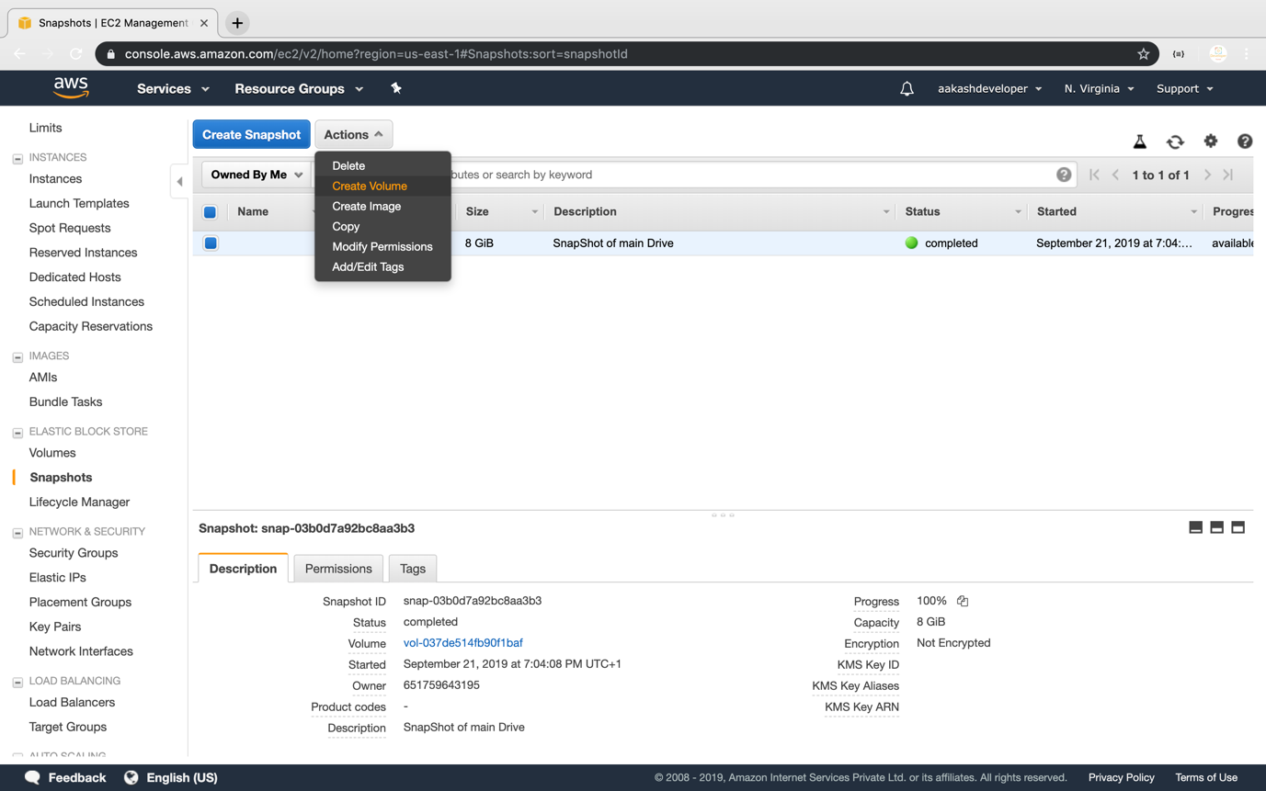

* You can specify the key and value to identify the volume

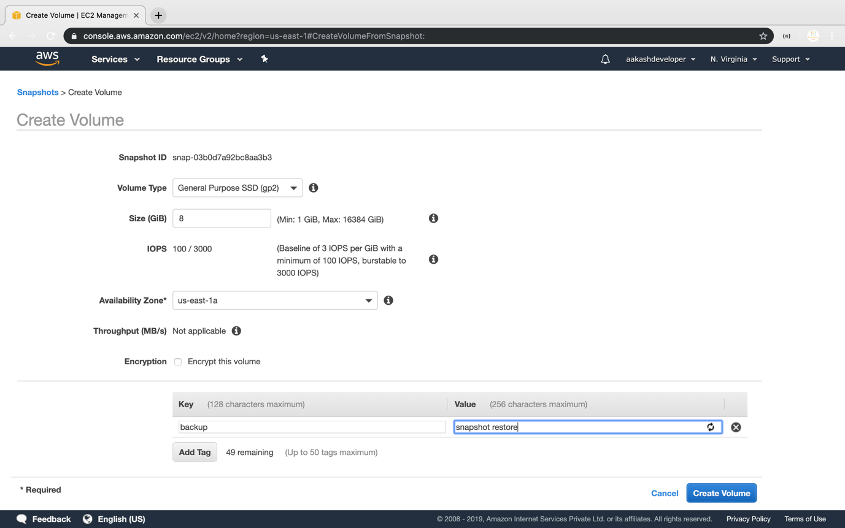

* Restore the volume from the snapshot

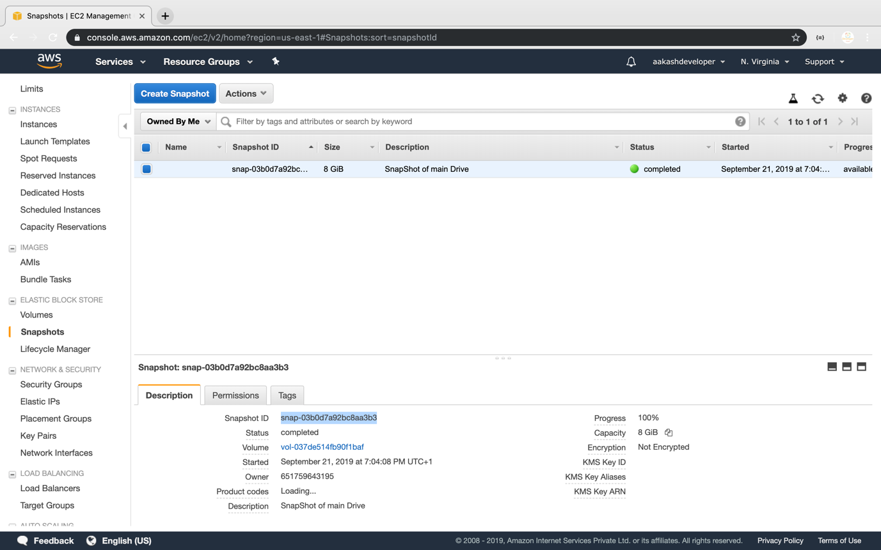

**Step 5.9.3:** Pushing the code to your GitHub repositories

Open your command prompt and navigate to the folder where you have created your files.

cd <folder path>

Initialize your repository using the following command:

git init

Add all the files to your git repository using the following command:

git add .

Commit the changes using the following command:

git commit -m “Changes have been committed.”

Push the files to the folder you created initially using the following command:

git push -u origin master