5.11 Delete an S3 Bucket

This section will guide you to:

* Delete an S3 bucket

This lab has two subsections, namely:

5.11.1 Selecting the S3 bucket you want to delete

5.11.2 Deleting the bucket

5.11.3 Pushing the code to your GitHub repositories

**Step 5.11.1:** Selecting the S3 bucket you want to delete

* Choose the bucket

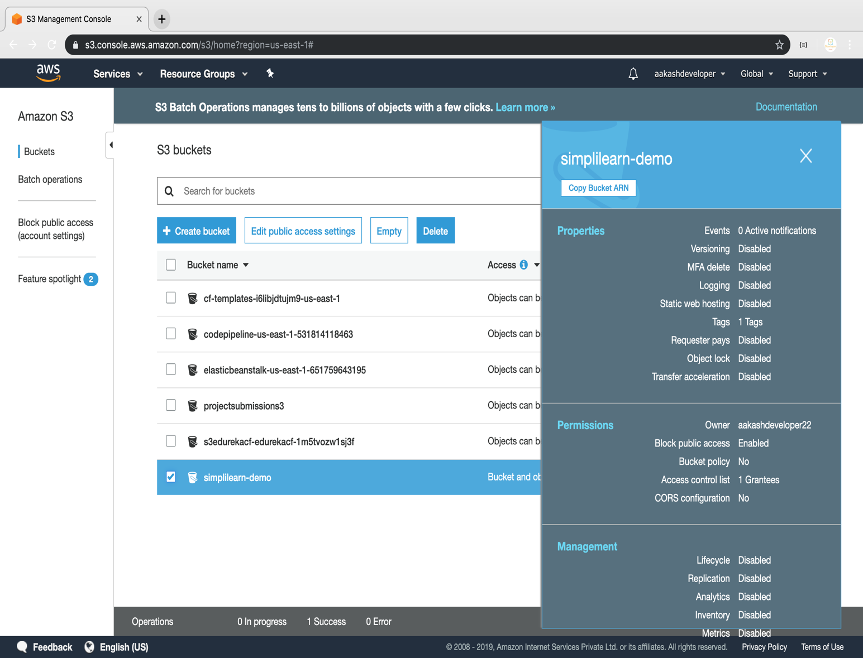

**Step 5.11.2:** Deleting the bucket

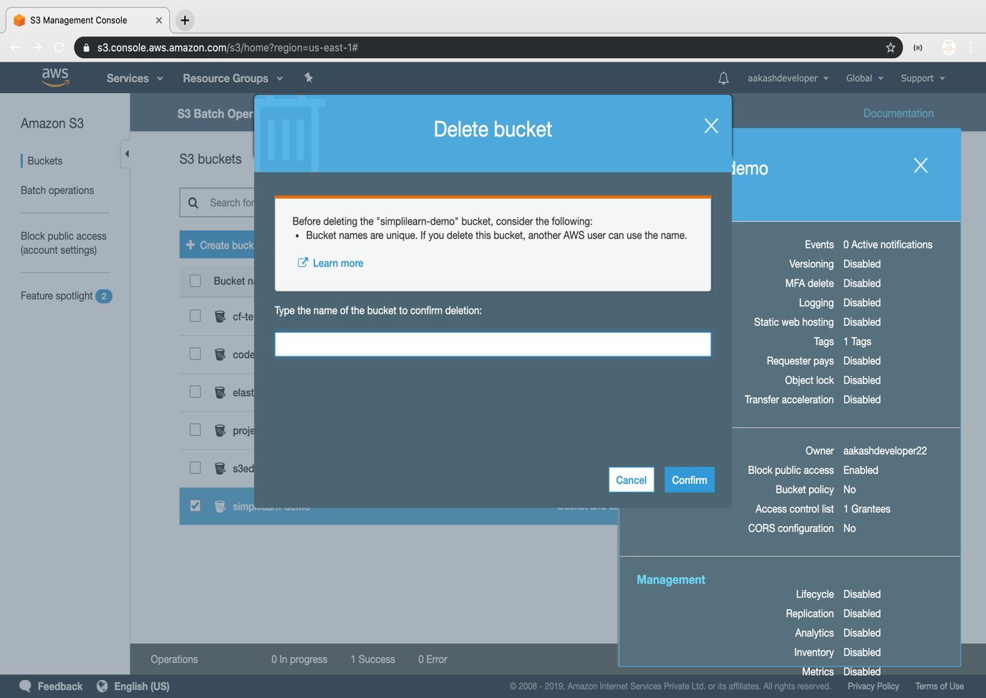

**Step 5.11.3:** Pushing the code to your GitHub repositories

Open your command prompt and navigate to the folder where you have created your files.

cd <folder path>

Initialize your repository using the following command:

git init

Add all the files to your git repository using the following command:

git add .

Commit the changes using the following command:

git commit -m “Changes have been committed.”

Push the files to the folder you created initially using the following command:

git push -u origin master