5.12 Empty an S3 Bucket

This section will guide you to:

* Empty an S3 bucket

This lab has two subsections, namely:

5.12.1 Selecting the S3 bucket you want to empty

5.12.2 Emptying the bucket

5.12.3 Pushing the code to your GitHub repositories

**Step 5.12.1:** Selecting the S3 bucket you want to empty

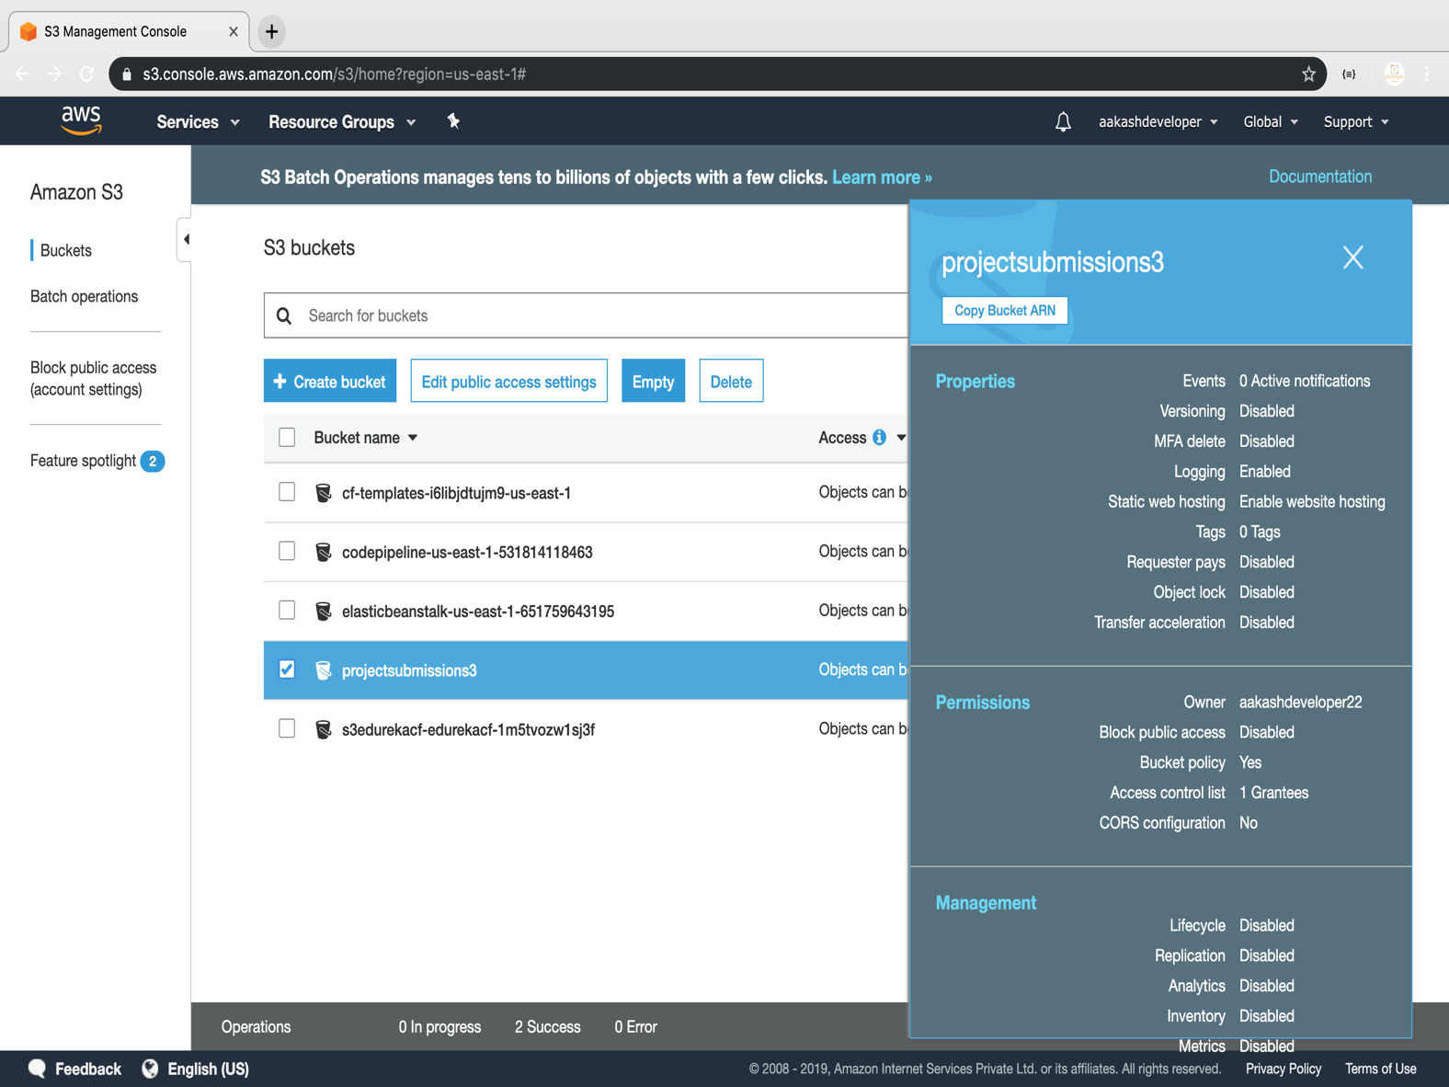

**Step 5.12.2:** Emptying the bucket

* Verify the content present in the bucket

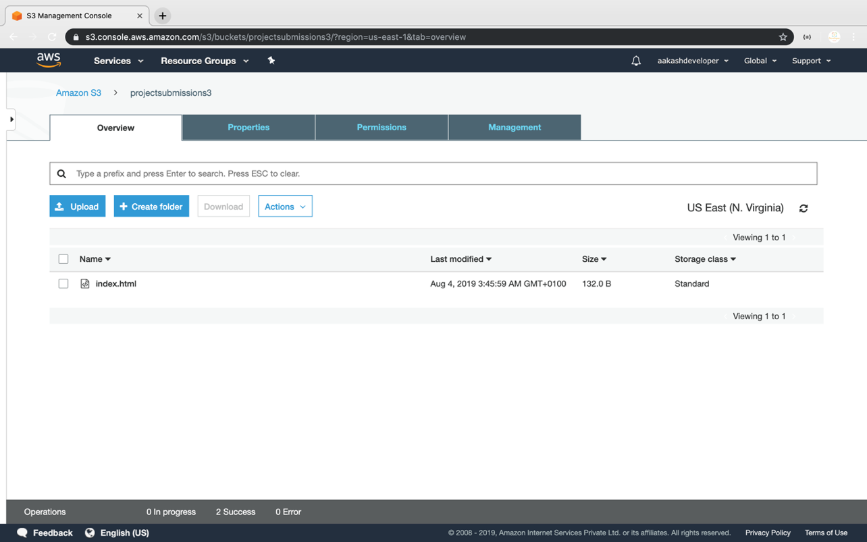

* Empty the bucket

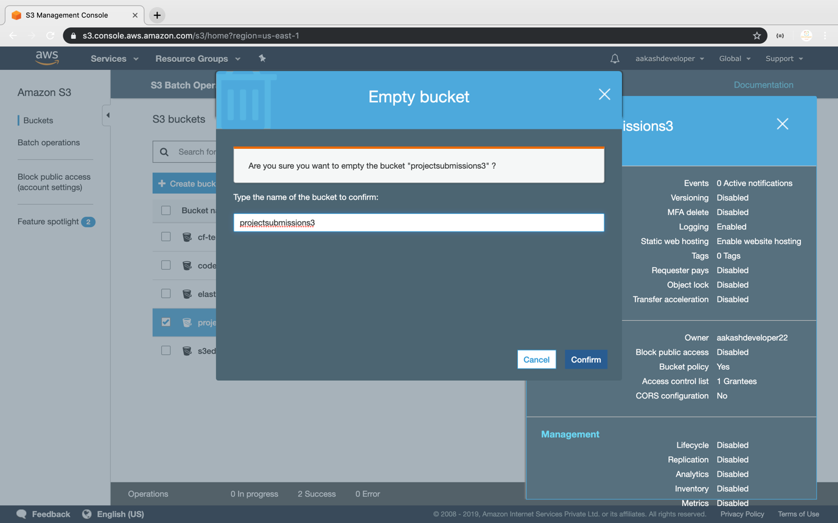

**Step 5.12.3:** Pushing the code to your GitHub repositories

Open your command prompt and navigate to the folder where you have created your files.

cd <folder path>

Initialize your repository using the following command:

git init

Add all the files to your git repository using the following command:

git add .

Commit the changes using the following command:

git commit -m “Changes have been committed.”

Push the files to the folder you created initially using the following command:

git push -u origin master