5.13 Set the Storage Class of an Object

This section will guide you to:

* Set the storage class of an object

This lab has two subsections, namely:

5.13.1 Selecting the bucket

5.13.2 Setting the storage class of an object

5.13.3 Pushing the code to your GitHub repositories

**Step 5.13.1:** Selecting the bucket

* Select the bucket and open the list of items

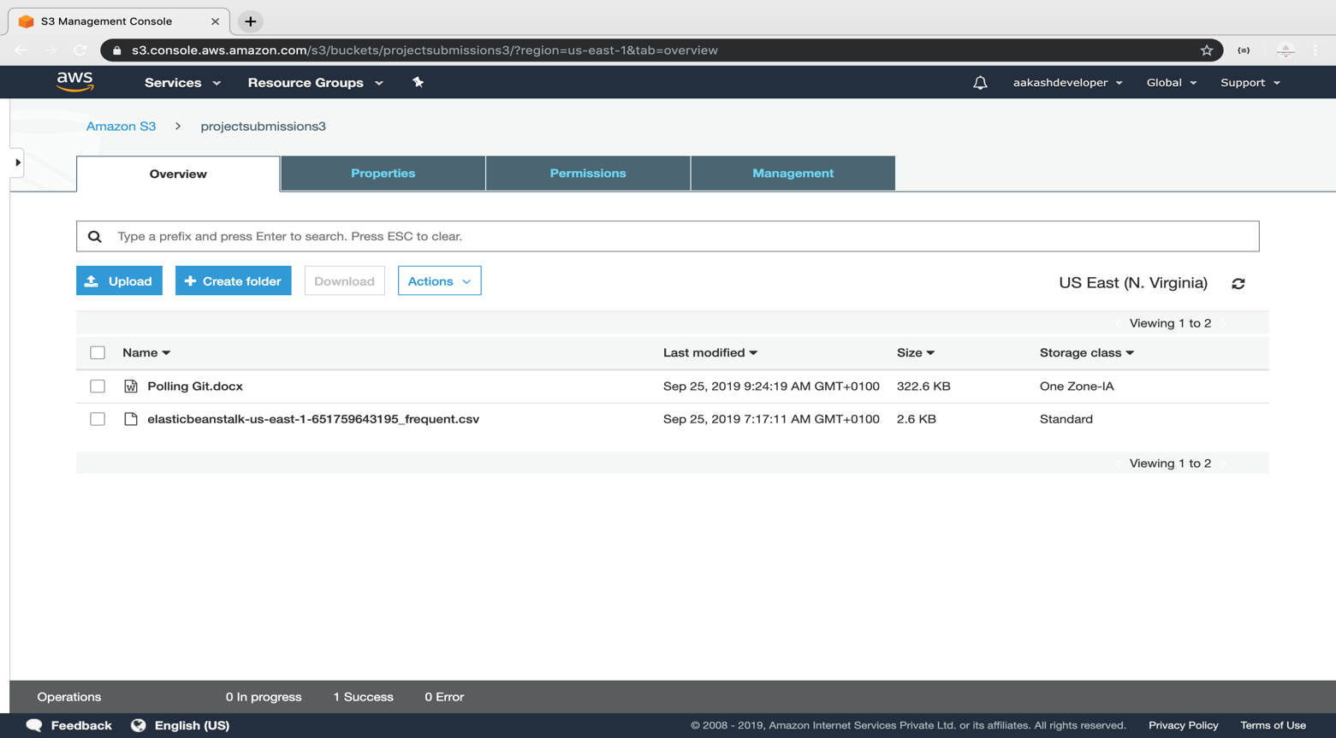

**Step 5.13.2:** Setting the storage class of an object

* Click on *Upload* and select the file and click *Next*

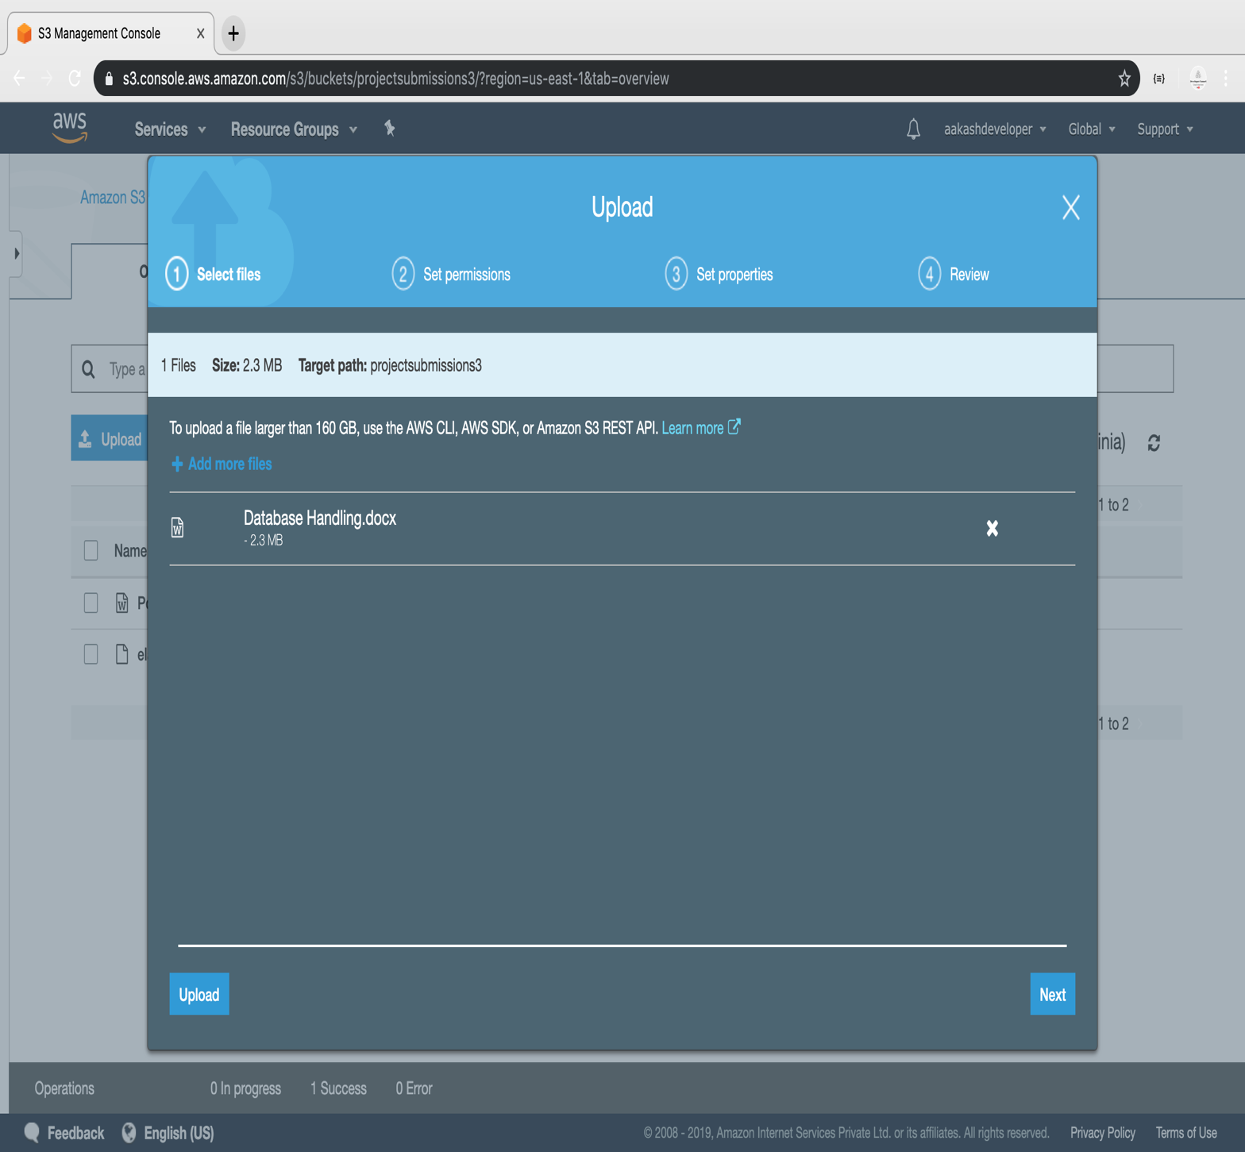

* Select the class and click *Next*

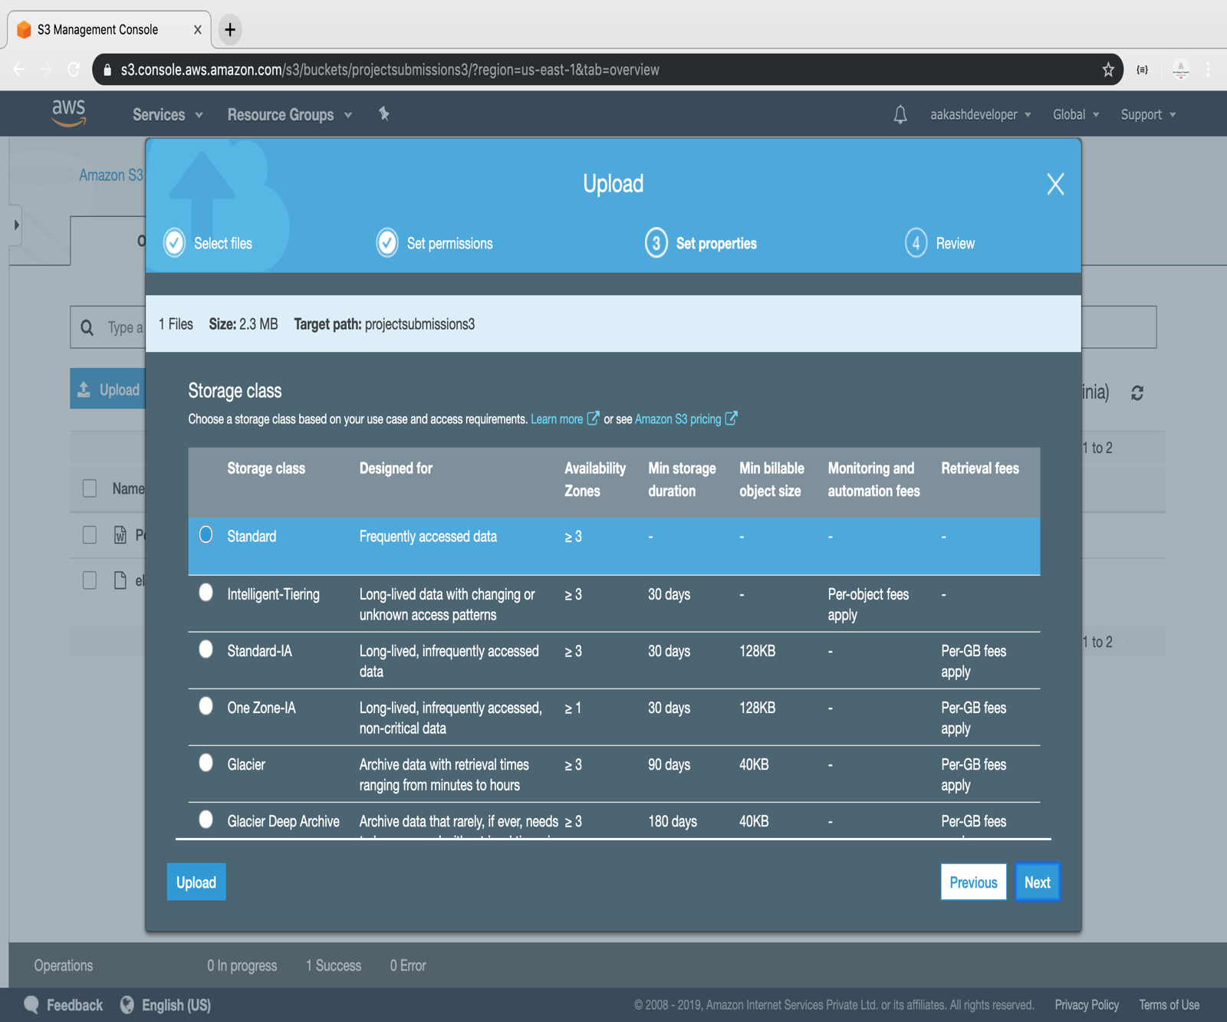

* The class will get assigned to the uploaded object

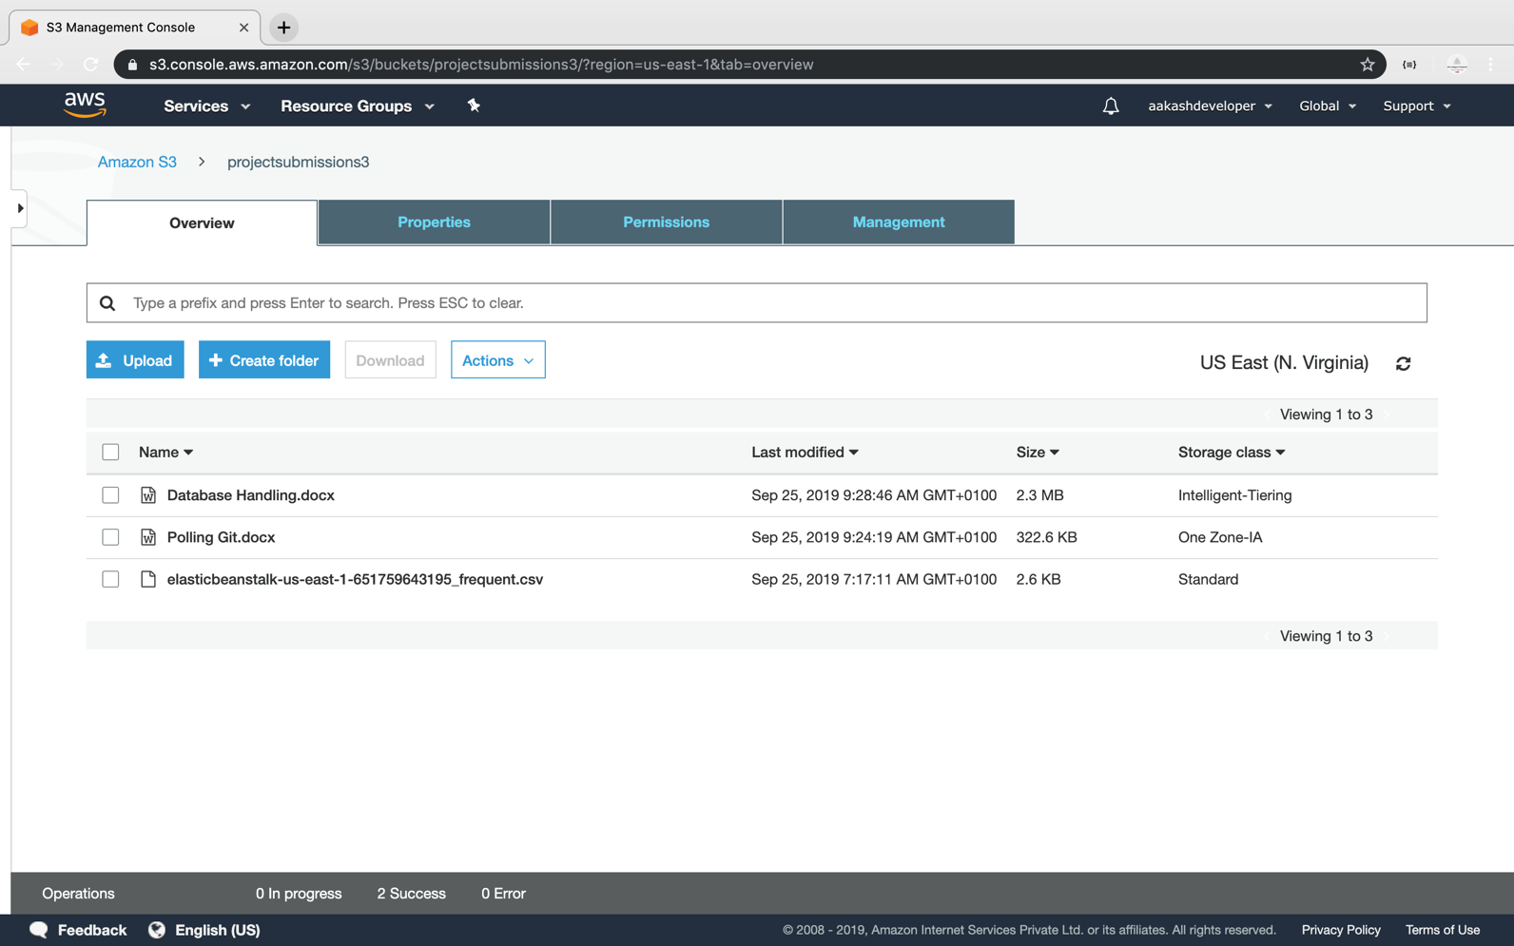

**Step 5.13.3:** Pushing the code to your GitHub repositories

Open your command prompt and navigate to the folder where you have created your files.

cd <folder path>

Initialize your repository using the following command:

git init

Add all the files to your git repository using the following command:

git add .

Commit the changes using the following command:

git commit -m “Changes have been committed.”

Push the files to the folder you created initially using the following command:

git push -u origin master