5.14 Create an IAM User



This section will guide you to:

* Create an IAM user
* Validate the newly created IAM user

This lab has four subsections, namely:

5.14.1 Selecting the IAM from the AWS Console

5.14.2 Navigating to the user creation page

5.14.3 Changing access permissions

5.14.4 Adding an identifier

5.14.5 Pushing the code to your GitHub repositories

**Step 5.14.1:** Selecting the IAM from the AWS console

* Login to your AWS console and search for IAM

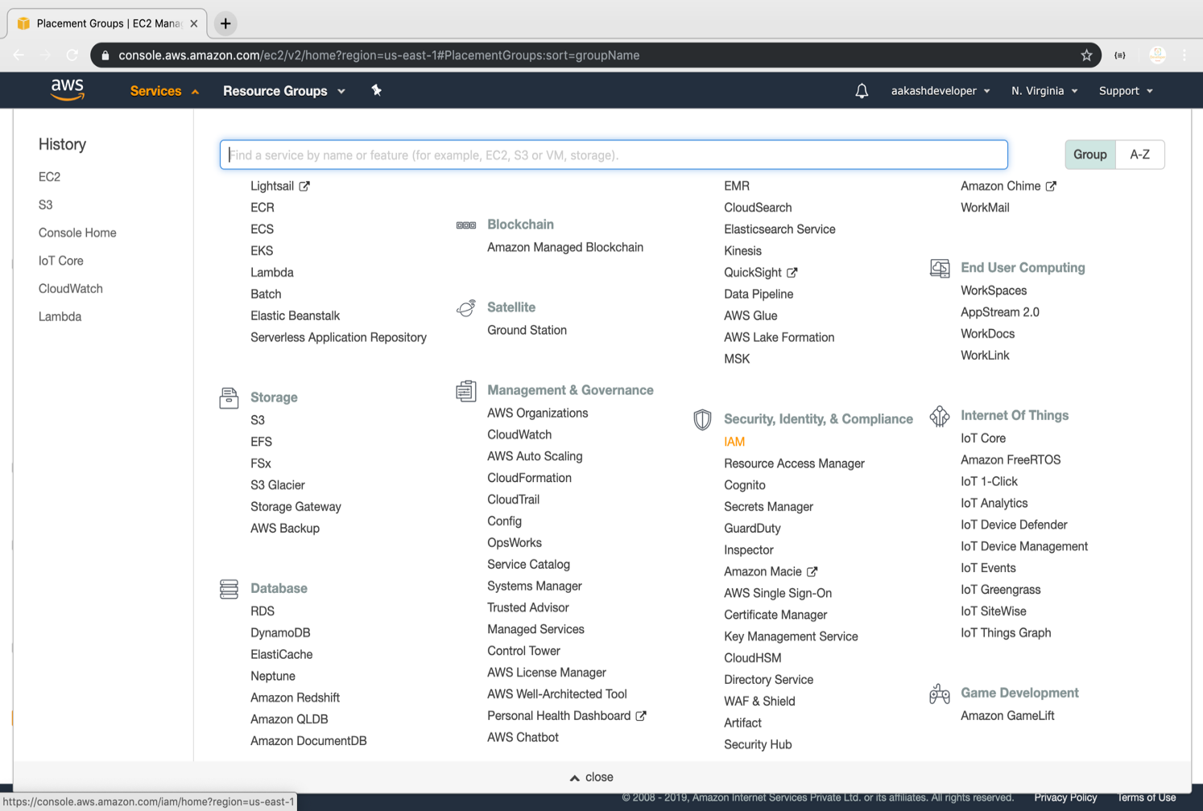

**Step 5.14.2:** Navigate to the user creation page

* Click on **Users** to redirect to the user creation page to create IAM users

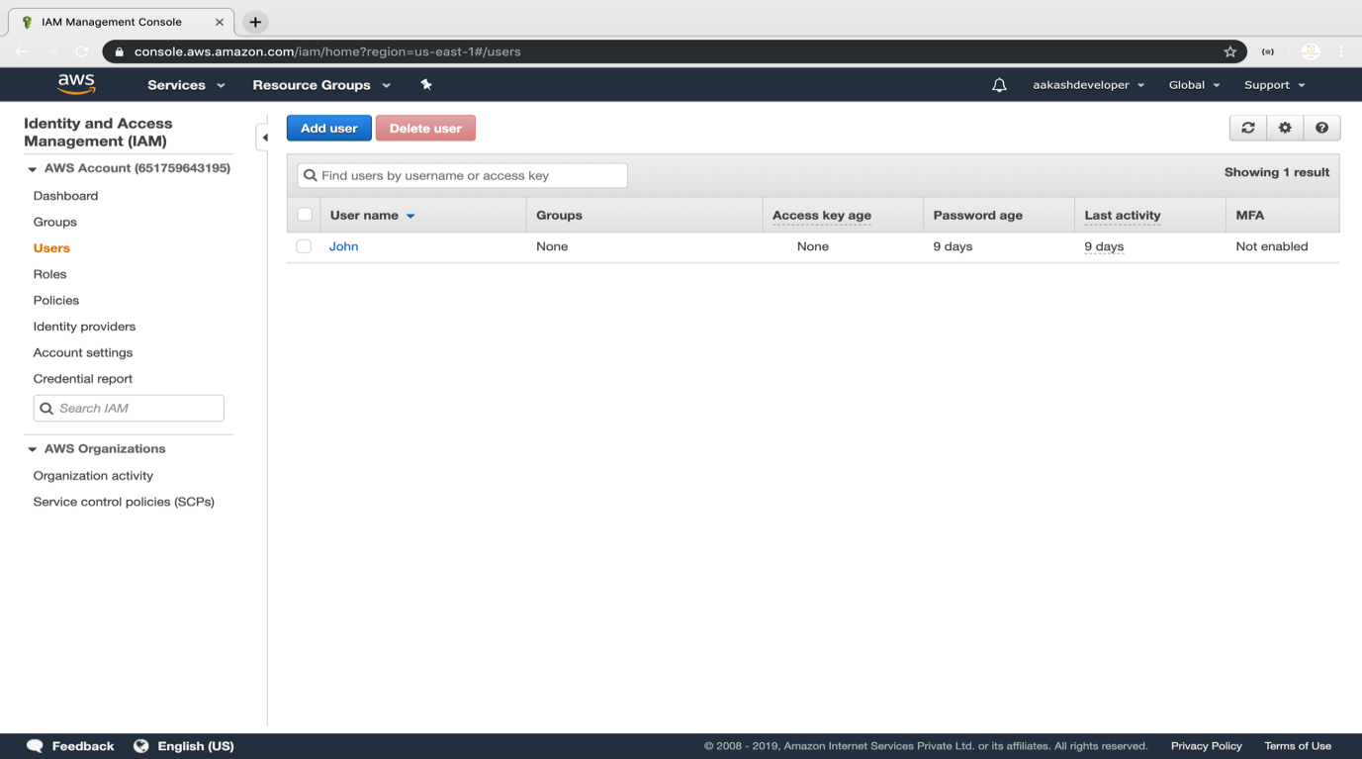

**Step 5.14.3:** Changing access permissions

* Add username in the **User name\*** section. Select **AWS Management Console access** and select one of the ways to configure **console password**

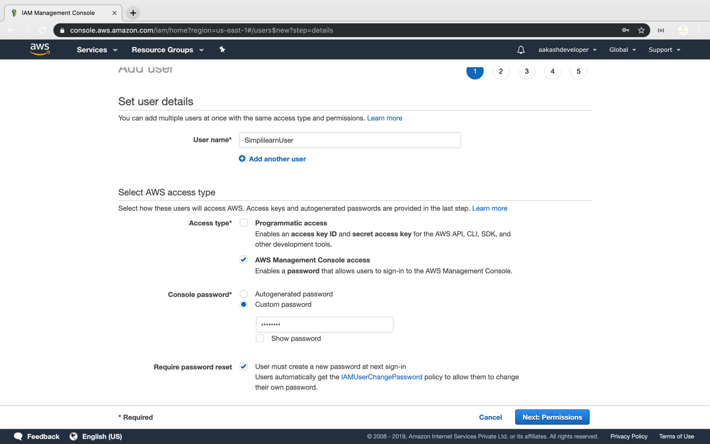

* Either we can add user to the created group or we can add policy as shown below:

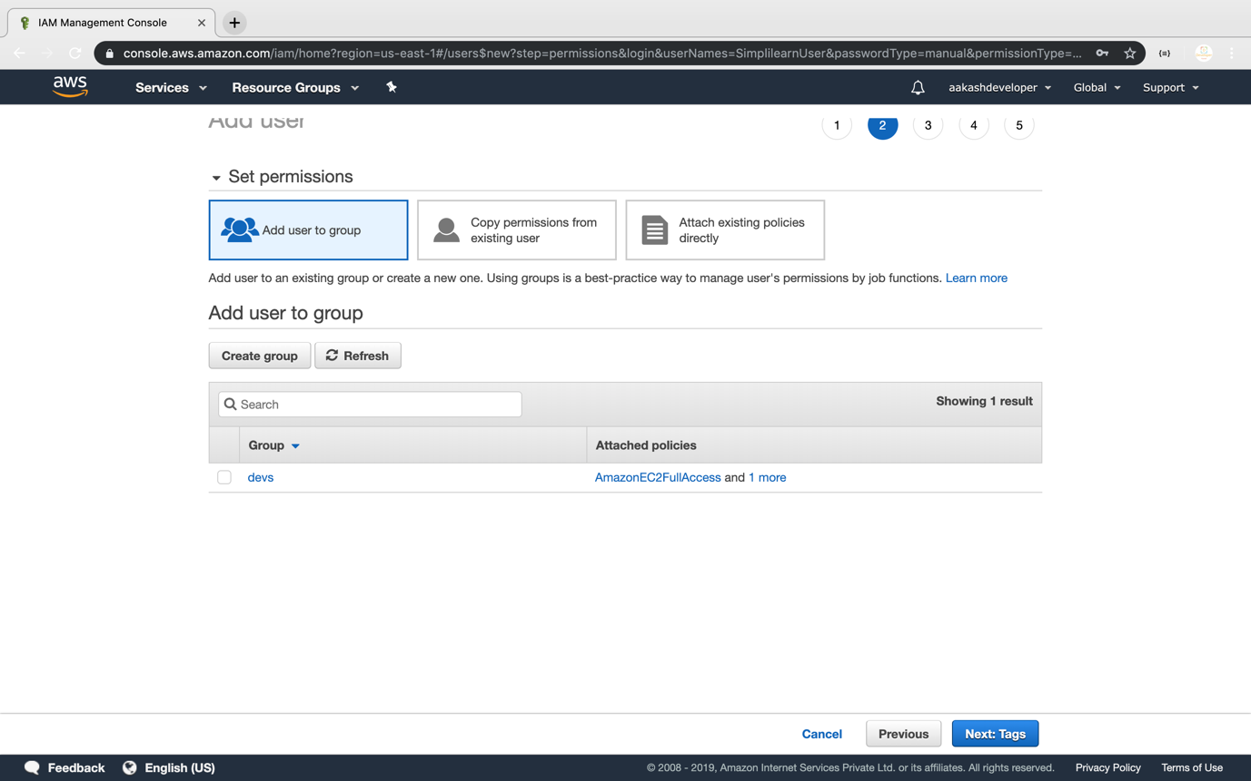

* In case a user needs to add a policy first, then he or she needs to search and then add policy to the user

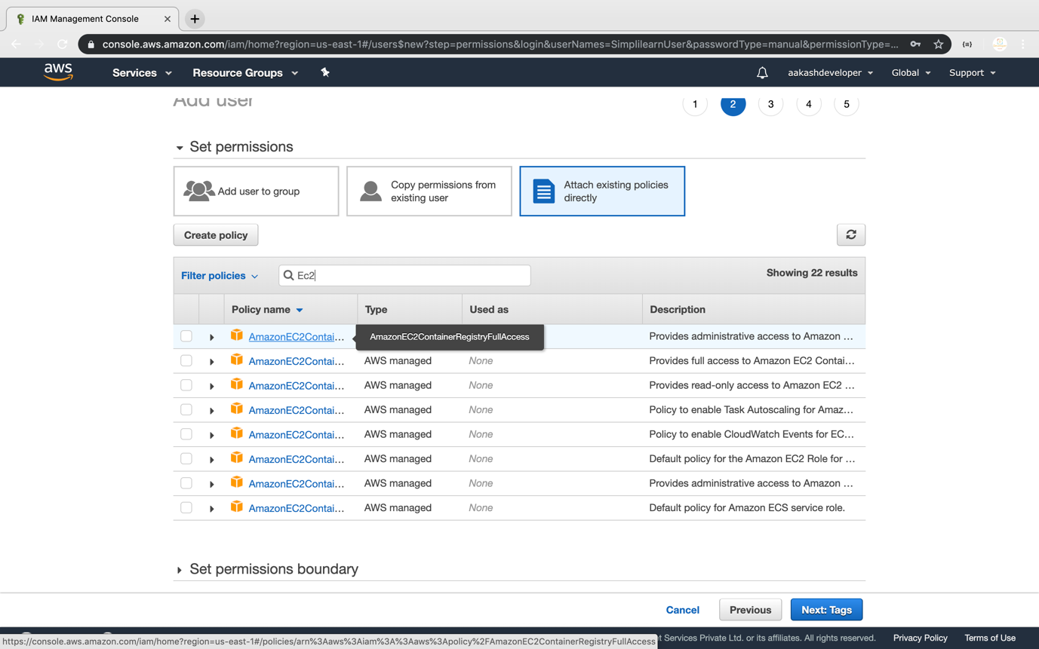

**Step 5.14.4:** Adding an identifier

* Add an identifier by adding key and value to tag each user as shown below:

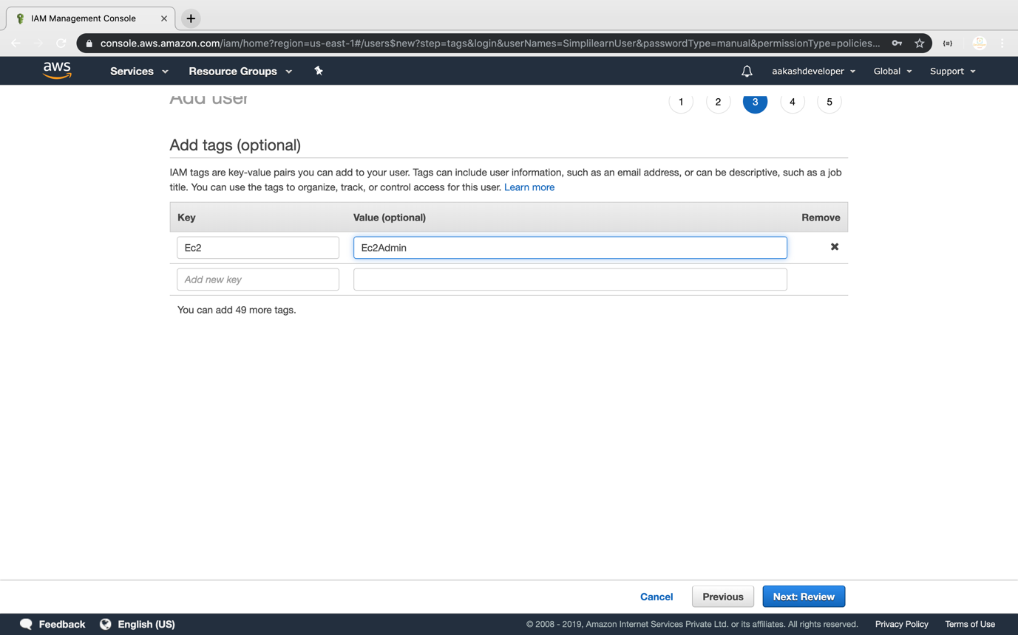

* Finally, it will create a user with a group or an added policy

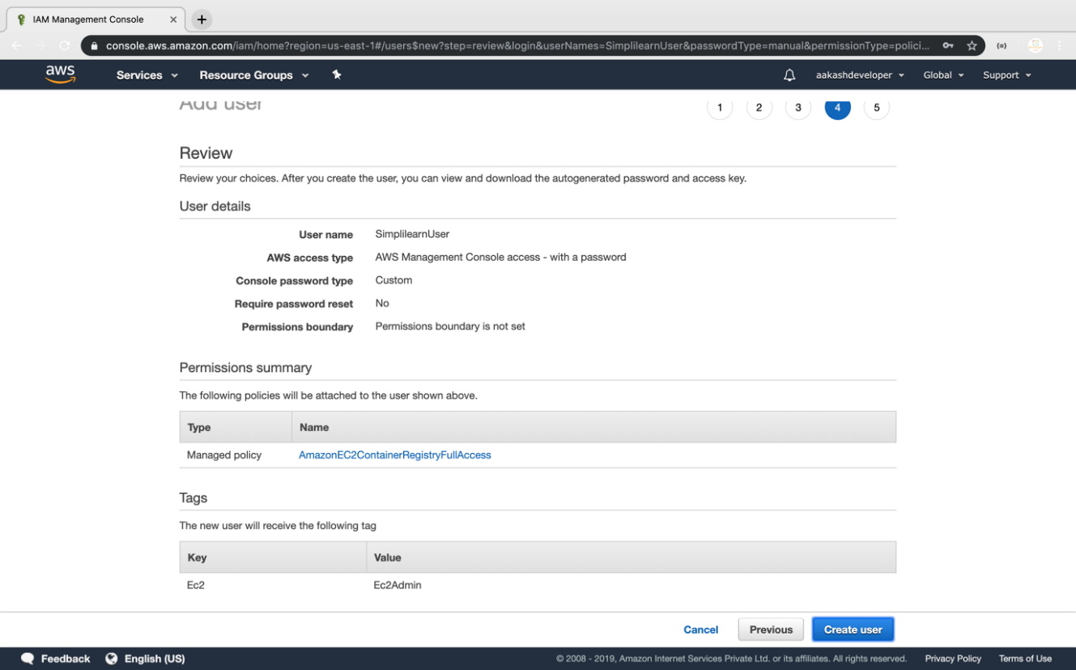

* On successful user creation, a URL will be created with which a user can login as an IAM user

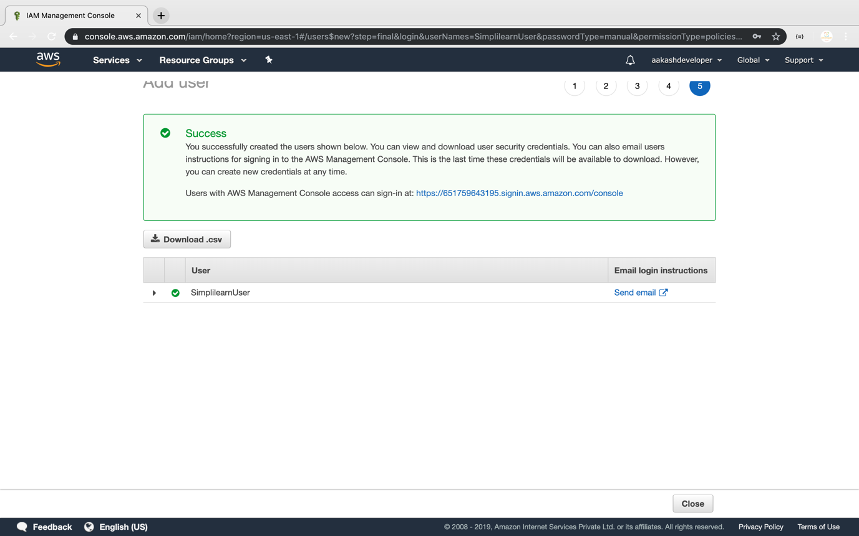

* The newly created user will be available on the dashboard as shown below:

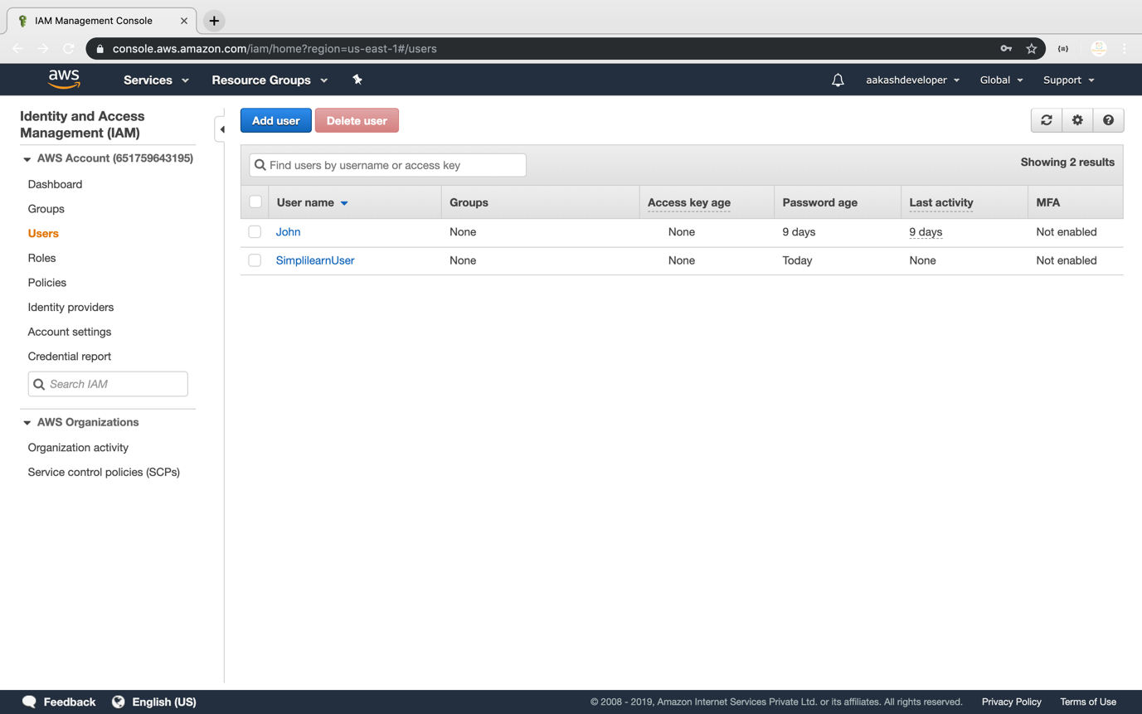

* By clicking on each user, you can see the key sign in the URL

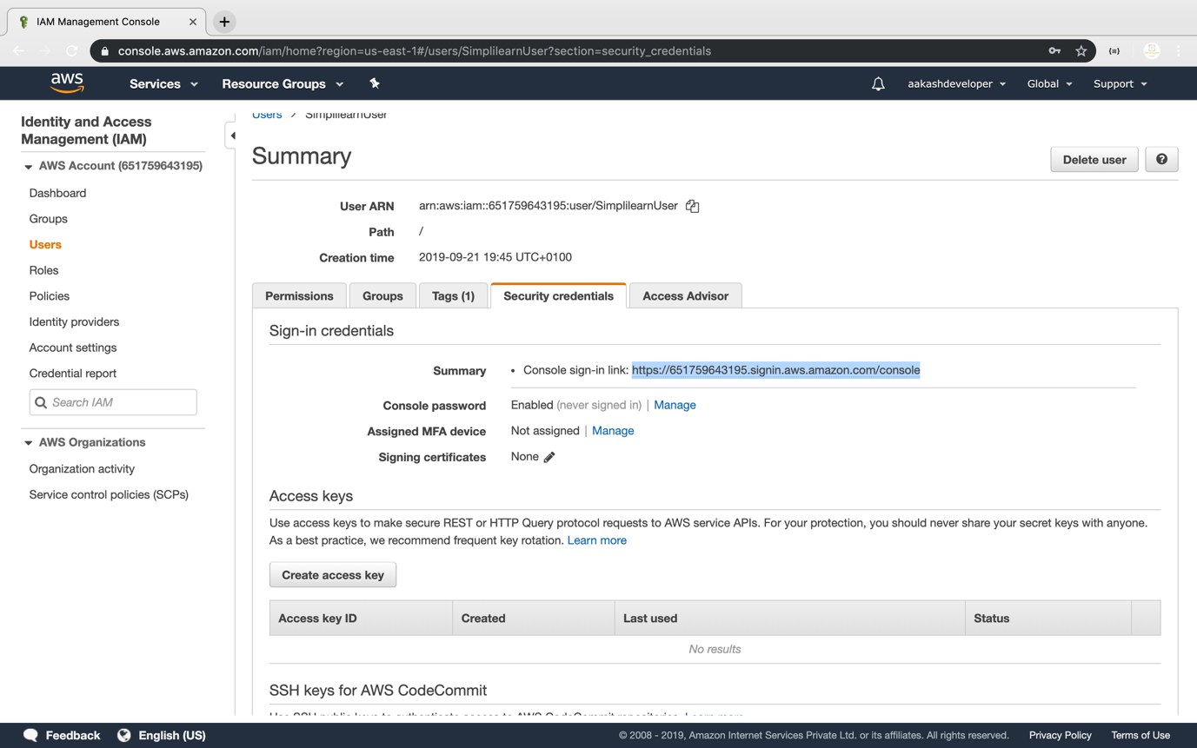

* By selecting a user, you can add that user to a particular group

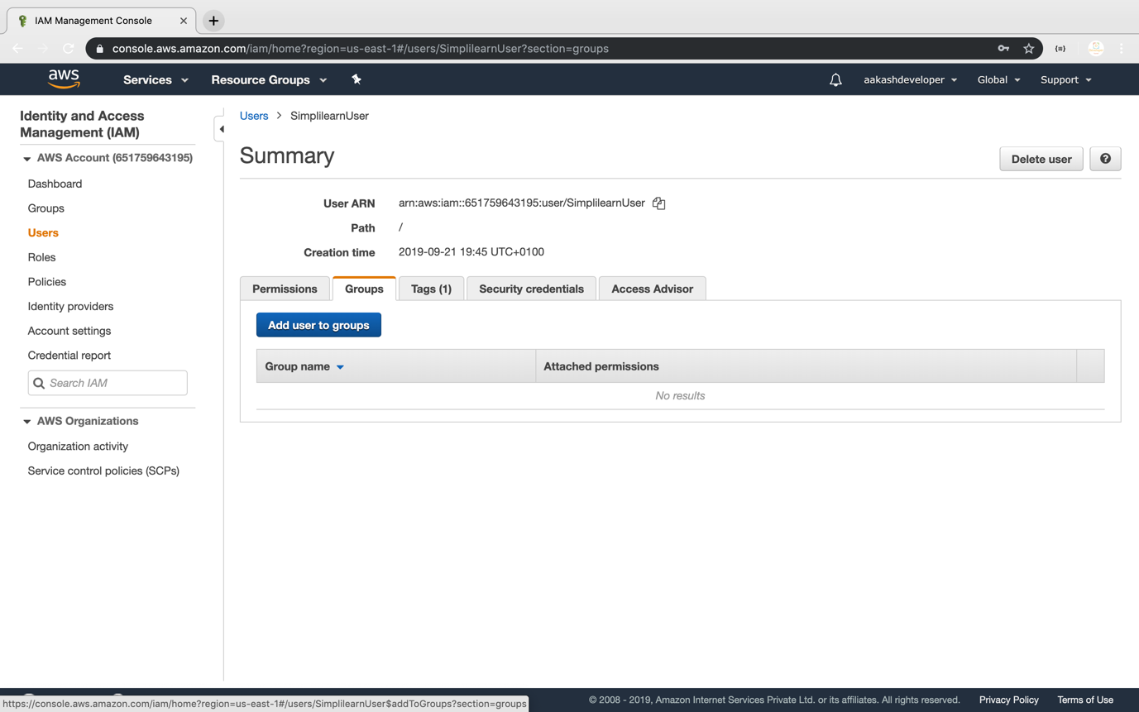

**Step 5.14.5:** Pushing the code to your GitHub repositories

Open your command prompt and navigate to the folder where you have created your files.

cd <folder path>

Initialize your repository using the following command:

git init

Add all the files to your git repository using the following command:

git add .

Commit the changes using the following command:

git commit -m “Changes have been committed.”

Push the files to the folder you created initially using the following command:

git push -u origin master