5.15 Create an IAM Role

This section will guide you to:

* Create an IAM role

This lab has three subsections, namely:

5.15.1 Creating an IAM role

5.15.2 Adding AWS policy to the role

5.15.3 Providing a key and a value for the role

5.15.4 Pushing the code to your GitHub repositories

**Step 5.15.1:** Creating an IAM role

* In the IAM panel, click on *Roles* -> *Create role*

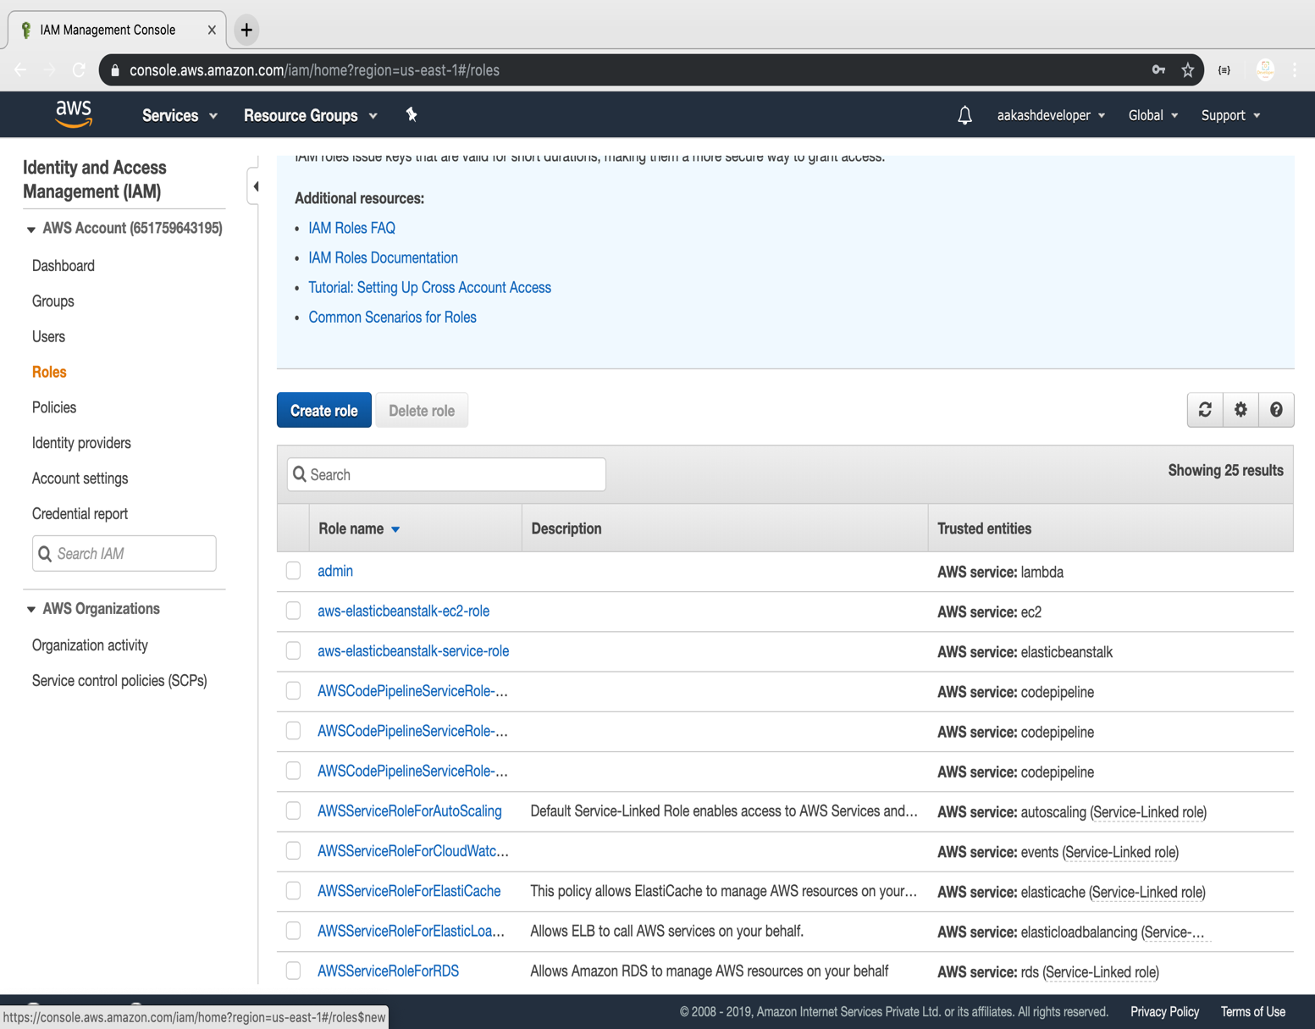

* Select the service and click on the Next permission button.

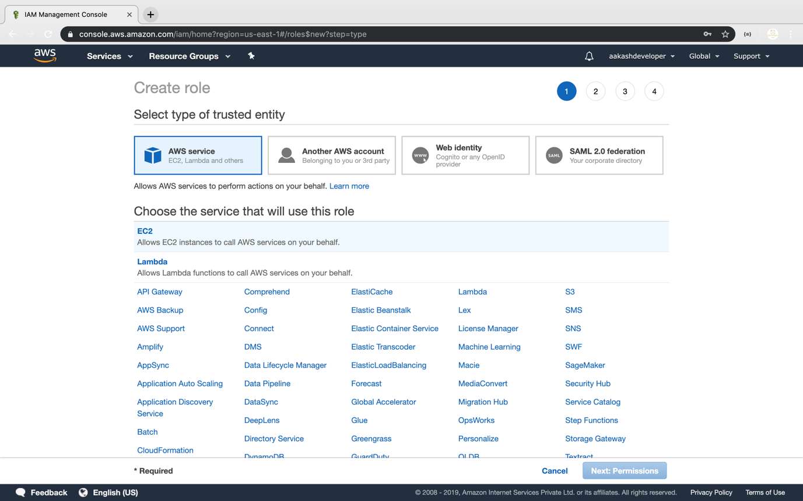

**Step 5.15.2:** Adding AWS policy to the role

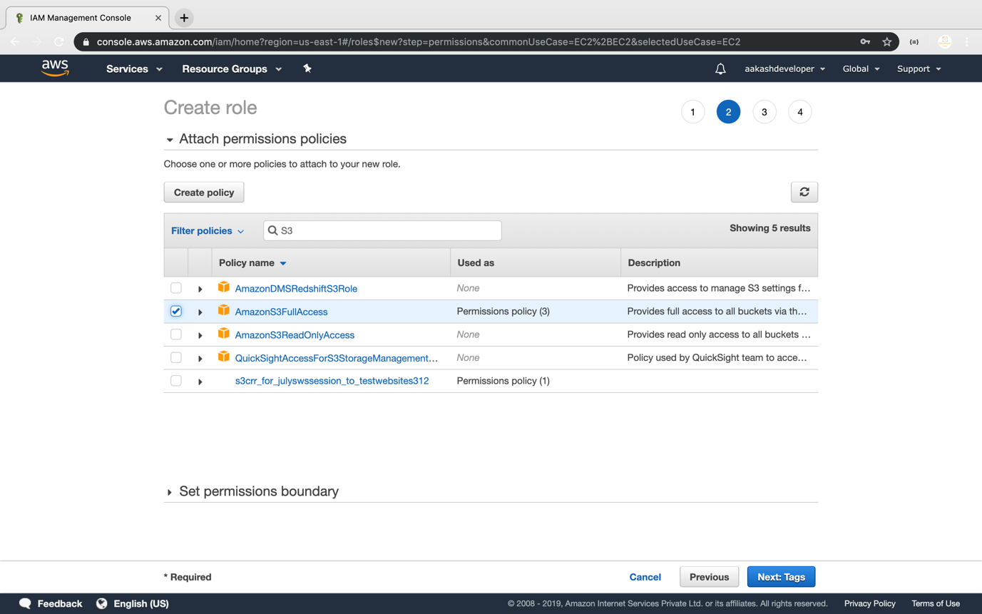

**Step 5.15.3:** Providing a key and a value for the role

* Add a key and a value to the role

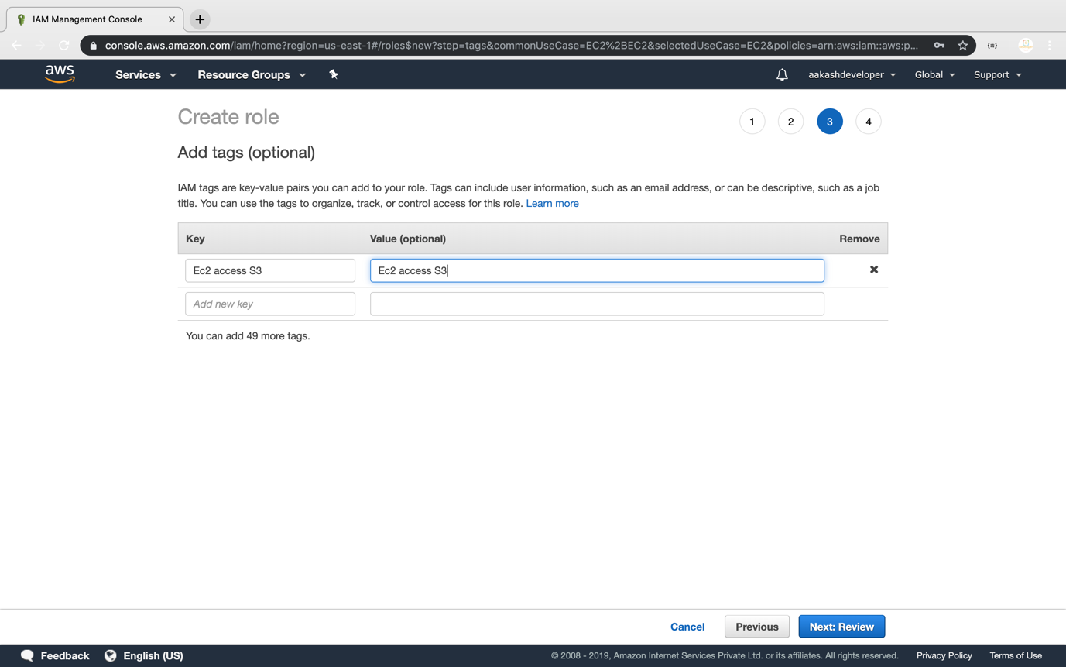

* Add a role:

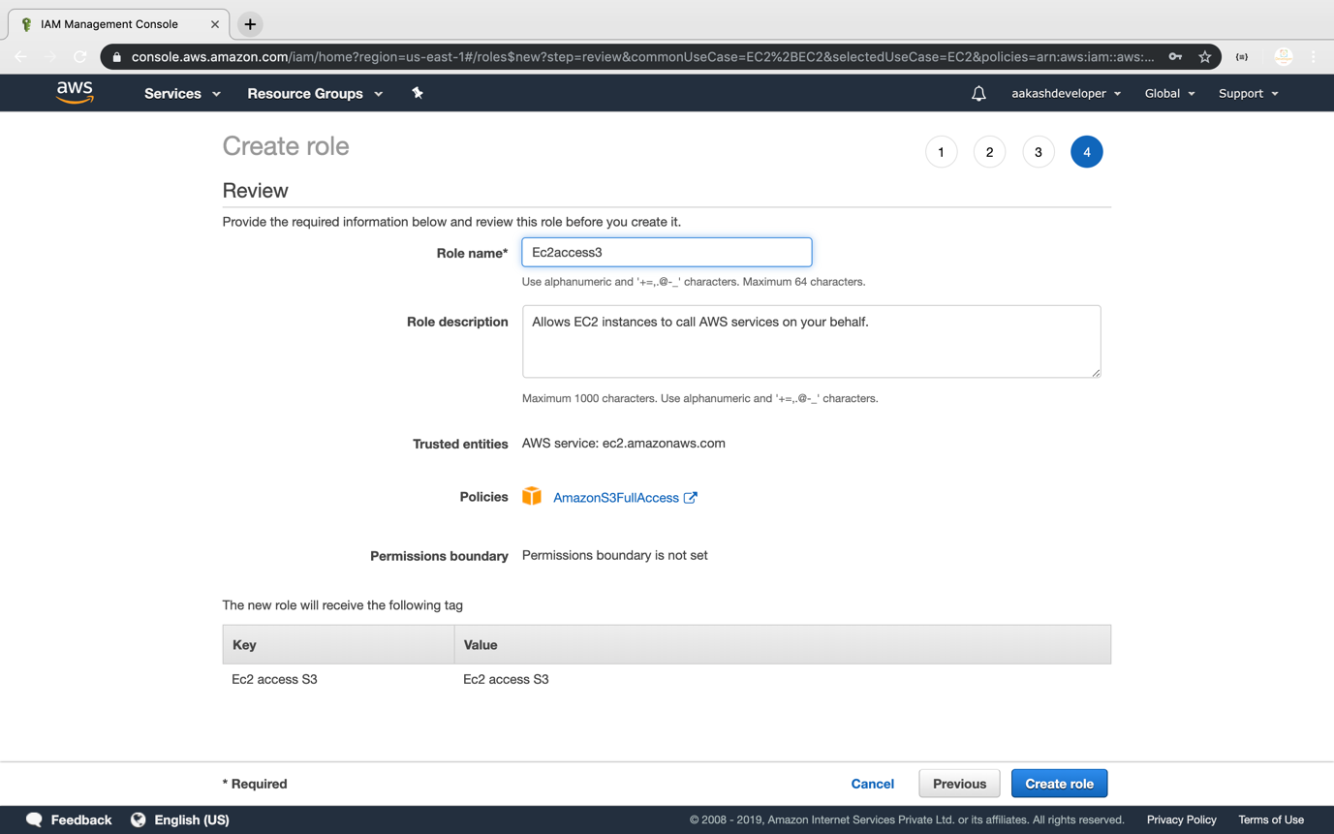

* Once the role is created, you can find it in the IAM panel

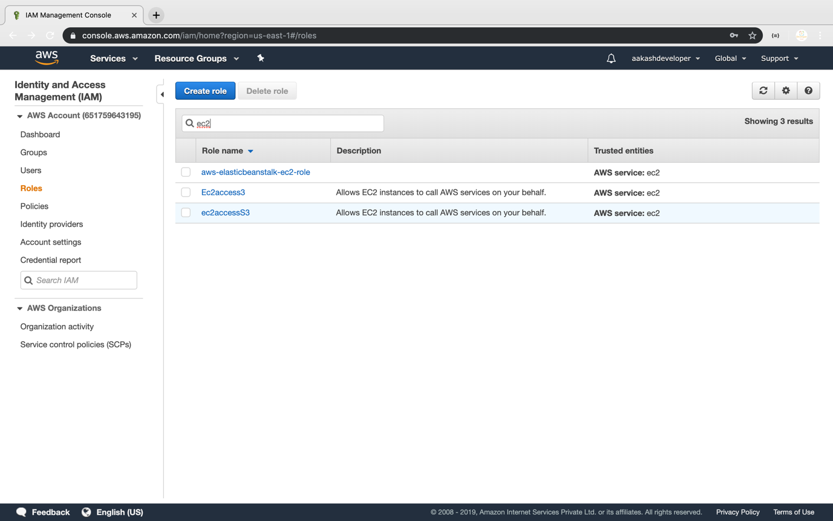

**Step 5.15.4:** Pushing the code to your GitHub repositories

Open your command prompt and navigate to the folder where you have created your files.

cd <folder path>

Initialize your repository using the following command:

git init

Add all the files to your git repository using the following command:

git add .

Commit the changes using the following command:

git commit -m “Changes have been committed.”

Push the files to the folder you created initially using the following command:

git push -u origin master