5.16 Create an IAM Group

This section will guide you to:

* Create an IAM group

This lab has two subsections, namely:

5.16.1 Creating an IAM group

5.16.2 Assigning the required policy to the group

5.16.3 Pushing the code to your GitHub repositories

**Step 5.16.1:** Creating an IAM group

* In the IAM panel, click on *Groups*, and you will land on the *Create New Group* page

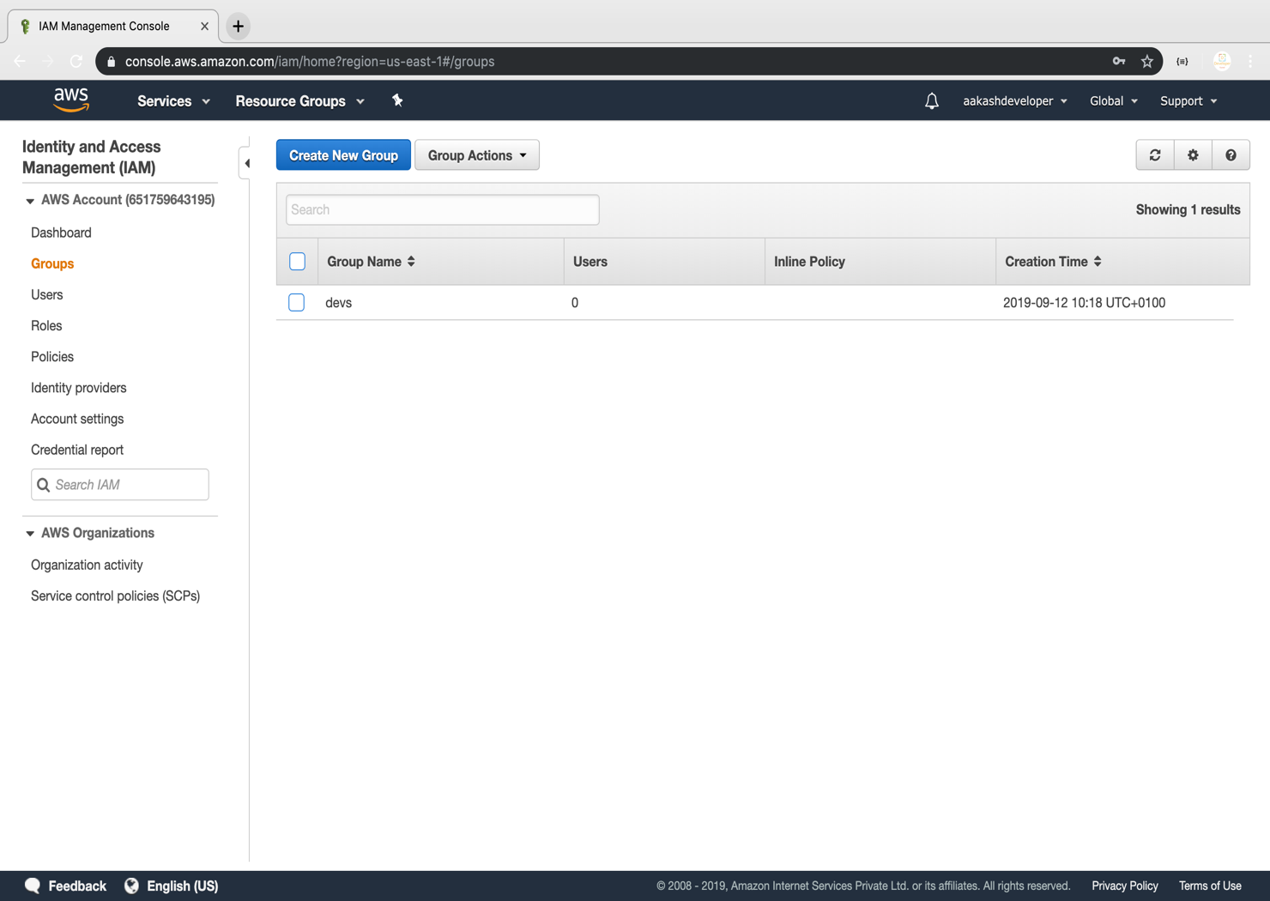

* Enter the group name

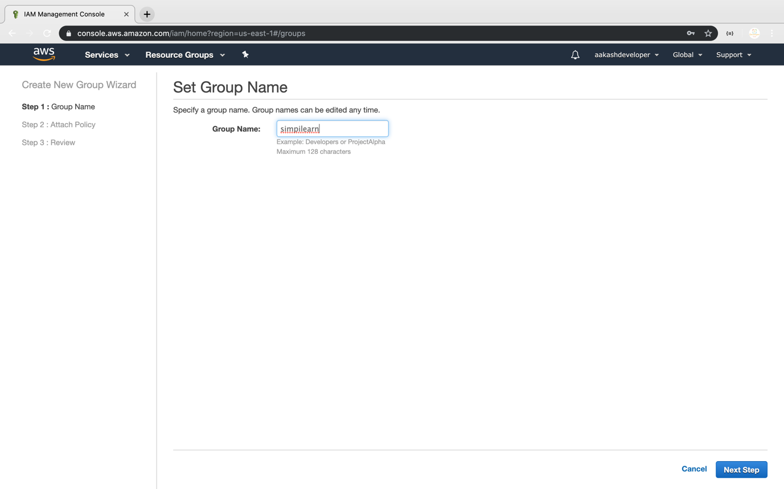

**Step 5.16.2:** Assigning the required policy to the group

* Assign the policy provided by AWS

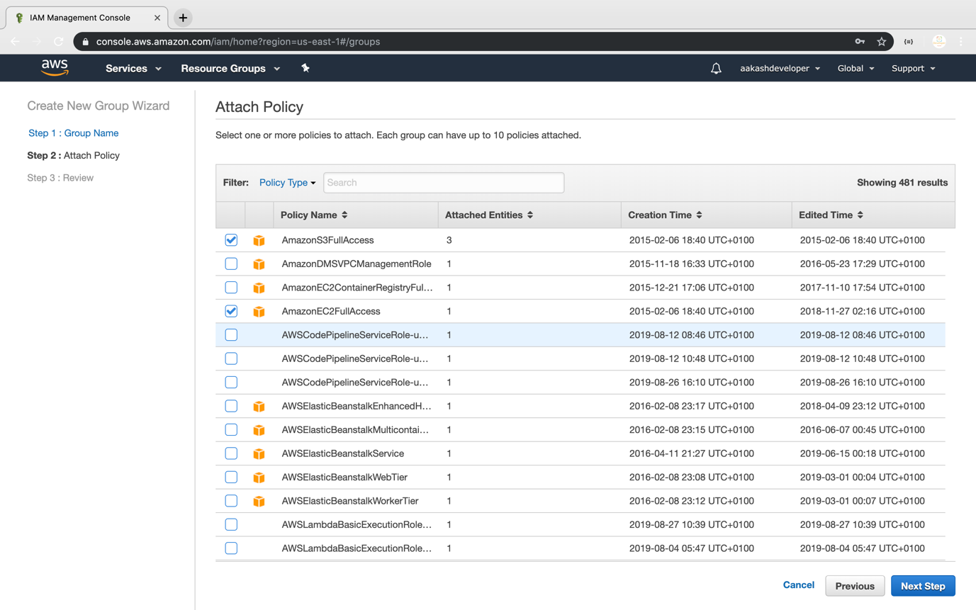

* Once the group is created, you can see the new group in the console

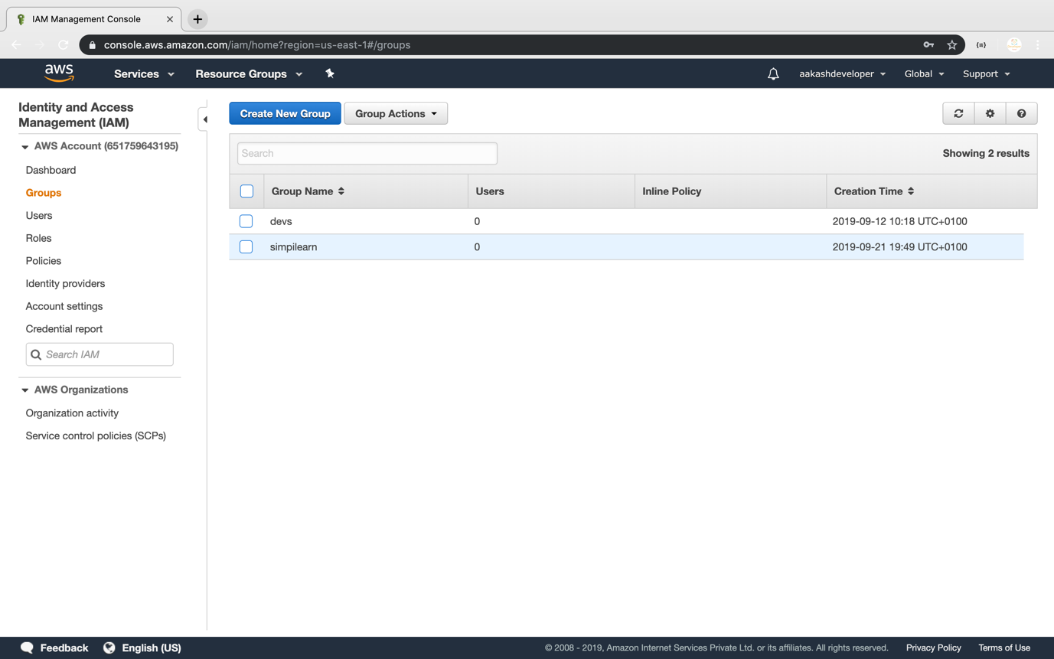

* You can add a user or a policy to the group any time

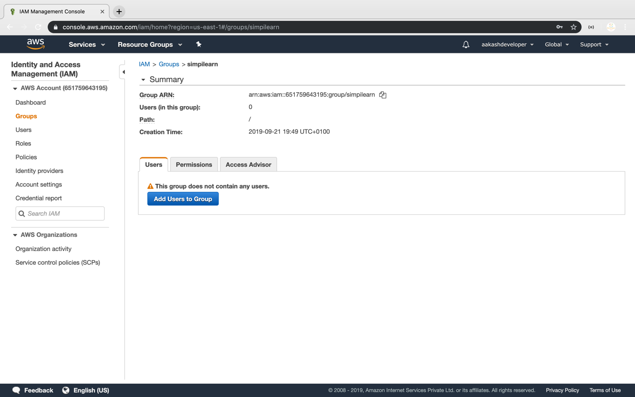

* You can see the user list by clicking on *Add User*

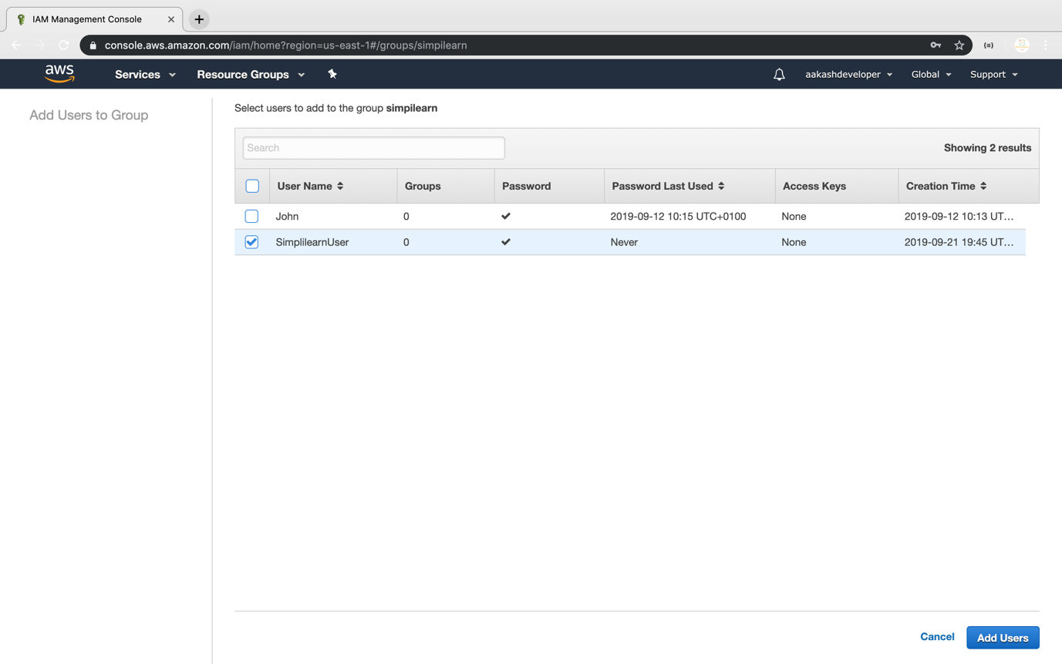

* You can also find all the policies added to the group

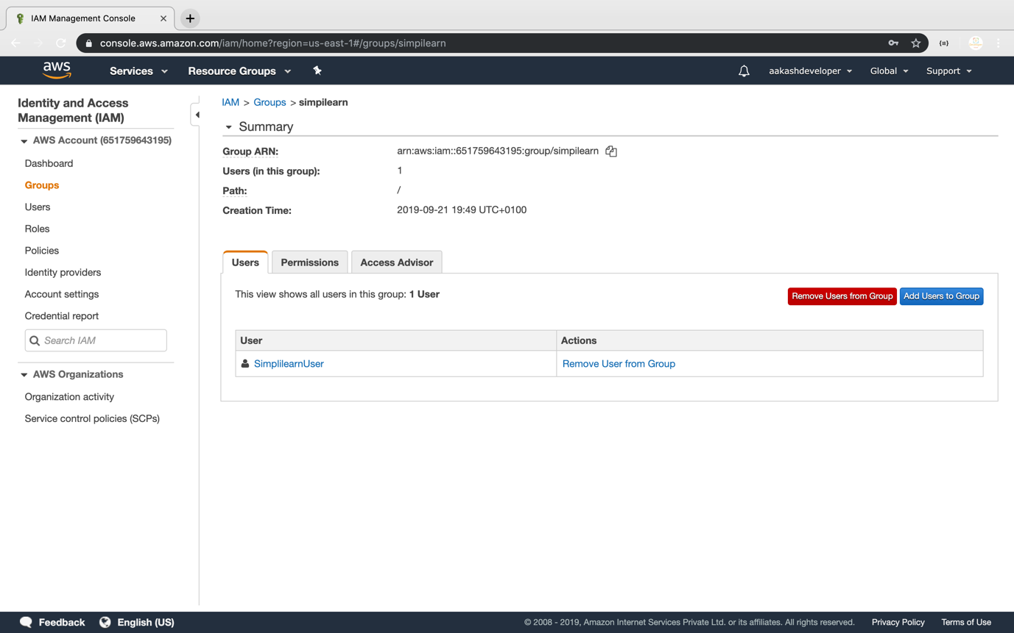

**Step 5.16.3:** Pushing the code to your GitHub repositories

Open your command prompt and navigate to the folder where you have created your files.

cd <folder path>

Initialize your repository using the following command:

git init

Add all the files to your git repository using the following command:

git add .

Commit the changes using the following command:

git commit -m “Changes have been committed.”

Push the files to the folder you created initially using the following command:

git push -u origin master