5.17 Policies and Permissions



This section will guide you to:

* Implement policies and permissions on an S3 bucket

This lab has three subsections, namely:

5.17.1 Creating a bucket

5.17.2 Adding policies

5.17.3 Pushing the code to your GitHub repositories

**Step 5.17.1:** Creating a bucket

* Create a new bucket in which we want to add policy with all default settings.

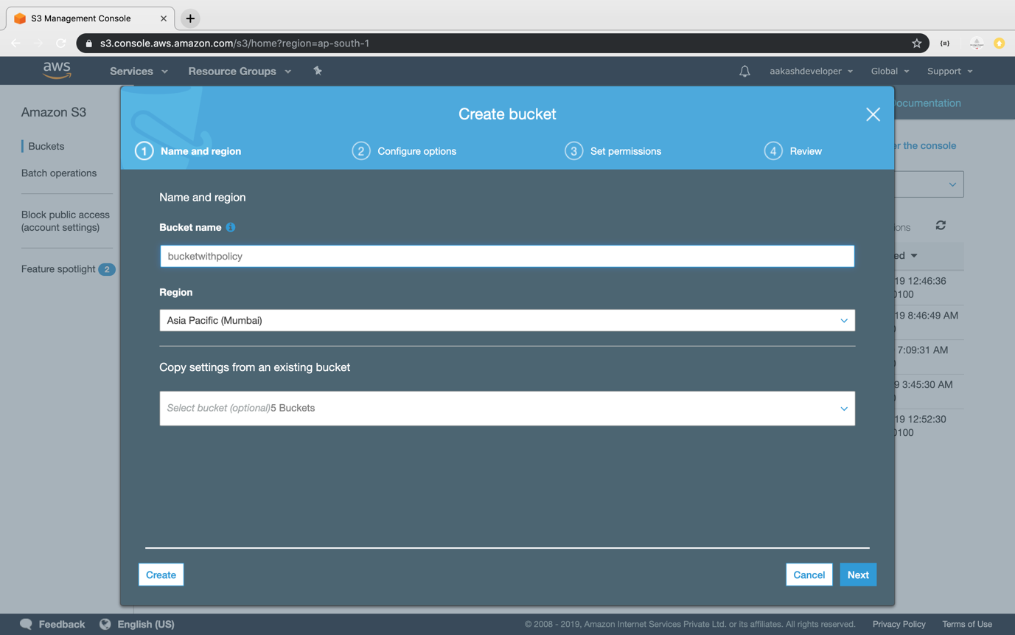

* Click on the *Permission* section.
* Go to *Bucket Policy*.

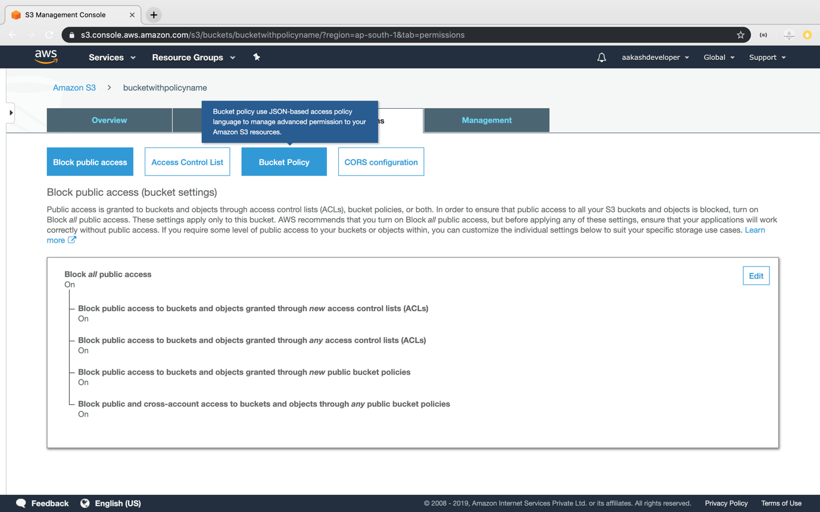

* It will open the console where you can add policy.

**Step 5.17.2:** Adding policies

* Click on the *Policy Generator*.

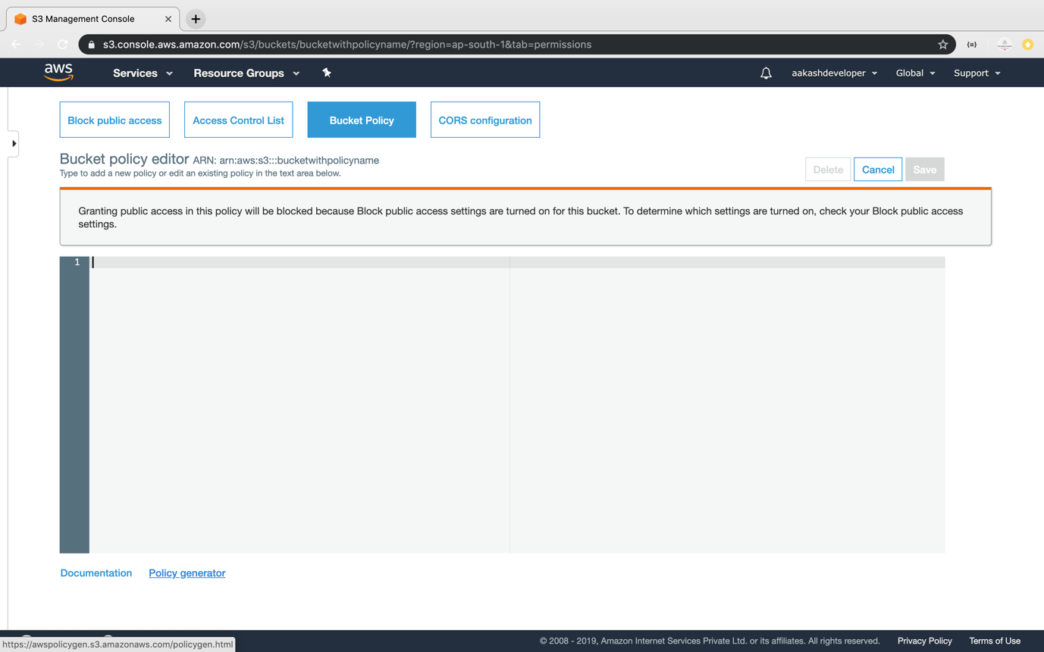

* Select the type of policy and services required.

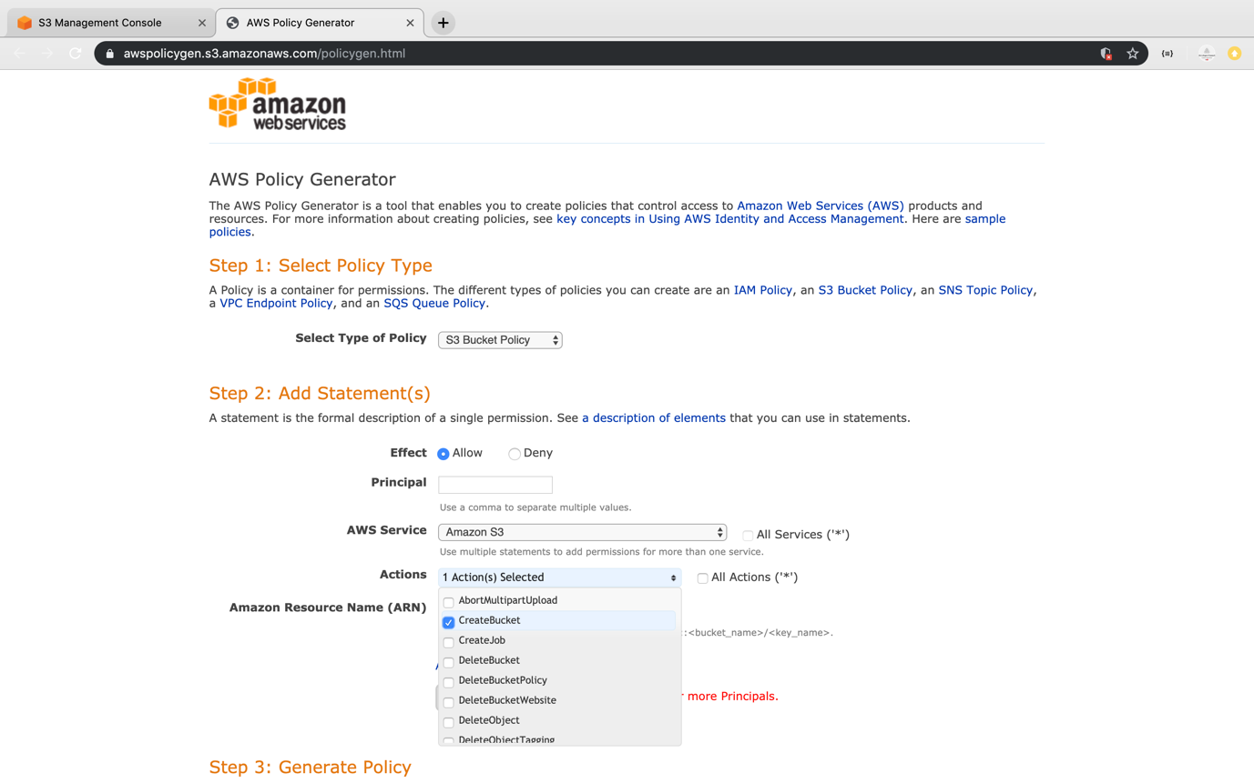

* Add ARN for S3 to add the policy.

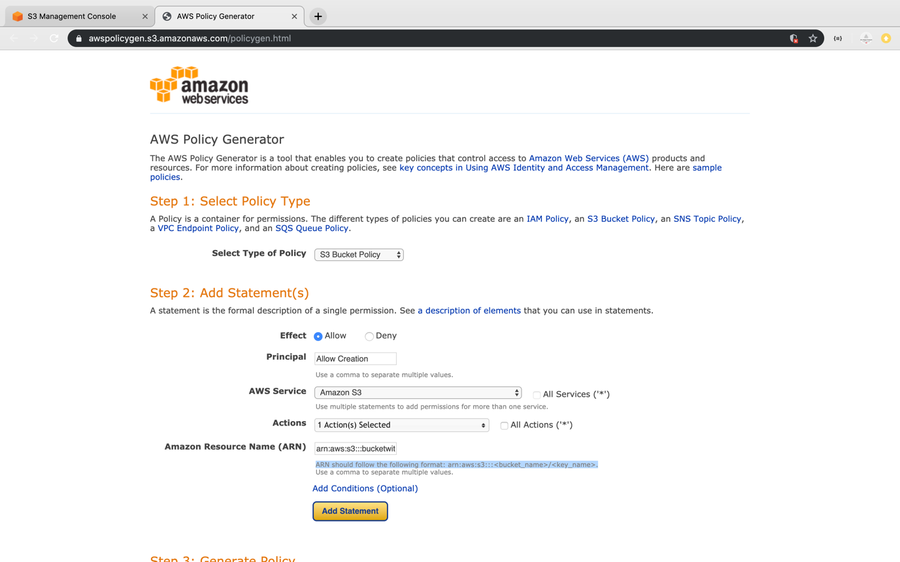

* Click on policy generator to create the JSON of the policy.

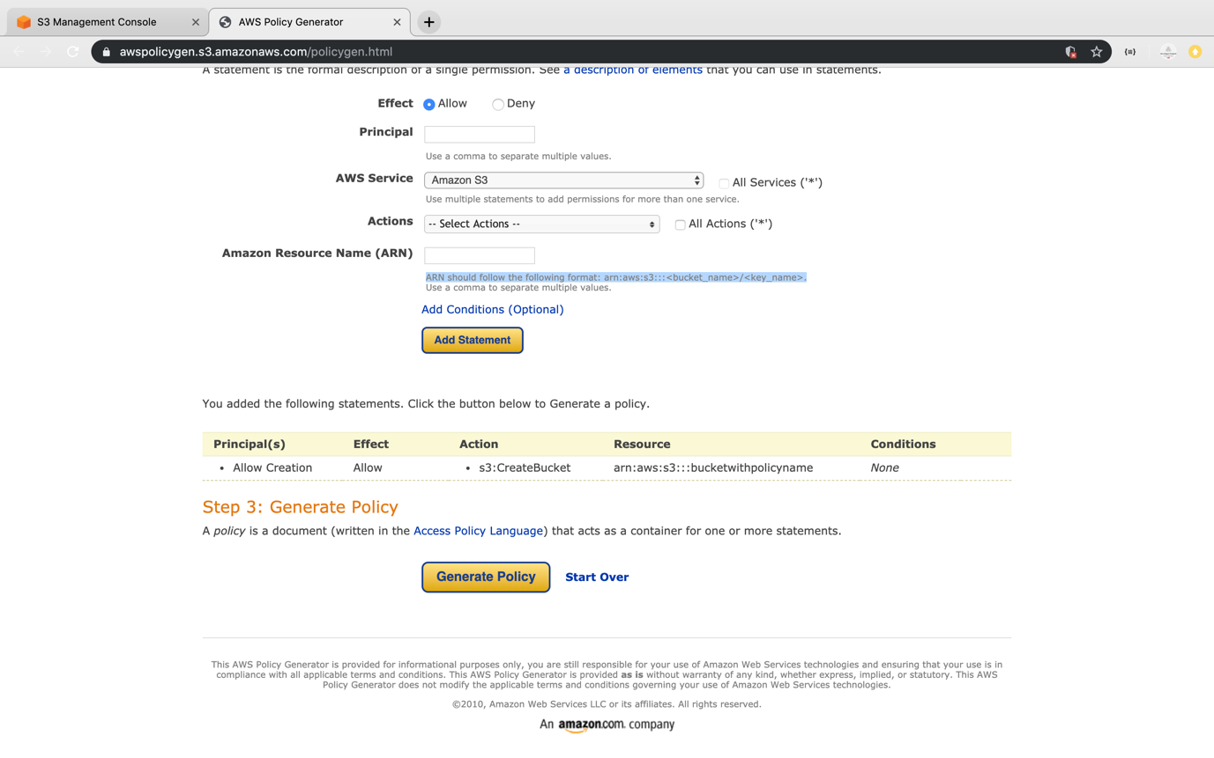

* Copy the generated JSON.

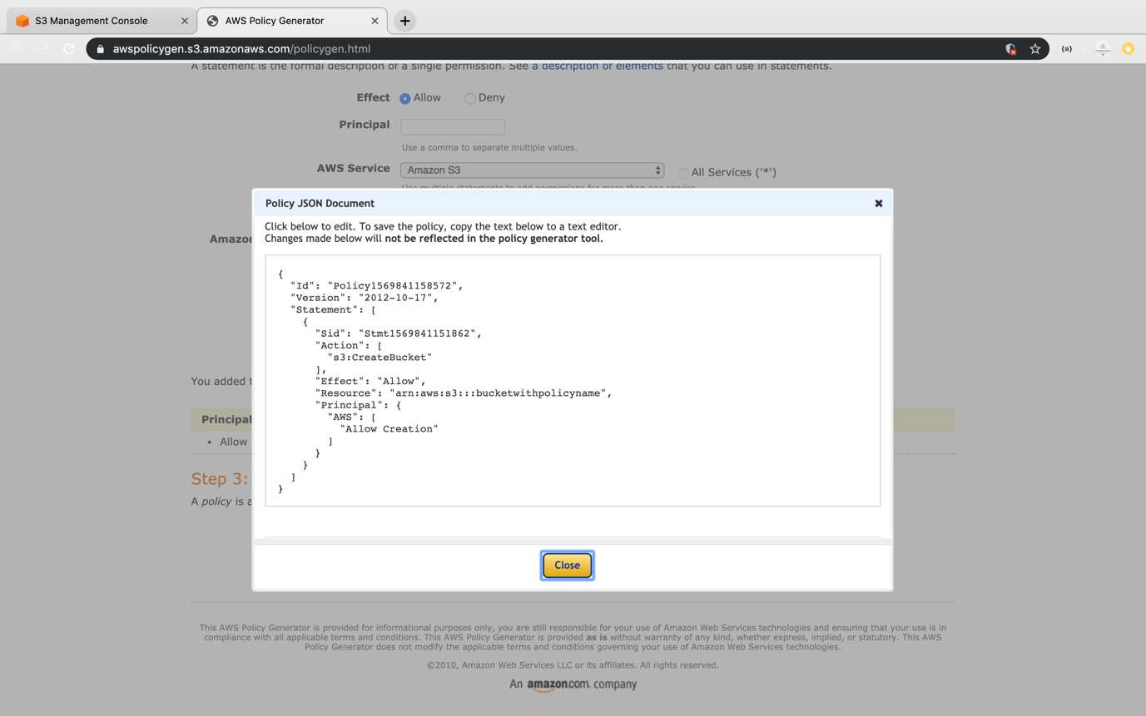

* Paste the JSON in the policy console of bucket and click on *Save*.

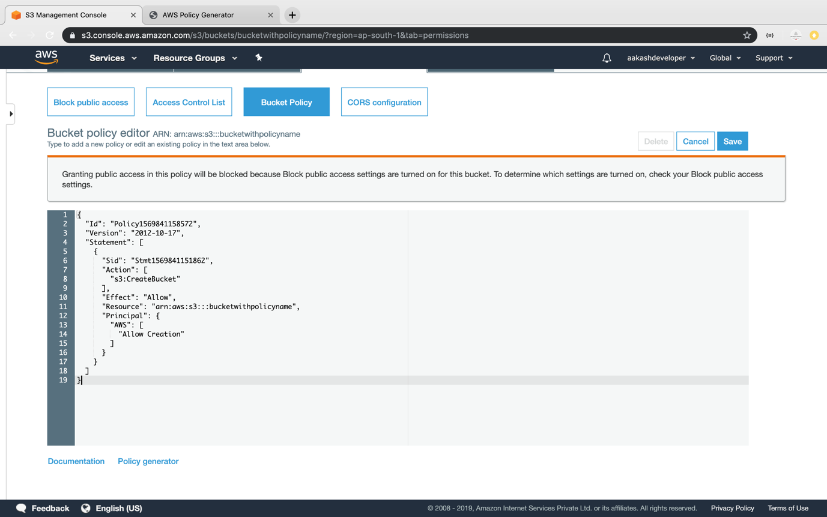

**Step 5.17.3:** Pushing the code to your GitHub repositories

Open your command prompt and navigate to the folder where you have created your files.

cd <folder path>

Initialize your repository using the following command:

git init

Add all the files to your git repository using the following command:

git add .

Commit the changes using the following command:

git commit -m “Changes have been committed.”

Push the files to the folder you created initially using the following command:

git push -u origin master