5.18 Web Hosting



This section will guide you to:

* Host an Angular application on AWS EC2 instance

This guide has mainly three subsections, namely:

5.18.1 Creating a basic Angular application

5.18.2 Creating and preparing an EC2 instance for deployment

5.18.3 Deploying the Angular application on EC2 instance

**Step 5.18.1:** Creating a basic Angular application

* Install Angular CLI in your local system using the following command in your command line:

**npm install -g @angular/cli**

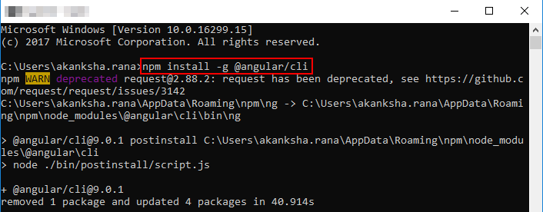

* Create a demo app using the following command:

**ng new the-demo**

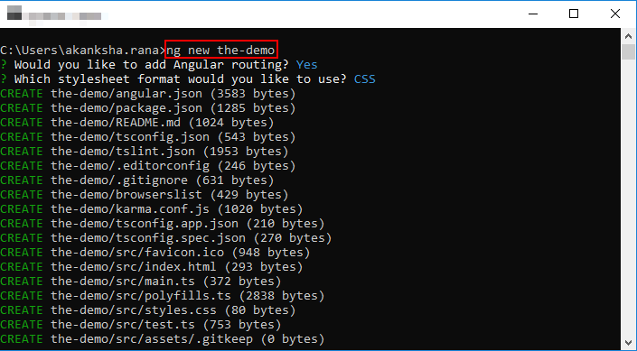

* Use the following command to move into the directory of the demo app:

**cd the-demo**

* Run the demo app using the following command:

**ng serve --open**

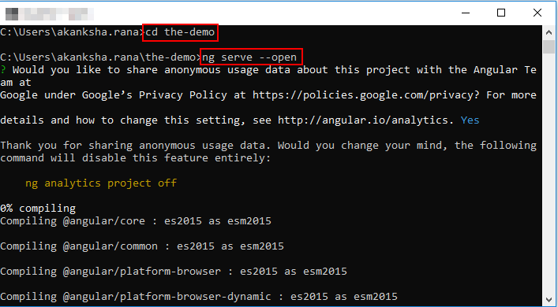

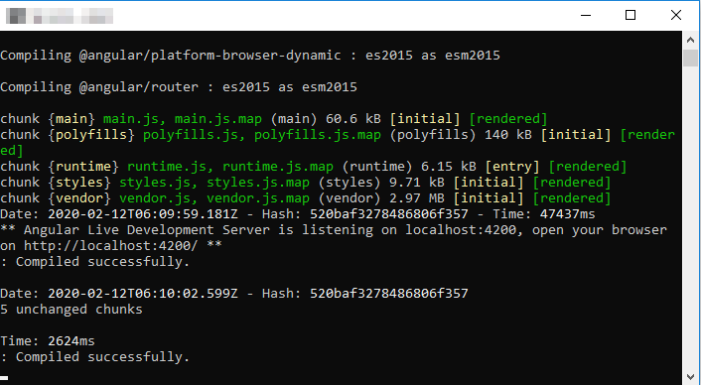

* Open localhost:4200 in your browser. The app should be running as shown in the screenshot below:

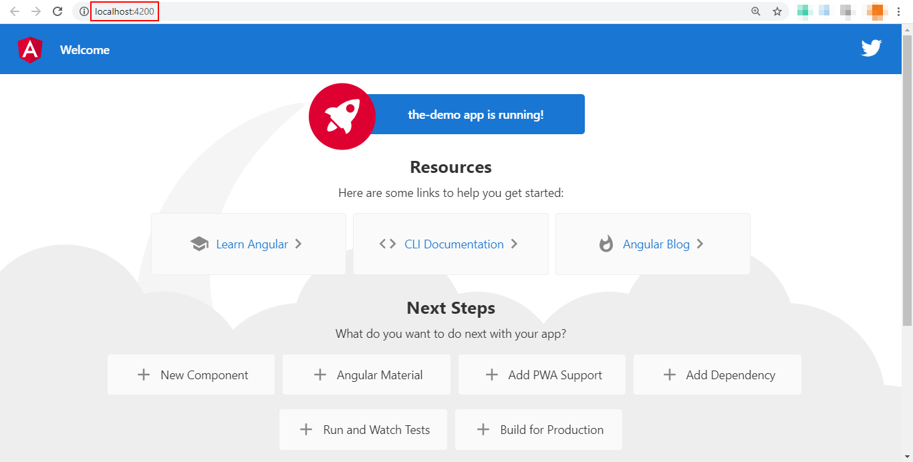

**Step 5.18.2:** Creating and preparing an EC2 instance for deployment

* Log in to the Amazon management console using the credentials given in your practice lab
* Search for EC2 in the search bar

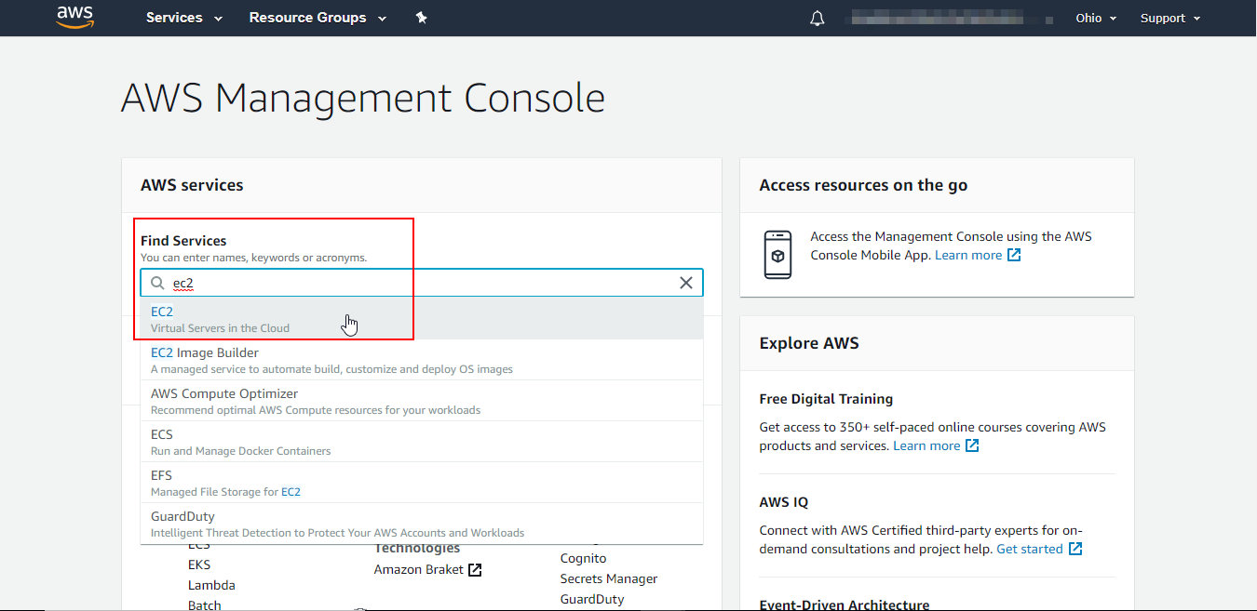

* Click on Launch instance as shown in the screenshot below:

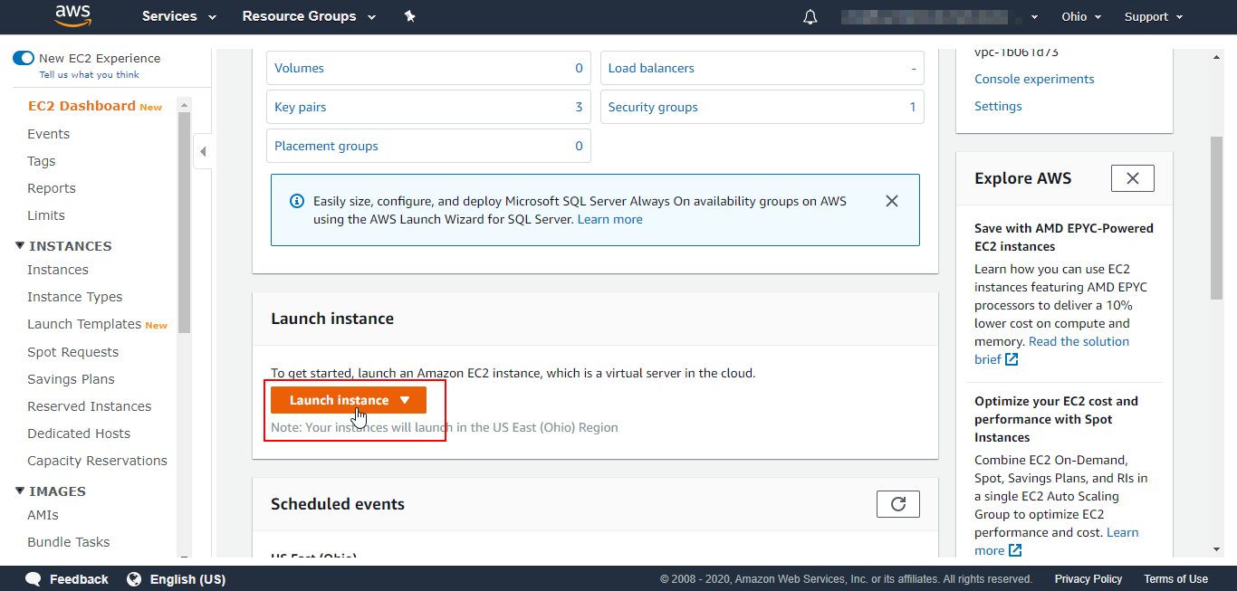

* Choose the instance AMI (the operating system you want in your instance)

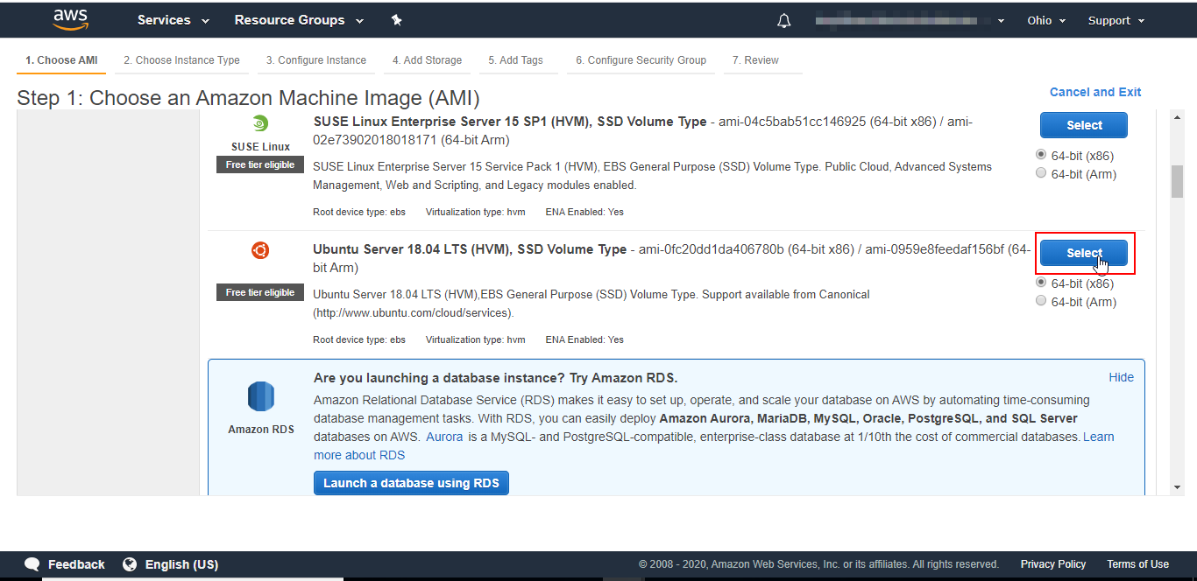

* Keep the default settings and click on the **Review and Launch** button

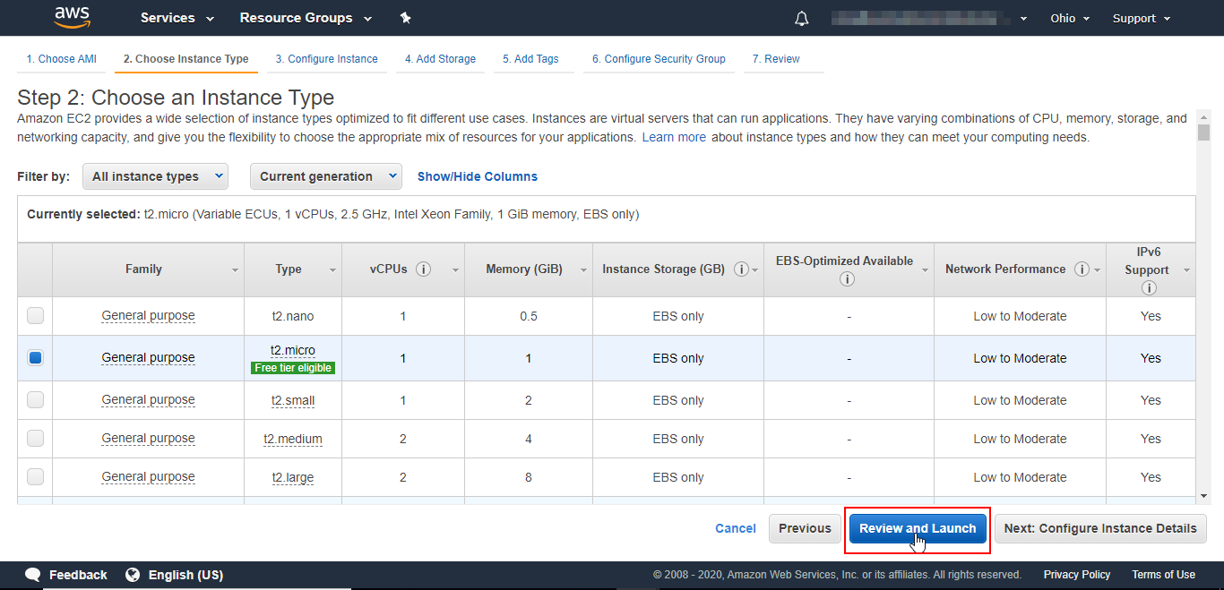

* Create a new key pair for your instance, download it and click on the Launch instance button

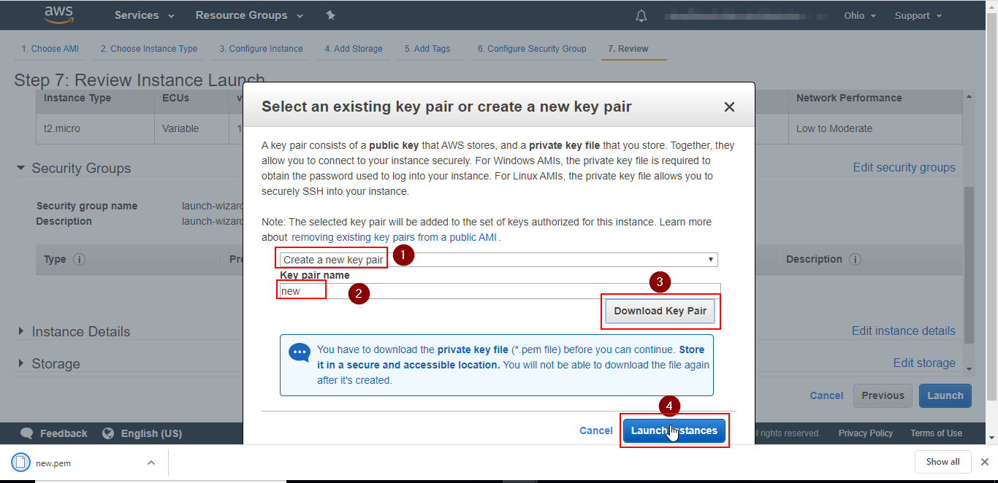

* Download [PuTTy](https://www.putty.org/). Open Puttygen in your system. Click on the **load** button, then browse for the key pair file that you downloaded while creating the instance

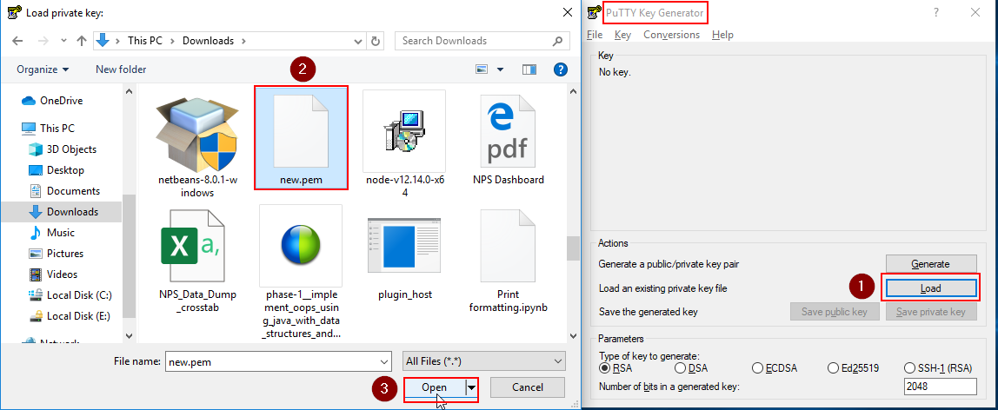

* Click on the **Save private key** button and save the key in the directory of your choice

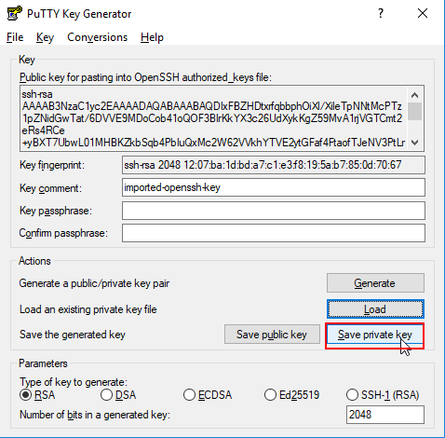

* Go back to the Amazon management console and search for EC2 in the search bar. Click on running instances. Copy the public IP address of the instance as shown in the screenshot below:

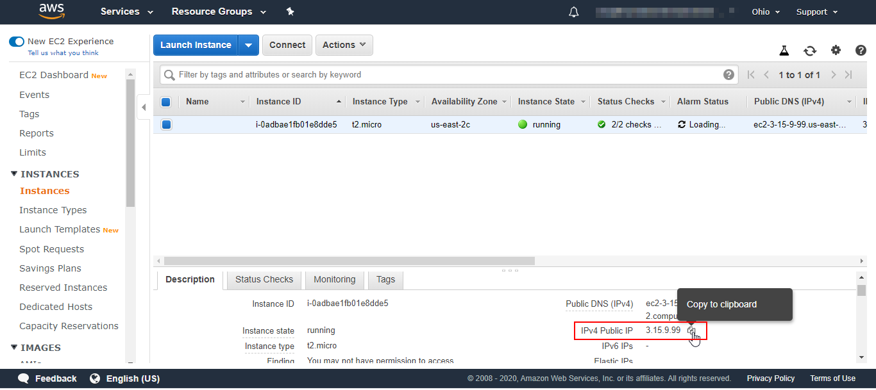

* Open puTTy in your system. Paste the public IP address in the **Host Name** field. Expand the SSH options in the left side menu, then click on Auth

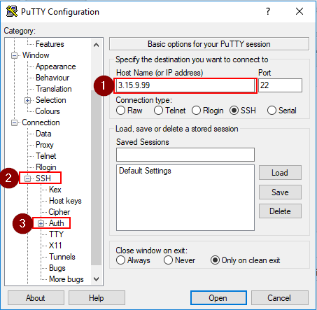

* Click on Browse, select the private key file you saved through puttygen then click on **Open**

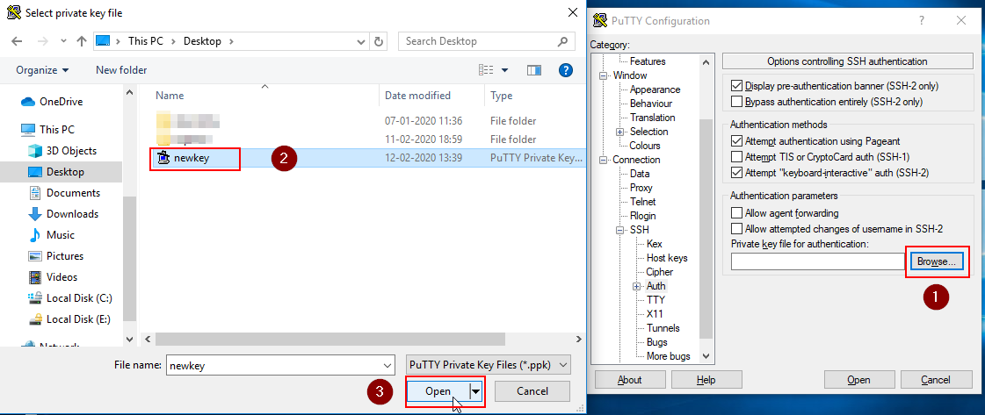

* A dialogue box will open, click on **Yes.** Login as ubuntu if you had selected ubuntu AMI while creating the instance

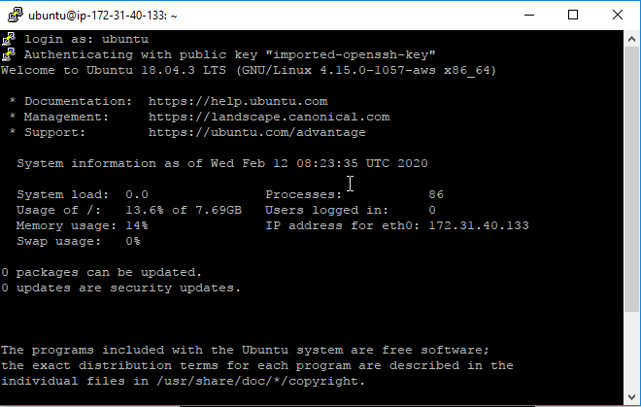

* Run the following command in the ubuntu session to update your EC2 instance:

**Sudo apt-get update**

* Use the following command to install git to pull the app:

**sudo apt-get install -y git**

* Run the following commands to install npm and nodejs in your EC2 instance:

**sudo apt-get install -y npm**

**sudo apt-get install -y nodejs**

* Run the following command to install nginx server:

**sudo apt-get install -y nginx**

* Run the following command to install Angular CLI:

**sudo npm install -g @angular/cli**

* Use the following command to navigate to the Nginx directory:

**cd /etc/nginx/sites-available**

* Use the following command to create a file:

**sudo vim thedemo**

* Paste the following content in the file:

**server {**

**listen 80;**

**listen [::]:80;**

**server_name http:thedemo;**

**root /var/www/the-demo/dist;**

**server_tokens off;**

**index index.html index.htm;**

**location / {**

**# First attempt to server request as file, then**

**# as directory, then fall back to displaying a 404.**

**try_files $uri $uri/ /index.html =404;**

**}**

**}**

* Run the following commands to link the file to another directory:

**cd /etc/nginx/sites-enabled**

**sudo ln -s ../sites-available/{your-site-name}**

**ls -l**

**sudo rm default //removes default directory**

**Step 5.18.3:** Deploying the Angular application on EC2 instance

Use the following command to pull the angular app created in your system from git:

**cd /var/www/**

**sudo git clone https://the-demo**

* Run the following commands to navigate to the app directory and to build it:

**cd /var/www/the-demo**

**ng build --prod --build-optimize**

